1+1 National Defence
National Defence Headquarters
Ottawa, Ontario
K1A OK2

Defense nationale

Quartier general de Ia Defense nationale
Ottawa, Ontario
K1A OK2

24 October 2019

To: Nunavut Water Board, Licensing Department

Re: Long Term Monitoring Reports for DEW Line Sites

DND is re-sending this cover letter to ensure that it was received by the NWB. The reports referenced herein were submitted to the NWB via Purolator on May 23, 2019 and were delivered to the NWB office in Gjoa Haven on June 10,2019.

Pursuant to Section 14.1 of the Nunavut Water Regulations (SOR/2013-69), the Department of National Defence is providing the Nunavut Water Board with this package which fulfills the obligations to provide annual reports for each of the DEW Line sites located in Nunavut that are monitored by DND.

As you are aware, the DND DEW Line sites are now in the Long Term Monitoring Phase of remediation. The current agreement between DND and NTI has the monitoring structured as follows:

• Phase I (years 1 to 5 post construction);
• Phase II (years 7, 10, 15, and 25 post construction); and,
• Phase III (yet to be determined).

The reports generated by the monitoring contractors for the 2018 field season are enclosed on a DVD. Please note that for those sites where no activity occurred in 2018, no monitoring report will be submitted to the NWB.

A summary of the long term monitoring activities that took place in 2018 and relevant reporting obligations to the NWB are summarized in Table 1 below.

Canada

Table 1. Summary of Long Term Monitoring Fulfilling the Obligation for Annual
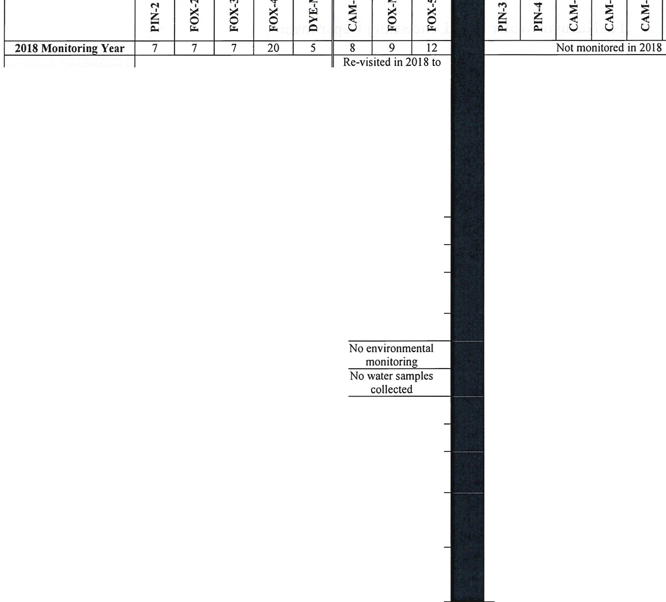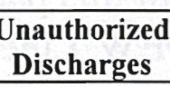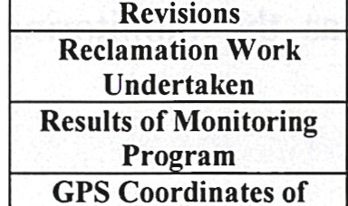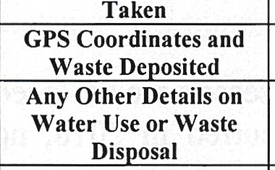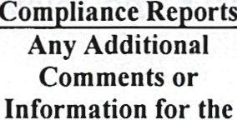Reporting Under Section 14.1 of the Nunavut Waters Regulations (SOR/2013-69)

=M
M M M Ill M

;;:; M

M M = M M M M = =::; M-
w- :3

\C -

.....

t--

:;;:

M M M- \C M Ill M = =
-
- cl: - -
u :z
Ill M

M ...,. M Ill
=-
u :3 M
M M < M t-- =
ii

..... Q
0
:><: > < < ;:;::
M
..l

< 0 0
Q ::; ::r:
Ill ""
::r: w

u ..l
5 > = ...., "" =-

cl: = = = = =
c=l:
= cl: c=l: =cl: c=l: ::
c=l:

cl: cl: cl:
-
cl: cl:
= = .....
:;

= ..... .....
..... ..... ._ ._

._ '7 ...,.
::;
u< u<

Summary of Water
Used On Site

Spill Contingency Plan

Regularly scheduled full monitoring event; < 30 L of groundwater purged and sampled at each site. Bottled water brought to the sites for personal consumption; no other water use.

None
complete geotechnical inspection work that was missed in 2016 and 2017; no water samples collected. Bottled water brought to the sites for personal
consumption; no
other water use.

Revisions None
Abandonment and
Restoration Plan None

None Not applicable

See monitoring reports

Water Taken See monitoring reports
Volume of Water < 30 L per site No water samples collected

None

None

Any Responses or
Follow Up Actions on
Inspections I None

Board to Consider
None

Should you have any questions regarding these reports or this summary table, please do not hesitate to contact me at alison. street(a),forces.gc.ca or at (613) 995-8603.

Regards,



Alison Street, P.Eng.
Project Engineer, DEW Line Clean-Up and Long Term Monitoring, DND Enclosed DVD (sent via Purolator in May, 2019):
PIN-2 2018 Monitoring Report (1BR-CAP1623) FOX-2 2018 Monitoring Report (1BR-LON1422) FOX-3 2018 Monitoring Report (1BR-FOD1320) FOX-4 2018 Monitoring Report (1BR-FOX1523) DYE-M 2018 Monitoring Report (1BR-DYE1623)

CAM-5 2018 Geotechnical Addendum (1BR-MAC1323) FOX-M 2018 Geotechnical Addendum (1BR-HAL1533) FOX-5 2018 Geotechnical Addendum (1BR-QIK1320)

