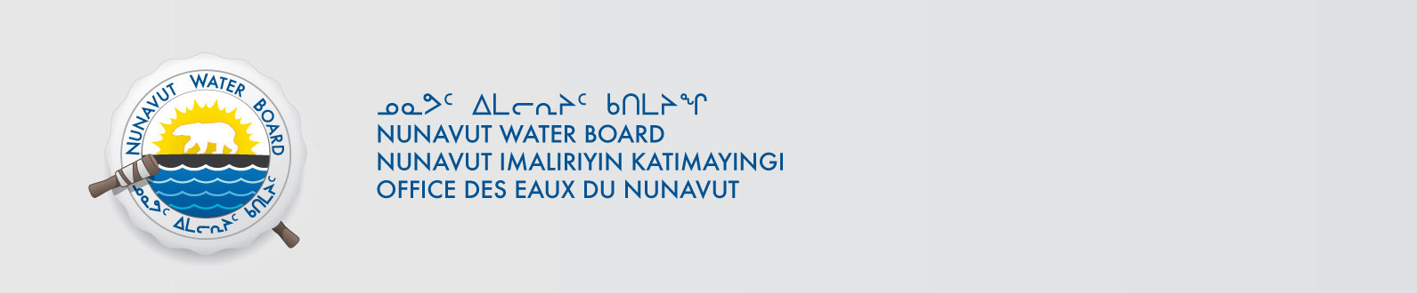
December 13, 2016 File No: 1BR-CST----NWB2MEL01--
Josh Foster
Kitnuna Environmental Ltd.
PO Box 92, 10 Omilik Road
Cambridge Bay, NU X0B 0C0
Email: jfoster@kblenv.com

Subject: Kitnuna Environmental Ltd. – WMC International Limited Cambridge Bay Soil and Water Treatment Facility – New – Type “B”, Kitikmeot

Dear : Josh Foster

The Nunavut Water Board (NWB) provides notice that, on November 8, 2016 a new an application for a licence renewalapplication for a Type “B” water license January 5, 2001for water use and/or waste disposal associated with exploratory drillingactivities in the Kitikmeot region of Nunavut was filed by Kitnuna Environmental Ltd.. By way of this correspondence, the Board invites parties to provide the NWB with their comments with respect to the application as outlined below. The application consists of the following documents:
- Cover Letter NIRB Screening Decision Report
- NIRB Screening Decision Report
- NIRB Notice of Release
- General Water Licence Application
- Hamlet Agreement Letter
- Certificate of Incorporation
- Closure and Reclamation Plan
- Environmental Protection Plan
- Resolution of Directors Feb 8 2016
- Operations and Maintenance Plan
- NIRB Section 4 Non Technical Project Proposal Description Final (Inuktitut)
- NIRB Section 4 Non Technical Project Proposal Description Final (English)
- NPC Letter
- NWB Water Licence Letter
- Tech Info for Supplementary Information Guideline I3 Landfarm
- Spill Contingency Plan

The application can be obtained from our ftp site at the following link:
ftp://ftp.nwb-oen.ca/registry/1%20INDUSTRIAL/1B/1BR%20-%20Remediation/1BR-CST----%20KEL/

As noted in the NWB’s earlier correspondence acknowledging receipt of this application, under the Agreement Between the Inuit of the Nunavut Settlement Area and Her Majesty the Queen in Right of Canada (Nunavut Agreement) Article 11, Section 11.5.9 and s. 76 (1) of Nunavut Planning and Project Assessment Act (NuPPAA), the proponent of a project proposal governed by the Nunavut Agreement and NuPPAA that requires a water licence is required to submit a project proposal document (which may include the water licence application) directly to the Nunavut Planning Commission (NPC or Commission). The NPC then reviews the project proposal and makes a determination regarding the applicable land use planning requirements and/or provides direction regarding whether the project proposal is subject to screening by the Nunavut Impact Review Board (NIRB). Under Articles 11, 12 and 13 of the Nunavut Agreement, NuPPAA and Part 3 of the Nunavut Waters and Nunavut Surface Rights Tribunal Act (NWNSRTA), until the project proposal has concluded the applicable land use planning and assessment process required by the NPC and the NIRB, the NWB cannot issue a water licence.

On this basis, the NWB, while previously acknowledging the receipt of the application, waited for the Commission’s determination and recommendations before proceeding to the next steps in the NWB’s processing of the application. Please be advised that on May 31, 2016 the NWB received the required determinations and recommendations from the Commission and on August 26, 2016 received the NIRB’s determination in respect of the project proposal associated with the water licence application.

Now that the application has concluded the pre-licensing steps required under the Nunavut Agreement, NuPPAA and the NWNSRTA, the NWB is now proceeding to the next steps in processing the application, including providing the attached Notice of Application which will be published in due course. In addition, to ensure this application is dealt with in a timely fashion, the NWB has forwarded notice of all documentation received by the NWB in respect of the application to regulators and Council of the Municipality(ies) most affected by the project. The NWB is also inviting interested parties to make representations about the application, including information requests, identifying issues of water user compensation and providing technical review comments directly to the NWB within thirty (30) days from the date of this letter; on or before January 13, 2017.

After the NWB receives and reviews the comments received, the Board may provide additional procedural instructions regarding the next steps in the Board’s processing of the application. Please note that throughout the Board’s consideration of the application, the NWB retains the right to request additional information and studies, as set out under ss. 48(1)-(3) of the NWNSRTA. If additional information will be requested, the NWB’s technical staff will contact the applicant to discuss the Board’s request in detail.

If the applicant or parties have any questions regarding this matter, please contact Sean Jospeh, the Technical Advisor for the file.

Sincerely,

Robin Ikkutisluk
Licence Administrator

Enclosure: Notice of Application
Cc: Distribution List – Kitikmeot

