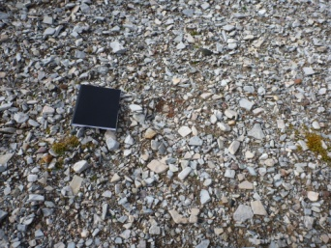  Photo A1  Close up view of erosion feature |  | 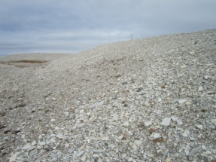  Photo A2  North view of southwest slope |  | 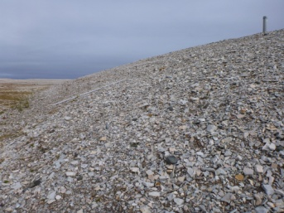  Photo A3  North view of northwest slope
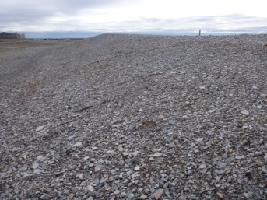  Photo A4  South view of northeast slope |  | 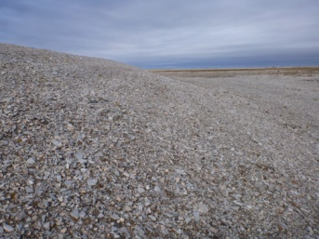  Photo A5  North view of southeast slope |  | 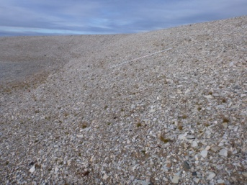  Photo A6  Northwest view of south slope
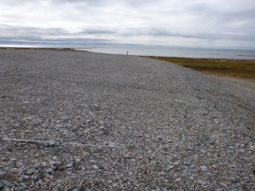  Photo A7  Southwest view of top from north corner |  | 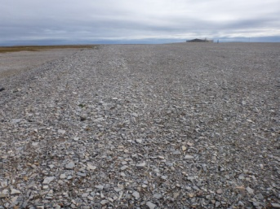  Photo A8  Southeast view of top from north corner |  | 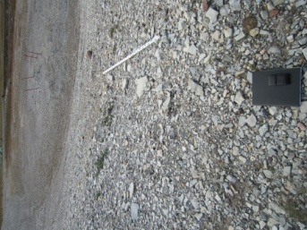  Photo A9  Erosion feature looking west
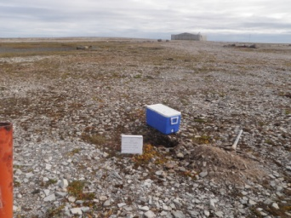  Photo A10  Soil Sampling  MW-5  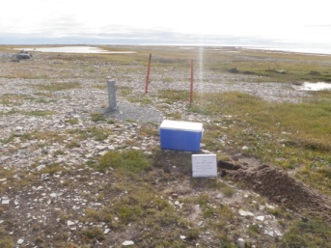  Photo A13  Soil Sampling  MW-8 |  | 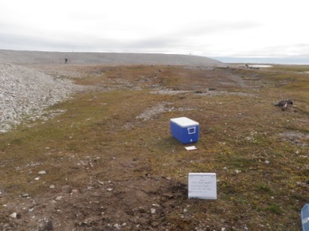  Photo A11  Soil Sampling  MW-6 |  | 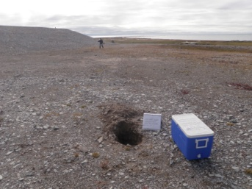  Photo A12  Soil Sampling  MW-7
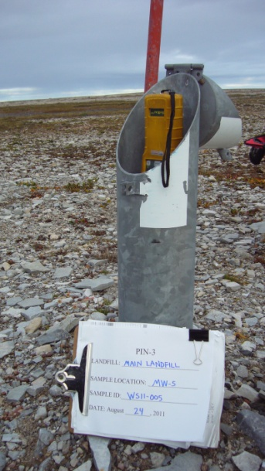  Photo A14  Groundwater Sampling  MW-5  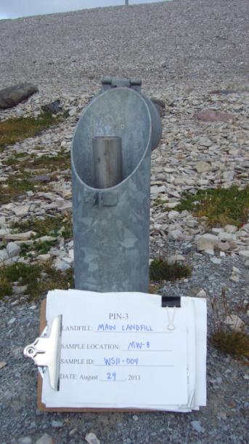 |  | 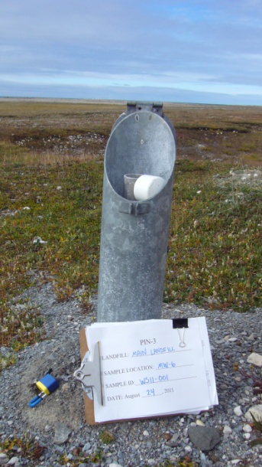  Photo A15  Groundwater Sampling  MW-6 |  | 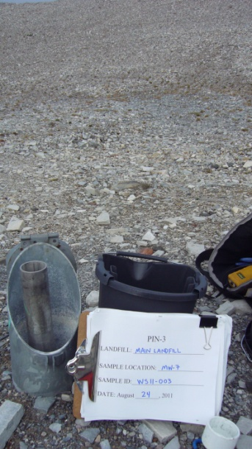  Photo A16  Groundwater Sampling  MW-7

Photo A17
Groundwater Sampling
MW-8

