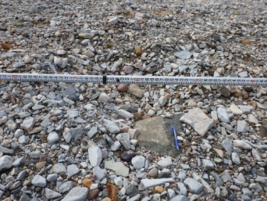  Photo C1  Close up view of erosion feature |  | 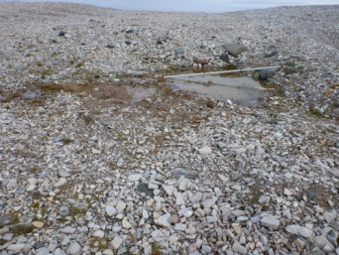  Photo C2  Close up view of ponded water |  | 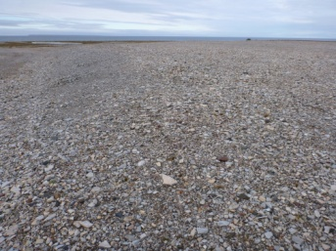  Photo C3  Southwest view of east regraded area
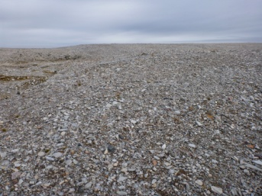  Photo C4  North view of west side of regraded area |  | 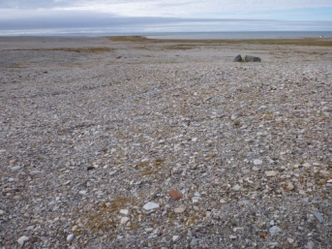  Photo C5  South view of main regraded area |  | 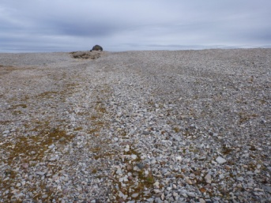  Photo C6  North view of main regraded area
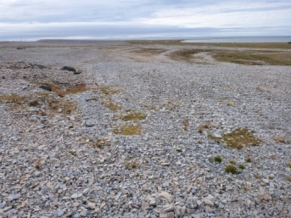  Photo C7  South view of west regraded area |  | 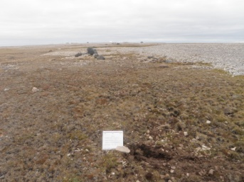  Photo C8  Soil Sampling  P3-1 |  | 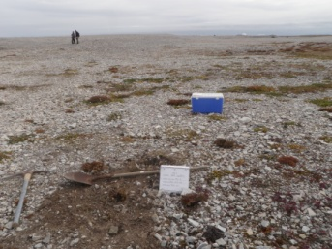  Photo C9  Soil Sampling  P3-2
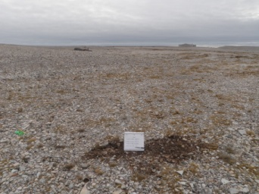  Photo C10  Soil Sampling  P3-3 |  | 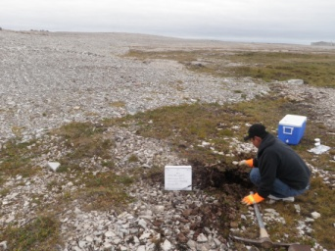  Photo C11  Soil Sampling  P3-4

