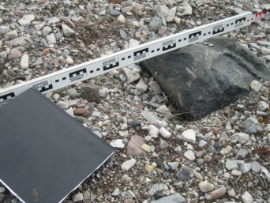  Photo D1  Close up view of erosion feature A |  | 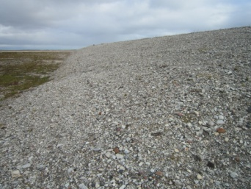  Photo D2  East view of north slope |  | 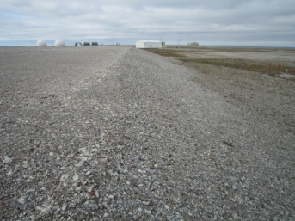  Photo D3  North view of east slope
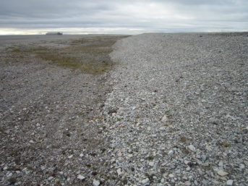  Photo D5  West view of South slope and toe |  | 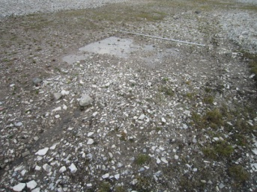  Photo D6  Ponded water looking northeast |  | 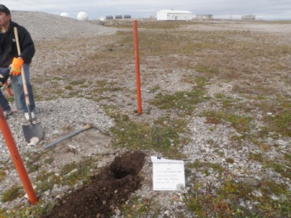  Photo D7  Soil Sampling  MW-13
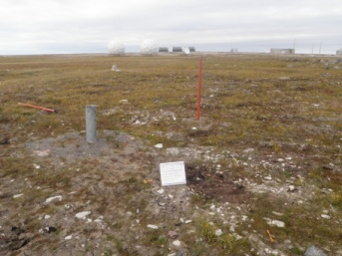  Photo D8  Soil Sampling  MW-14 |  | 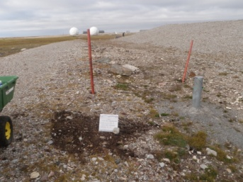  Photo D9  Soil Sampling  MW-15 |  | 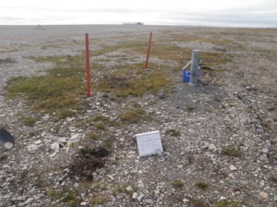  Photo D10  Soil Sampling  MW-16
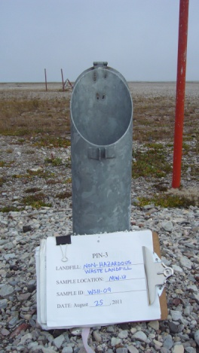  Photo D11  Groundwater Sampling  MW-13 |  | 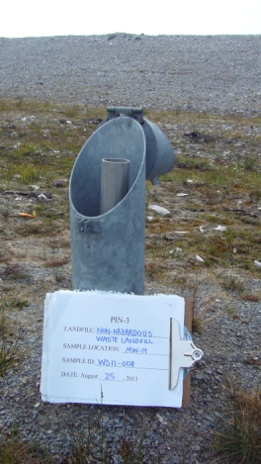  Photo D12  Groundwater Sampling  MW-14 |  | 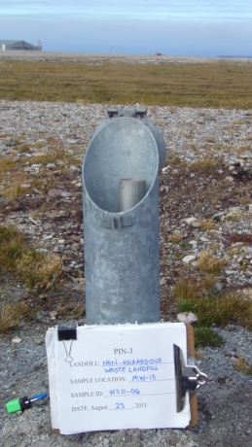  Photo D13  Groundwater Sampling  MW-15
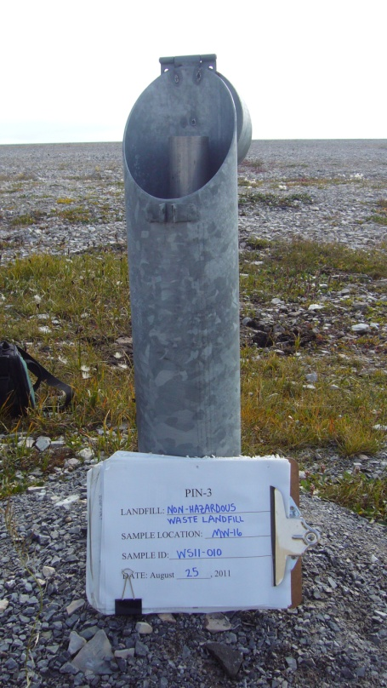

Photo D14
Groundwater Sampling
MW-16

