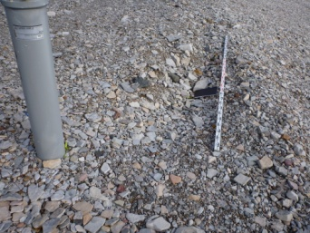  Photo B1  View of settlement feature A near VT-7 |  | 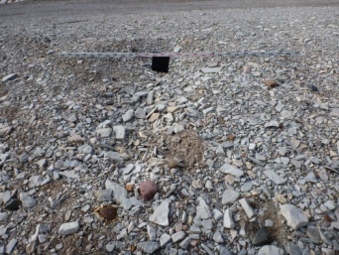  Photo B2  View of settlement feature B near southwest corner crest |  | 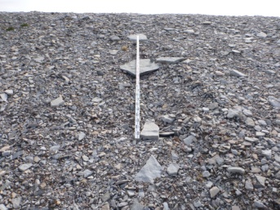  Photo B4  View of erosion feature D near northwest corner
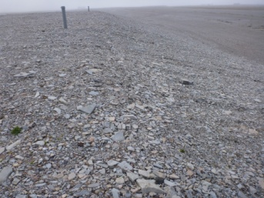  Photo B5  West view of differential settlement feature E on north crest and slope |  | 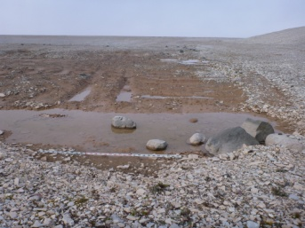  Photo B6  North view of ponded area F at toe of southwest corner |  | 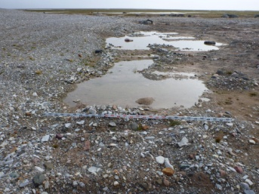  Photo B7  South view of ponded area F at toe of southwest corner
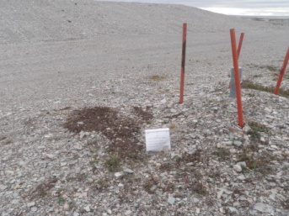  Photo B8  Soil Sampling  MW-9 |  | 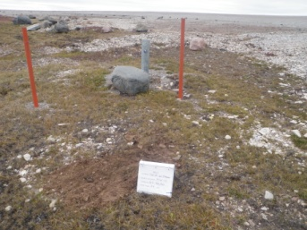  Photo B9  Soil Sampling  MW-10 |  | 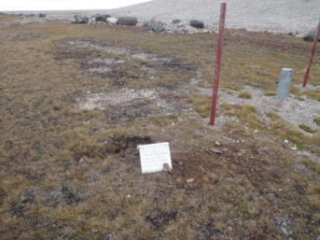  Photo B10  Soil Sampling  MW-11
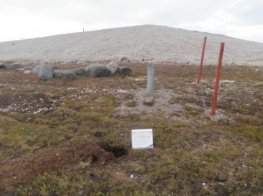

Photo B11
Soil Sampling
MW-12

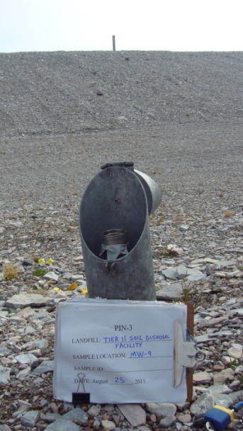  Photo B12  Groundwater Sampling  MW-9 |  | 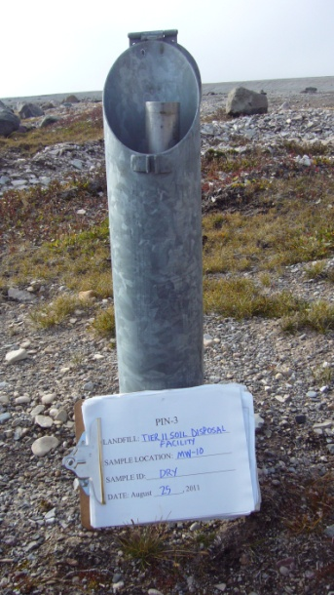  Photo B13  Groundwater Sampling  MW-10 |  | 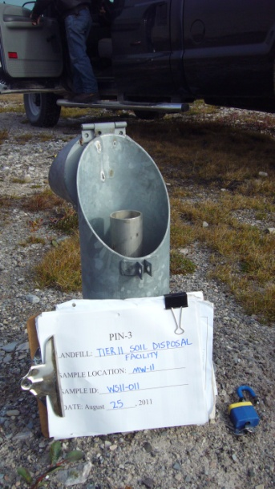  Photo B14  Groundwater Sampling  MW-11

