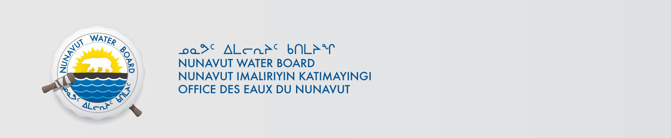

January 30, 2019 NWB File No: 1BR-KRK1318

Shah Alam, P. Eng. E.P
Municipal Planning Engineer
Cambridge Bay Nu,
X0B 0C0
E-mail: salam@gov.nu.ca

Subject: Application Acknowledgement for the Kugaaruk Landfarm Renewal

Dear Mr. Alam:

The Nunavut Water Board (“NWB”) acknowledges receipt on December 18, 2018 of your renewal water licence application, for the Kugaaruk Landfarm. This application has been assigned file number 1BR-KRK1318. Please refer to this number on future submissions. Application documents received are as follows:

- Licence Renewal Application & Supporting Documents
- Compliance Assessment for Renewal Application
- Executive Summary Inuktitut
- Kugaaruk Landfarm Compliance Plan
- NPC Letter

Please be advised that under the Agreement Between the Inuit of the Nunavut Settlement Area and Her Majesty the Queen in Right of Canada (Nunavut Agreement) Article 11, Section 11.5.9 and s. 76 (1) of Nunavut Planning and Project Assessment Act (NuPPAA), the proponent of a project governed by NuPPAA is also required to submit a project proposal document directly to the Nunavut Planning Commission (NPC or Commission) for the NPC’s determination regarding the applicable land use planning requirements and/or directions regarding whether the project is subject to screening by the Nunavut Impact Review Board. In particular, please note that as established under Articles 11, 12 and 13 of the Nunavut Agreement, NuPPAA and Part 3 of the Nunavut Waters and Nunavut Surface Rights Tribunal Act, until the project has completed the applicable land use planning and assessment process required by the NPC and the NIRB, the NWB cannot issue a water licence/approval.

The NWB confirms receipt of NPC conformity under NuPPAA on December 19, 2018. This application is now ready for review and comments. Deadline for submissions is February 28, 2019.

Please call the undersigned at (867) 360-6338 or email to licensing@nwb-oen.ca if you have any questions.

Sincerely,

Licensing Administrator

BCC: Kitikmeot Distribution List

