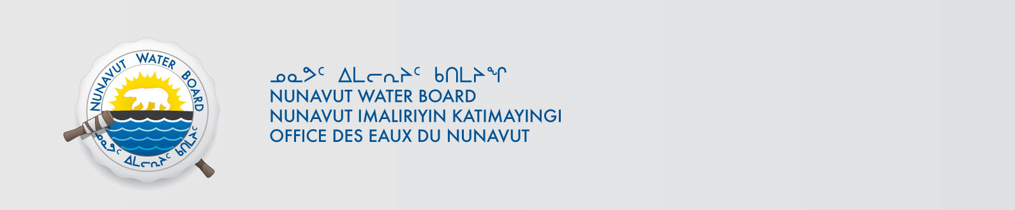

January 30, 2019 File No: 1BR-KRK1318

To: Hamlet, CLARC, HTO, RIA, Coop, and NorthernLocal Organizations – Request to Post Notices

The Nunavut Water Board requests that you post on a bulletin board, until February 28, 2019, the attached notices (in English and Inuktitut), where they can be viewed by the public. The attached letter is for your information and does not require posting.

Your time and effort is greatly appreciated.

Sincerely,

Licensing Administrator

Cc: Hamlet of Kugaaruk (867) 769-6069
Kitikmeot Inuit Association (867) 769-6202
Kurtaijuark HTO (867) 769-6713
Koomiut Co-op (867) 769-6098

