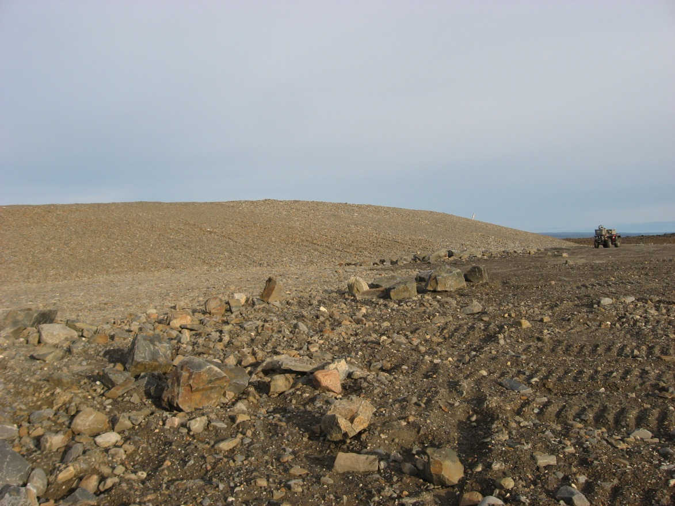
Photograph 94. Upper Site Landfill Lobe A – Looking SE (Way Point 095, Photo FOX-2 01).
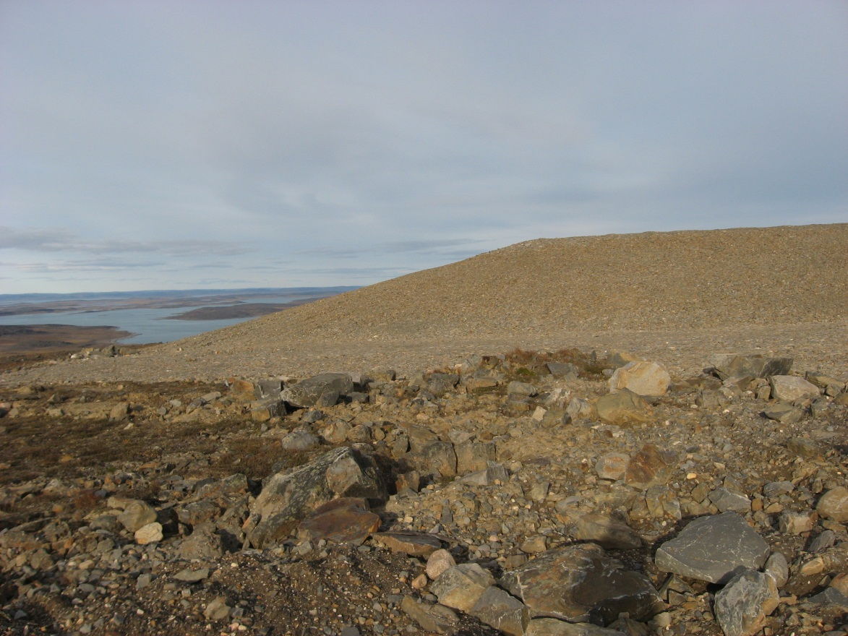
Photograph 95. Looking E (WP 095, FOX-2 02).
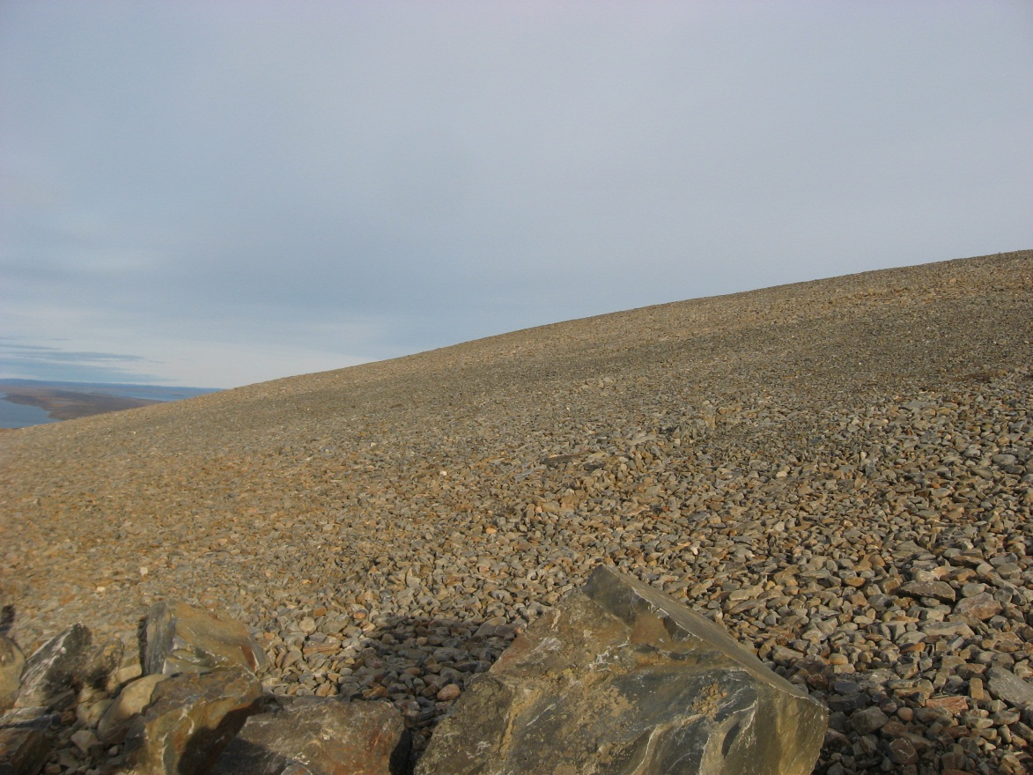
Photograph 96. Looking E (WP 096, FOX-2 03).
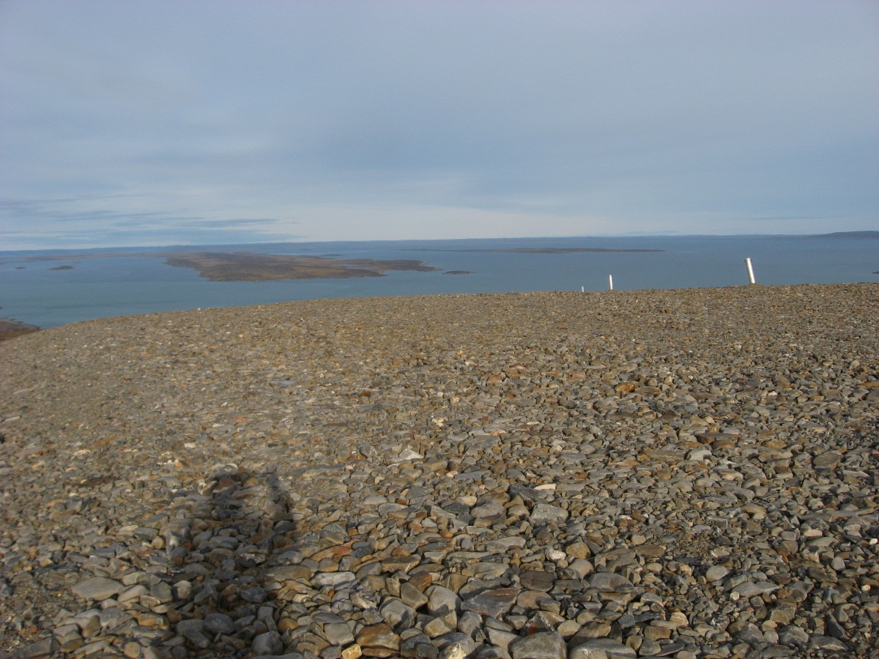

Photograph 97. Looking E (WP 097, FOX-2 04).
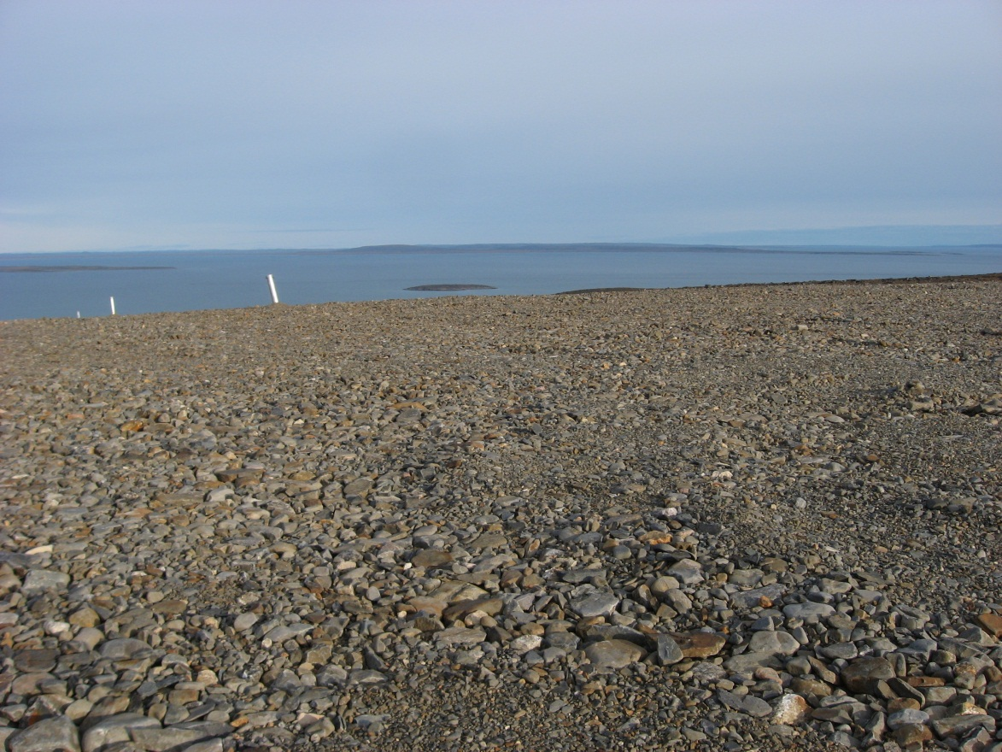
Photograph 98. Looking SE (WP 097, FOX-2 05).
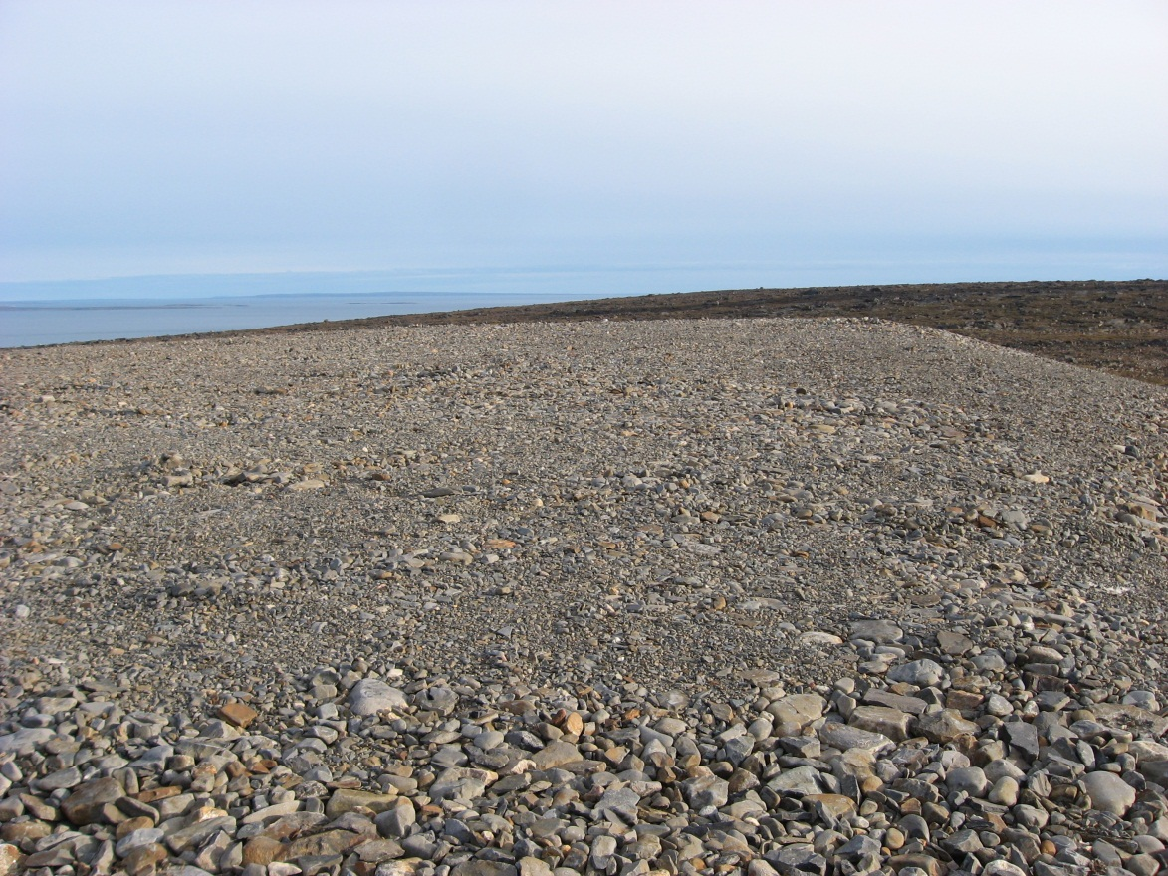
Photograph 99. Looking S (WP 097, FOX-2 06).
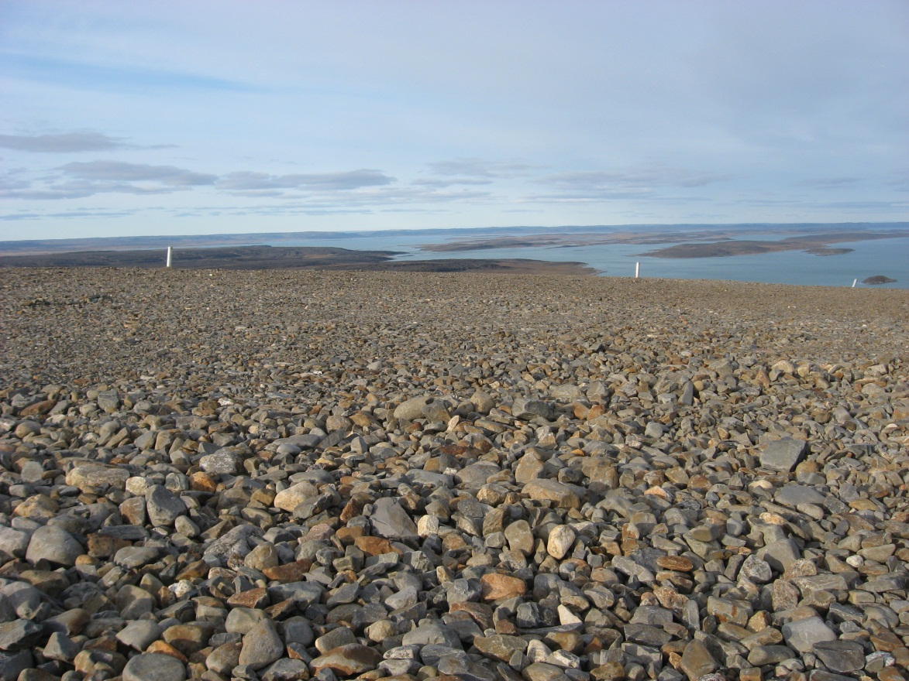
Photograph 100. Looking NE (WP 098, FOX-2 07).
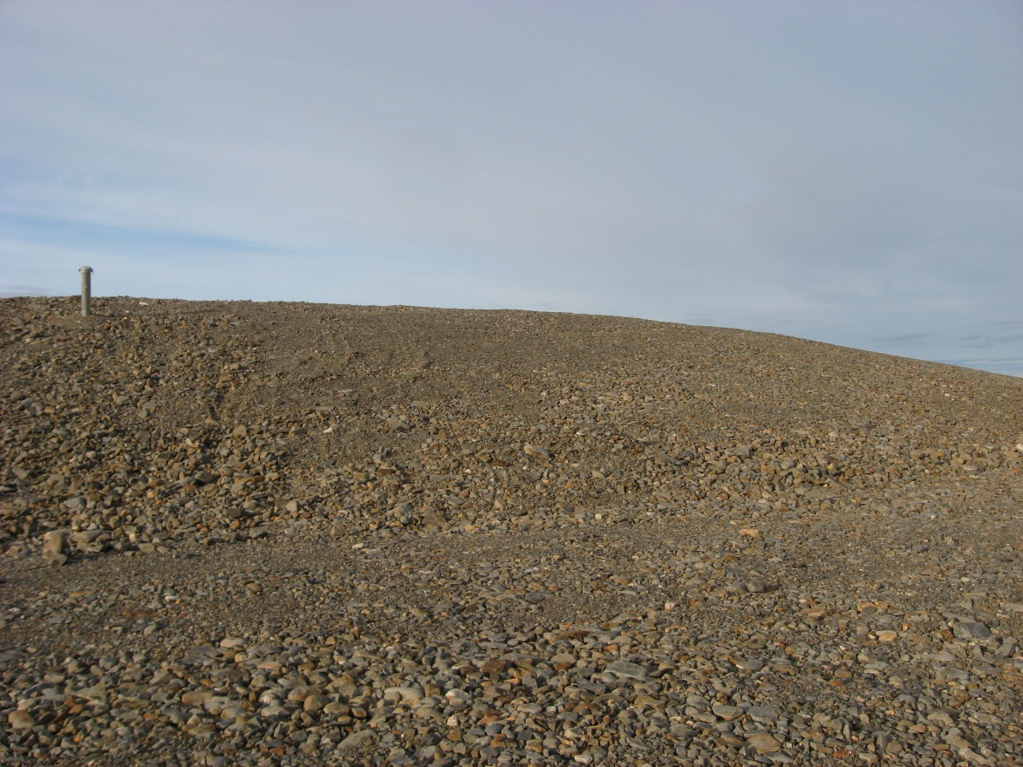
Photograph 101. Looking N (WP 099, FOX-2 08).
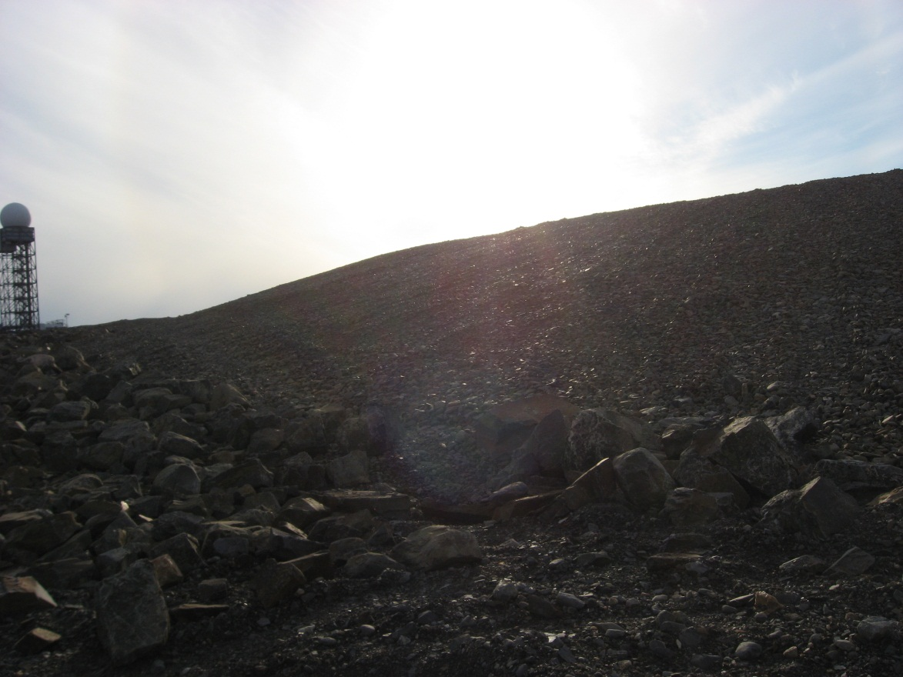
Photograph 102. Looking W (WP 100, FOX-2 09).
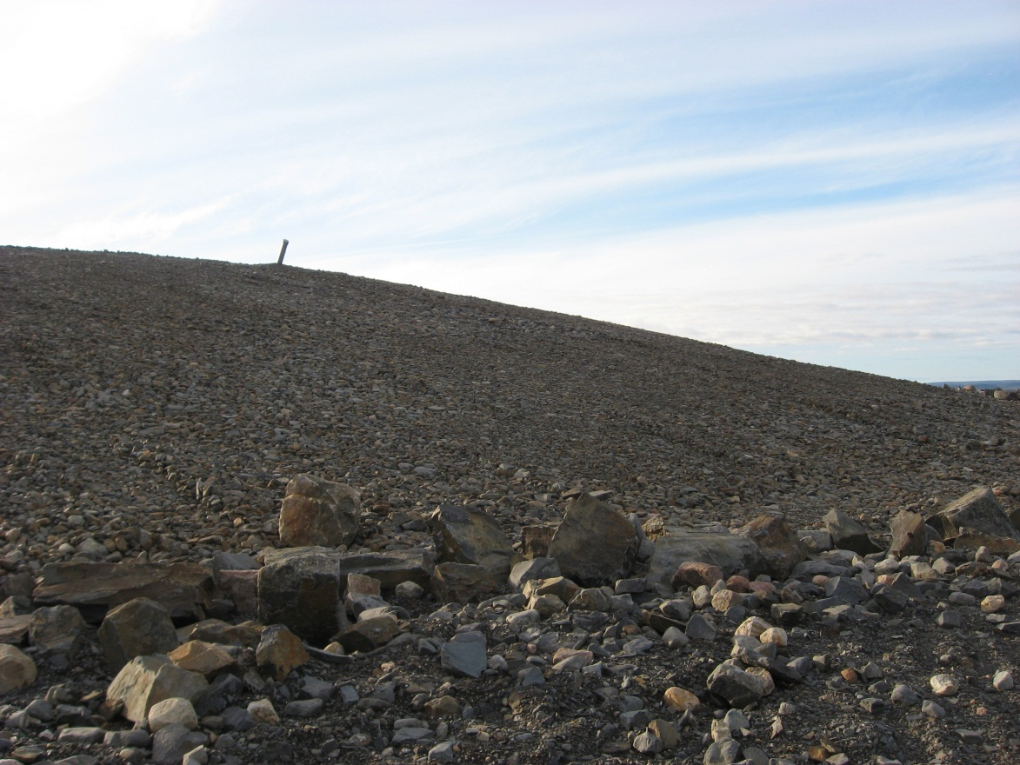
Photograph 103. Looking N (WP 100, FOX-2 10).
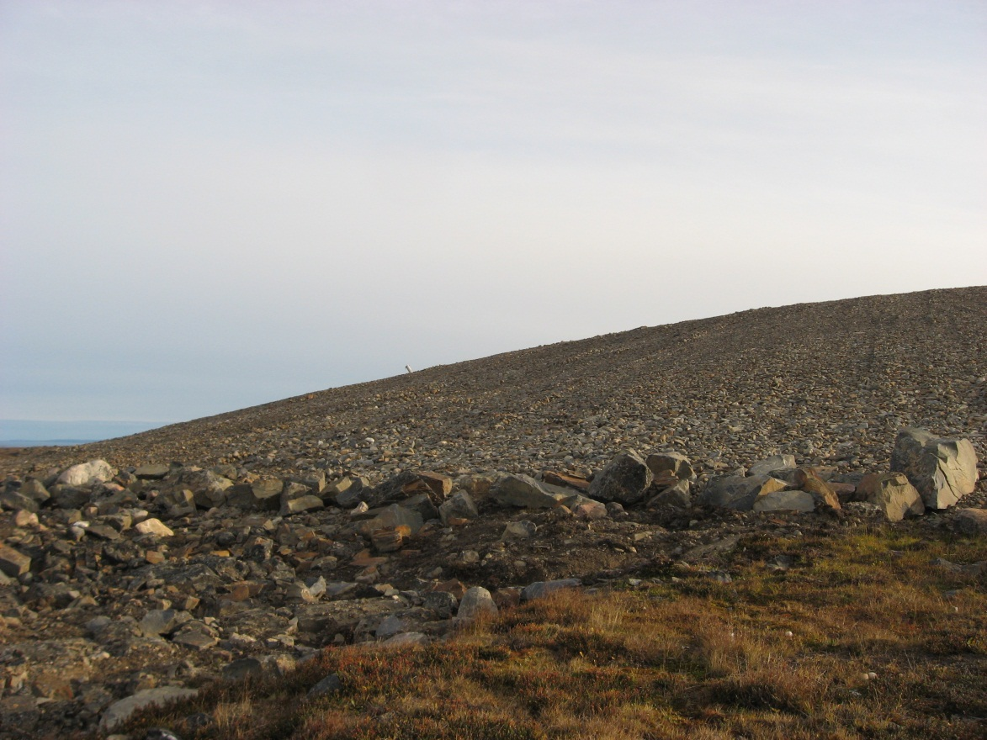
Photograph 104. Looking SE (WP 101, FOX-2 11).
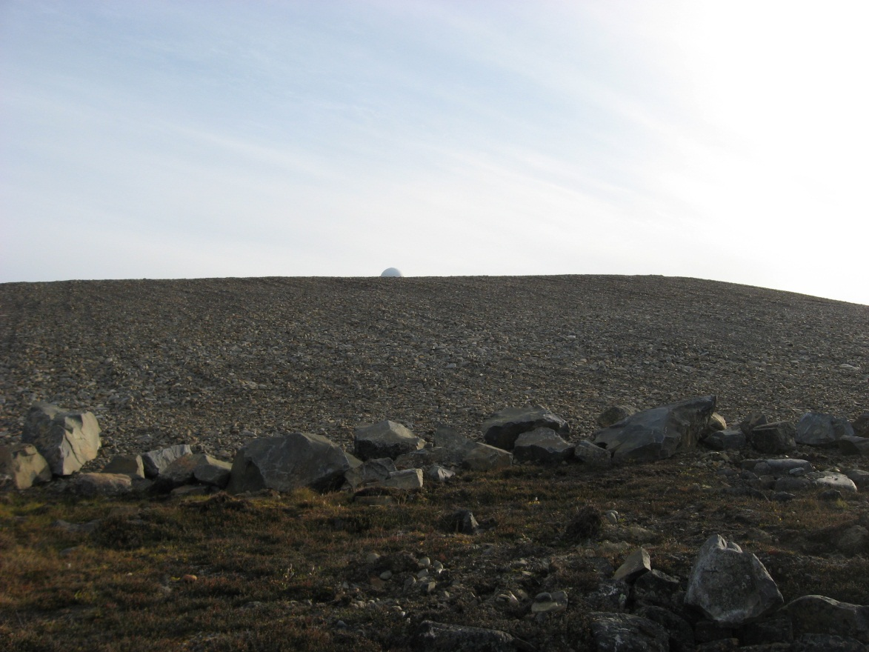
Photograph 105. Looking S (WP 101, FOX-2 12).
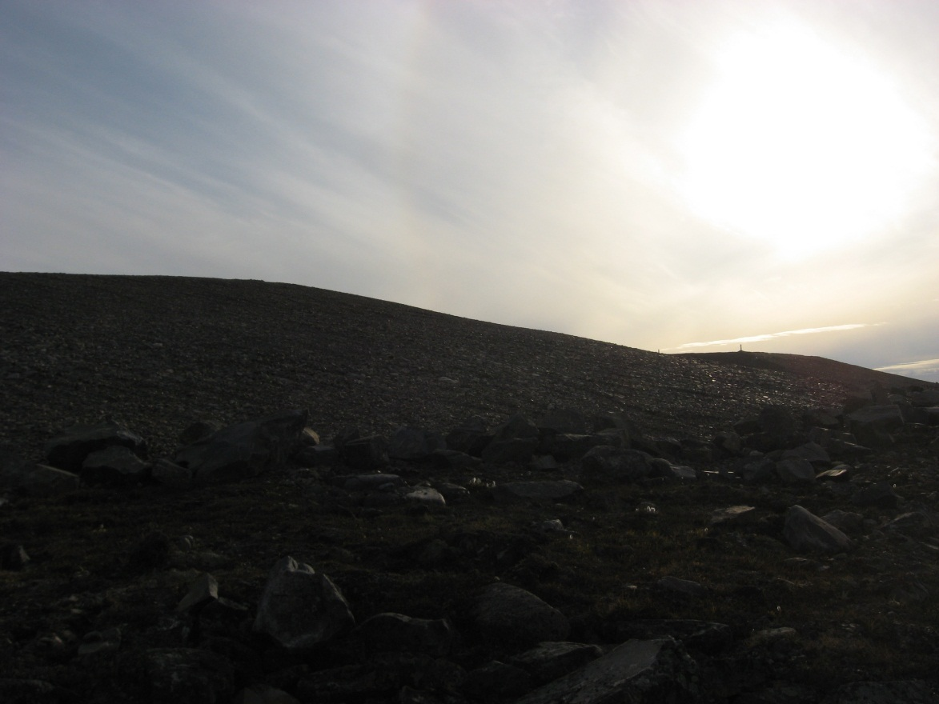
Photograph 106. Looking W (WP 101, FOX-2 13).
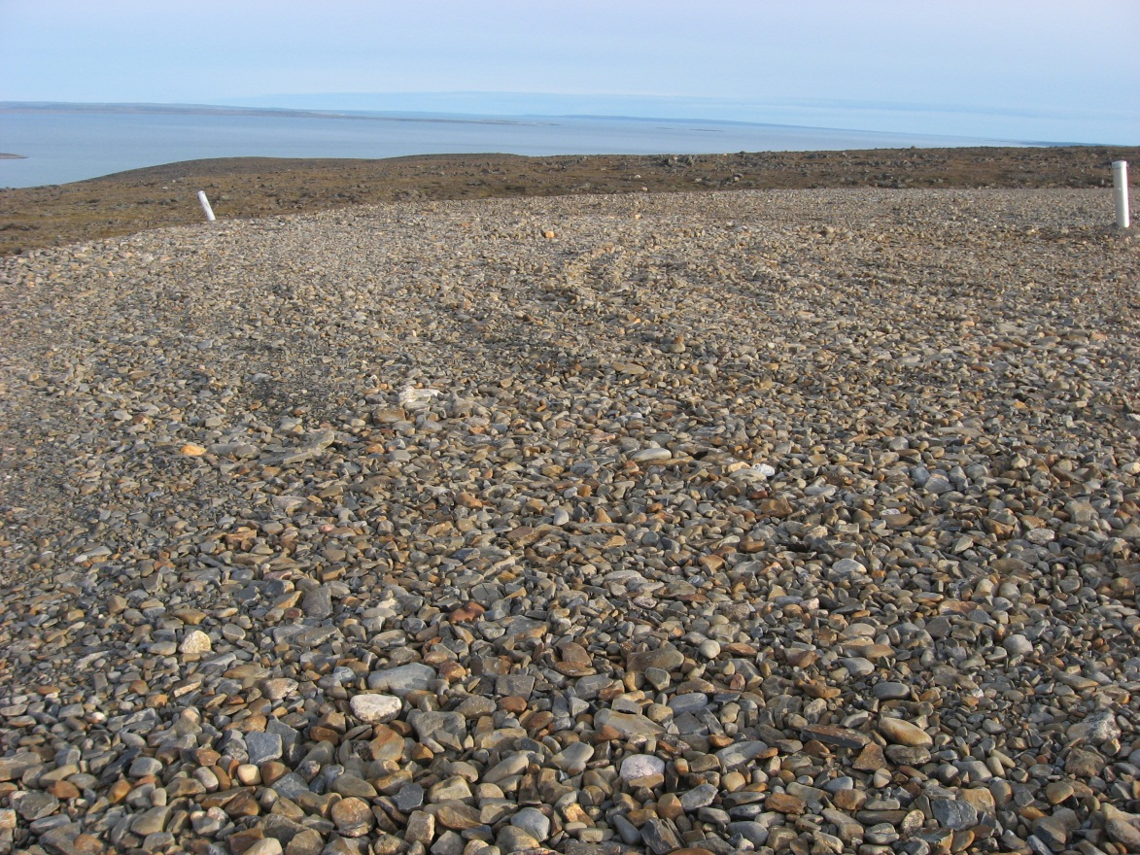
Photograph 107. Looking SE (WP 102, FOX-2 14).
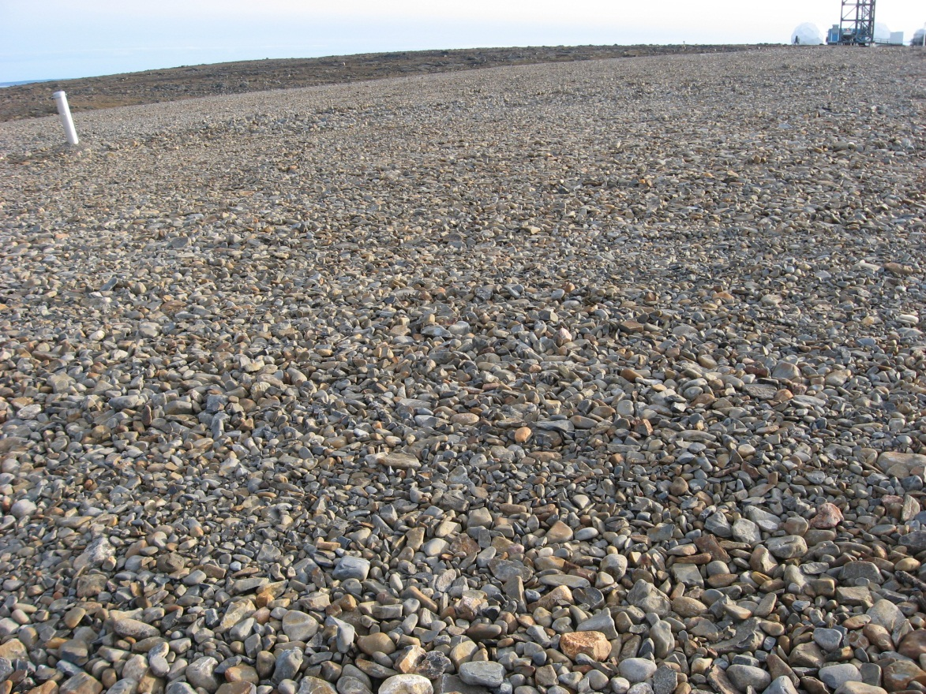
Photograph 108. Looking S (WP 102, FOX-2 15).
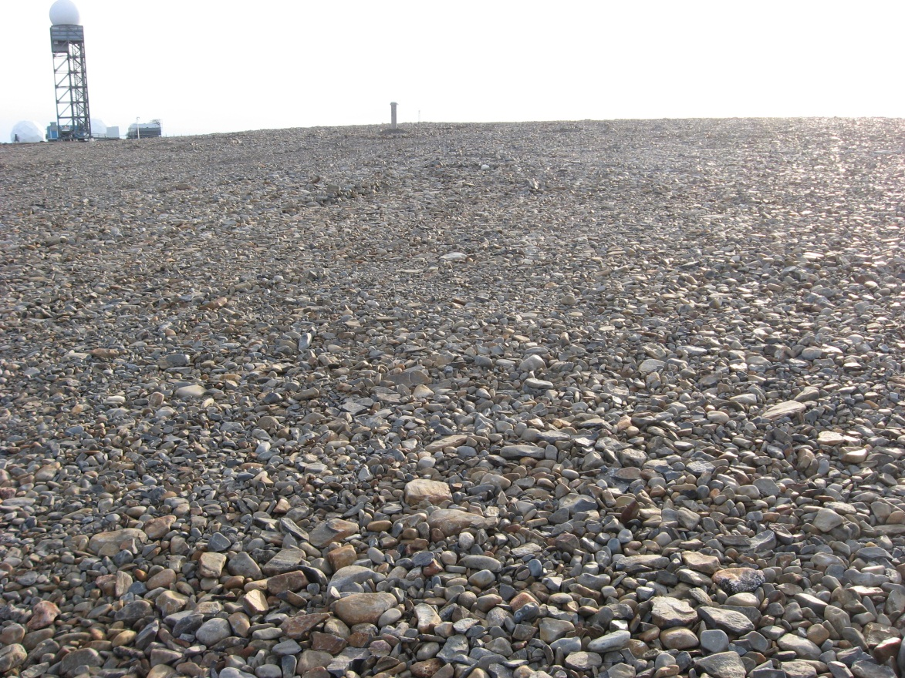
Photograph 109. Looking SW (WP 102, FOX-2 16).
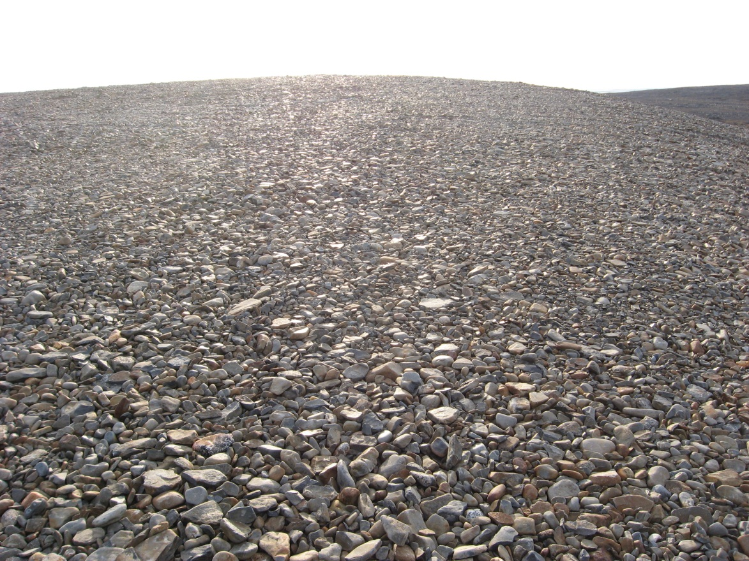
Photograph 110. Looking W (WP 102, FOX-2 17).
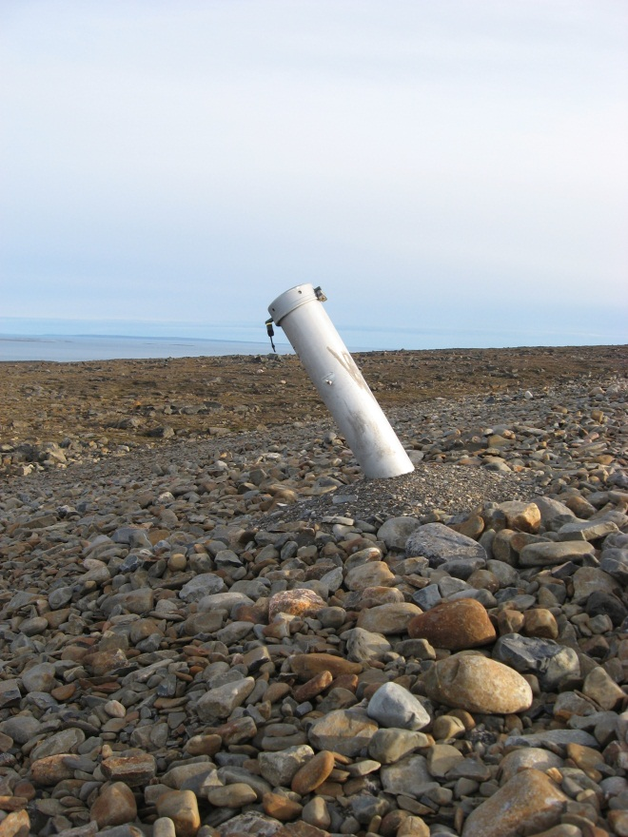
Photograph 111. VT-8 Looking S (WP 103, FOX-2 18).
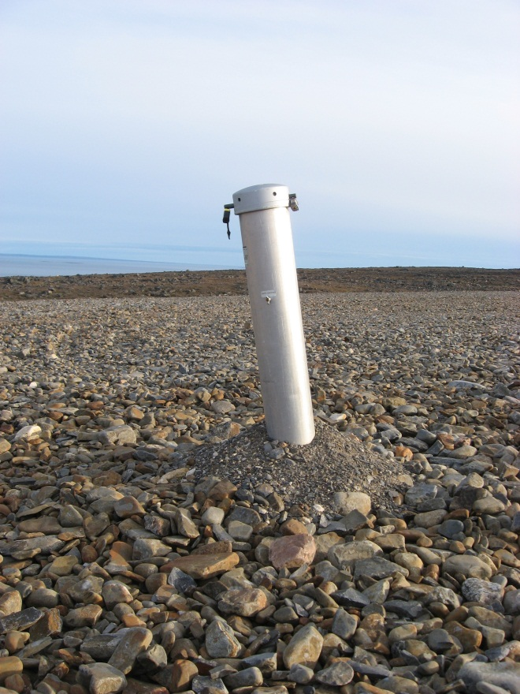
Photograph 112. VT-6 Looking S (WP 104, FOX-2 19).
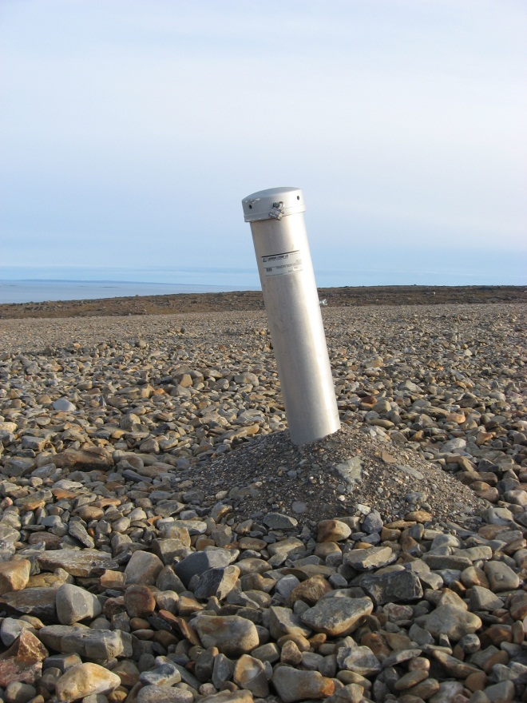
Photograph 113. VT-5 Looking S (WP 105, FOX-2 20).
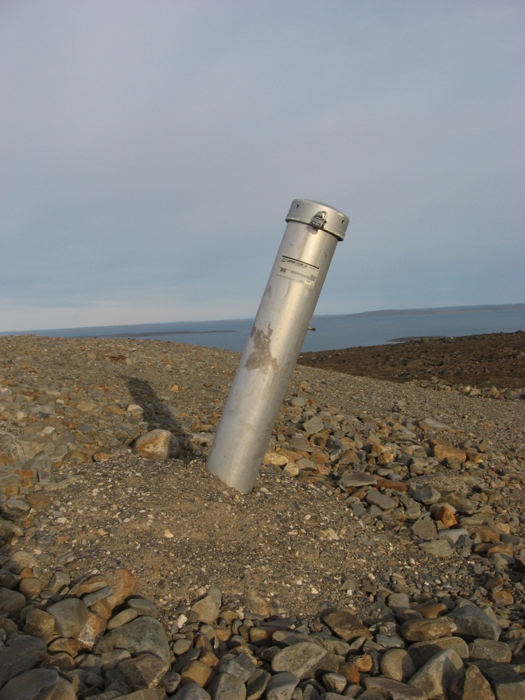
Photograph 114. VT-7 Looking E (WP 106, FOX-2 21).
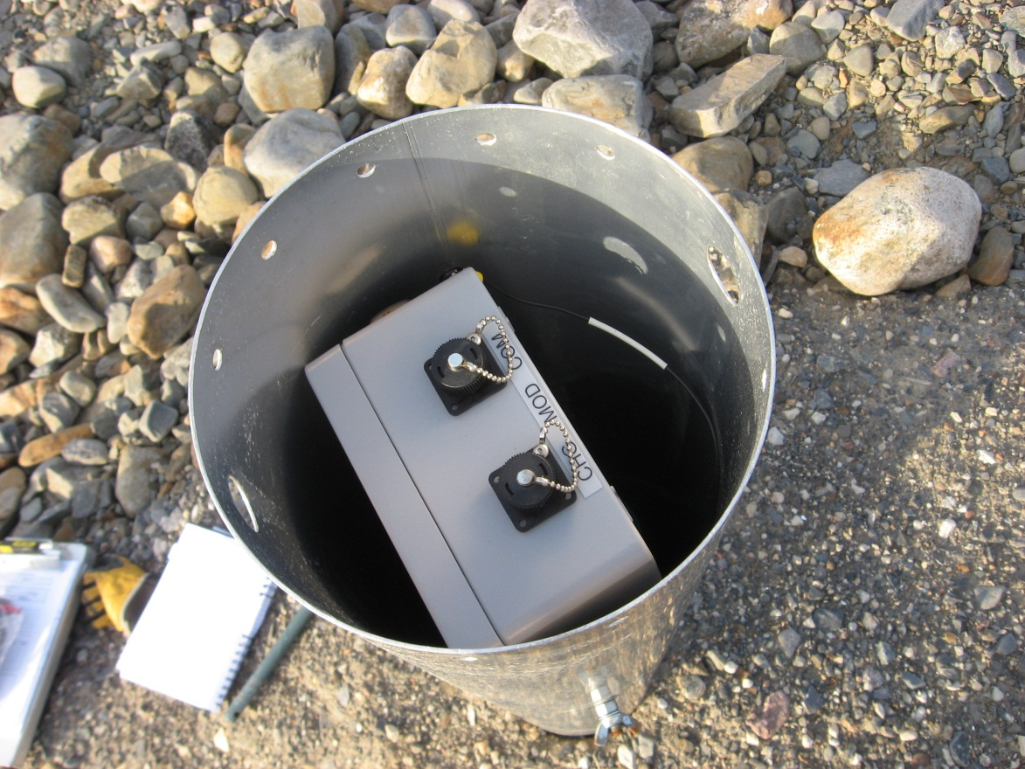
Photograph 115. VT-7 Data Logger (WP 107, FOX-2 22).
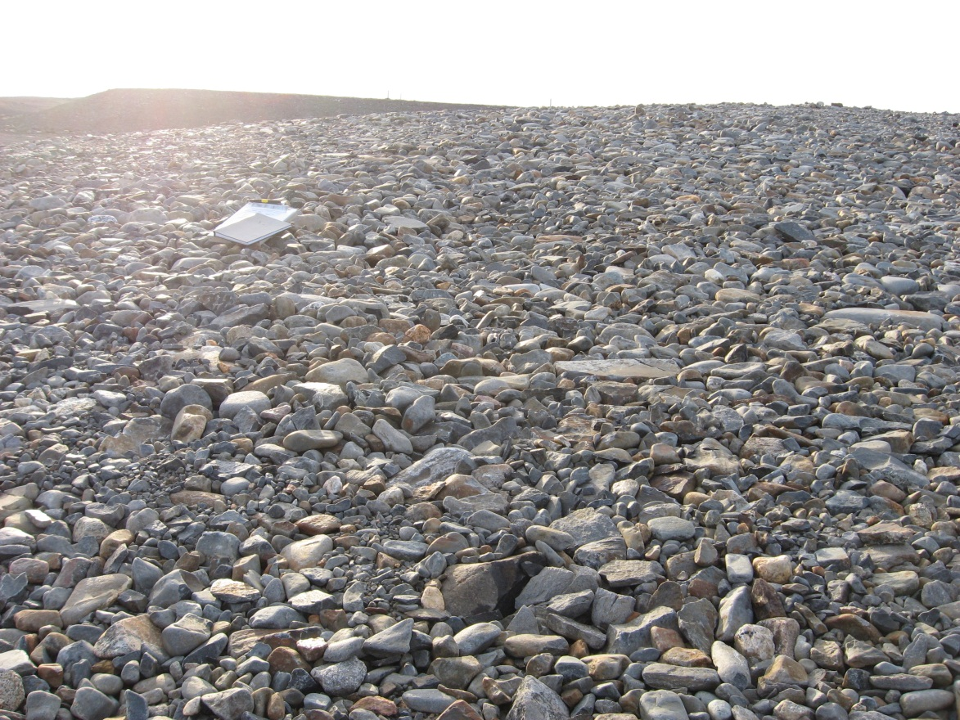
Photograph 116. Settlement Feature Looking E (WP 108, FOX-2 23).
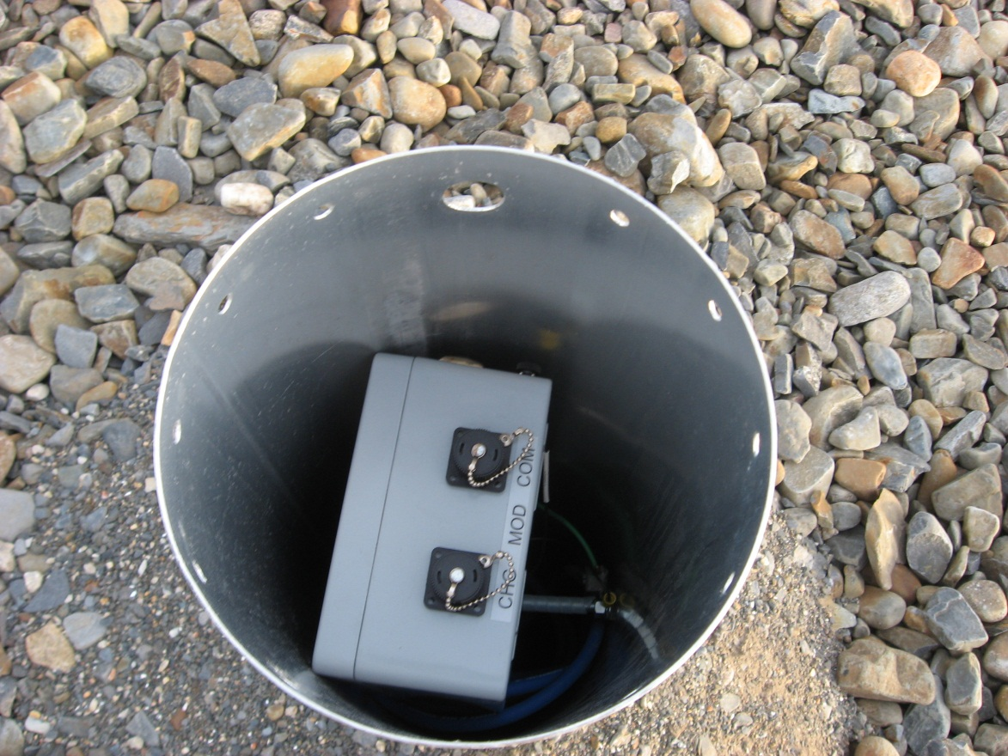
Photograph 117. VT-5 Data Logger (WP 109, FOX-2 24).
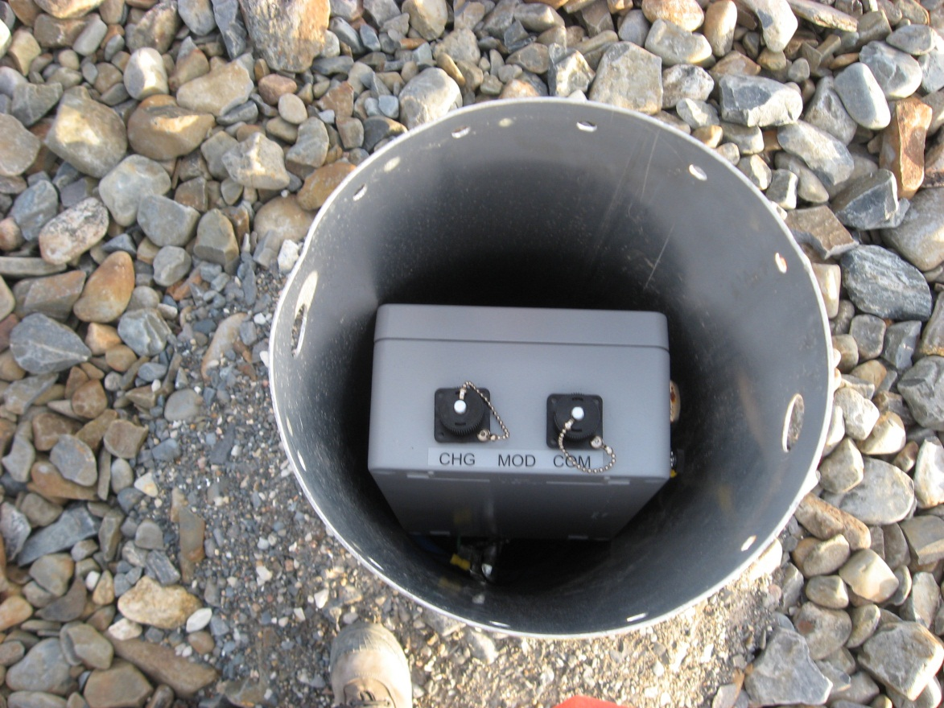
Photograph 118. VT-6 Data Logger (WP 110, FOX-2 25).
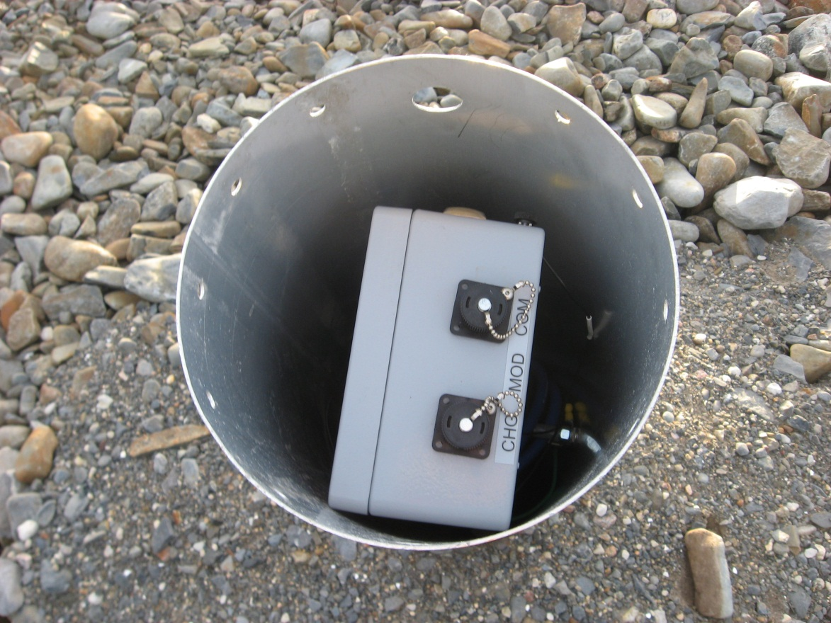
Photograph 119. VT-8 Data Logger (WP 111, FOX-2 26).
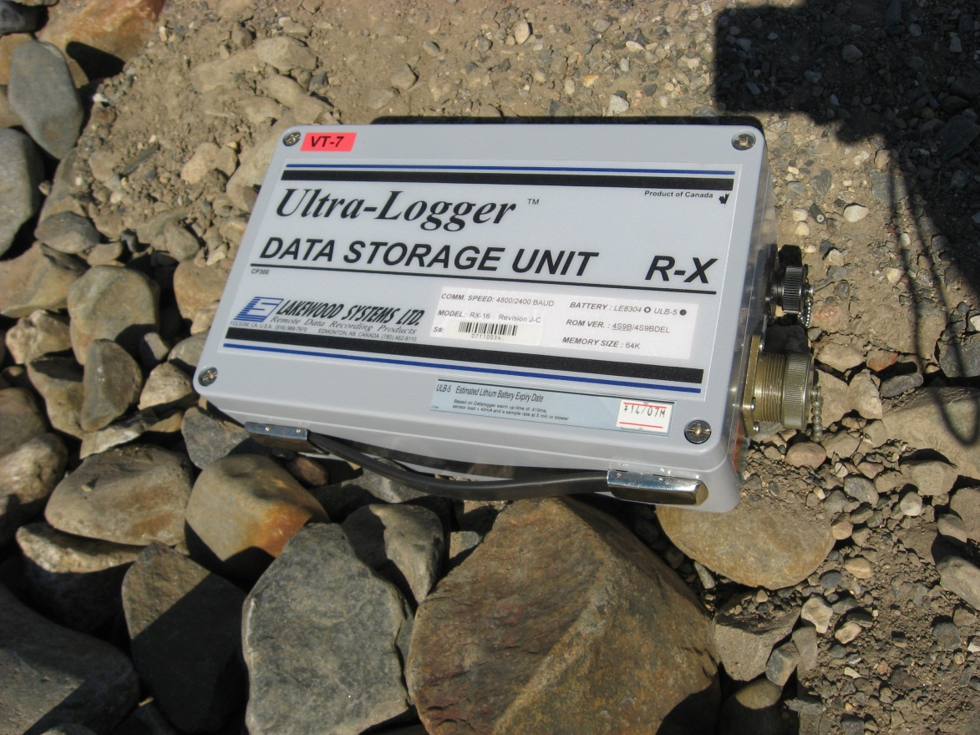
Photograph 120. VT-7 Data Logger (FOX-2 27).
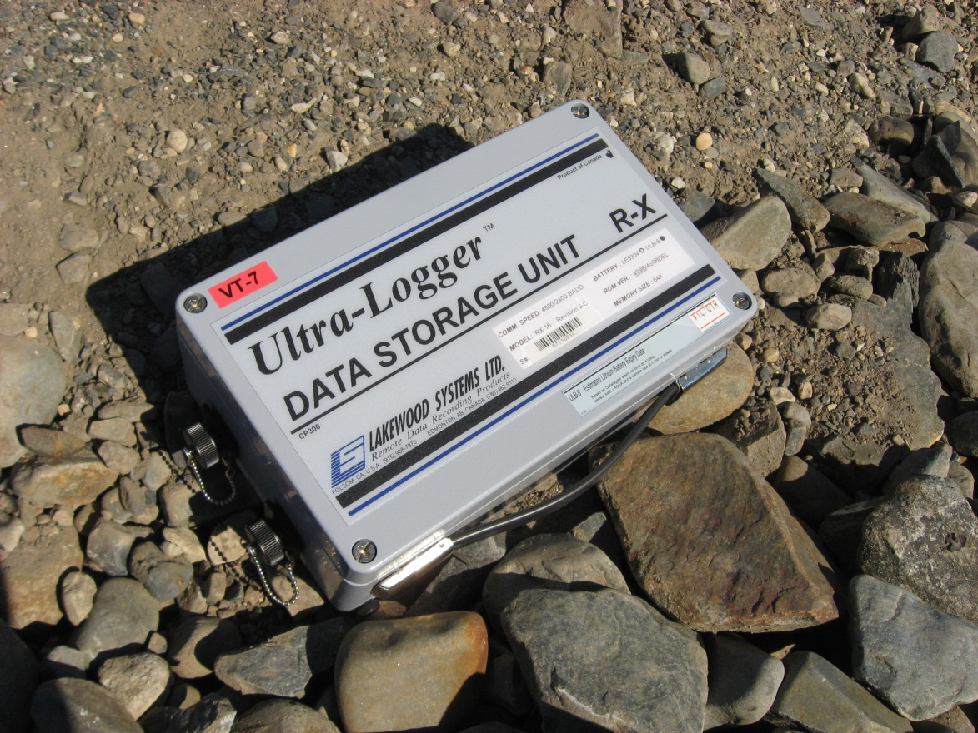
Photograph 121. VT-7 Data Logger (FOX-2 28).
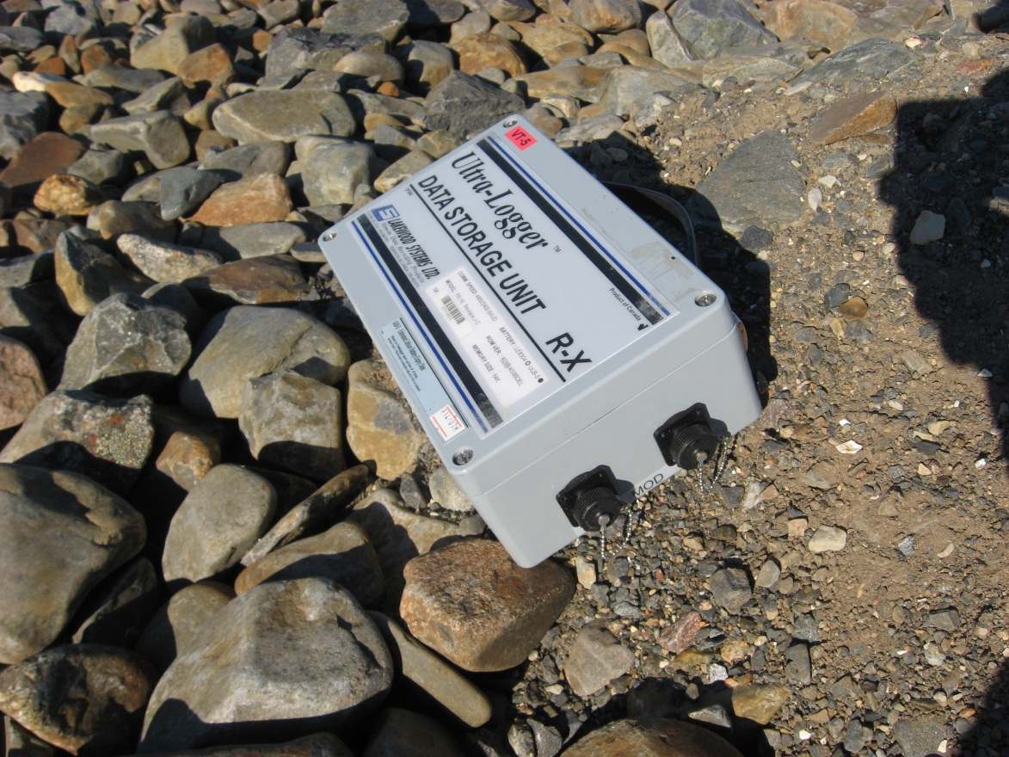
Photograph 122. VT-5 Data Logger (FOX-2 29).
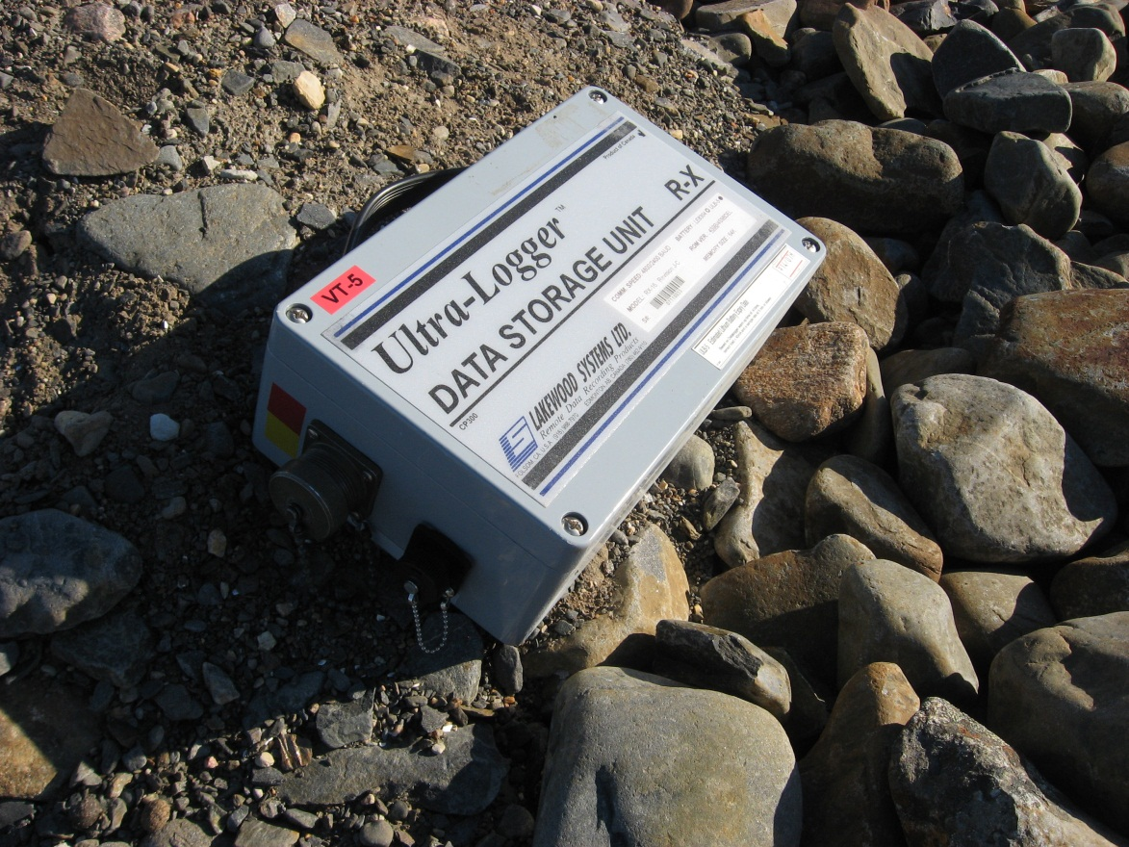
Photograph 123. VT-5 Data Logger (FOX-2 30).
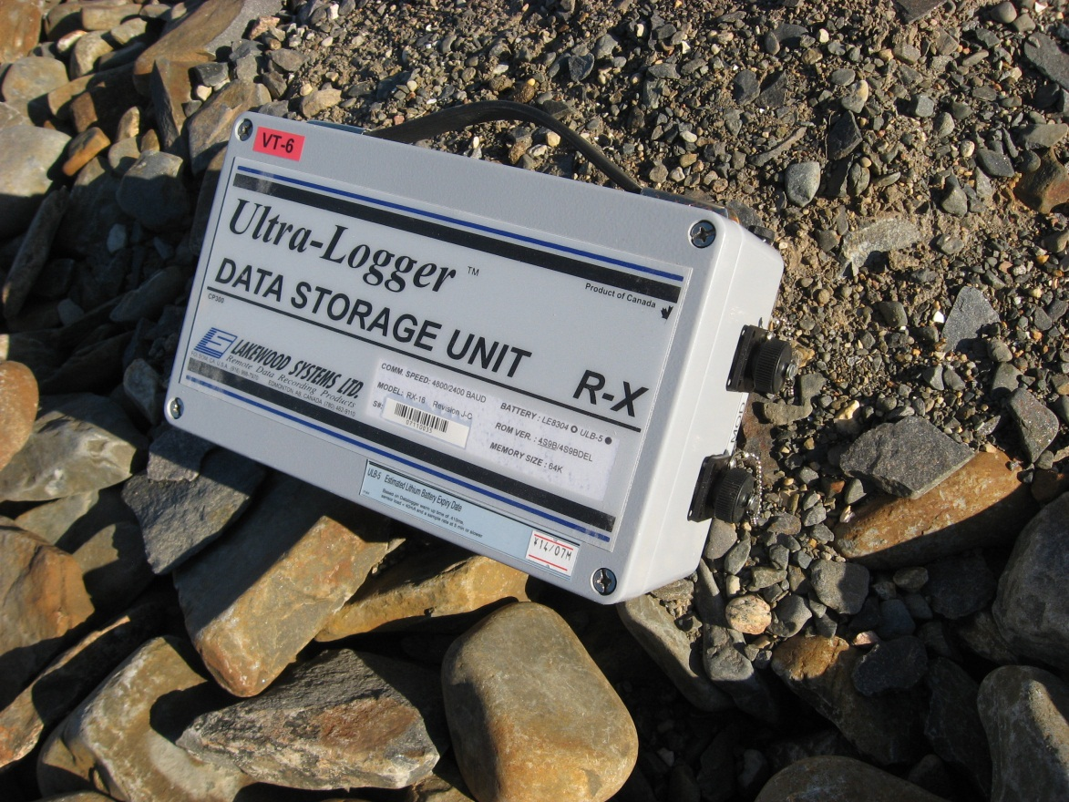
Photograph 124. VT-6 Data Logger (FOX-2 31).
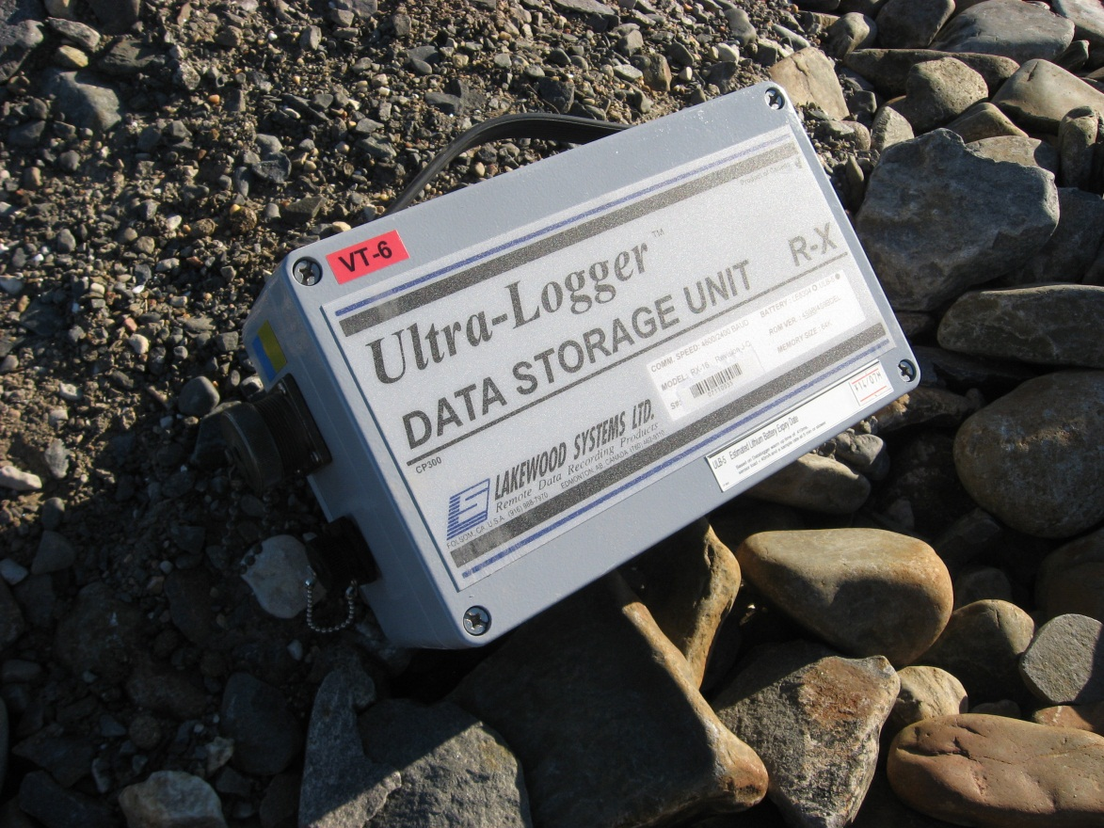
Photograph 125. VT-6 Data Logger (FOX-2 32).
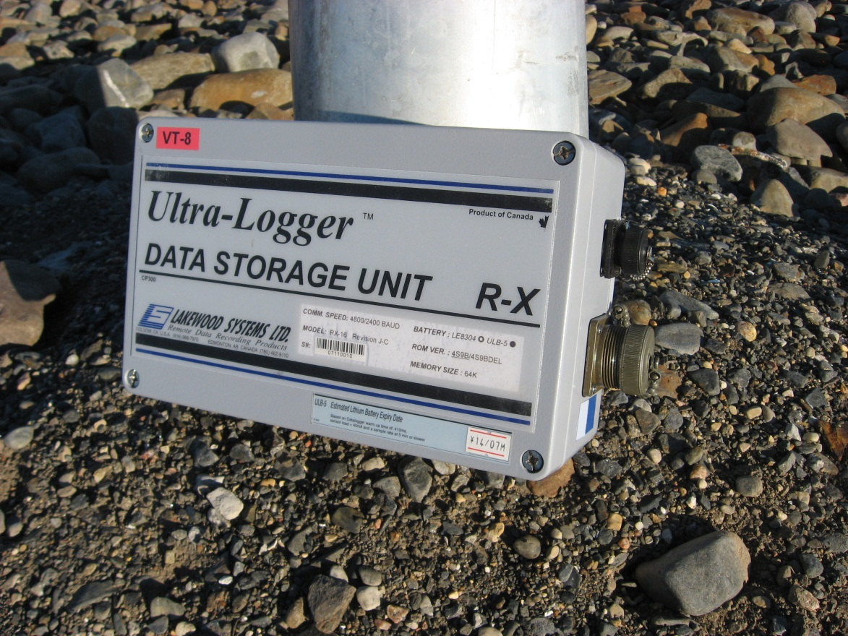
Photograph 126. VT-8 Data Logger (FOX-2 33).
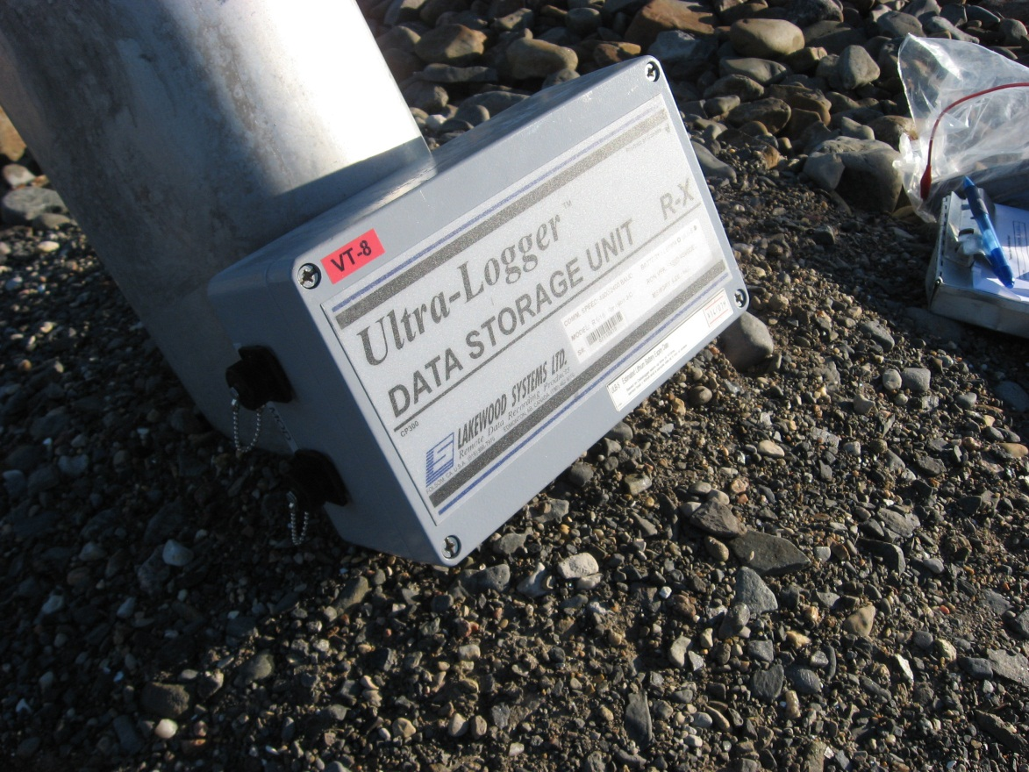
Photograph 127. VT-8 Data Logger (FOX-2 34).

