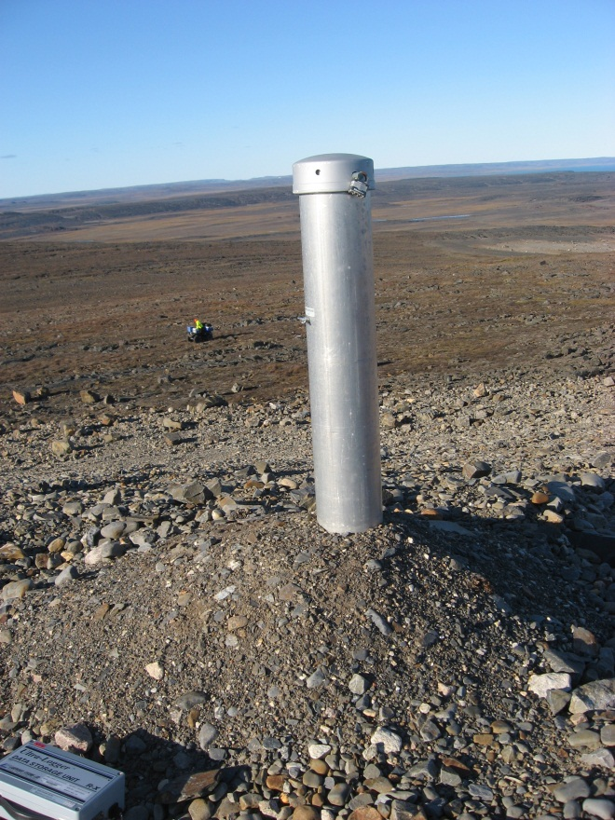
Photograph 64. Tier II Disposal Facility – VT-4 Looking N (Way Point 112, Photo FOX-2 35).
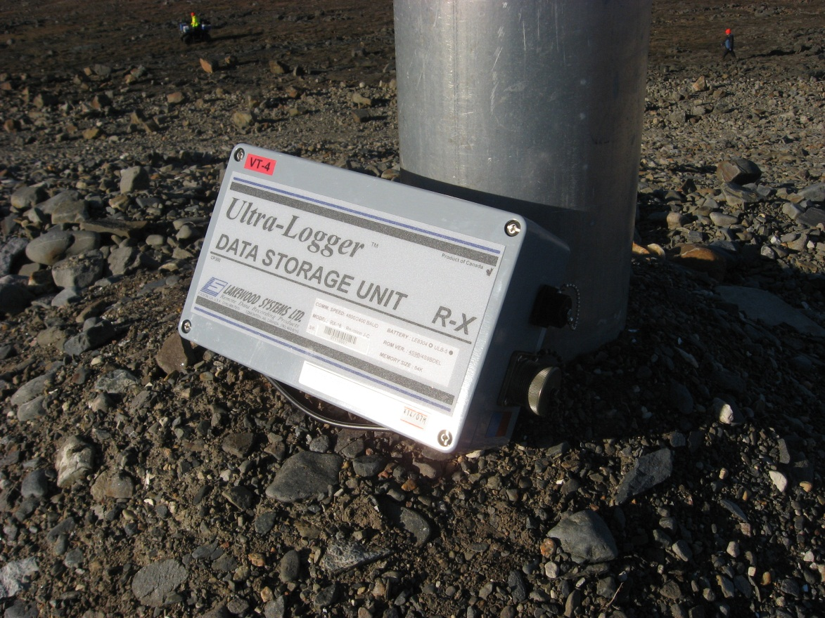
Photograph 65. VT-4 Data Logger (FOX-2 36).
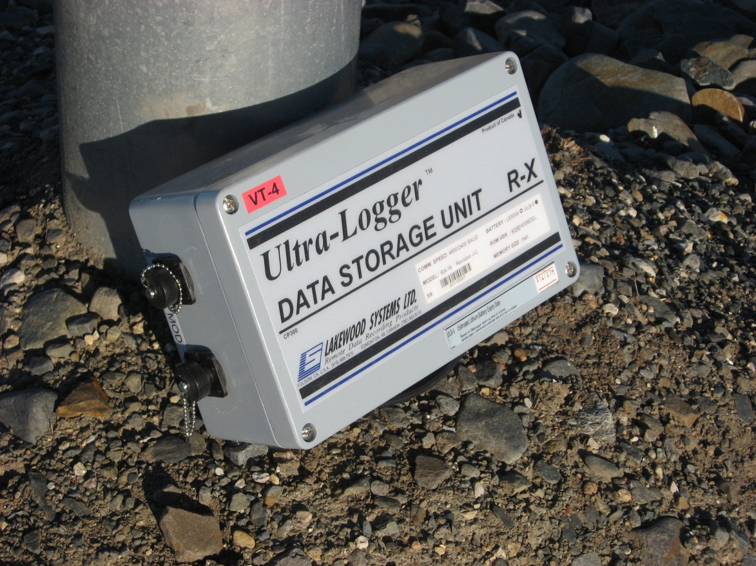
Photograph 66. VT-4 Data Logger (FOX-2 37).
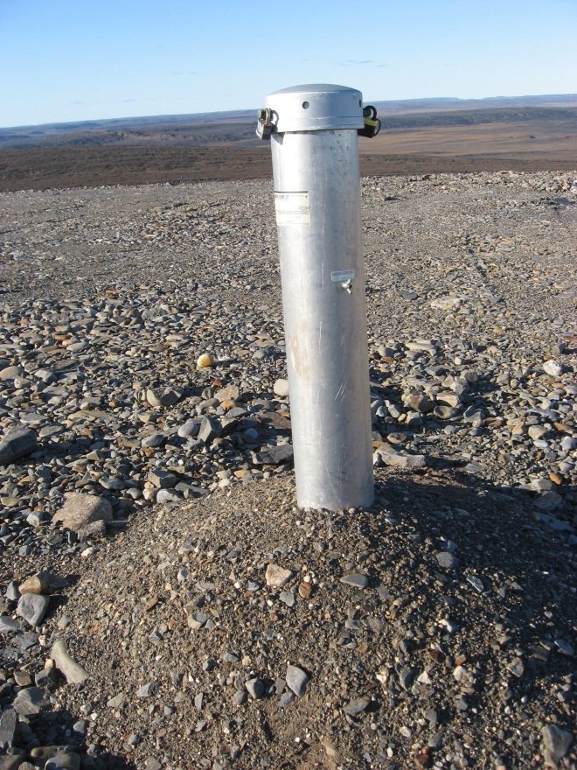

Photograph 67. VT-3 Looking N (WP 113, FOX-2 38).
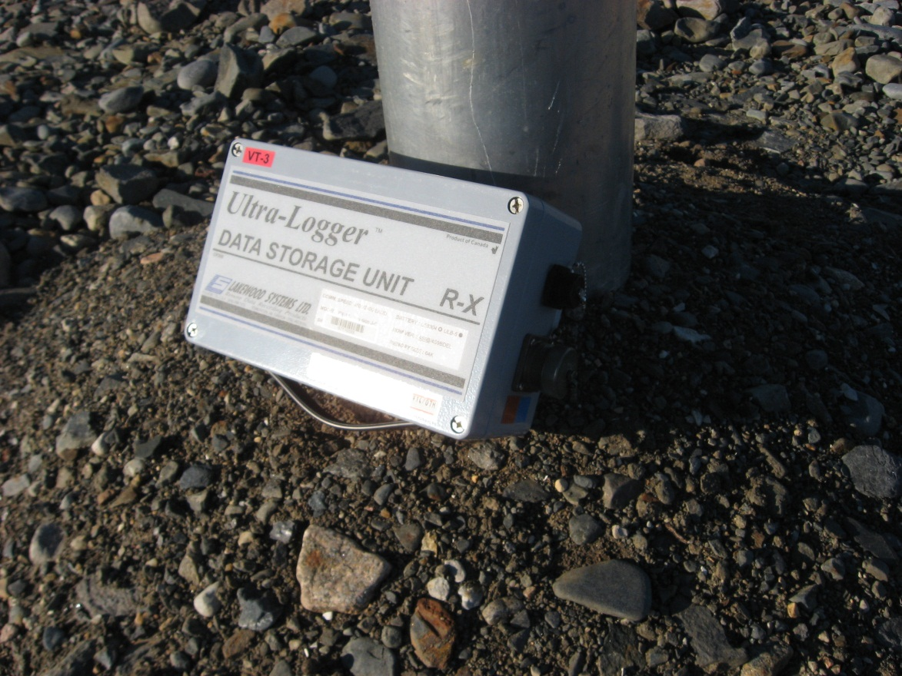
Photograph 68. VT-3 Data Logger (FOX-2 39).
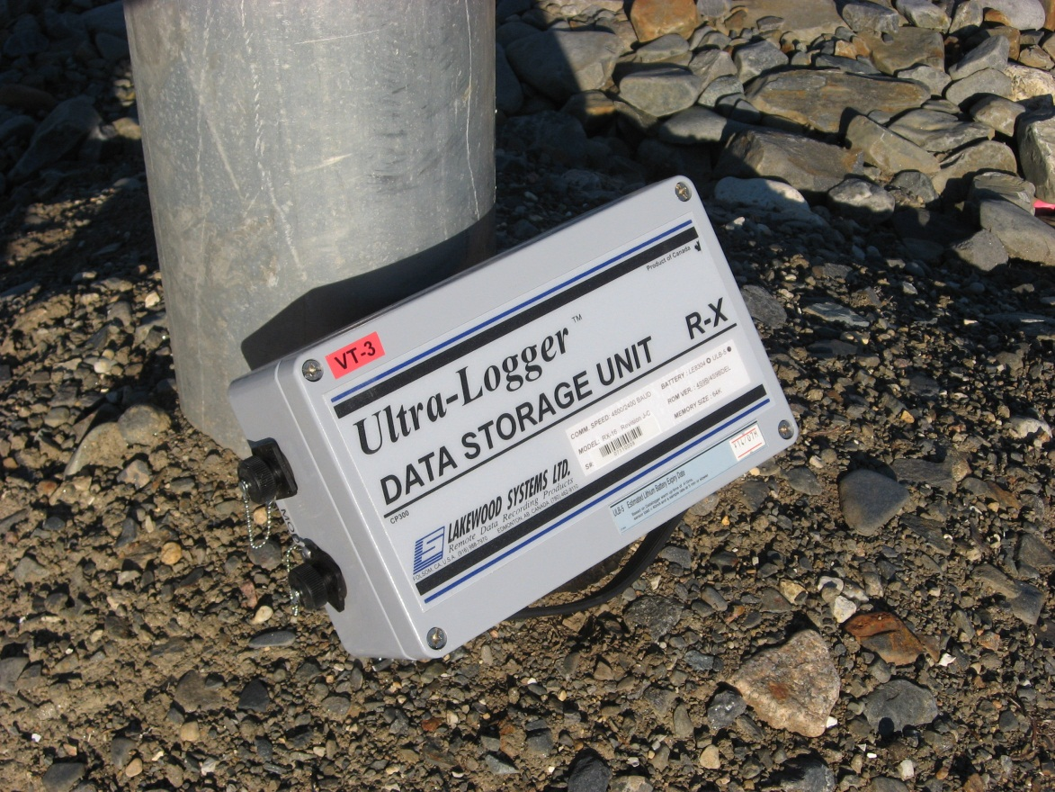
Photograph 69. VT-3 Data Logger (WP 097, FOX-2 40).
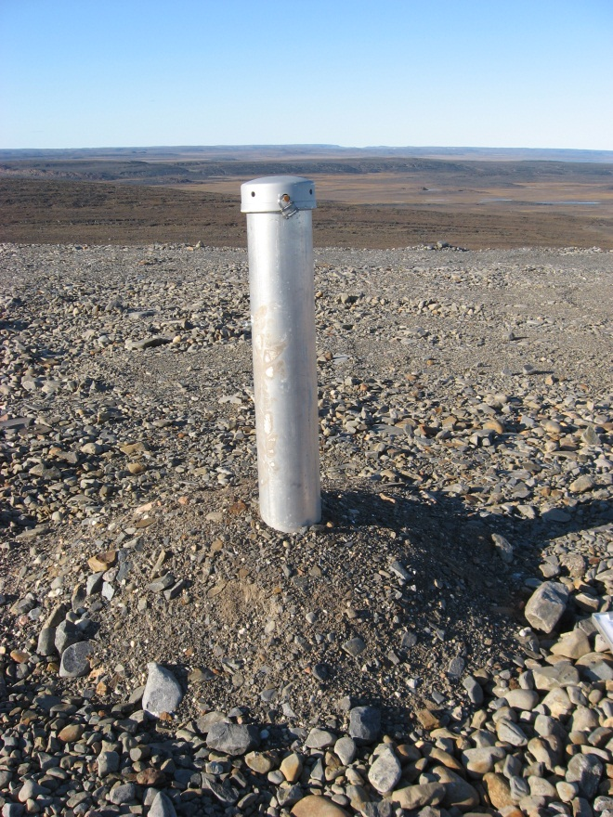
Photograph 70. VT-2 Looking N (WP 114, FOX-2 41).
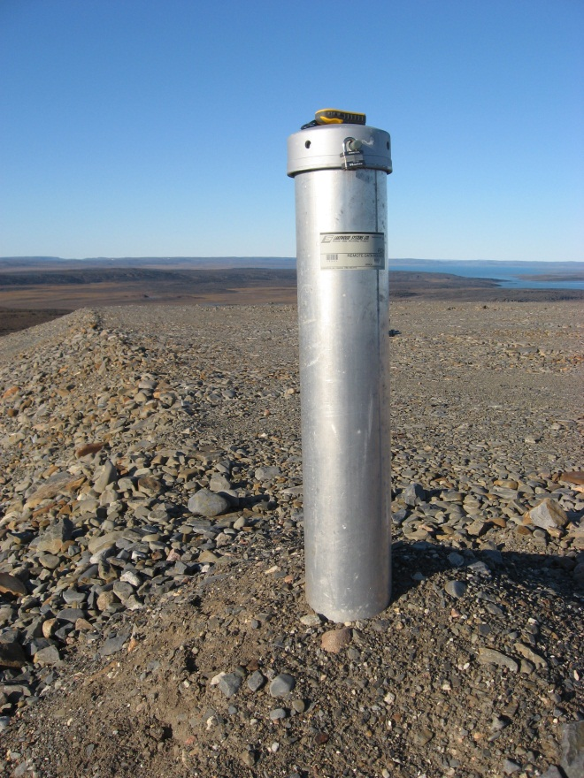
Photograph 71. VT-1 Looking N (WP 115, FOX-2 42).
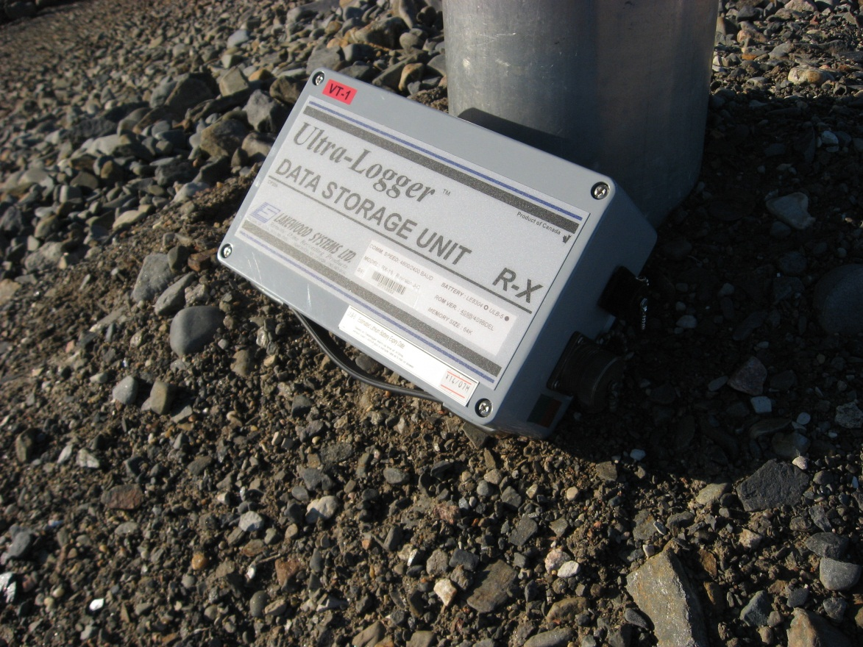
Photograph 72. VT-1 Data Logger (FOX-2 43).
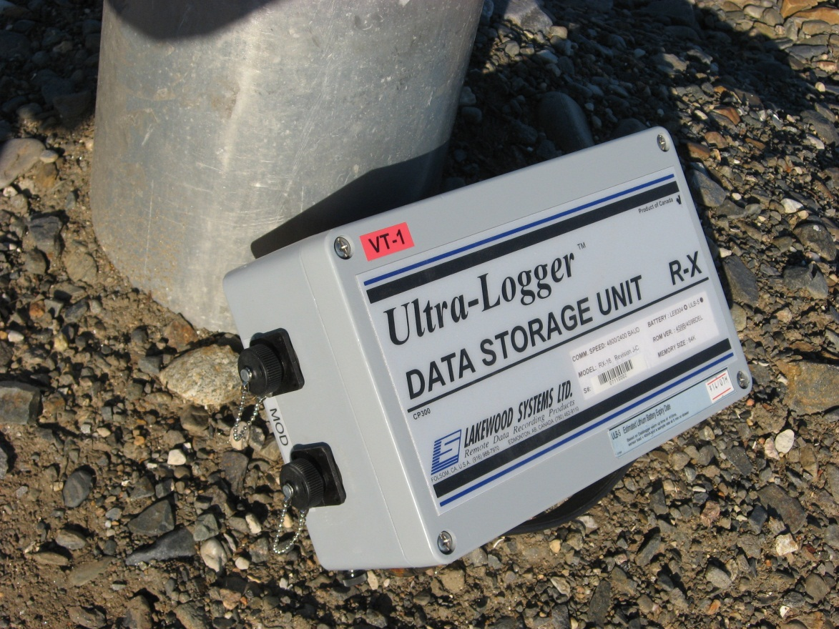
Photograph 73. VT-1 Data Logger (FOX-2 44).
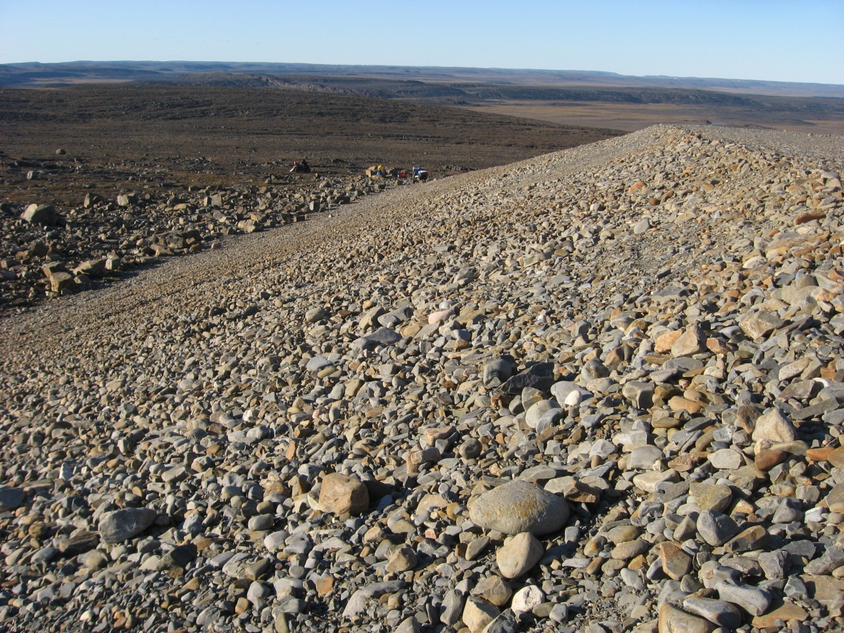
Photograph 74. Looking N (WP 116, FOX-2 45).
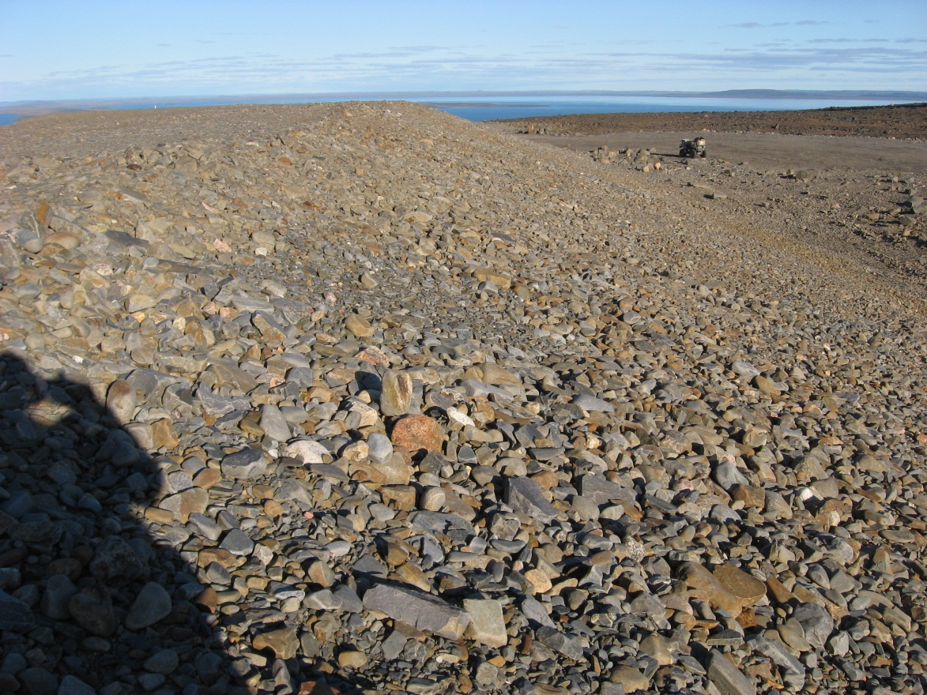
Photograph 75. Looking E (WP 116, FOX-2 46).
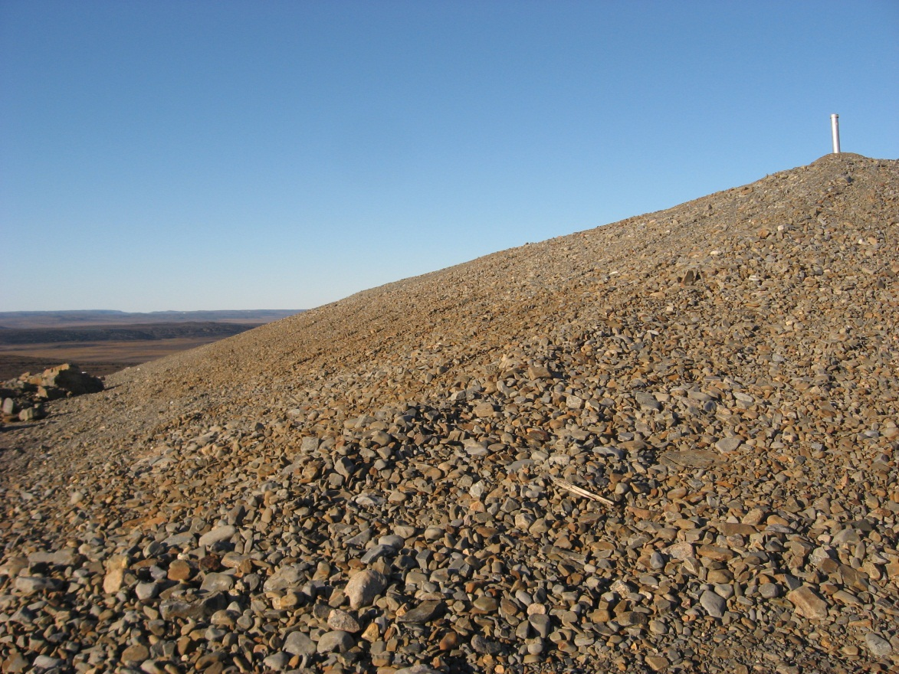
Photograph 76. Looking N (WP 117, FOX-2 47).
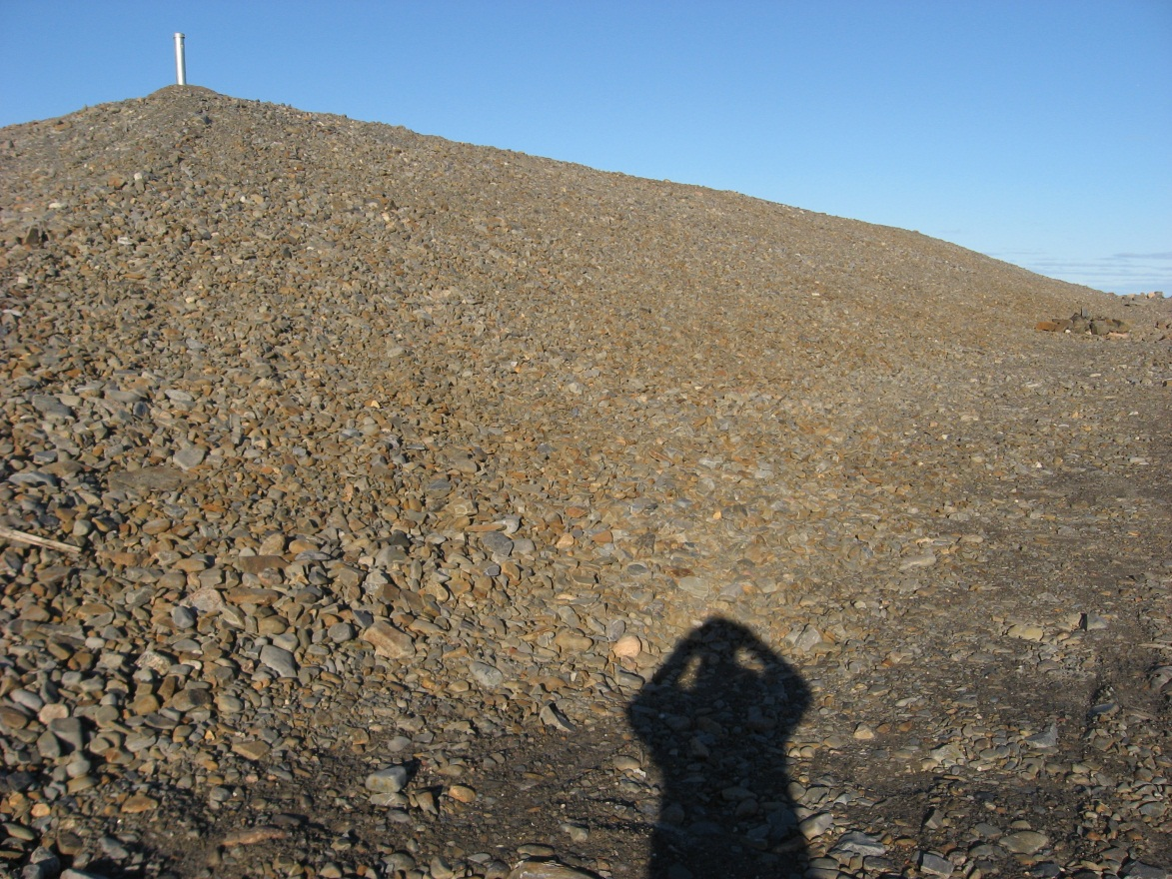
Photograph 77. Looking E (WP 117, FOX-2 48).
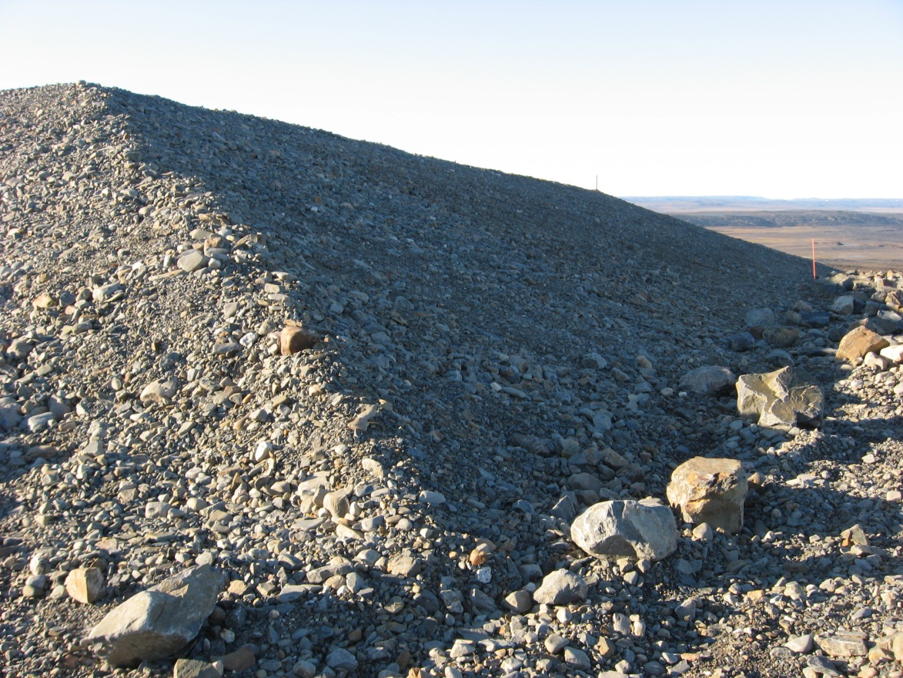
Photograph 78. Looking N (WP 118, FOX-2 49).
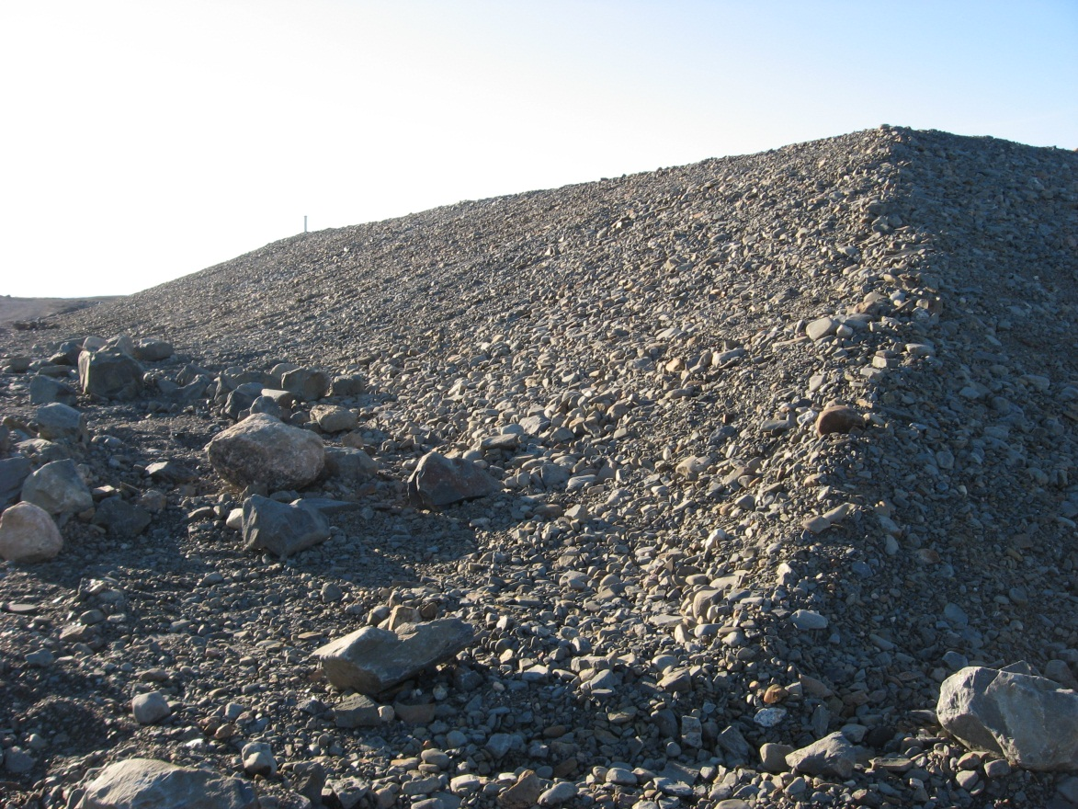
Photograph 79. Looking W (WP 118, FOX-2 50).
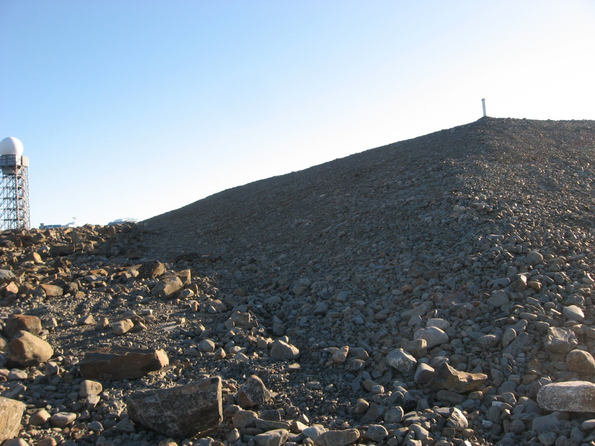
Photograph 80. Looking S (WP 119, FOX-2 51).
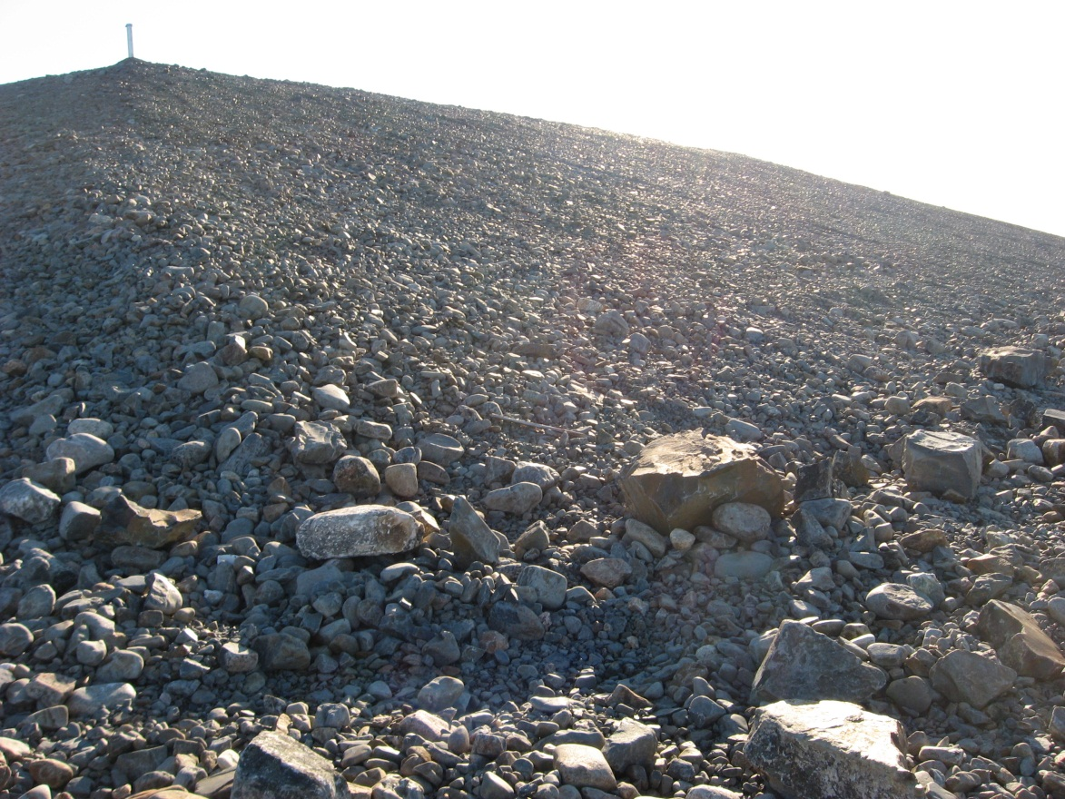
Photograph 81. Looking W (WP 119, FOX-2 52).
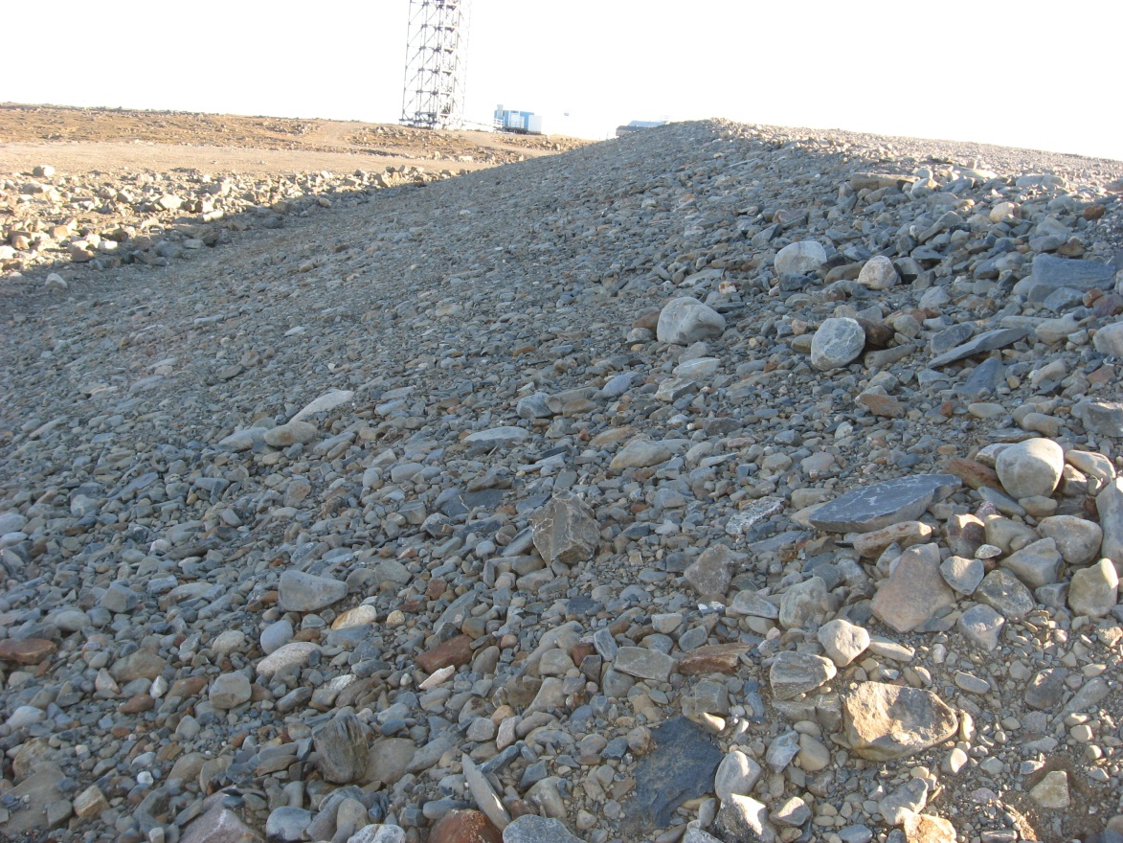
Photograph 82. Looking S (WP 120, FOX-2 53).
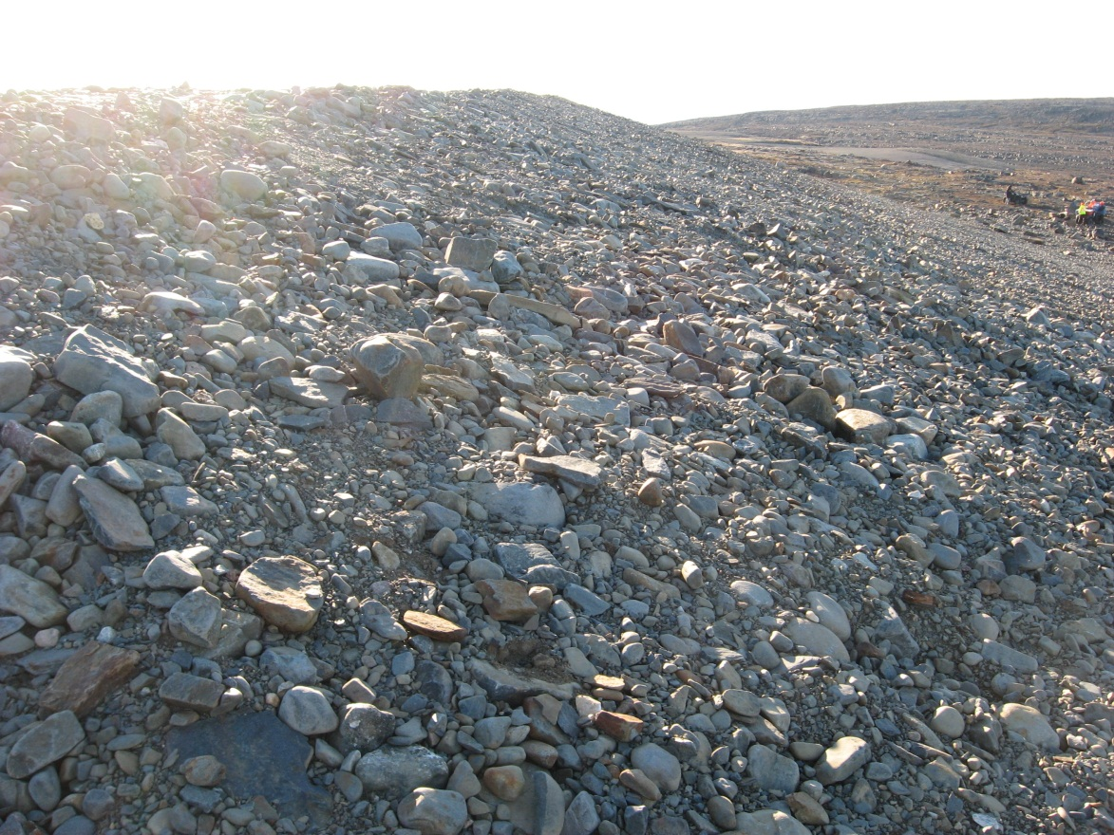
Photograph 83. Looking W (WP 120, FOX-2 54).
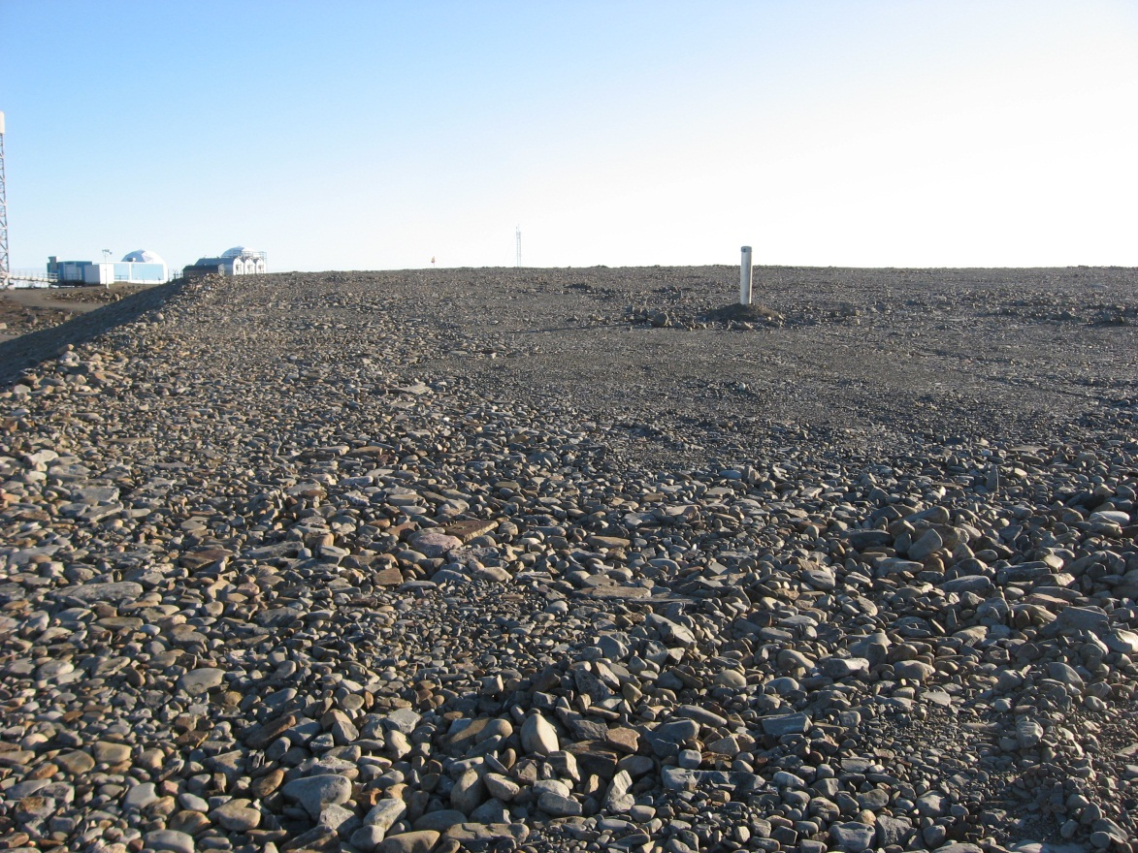
Photograph 84. Looking S (WP 121, FOX-2 55).
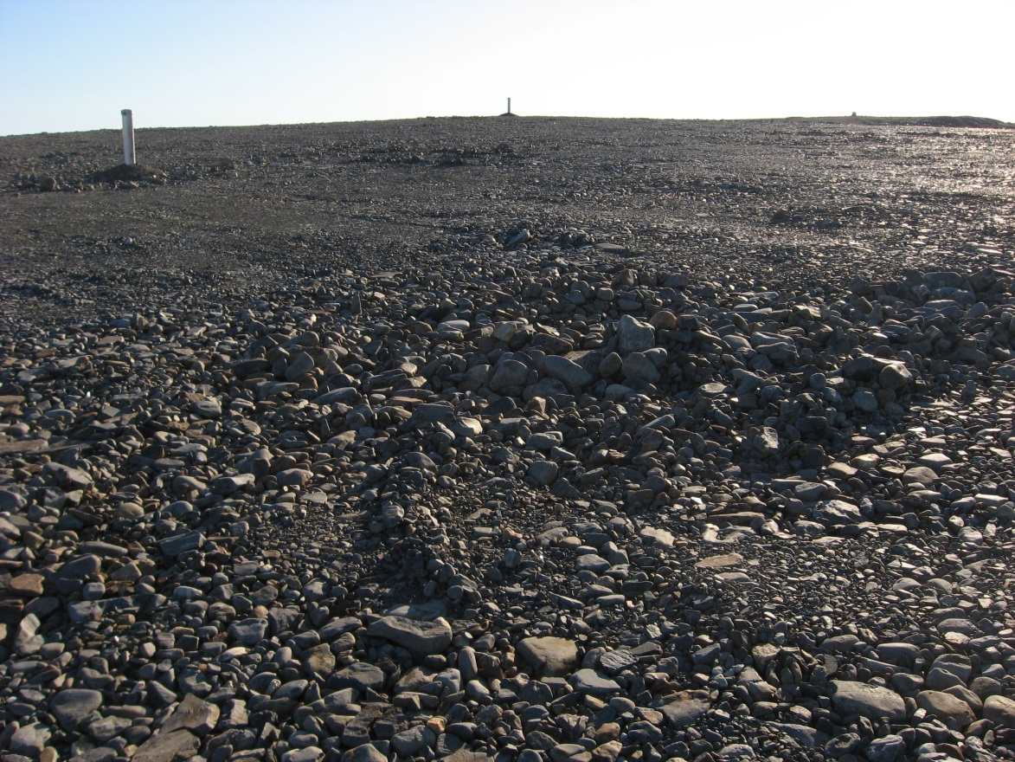
Photograph 85. Looking SW (WP 121, FOX-2 56).
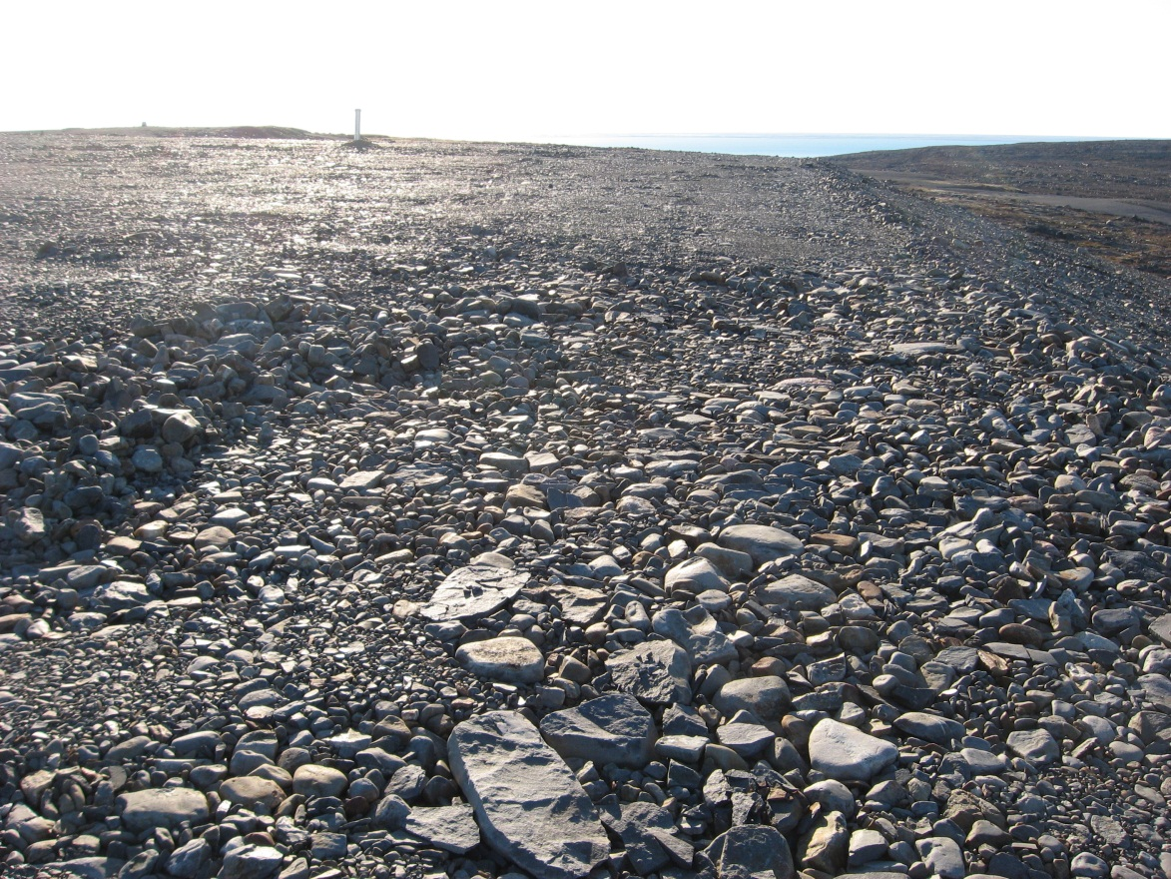
Photograph 86. Looking W (WP 121, FOX-2 57).
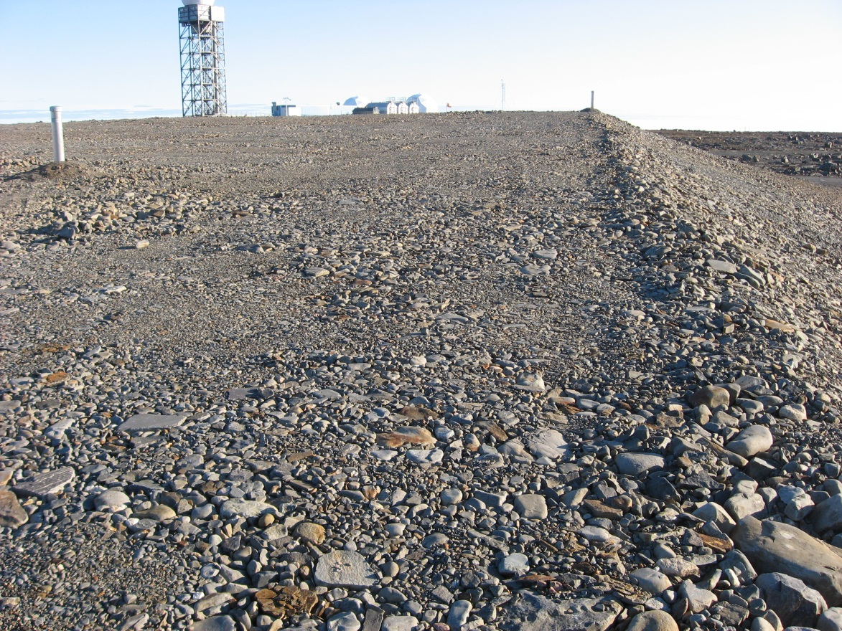
Photograph 87. Looking S (WP 122, FOX-2 58).
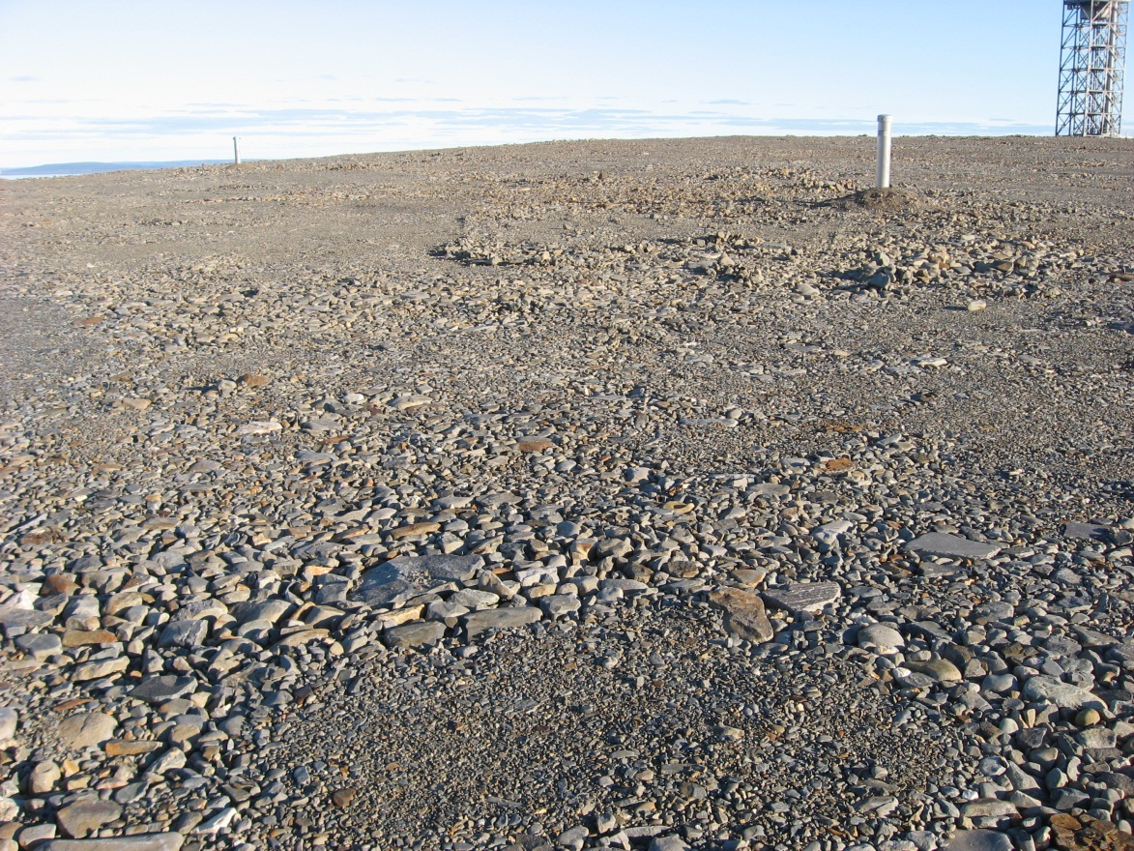
Photograph 88. Looking SE (WP 122, FOX-2 59).
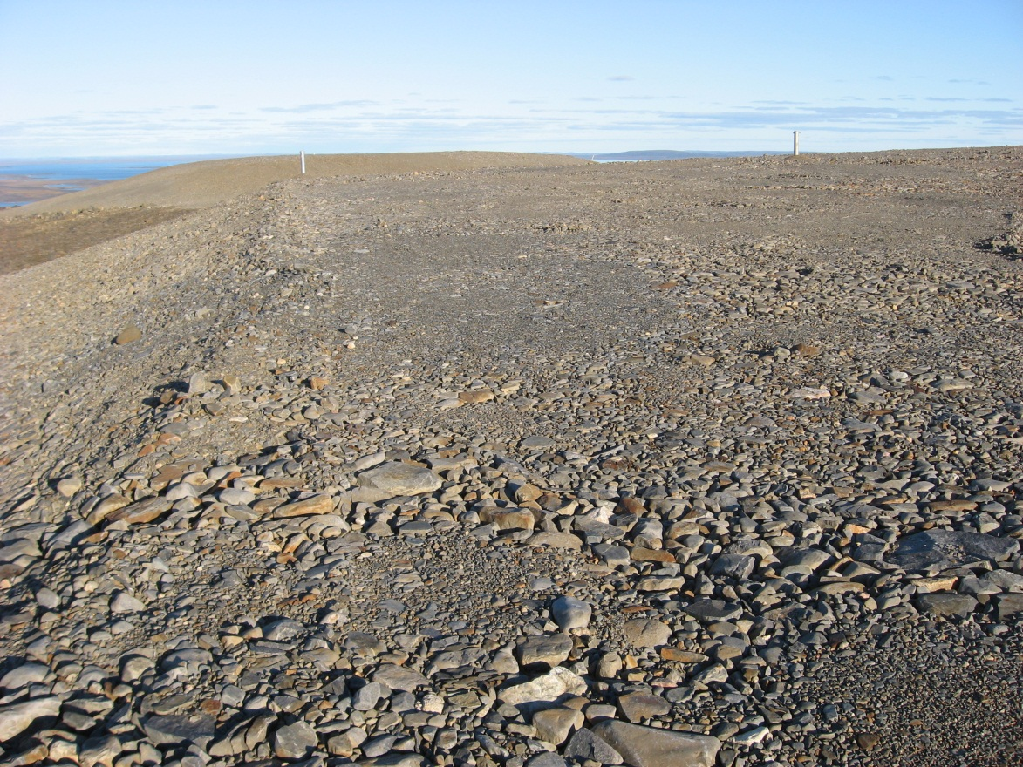
Photograph 89. Looking E (WP 122, FOX-2 60).
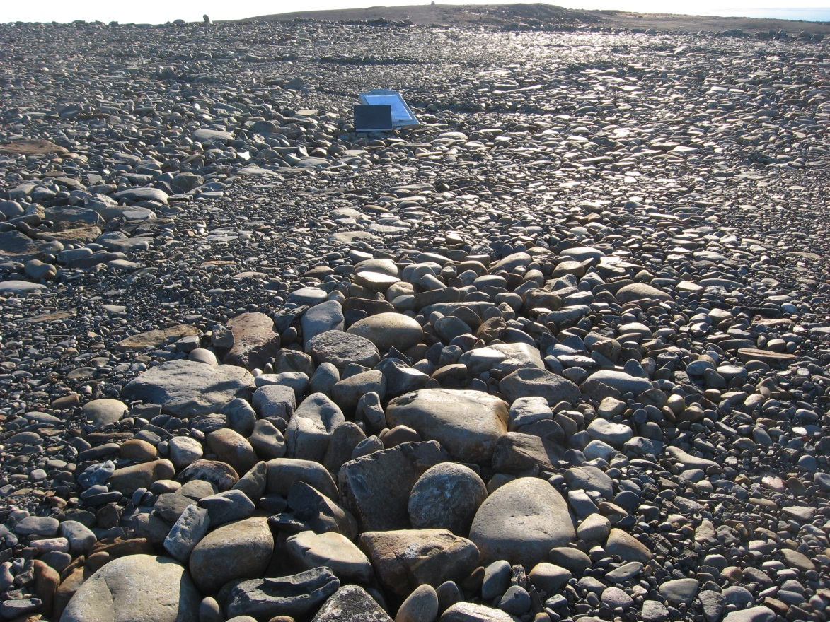
Photograph 90. Minor Settlement – Looking SW (WP 123, FOX-2 61).
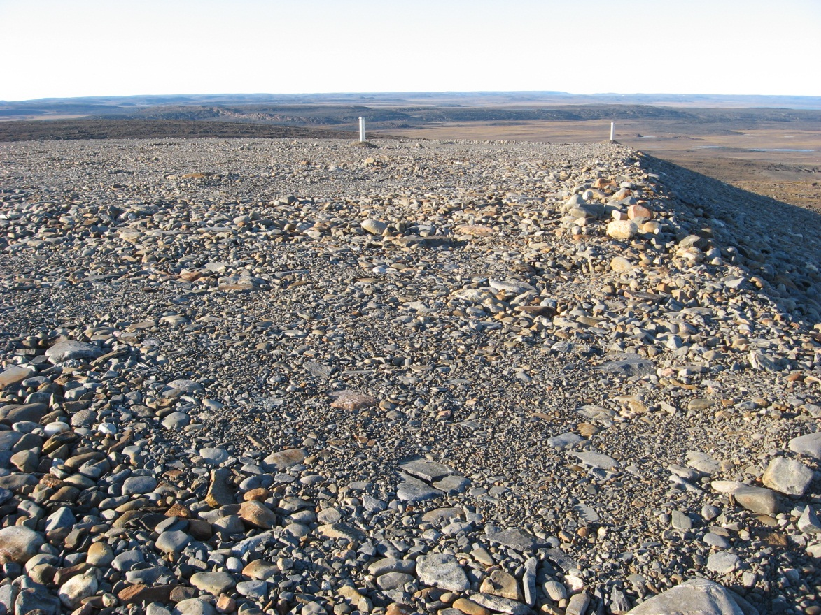
Photograph 91. Looking N (WP, 124, FOX-2 62).
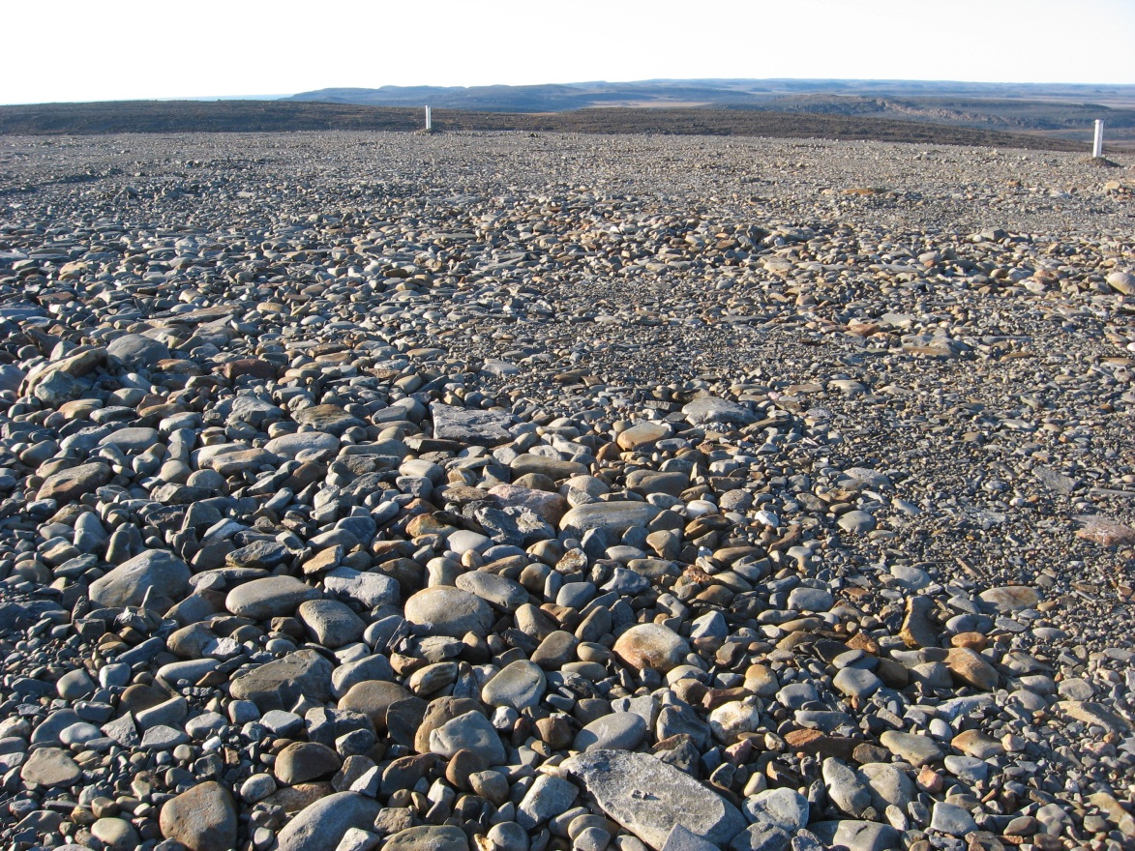
Photograph 92. Looking NW (WP 124, FOX-2 63).
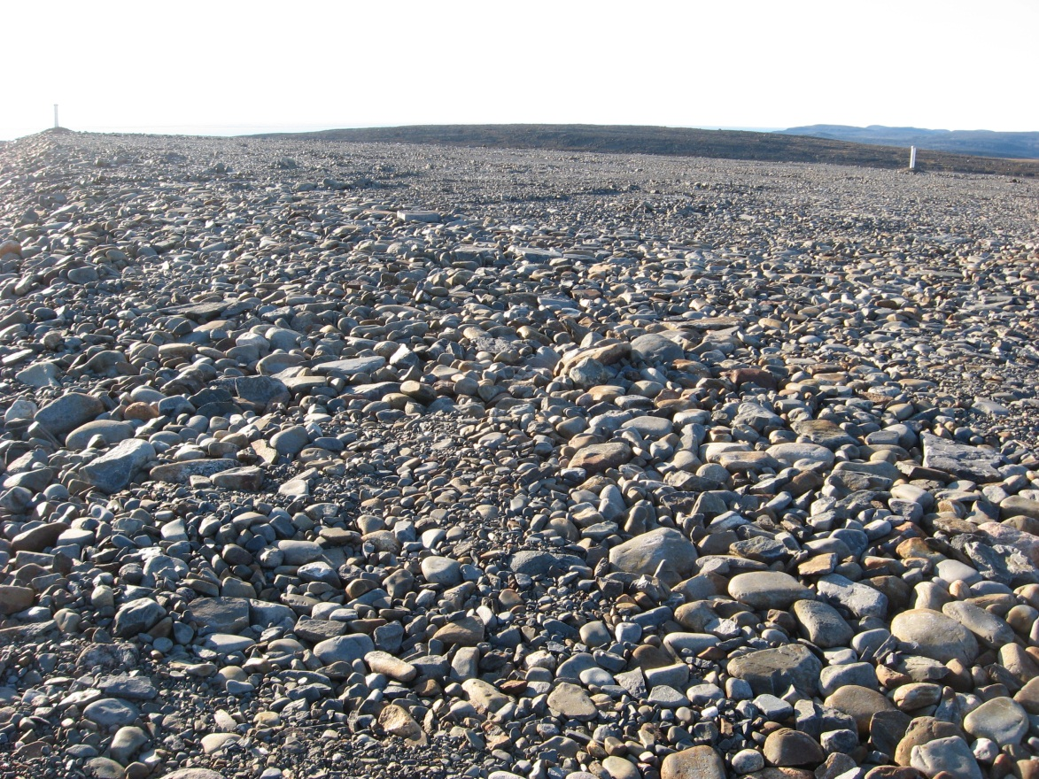
Photograph 93. Looking W (WP 124, FOX-2 64).

