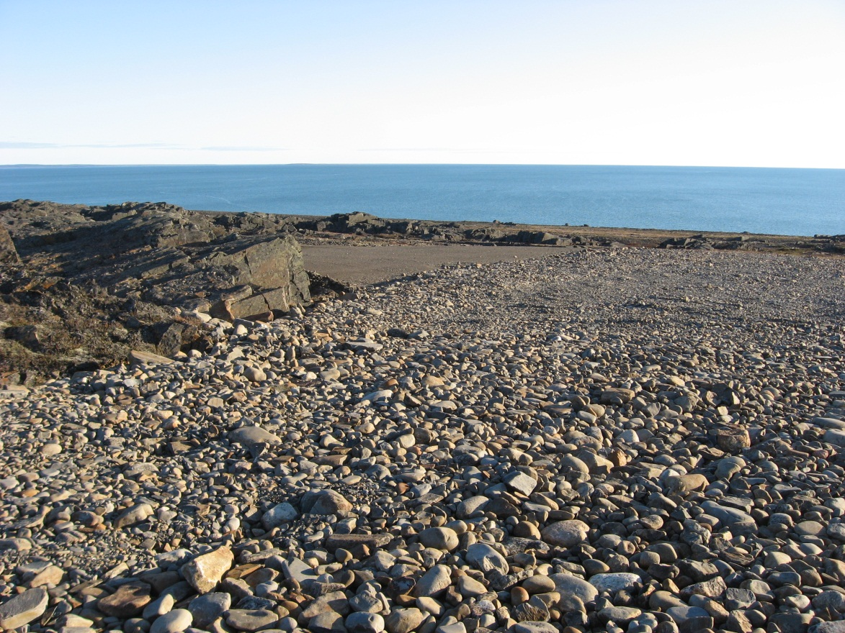
Photograph 40. West Landfill Lobe E – Looking S (Way Point 125, Photo FOX-2 65).
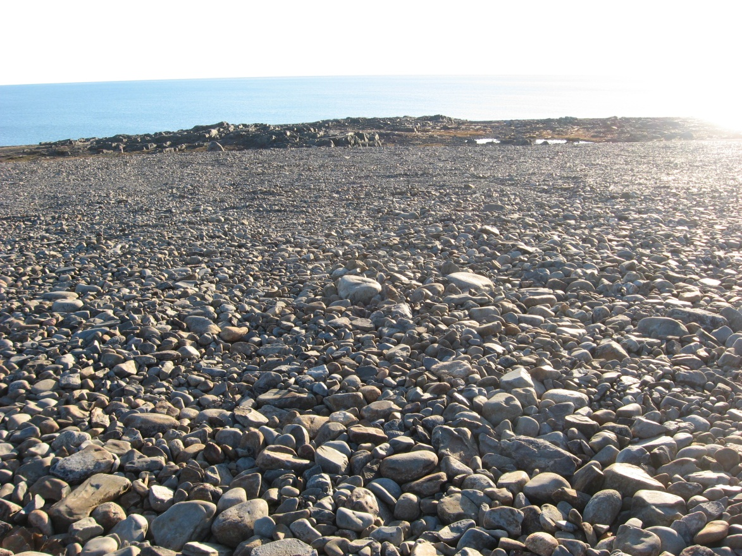
Photograph 41. Looking SW (WP 125, FOX-2 66).
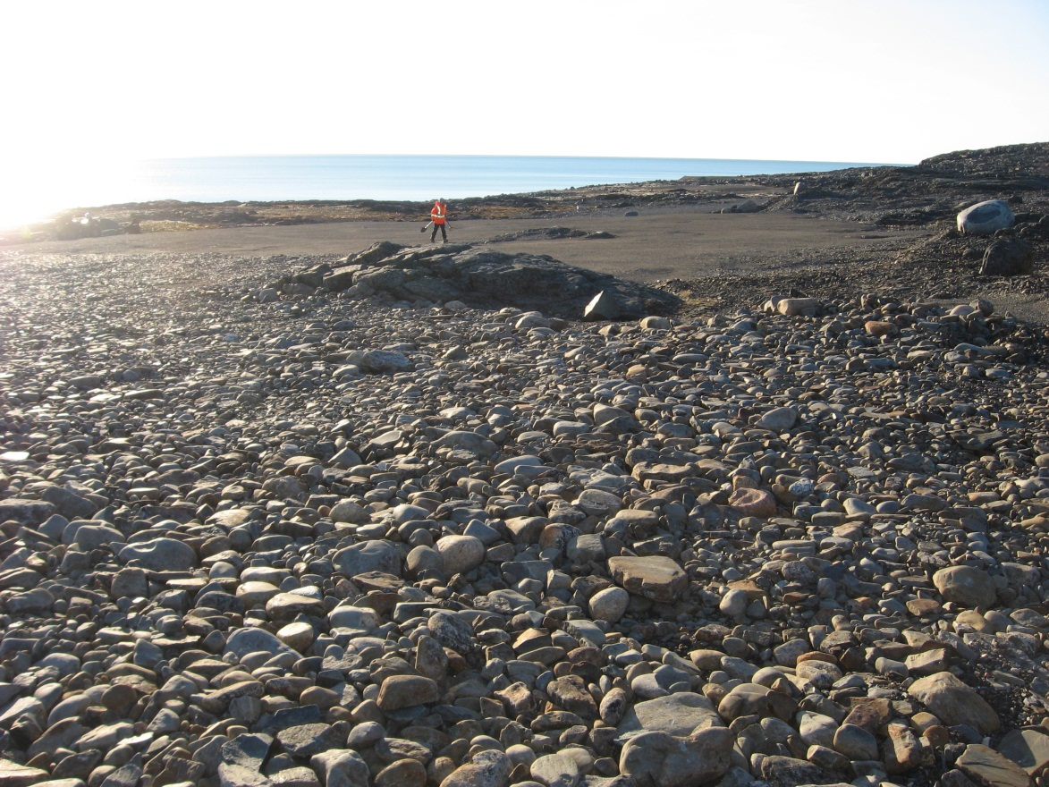
Photograph 42. Looking NW (WP 125, FOX-2 67).
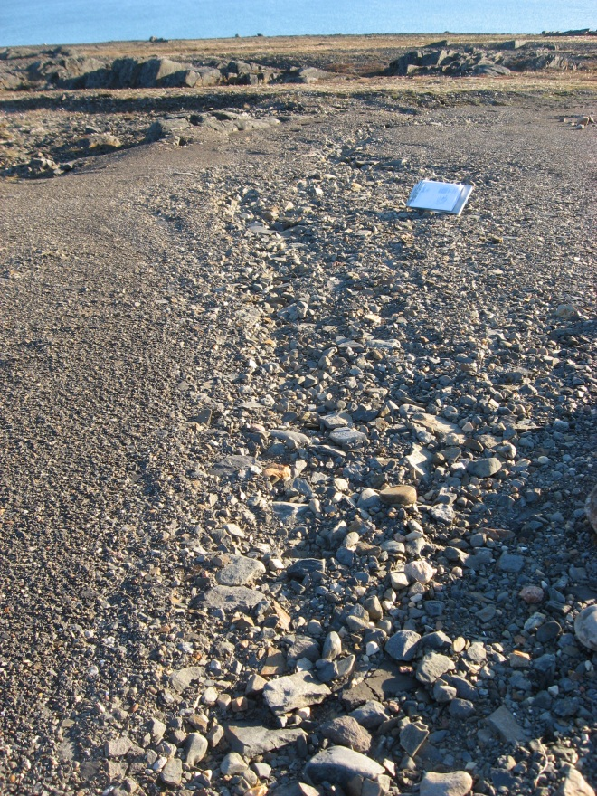

Photograph 43. Erosion from Surface Runoff – Looking SW (WP 126, FOX-2 68).
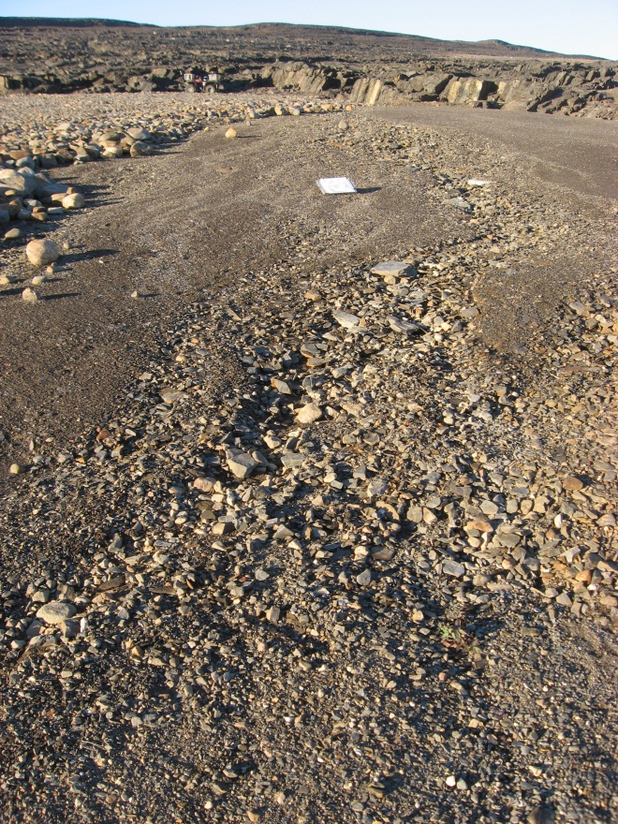
Photograph 44. Erosion from Surface Runoff – Looking NE (WP 127, FOX-2 69).
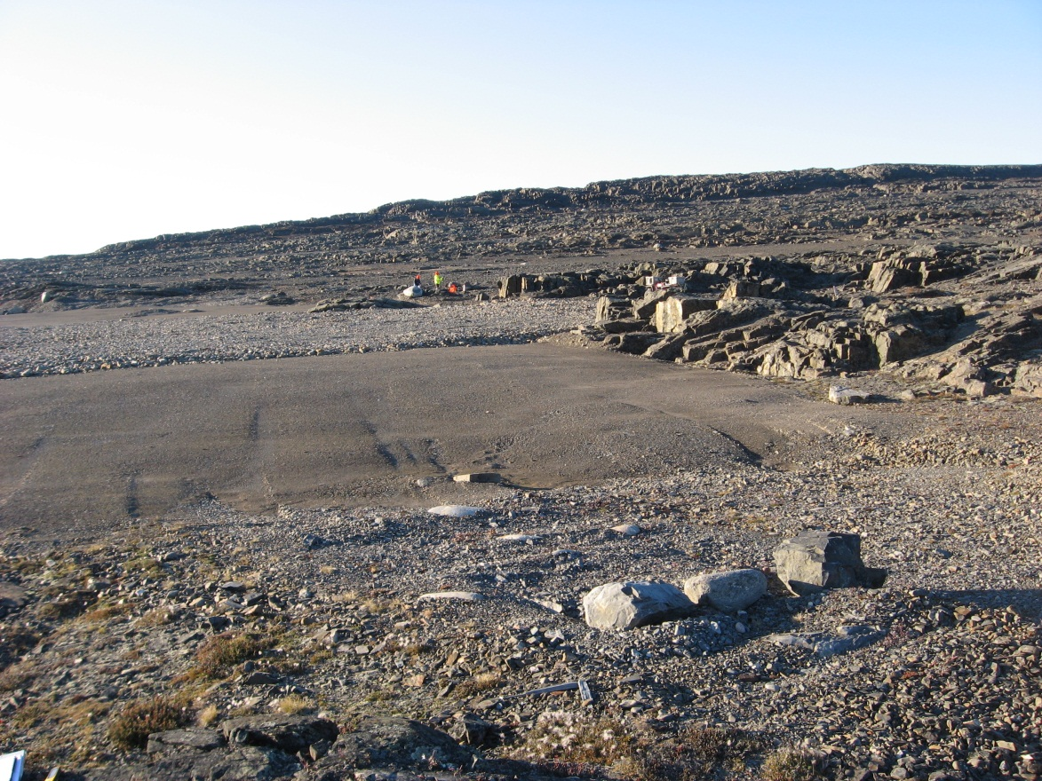
Photograph 45. Looking N (WP 128, FOX-2 70).
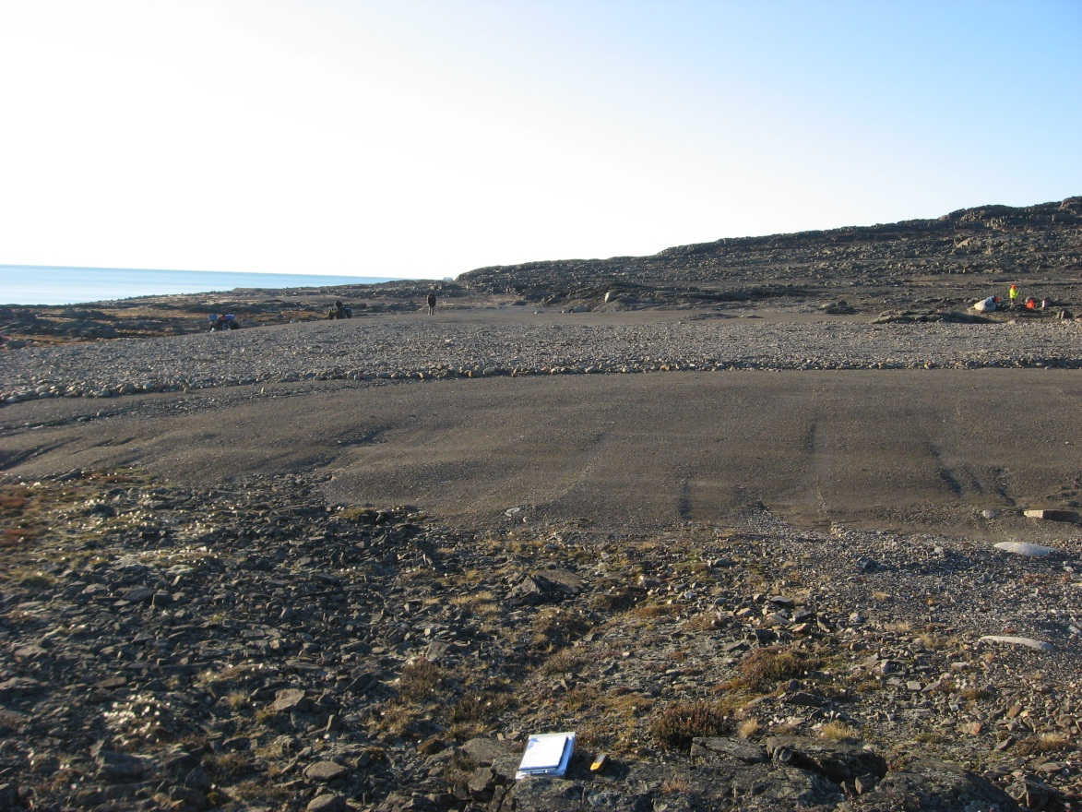
Photograph 46. Looking NW (WP 128, FOX-2 71).
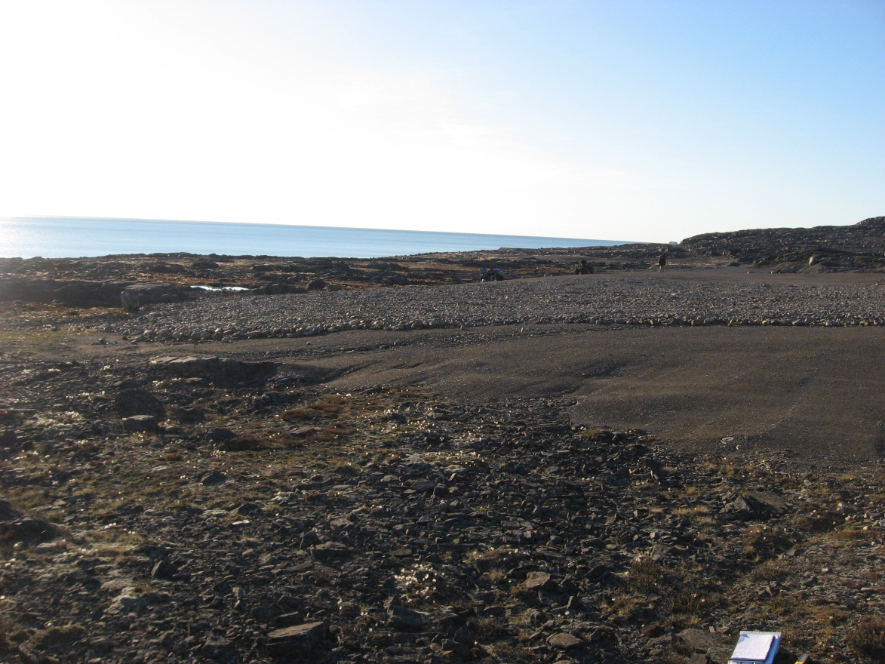
Photograph 47. Looking W (WP 128, FOX-2 72).
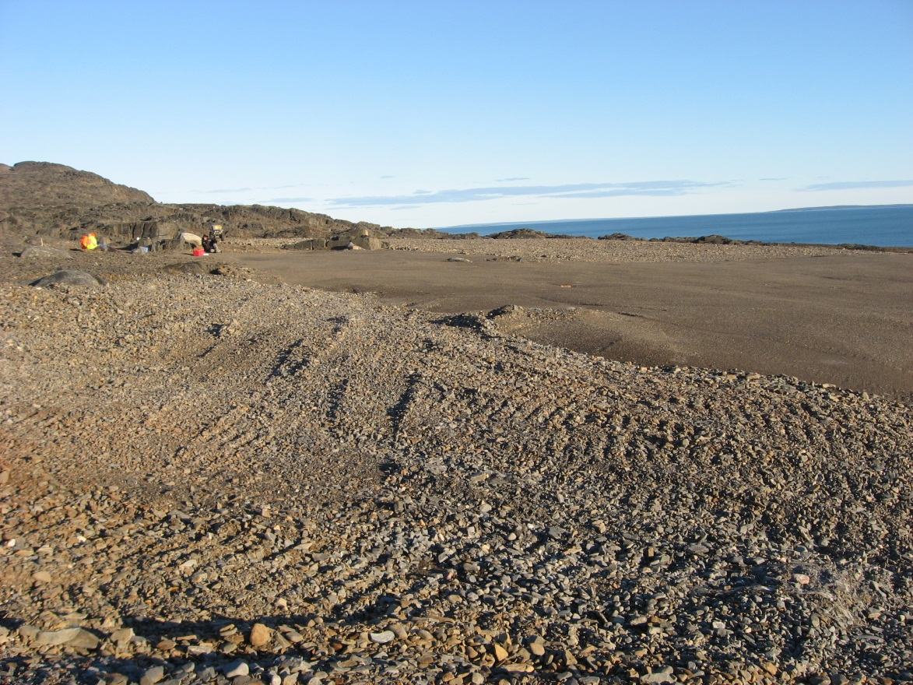
Photograph 48. Looking SE (WP 129, FOX-2 73).
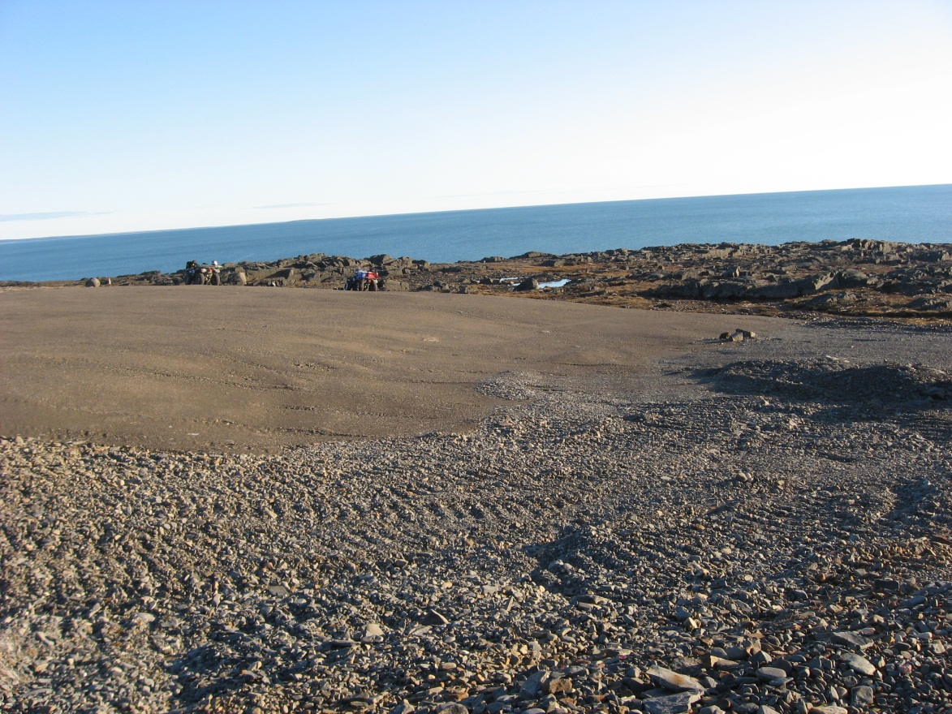
Photograph 49. Looking S (WP 129, FOX-2 74).
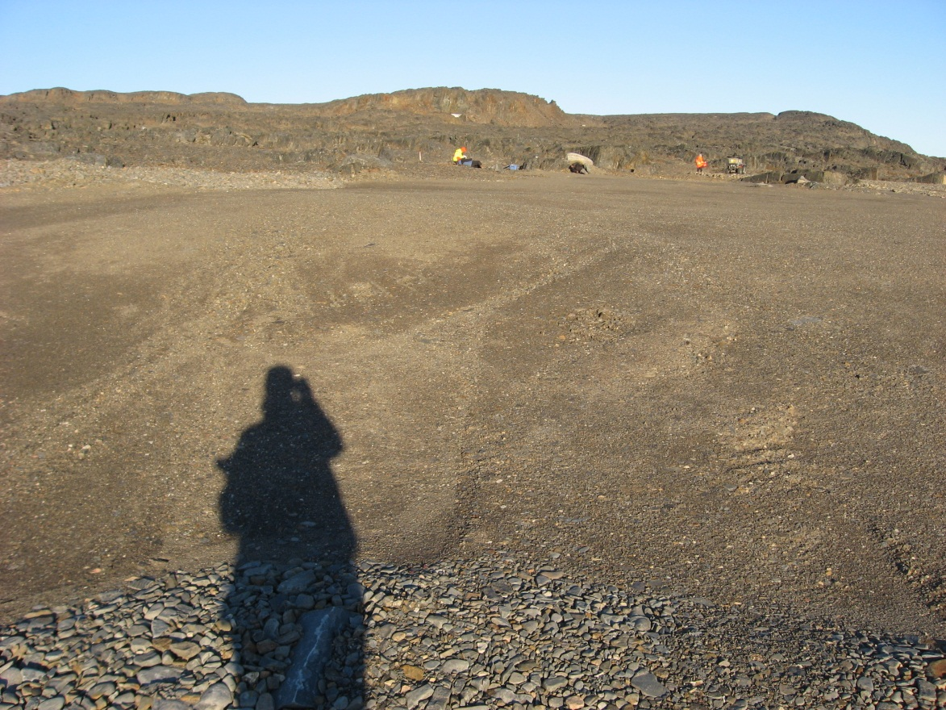
Photograph 50. Looking SE (WP 130, FOX-2 75).
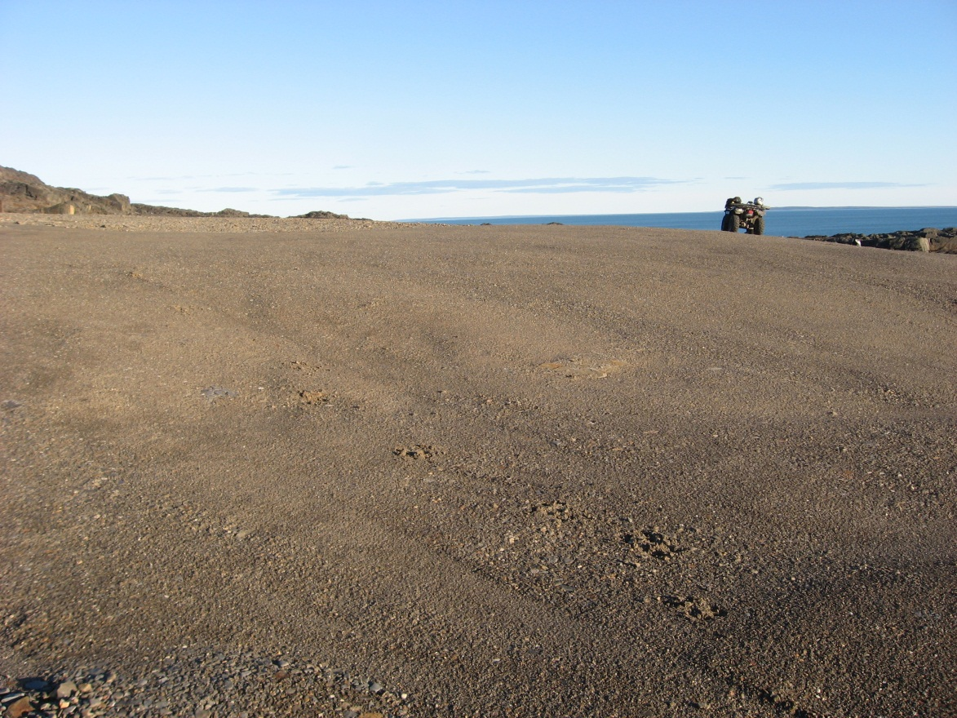
Photograph 51. Looking S (WP 130, FOX-2 76).
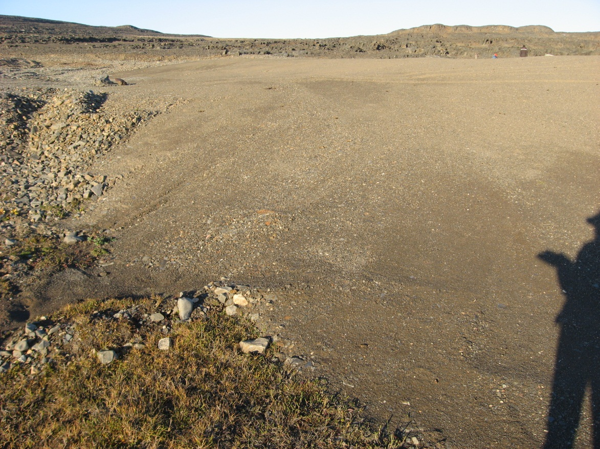
Photograph 52. Looking NE (WP 131, FOX-2 77).
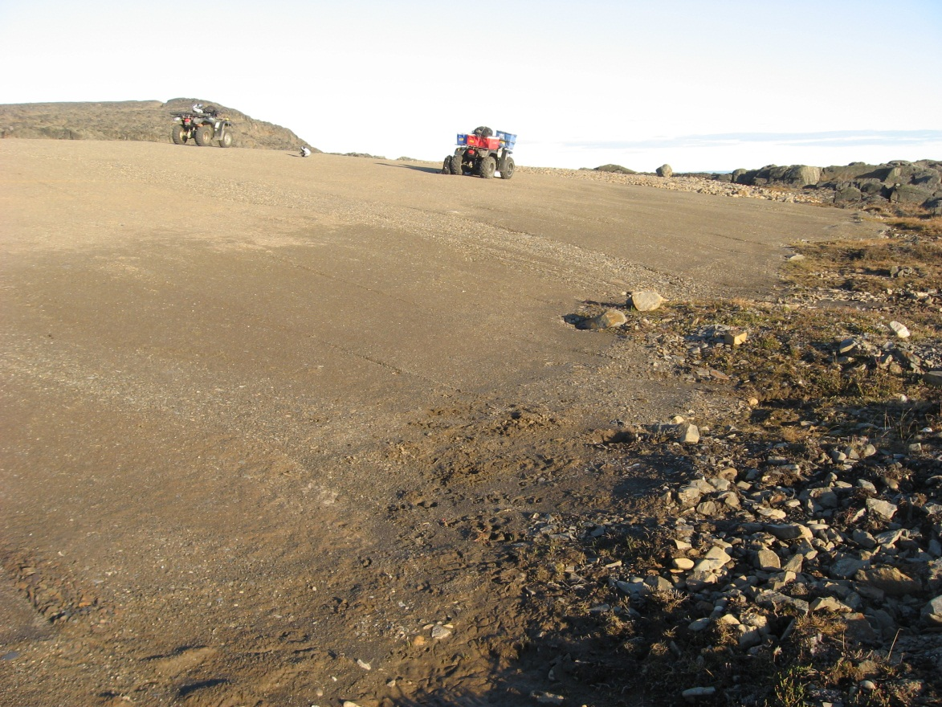
Photograph 53. Looking SE (WP 131, FOX-2 78).
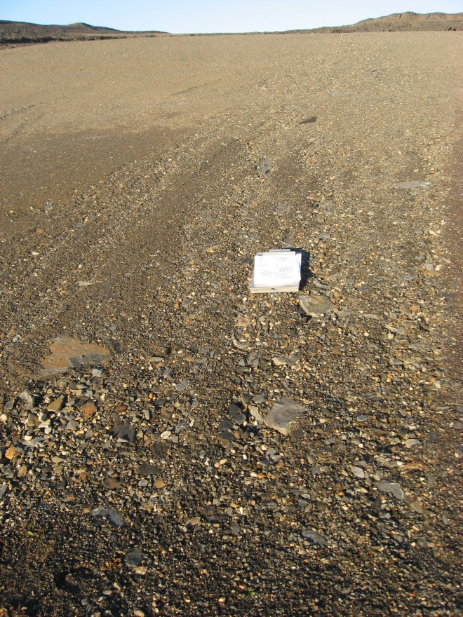
Photograph 54. Minor Erosion from Surface Runoff – Looking NE (WP 132, FOX-2 79).
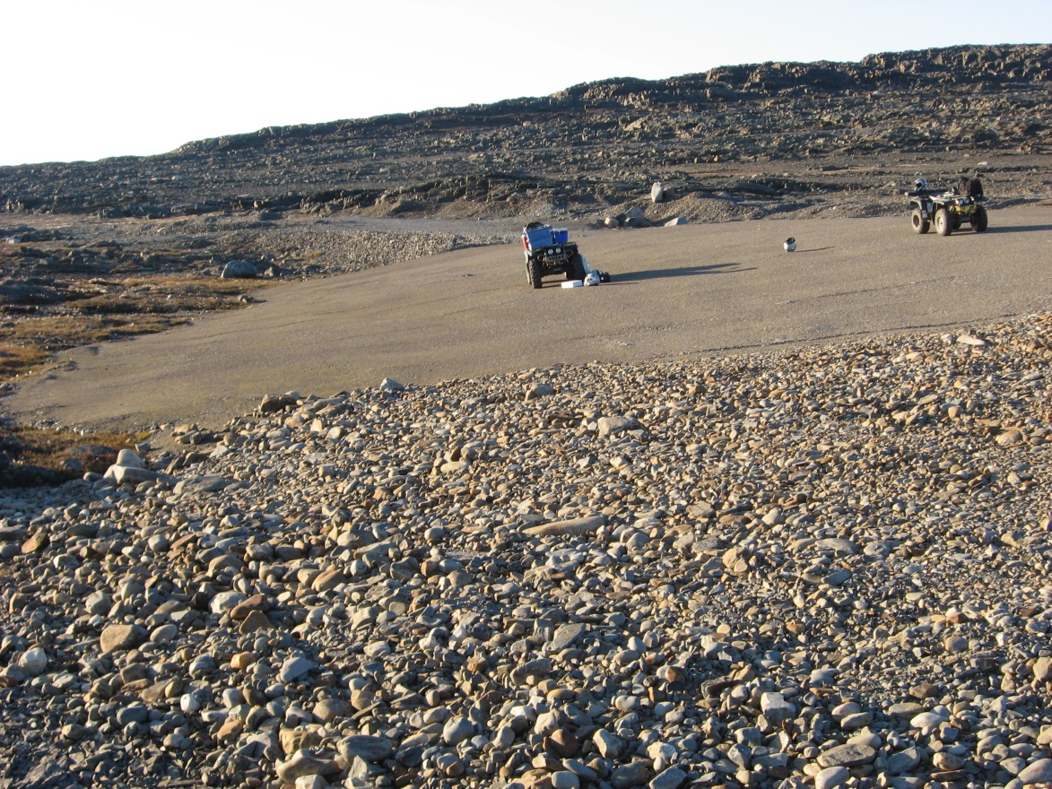
Photograph 55. Looking NW (WP 133, FOX-2 80).
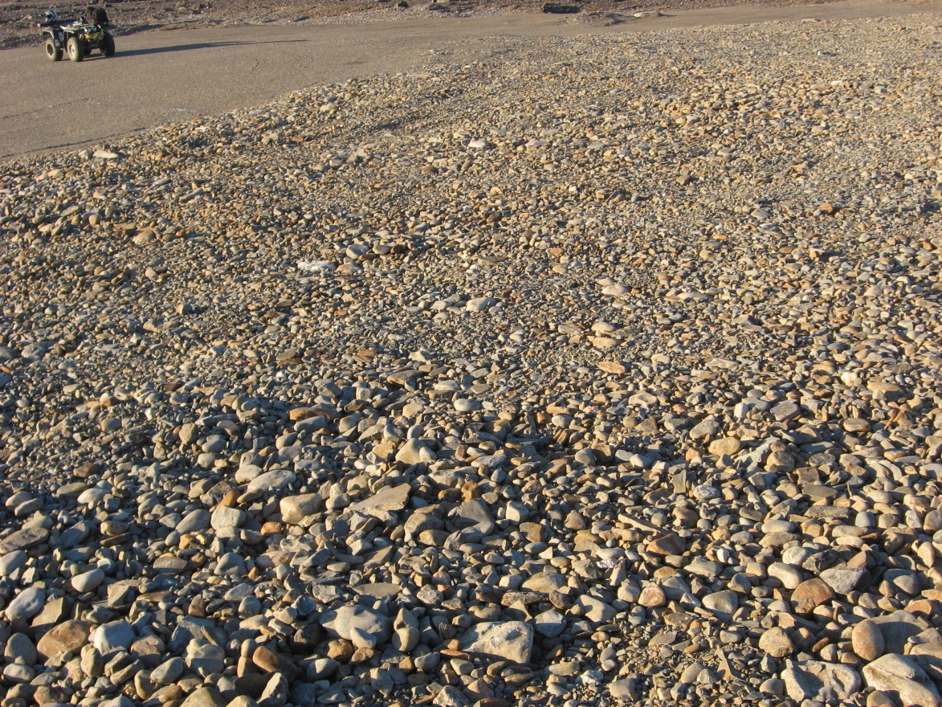
Photograph 56. Looking N (WP 133, FOX-2 81).
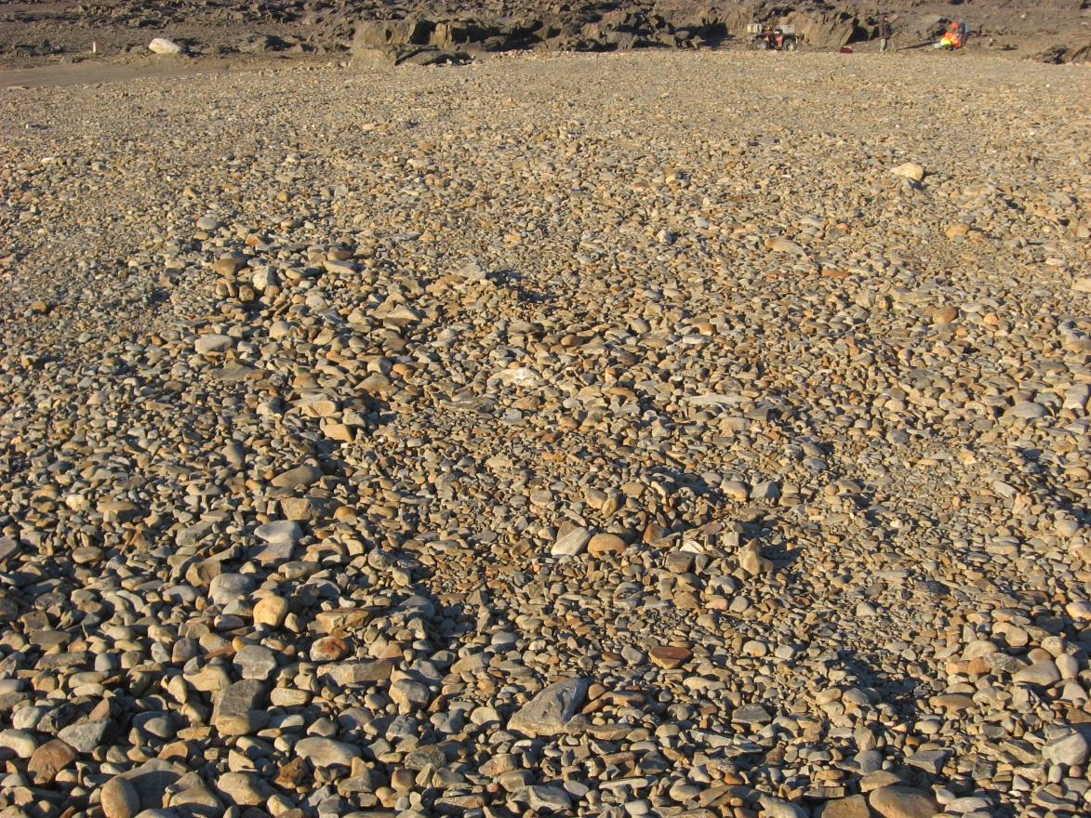
Photograph 57. Looking NE (WP 133, FOX-2 82).
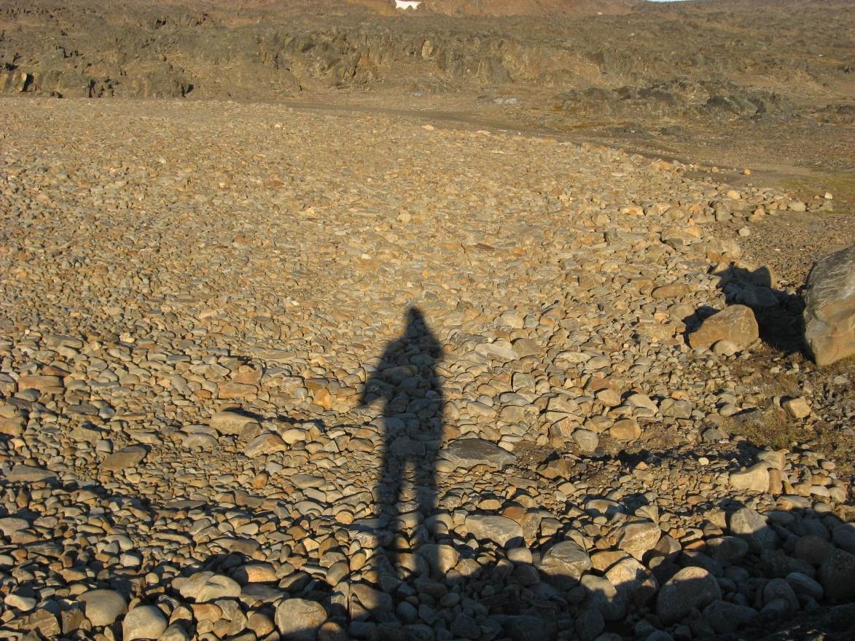
Photograph 58. Looking E (WP 133, FOX-2 83).
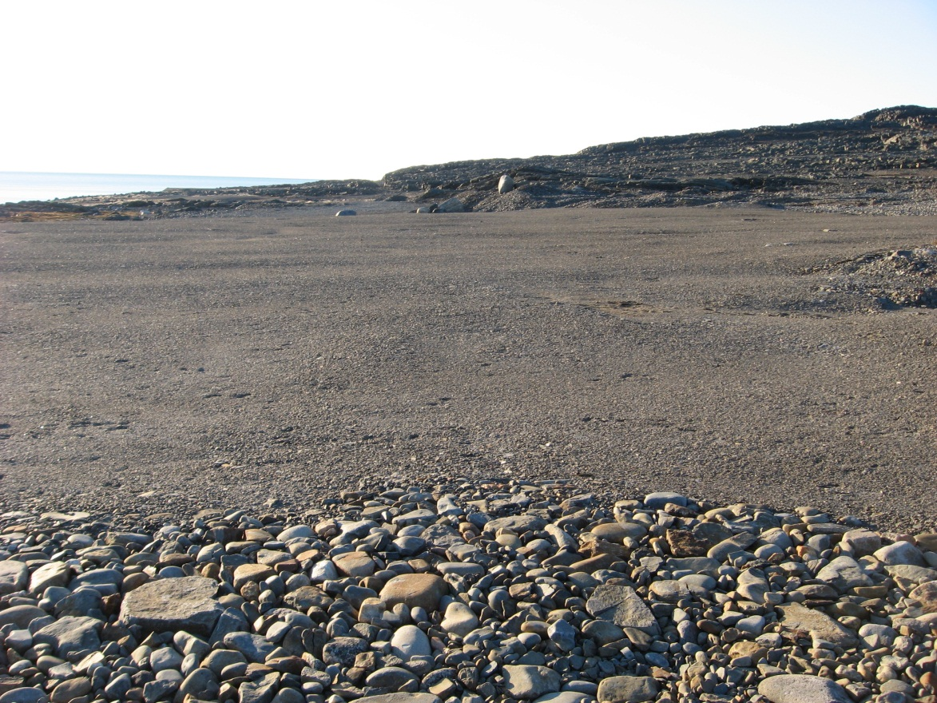
Photograph 59. Looking NW (WP 134, FOX-2 84).
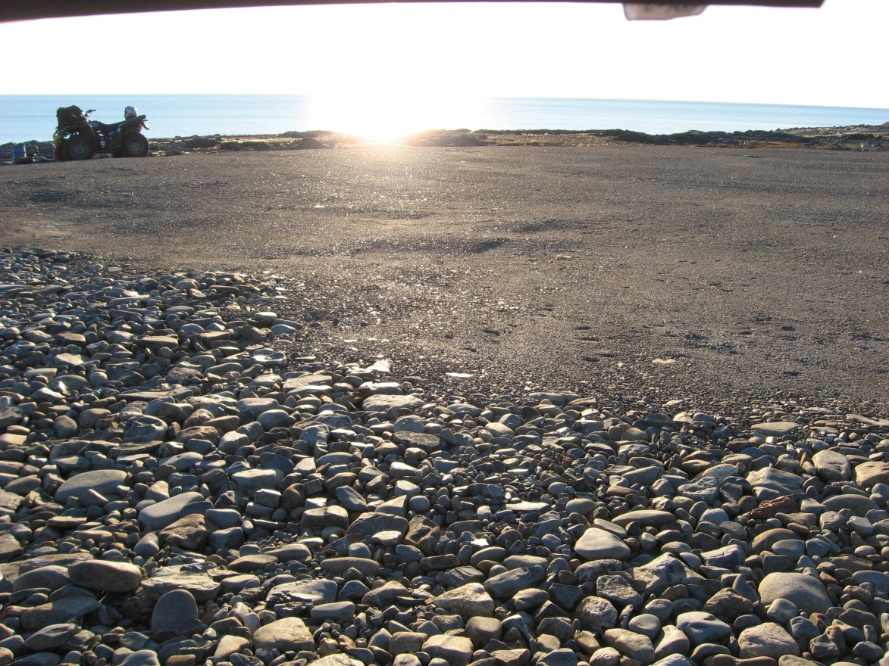
Photograph 60. Looking SW (WP 134, FOX-2 85).
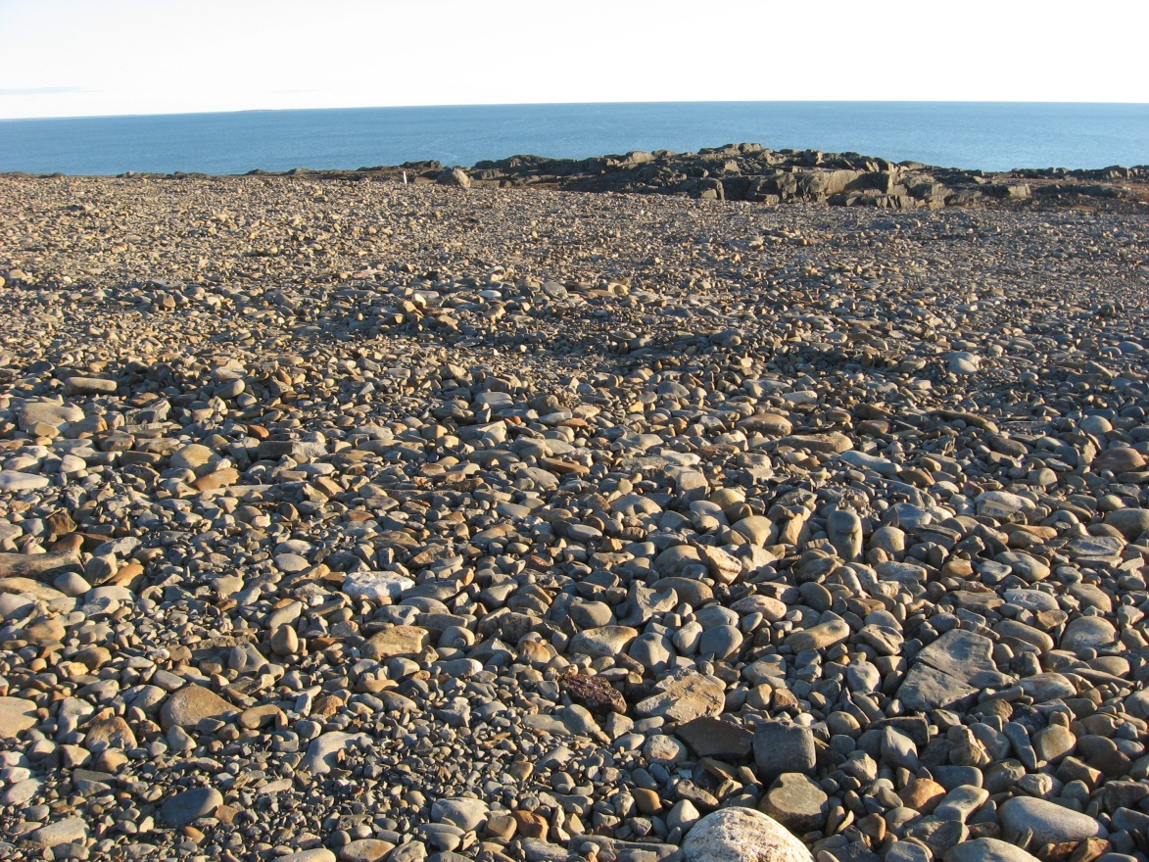
Photograph 61. Looking S (WP 134, FOX-2 86).
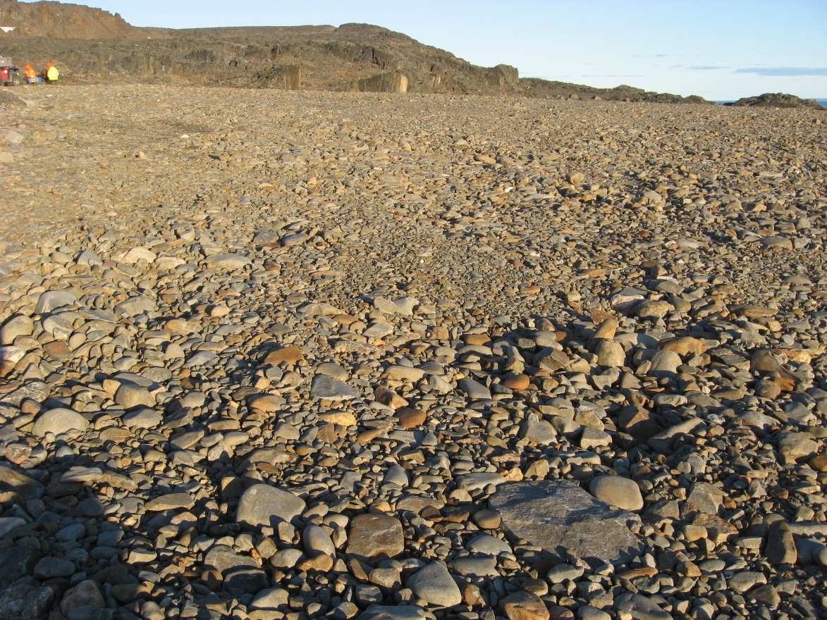
Photograph 62. Looking SE (WP 134, FOX-2 87).
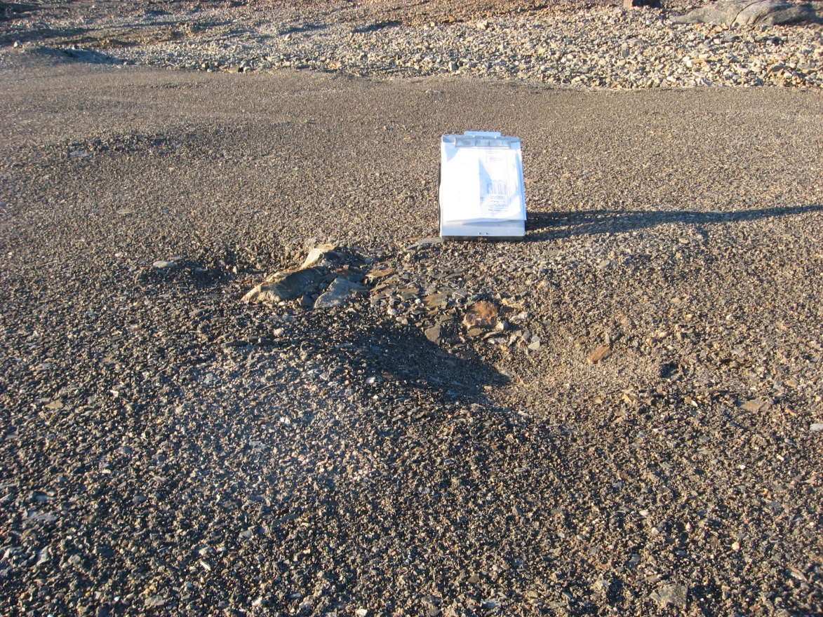
Photograph 63. Minor Settlement – Looking N (WP 135, FOX-2 88).

