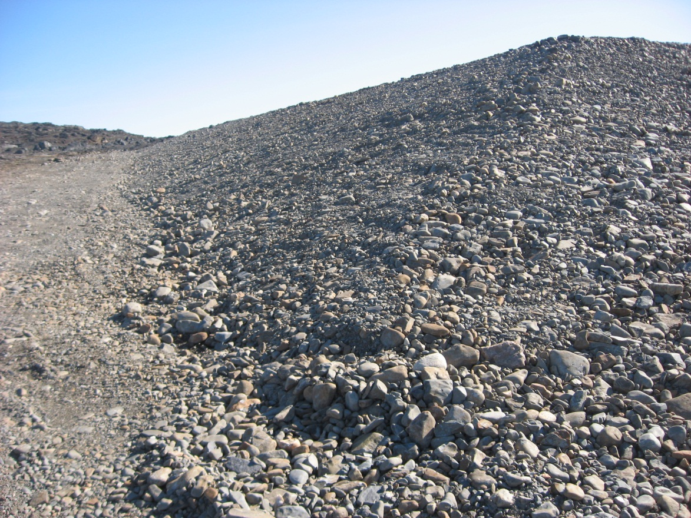
Photograph 15. Hangar Non-Hazardous Waste Landfill – Looking E (Way Point 136, Photo FOX-2 89).
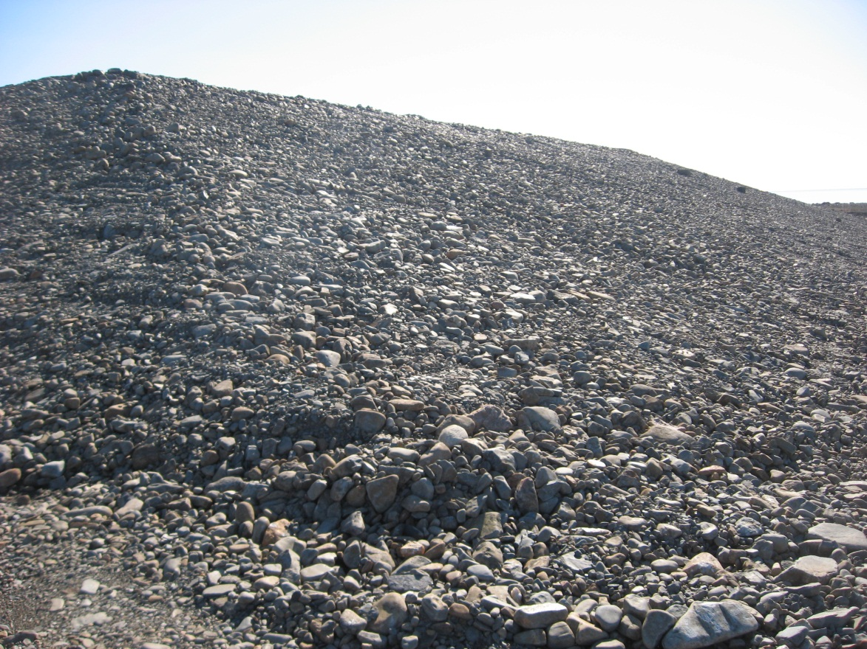
Photograph 16. Looking S (WP 136, FOX-2 90).
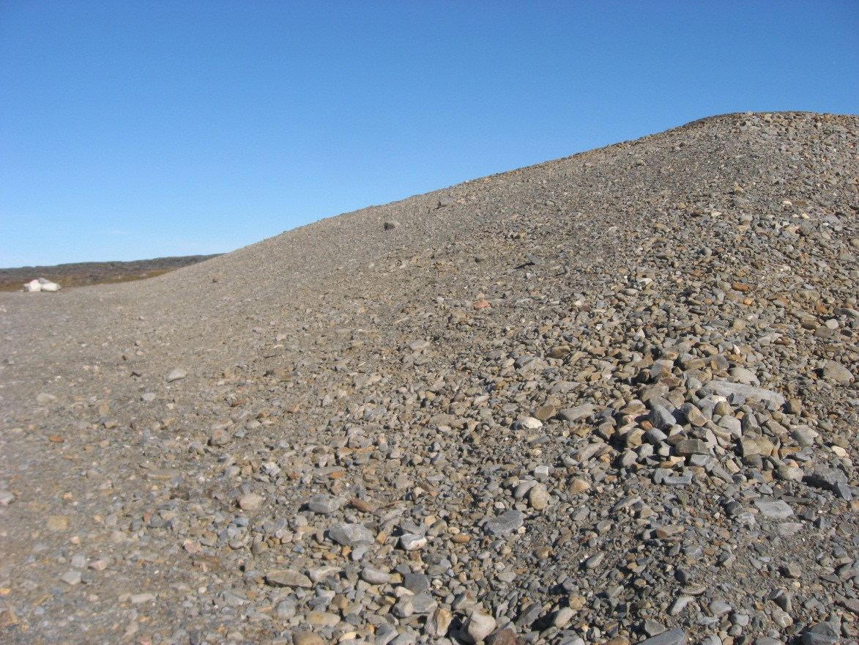
Photograph 17. Looking N (WP 137, FOX-2 91).
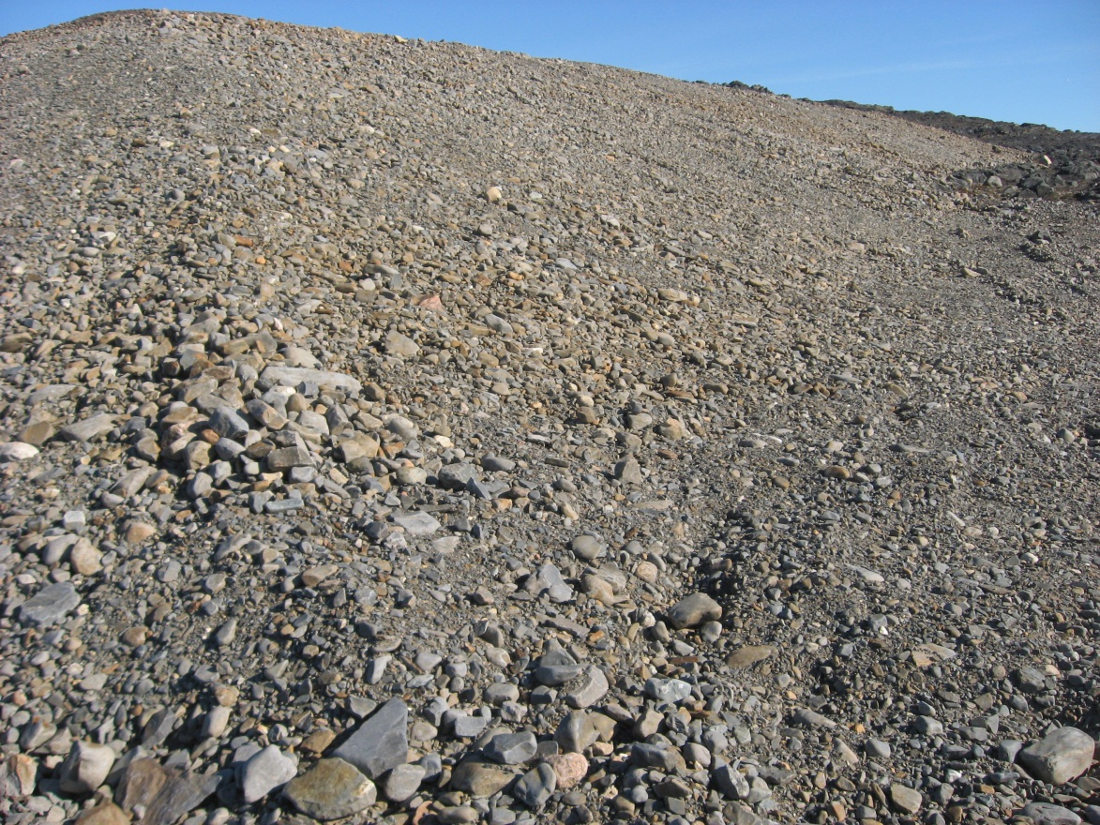

Photograph 18. Looking E (WP 137, FOX-2 92).
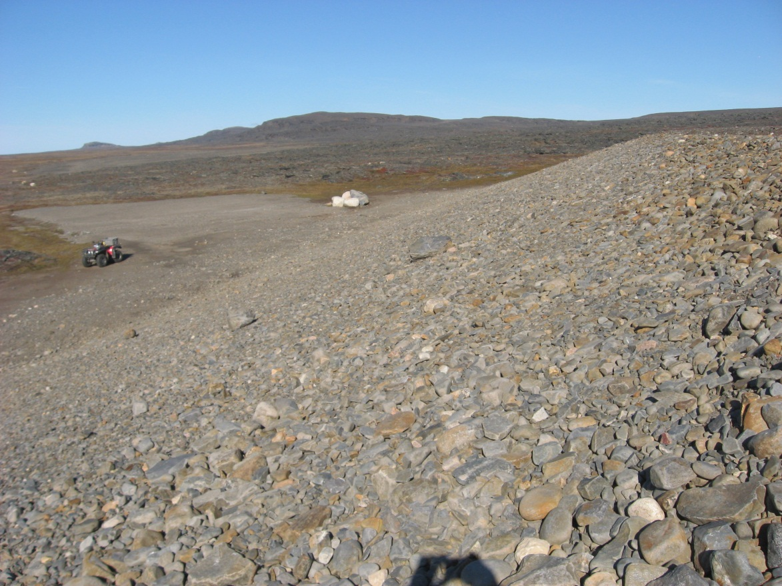
Photograph 19. Looking N (WP 138, FOX-2 93).
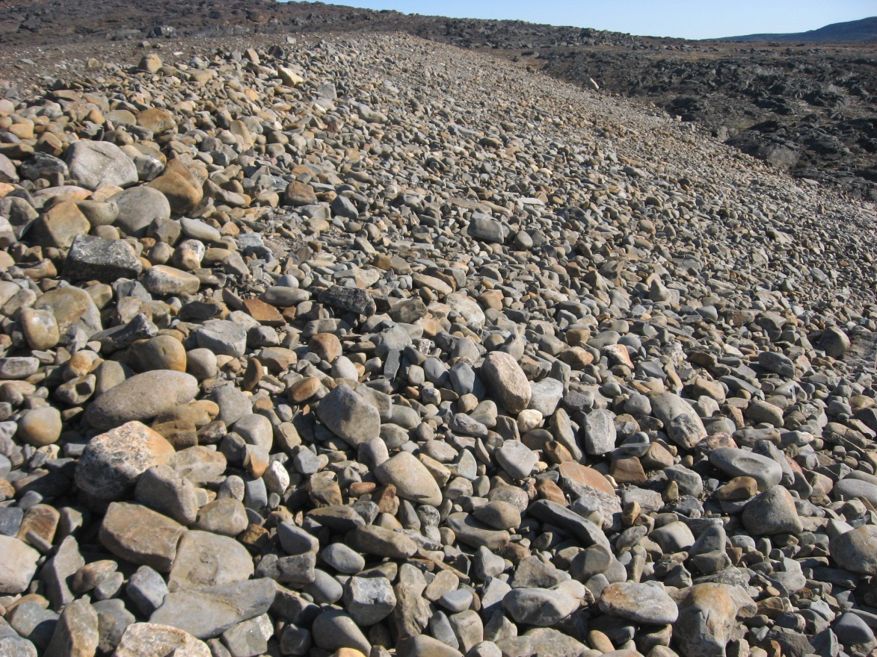
Photograph 20. Looking E (WP 138, FOX-2 94).
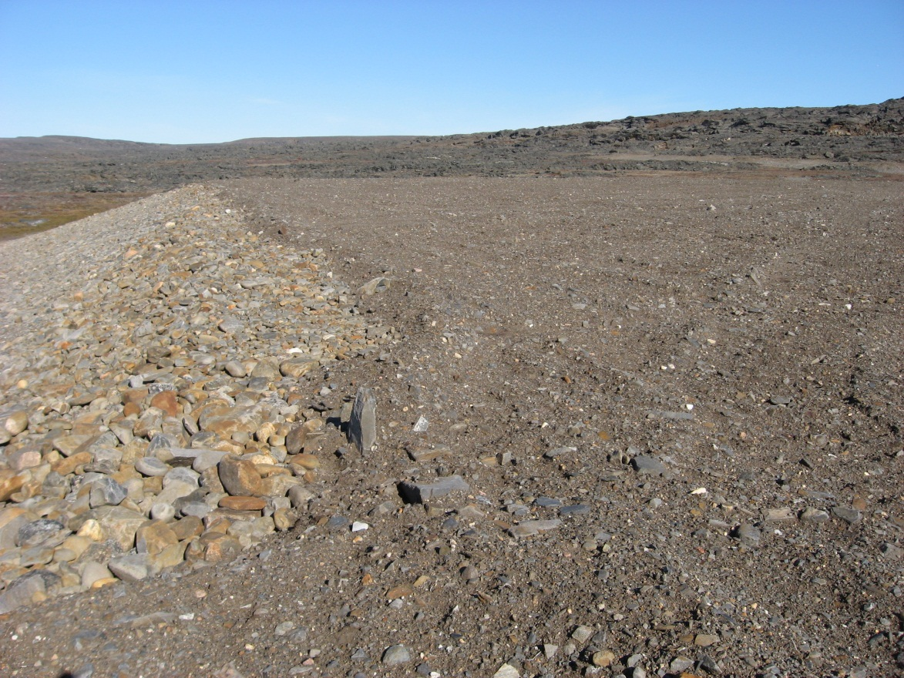
Photograph 21. Looking N (WP 139, FOX-2 95).
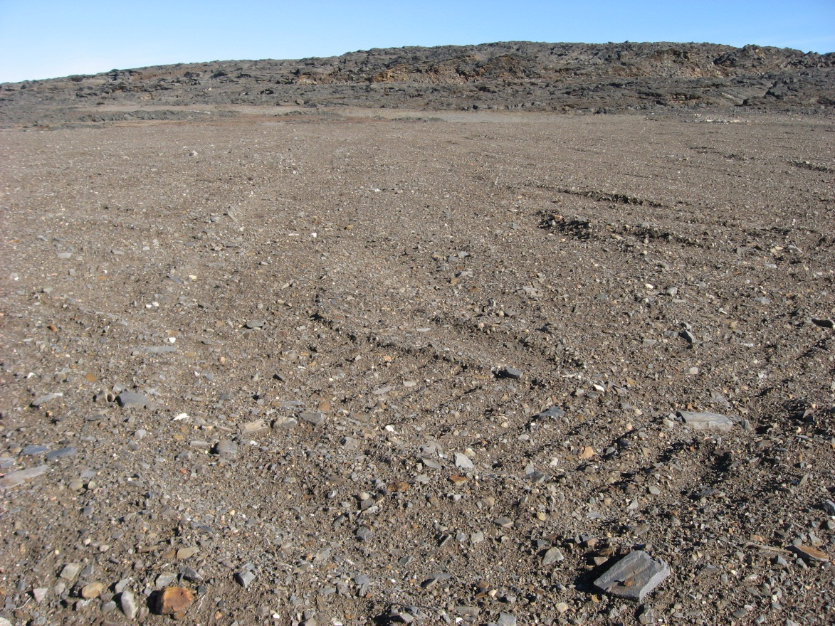
Photograph 22. Looking NE (WP 139, FOX-2 96).
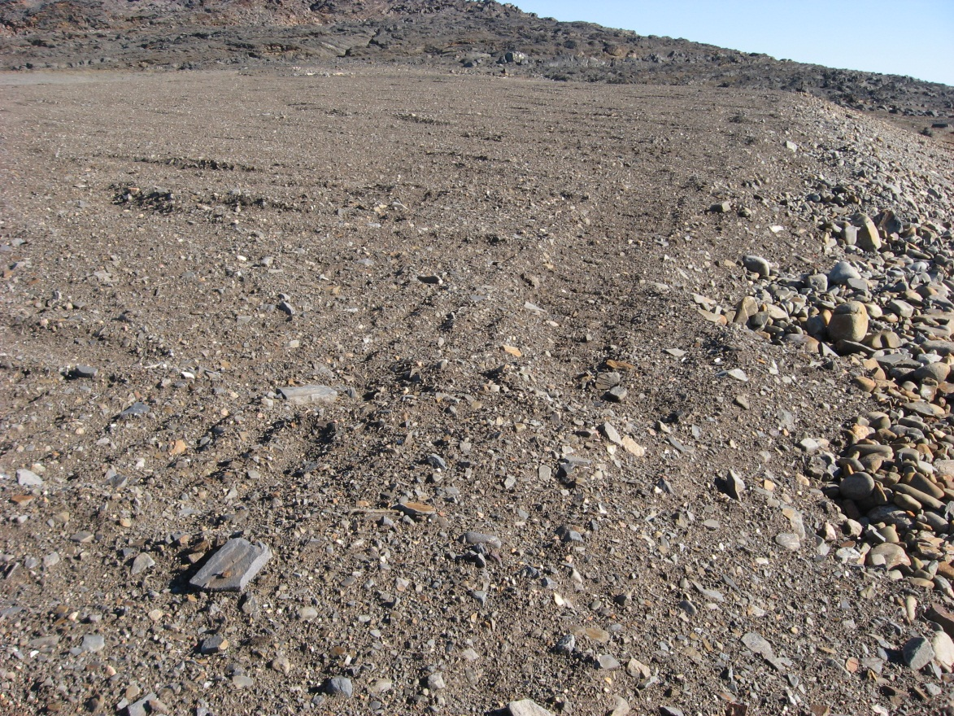
Photograph 23. Looking E (WP 139, FOX-2 97).
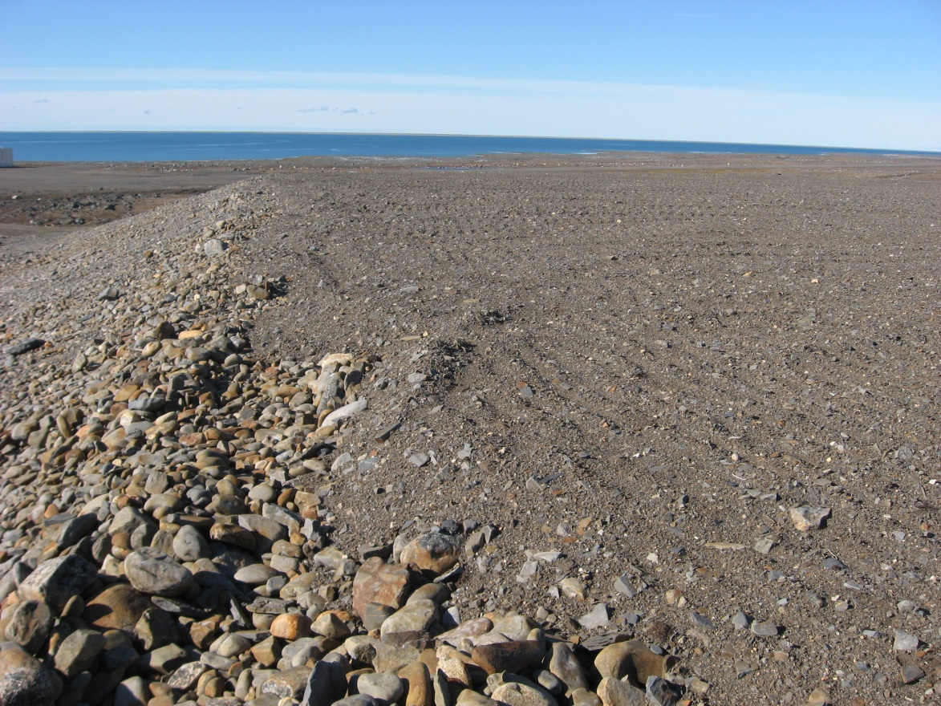
Photograph 24. Looking W (WP 140, FOX-2 98).
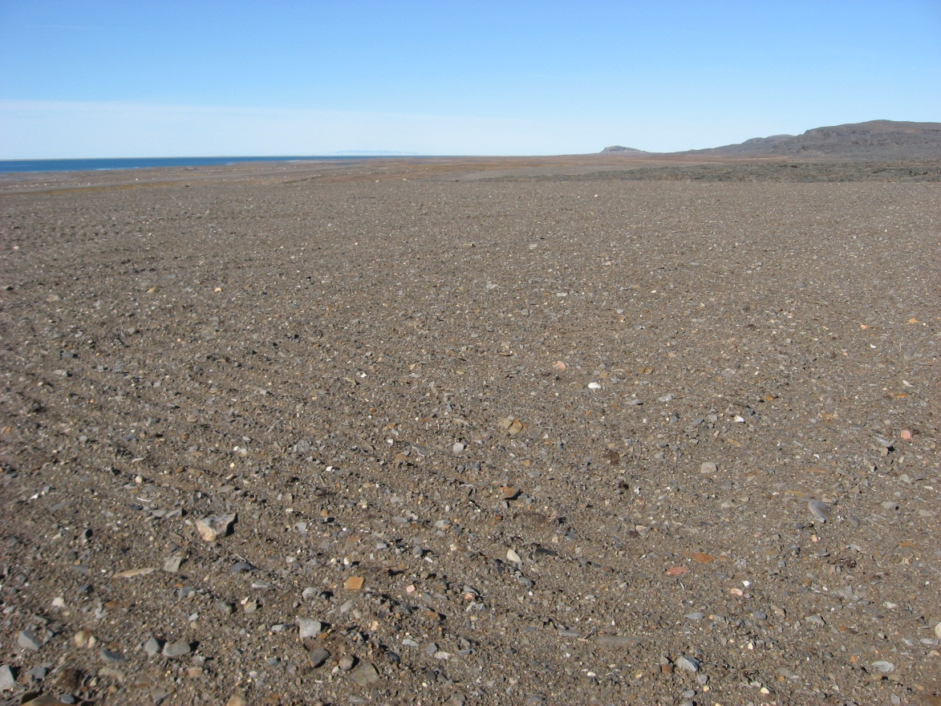
Photograph 25. Looking NW (WP 140, FOX-2 99).
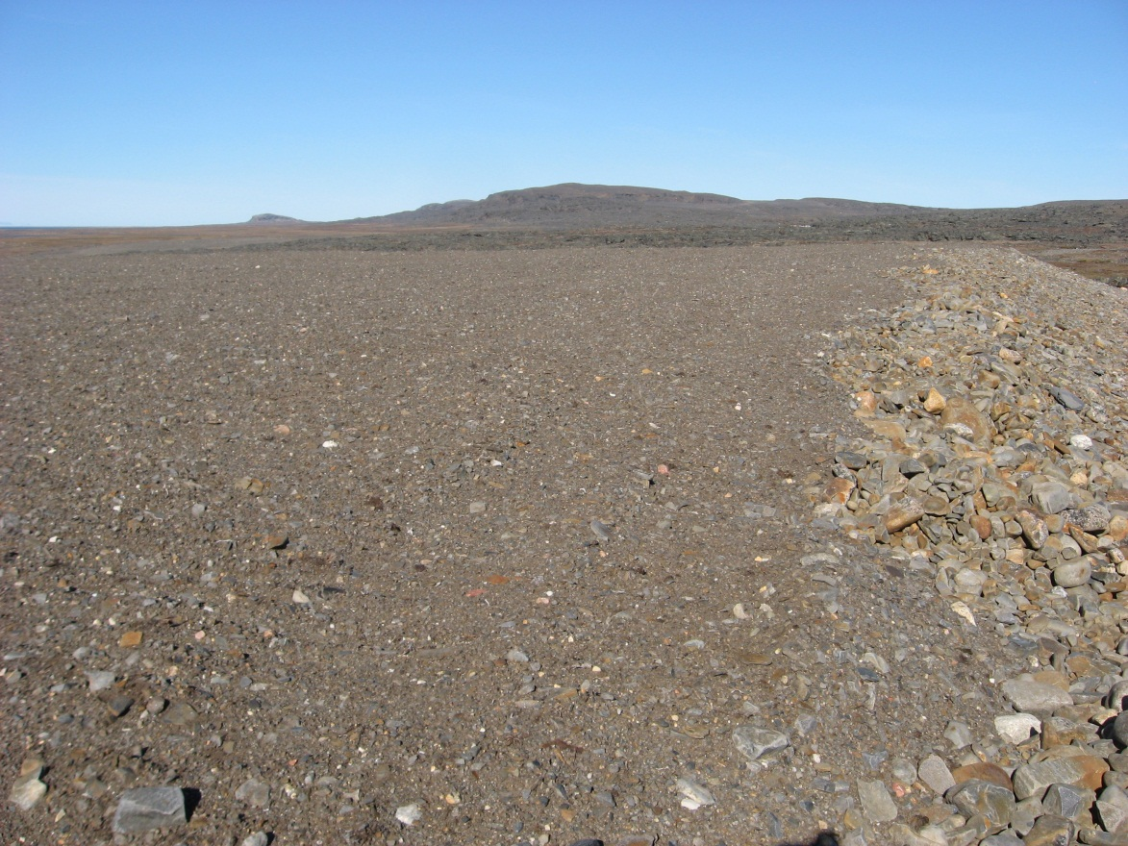
Photograph 26. Looking N (WP 140, FOX-2 100).
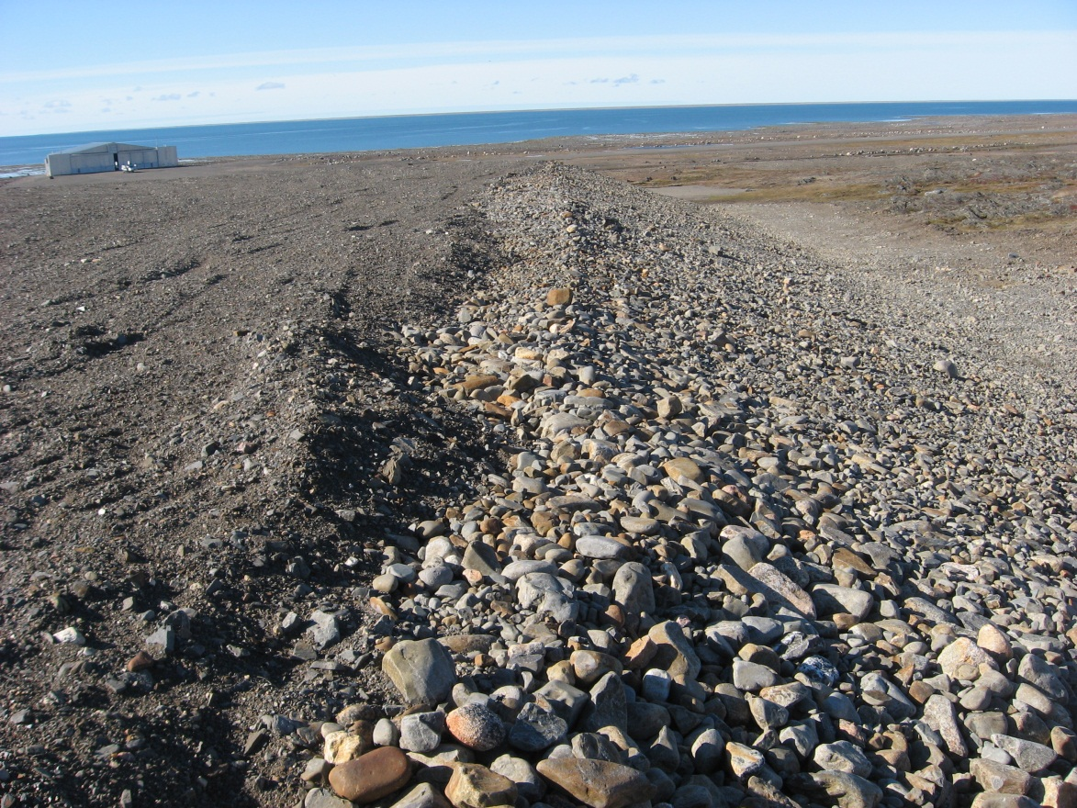
Photograph 27. Looking W (WP 141, FOX-2 101).
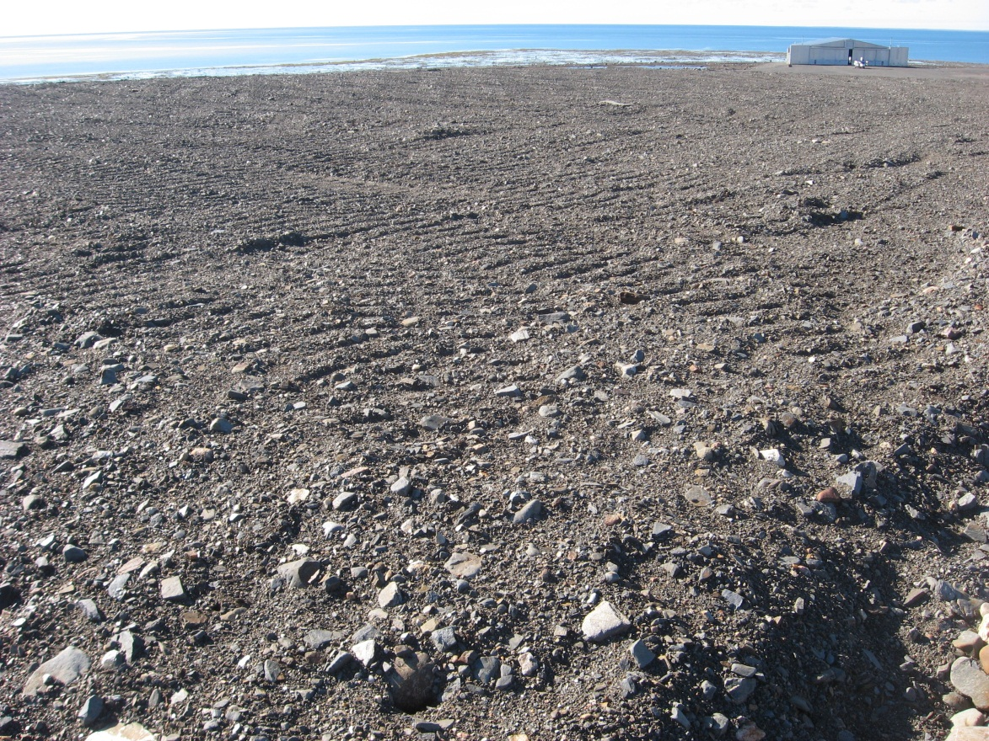
Photograph 28. Looking SW (WP 141, FOX-2 102).
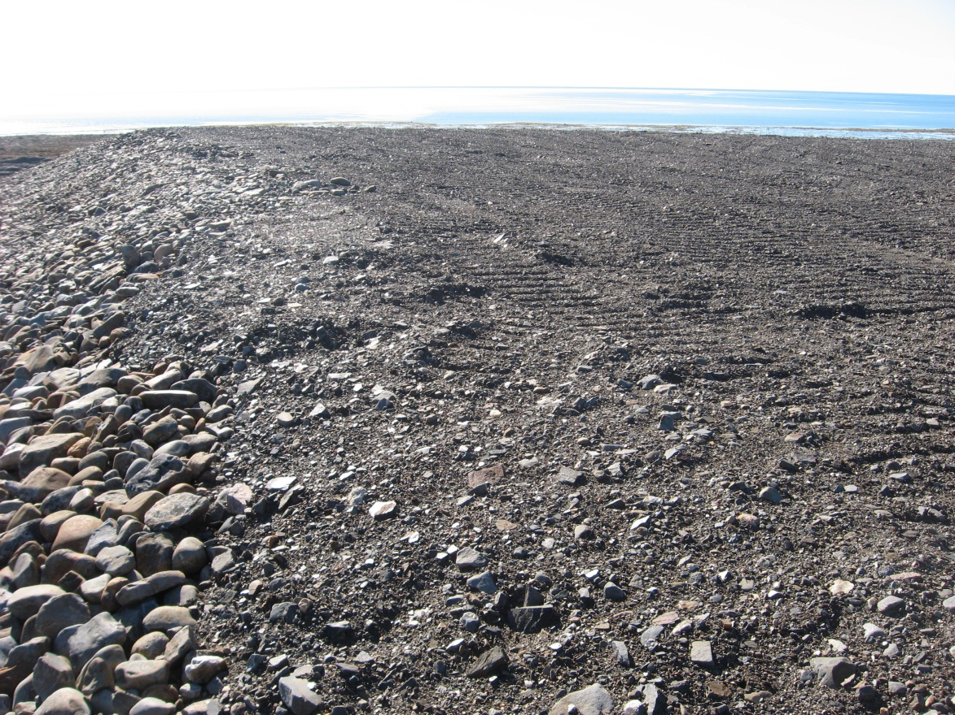
Photograph 29. Looking S (WP 141, FOX-2 103).
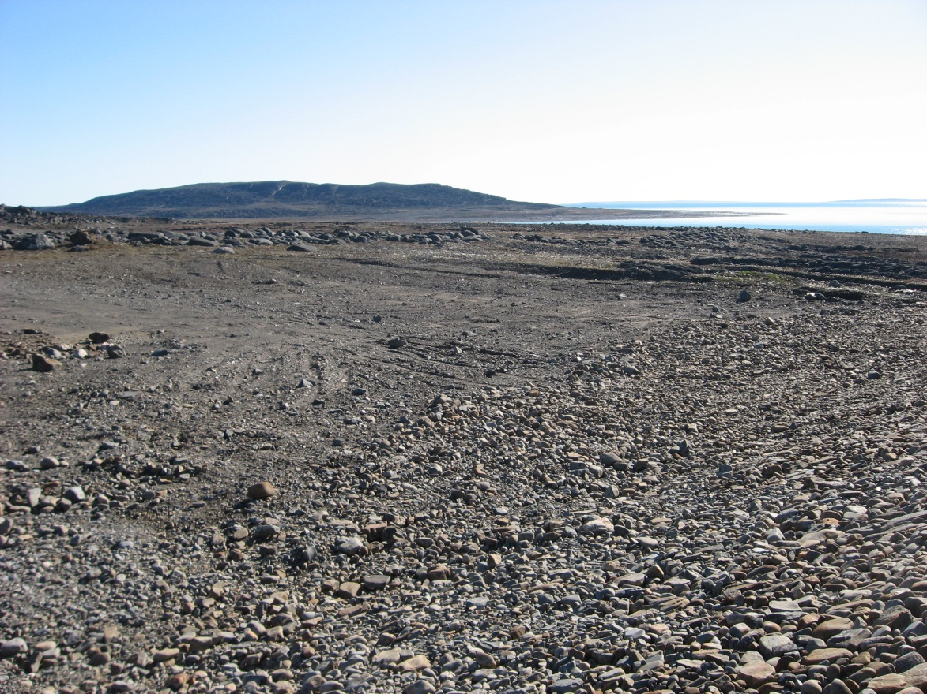
Photograph 30. Looking SE (WP 141, FOX-2 104).
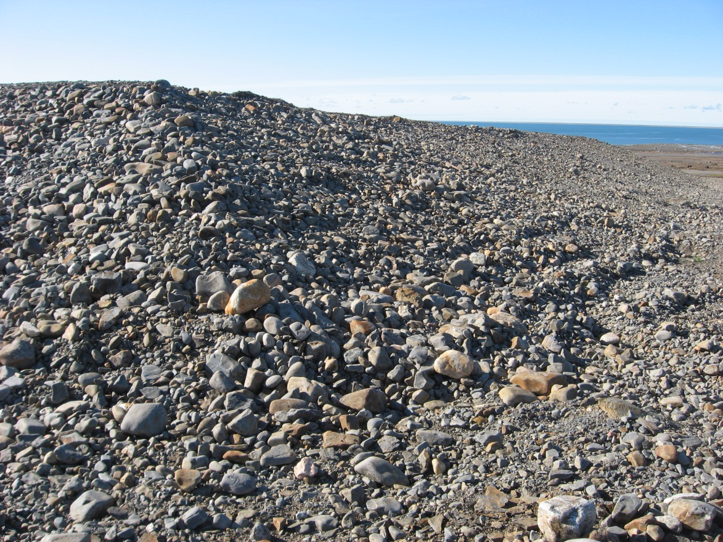
Photograph 31. Looking W (WP 142, FOX-2 105).
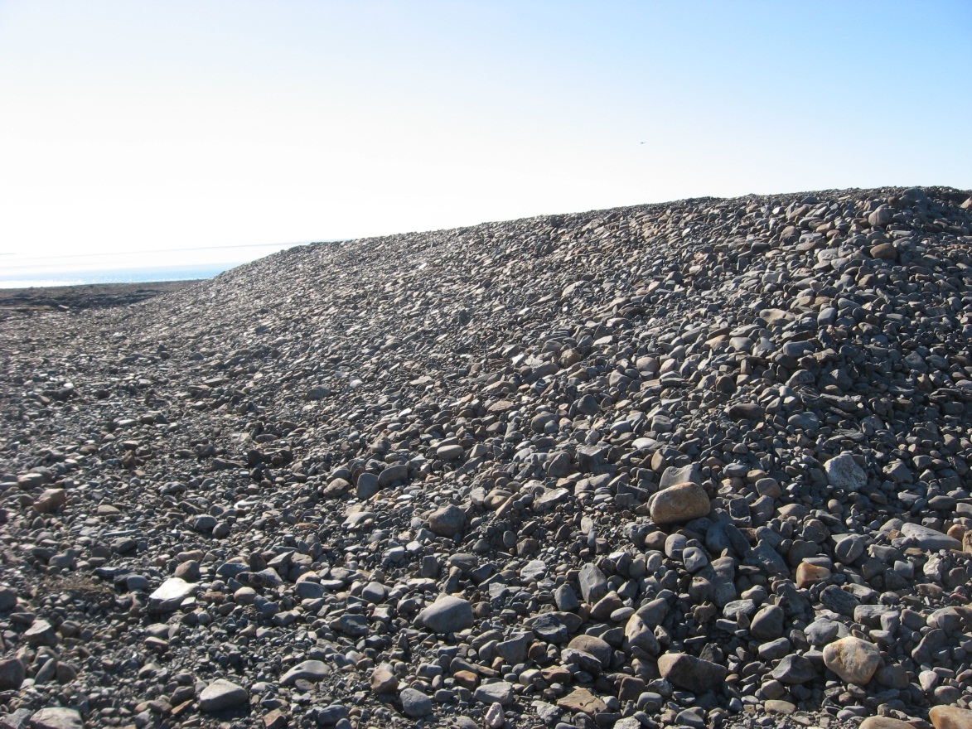
Photograph 32. Looking S (WP 142, FOX-2 106).

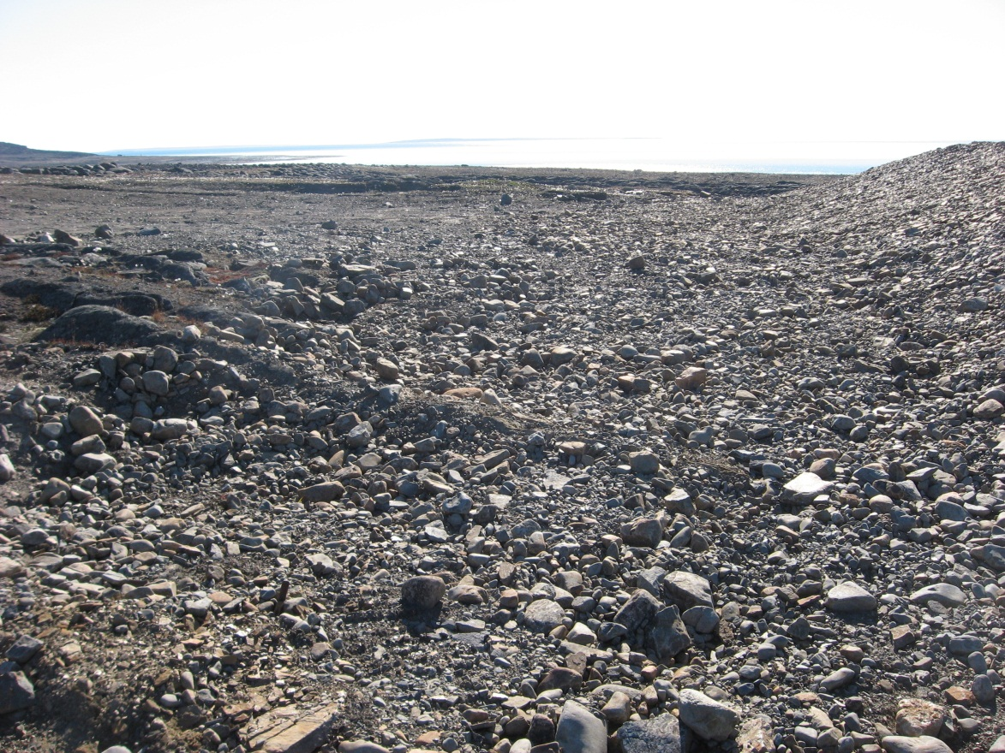
Photograph 33. Looking SE (WP 142, FOX-2 107).
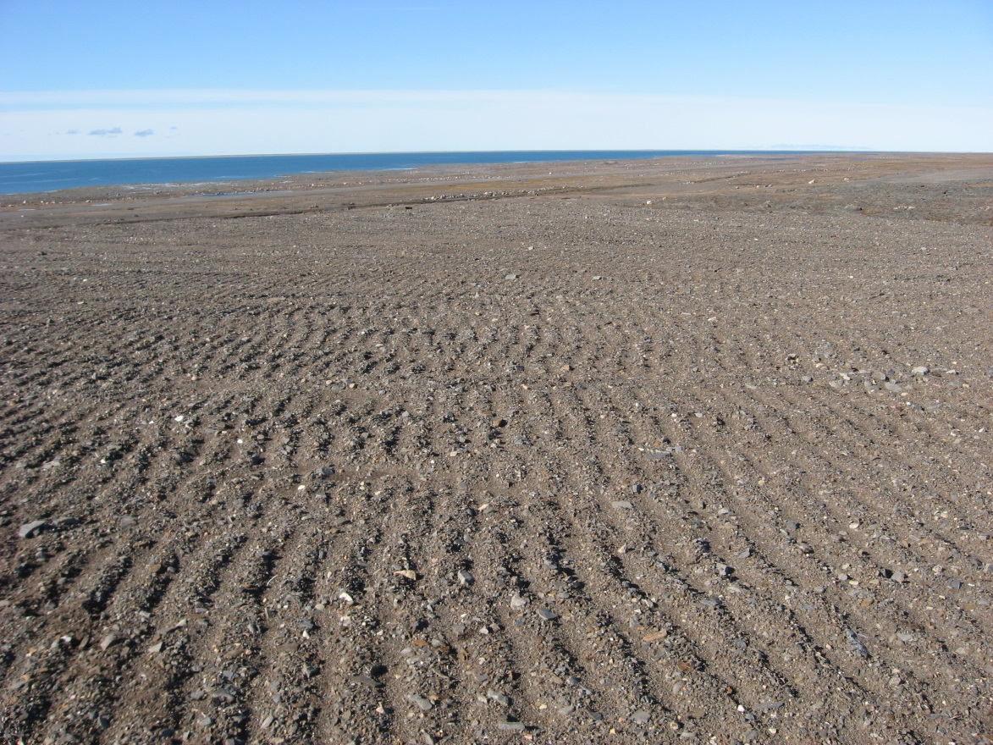
Photograph 34. Looking NW (WP 143, FOX-2 108).
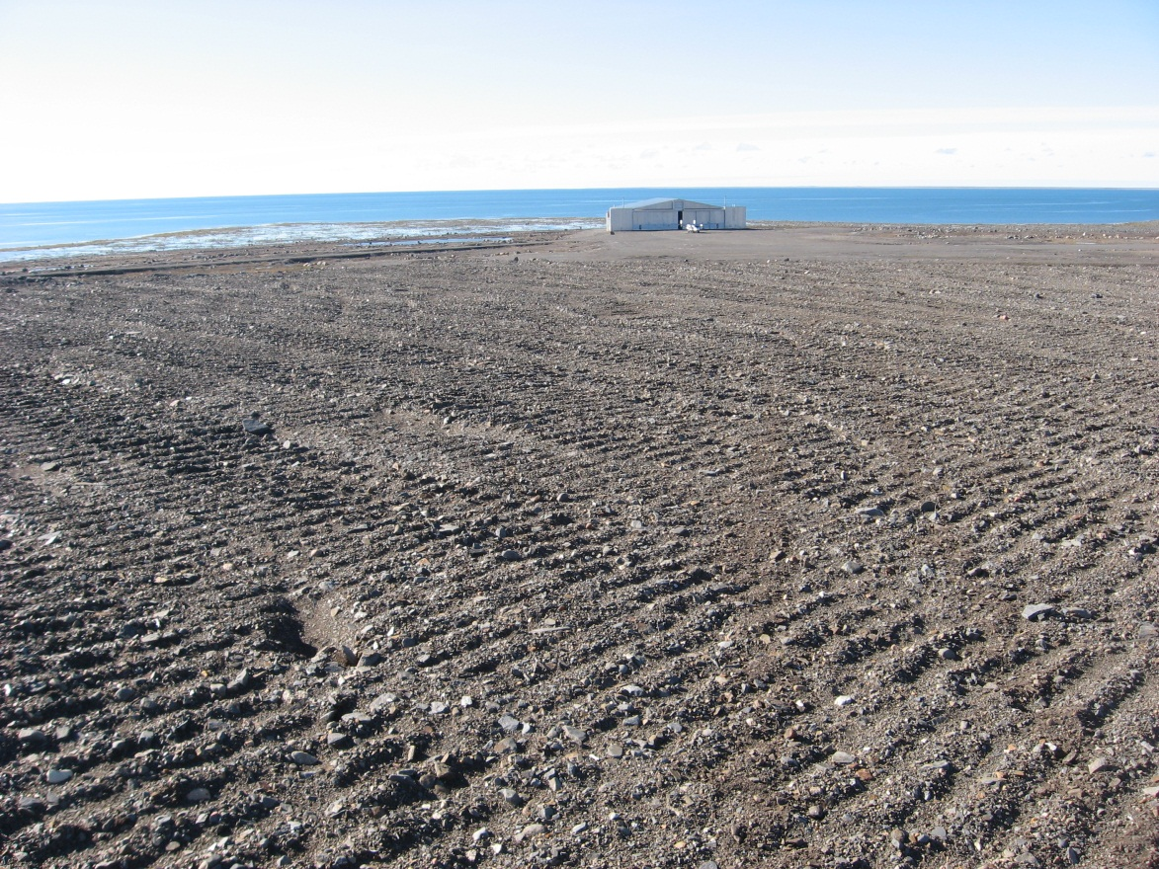
Photograph 35. Looking SW (WP 143, FOX-2 109).
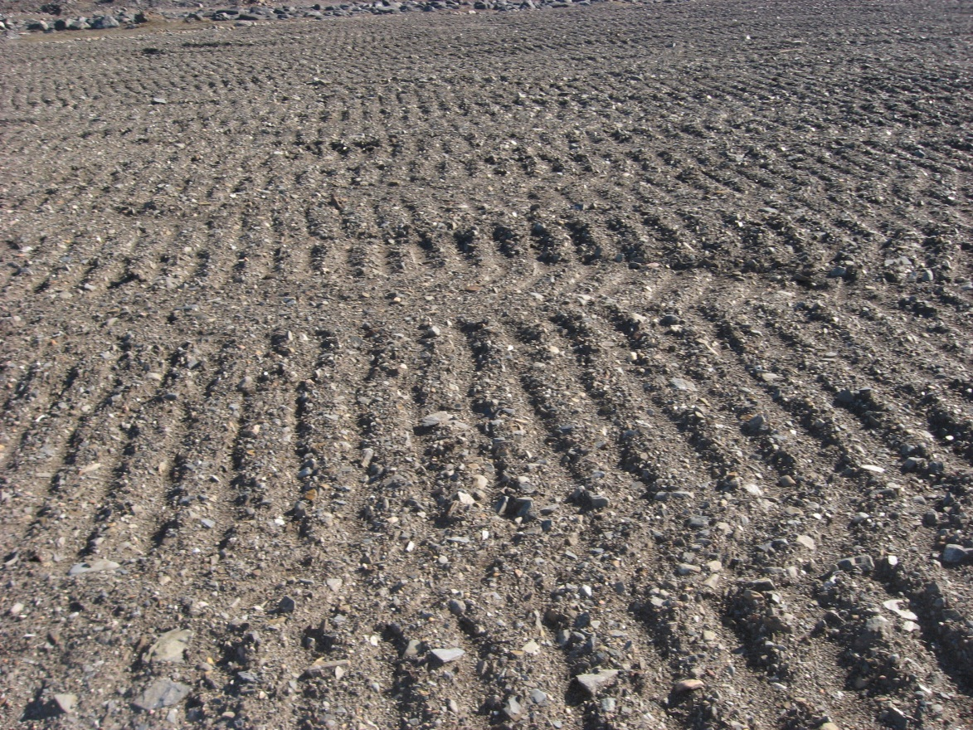
Photograph 36. Looking SE (WP 143, FOX-2 110).
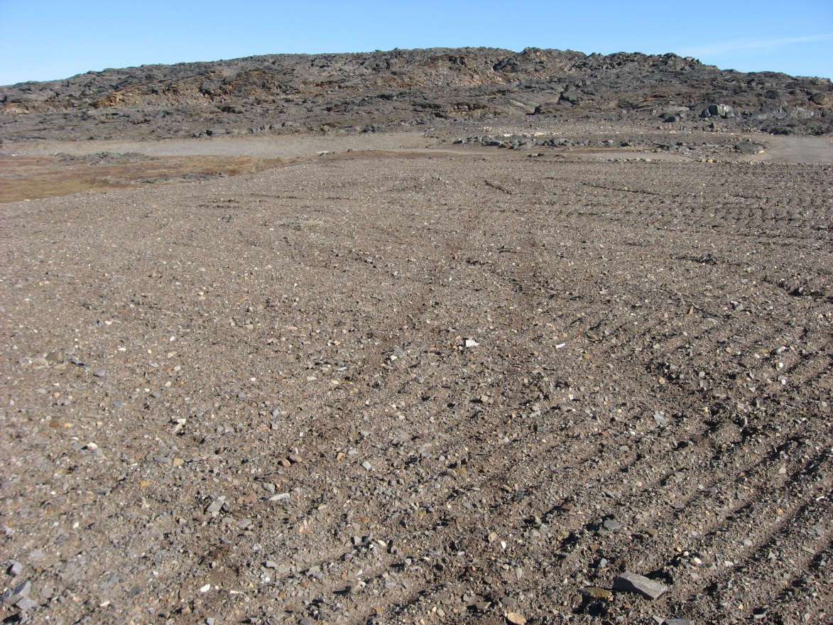
Photograph 37. Looking NE (WP 143, FOX-2 111).
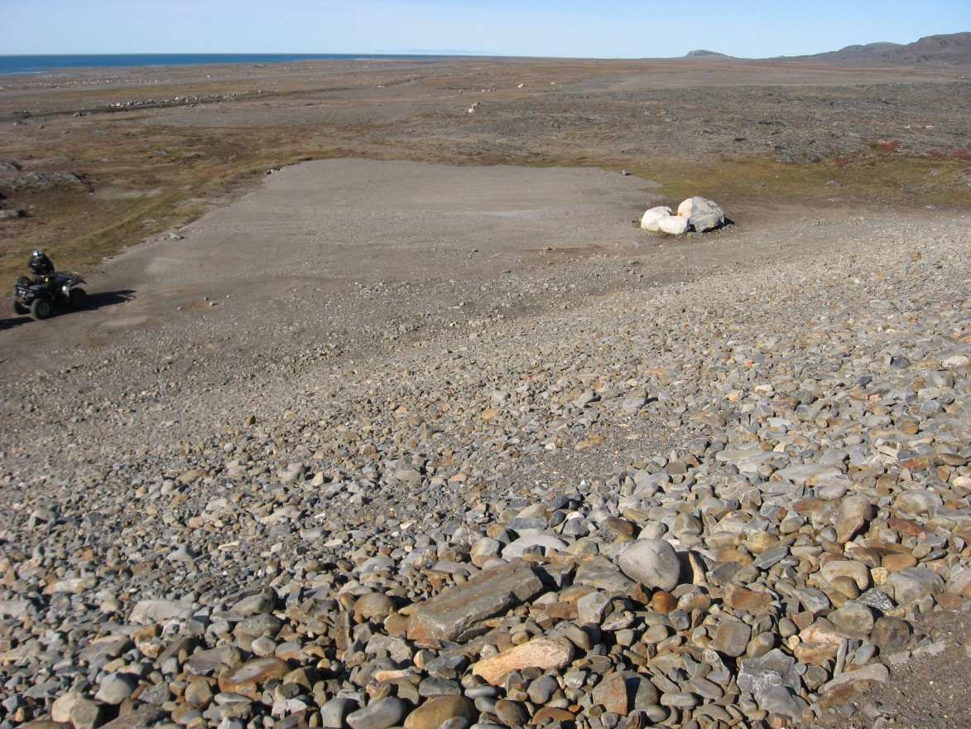
Photograph 38. Looking NW (WP 144, FOX-2 112).
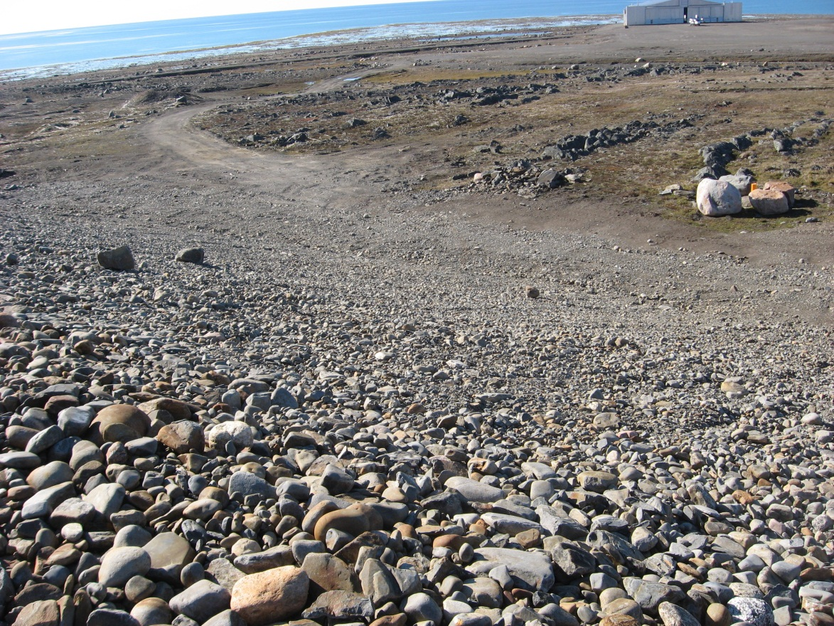
Photograph 39. Looking SW (WP 144, FOX-2 113).

