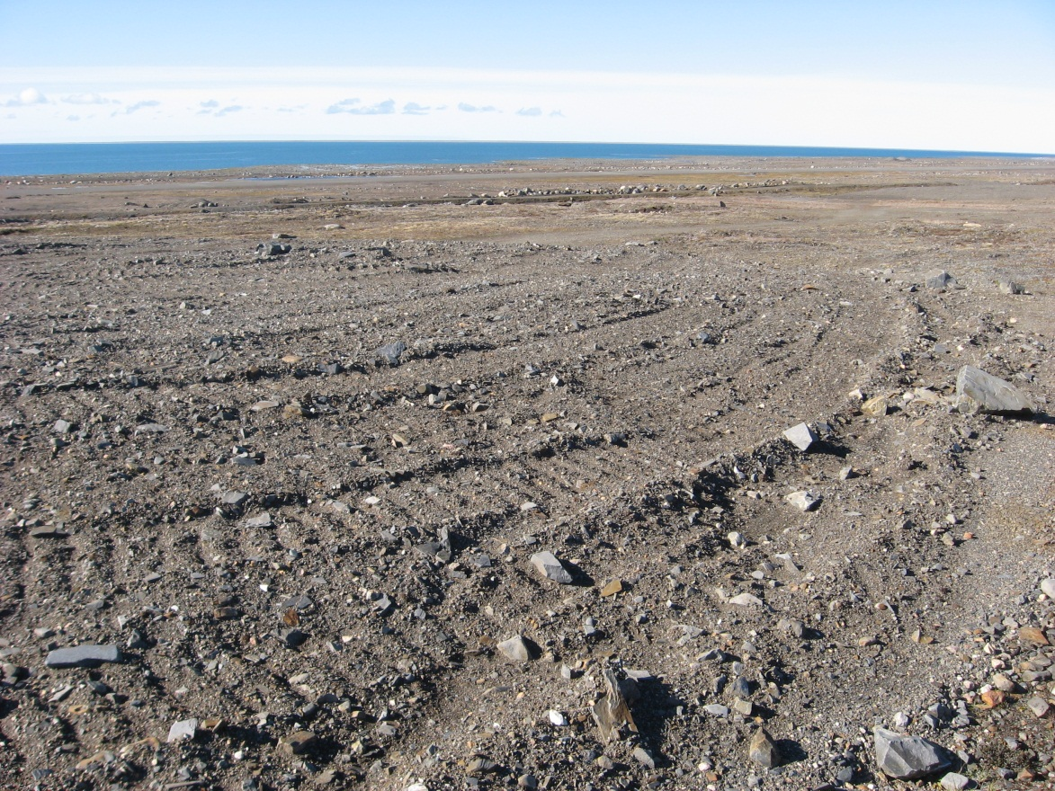
Photograph 114. Airstrip Camp Debris Area Lobe E – Looking W (Way Point 145, Photo FOX-2 114).
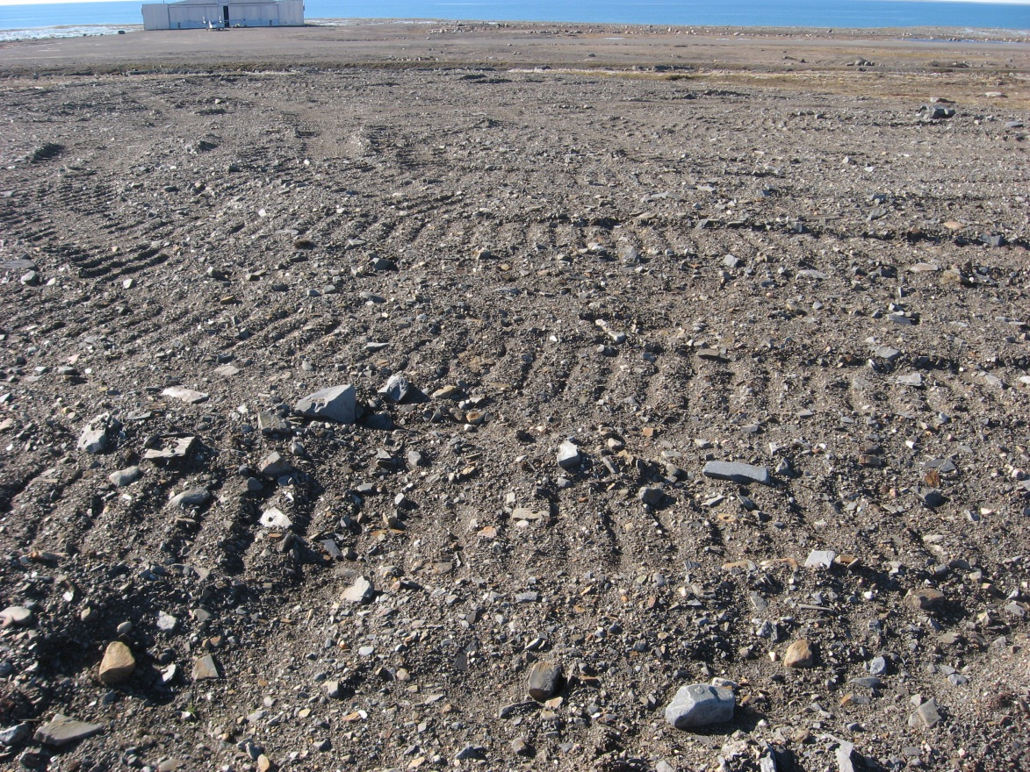
Photograph 115. Looking SW (WP 145, FOX-2 115).
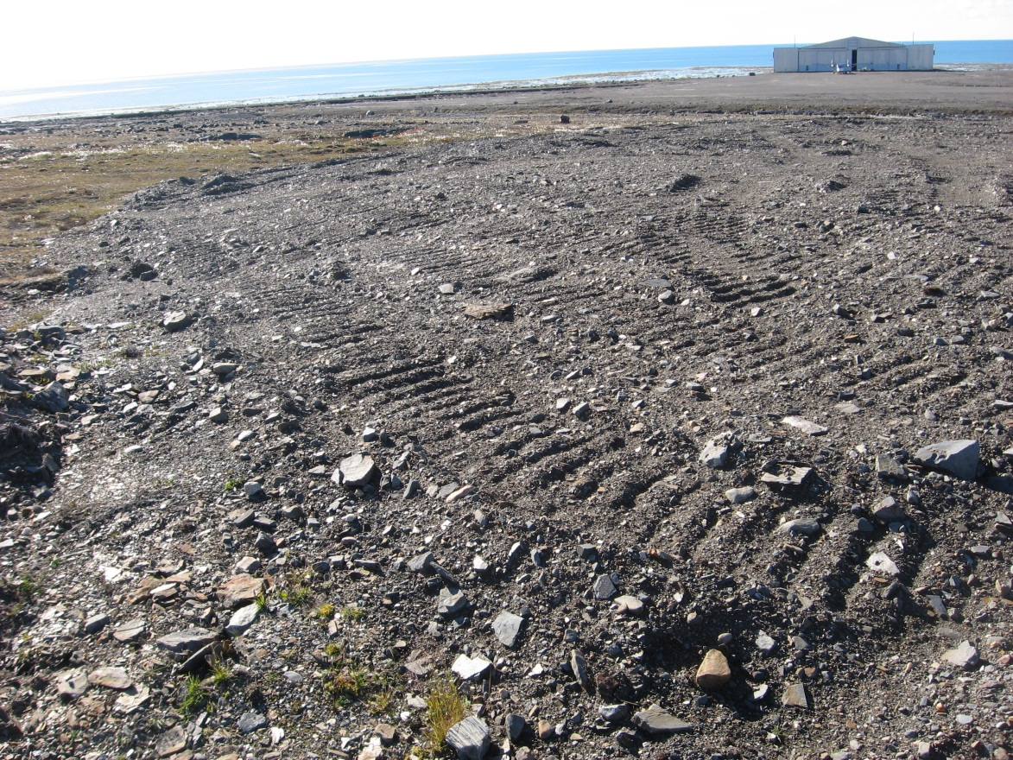
Photograph 116. Looking S (WP 145, FOX-2 116).
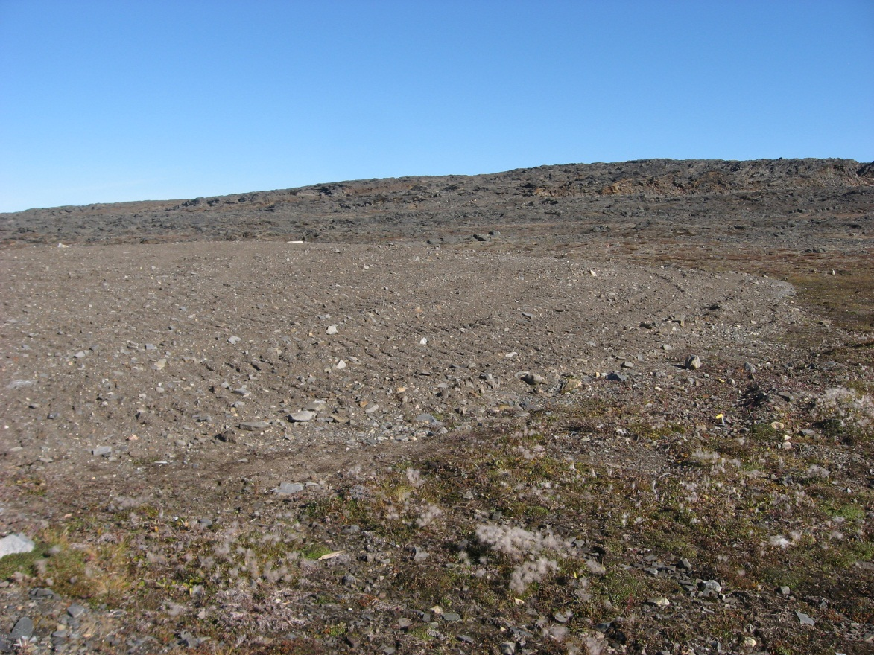

Photograph 117. Looking NE (WP 146, FOX-2 117).
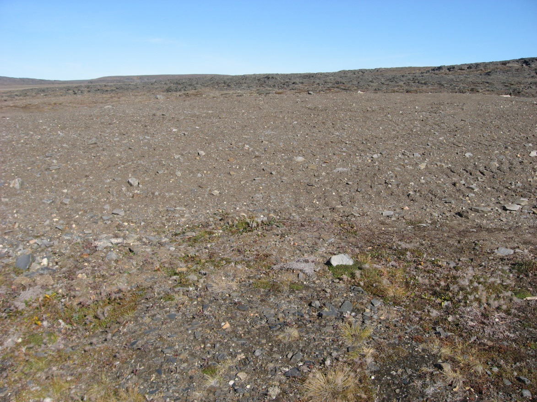
Photograph 118. Looking N (WP 146, FOX-2 118).
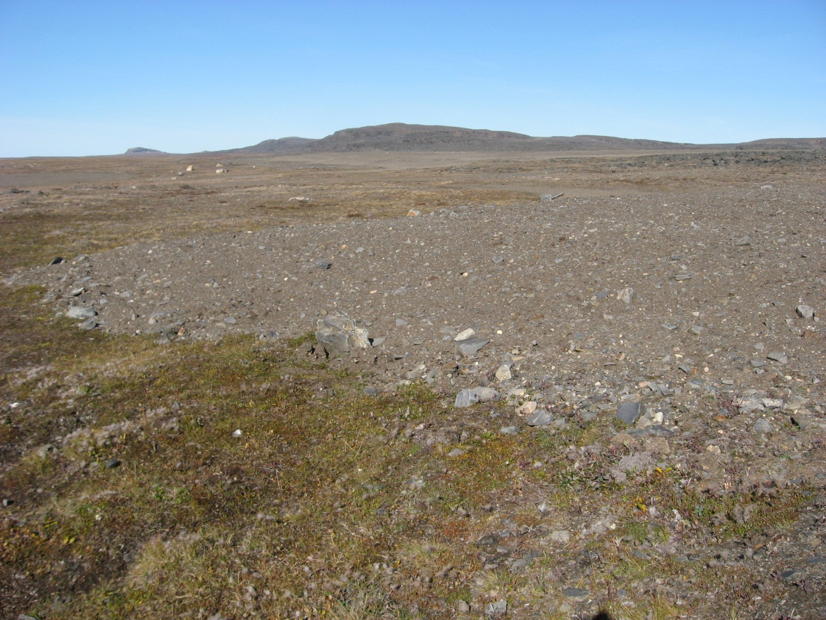
Photograph 119. Looking NW (WP 146, FOX-2 119).
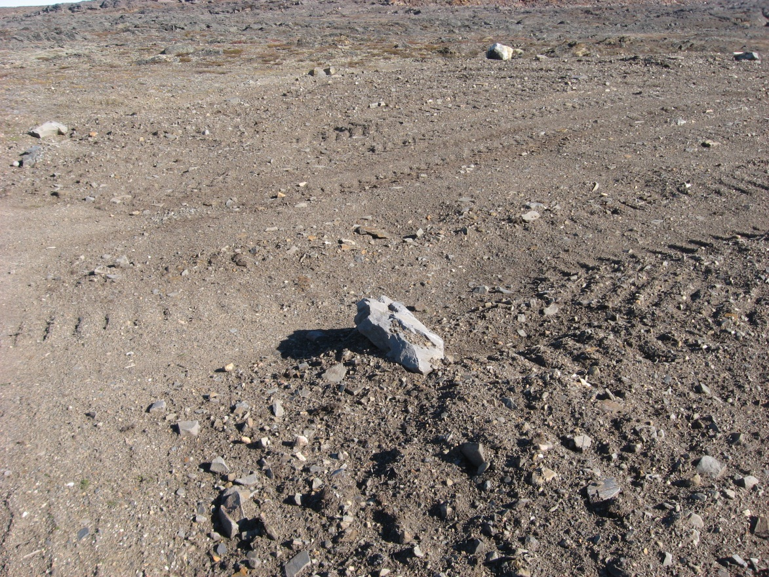
Photograph 120. Looking NE (WP 147, FOX-2 120).
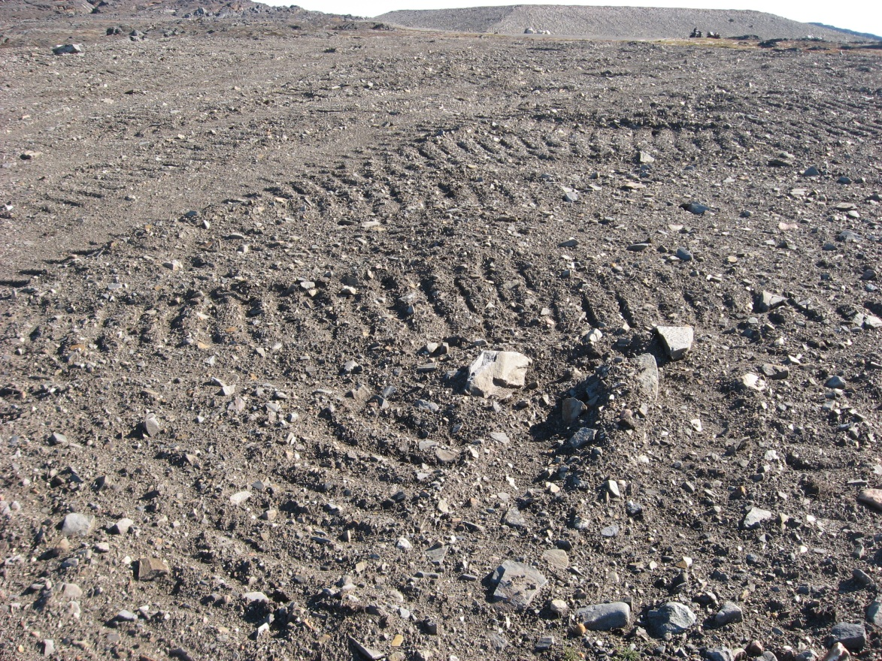
Photograph 121. Looking E (WP 147, FOX-2 121).
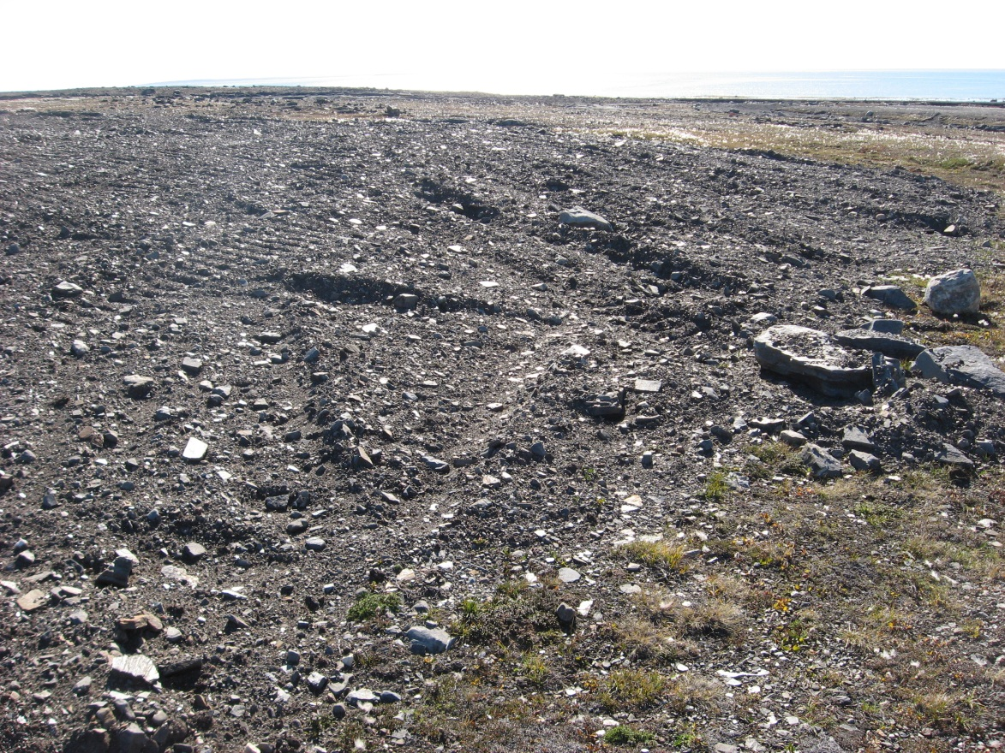
Photograph 122. Looking SE (WP 147, FOX-2 122).

