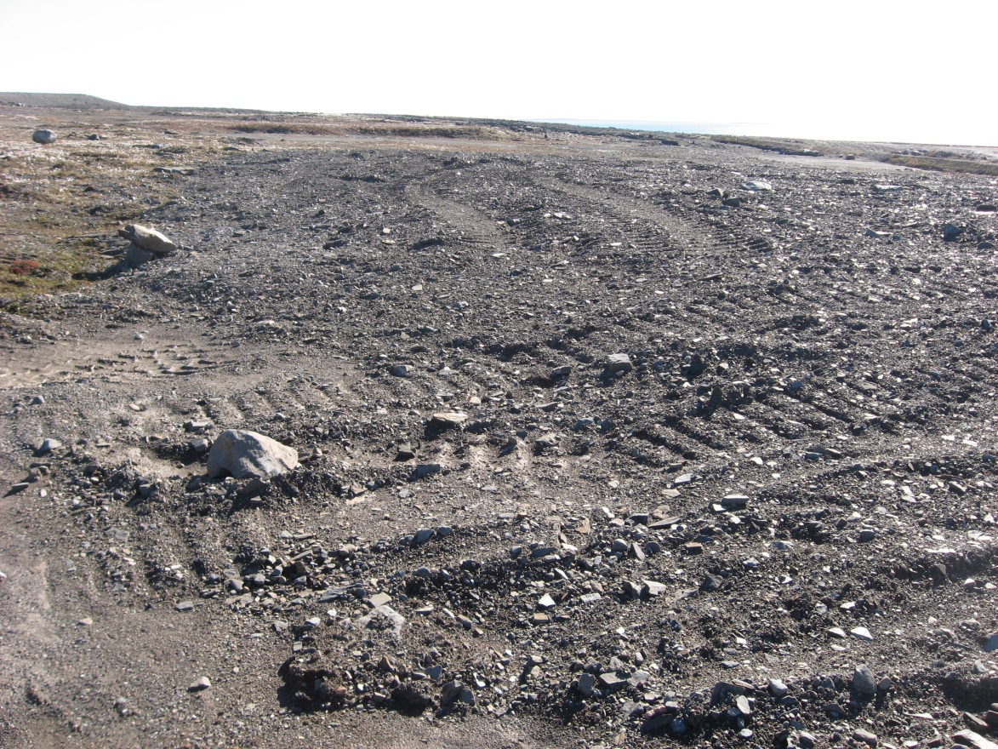
Photograph 1. Airstrip Camp Landfill Lobe A – Looking SE (Way Point 148, Photo FOX-2 123).
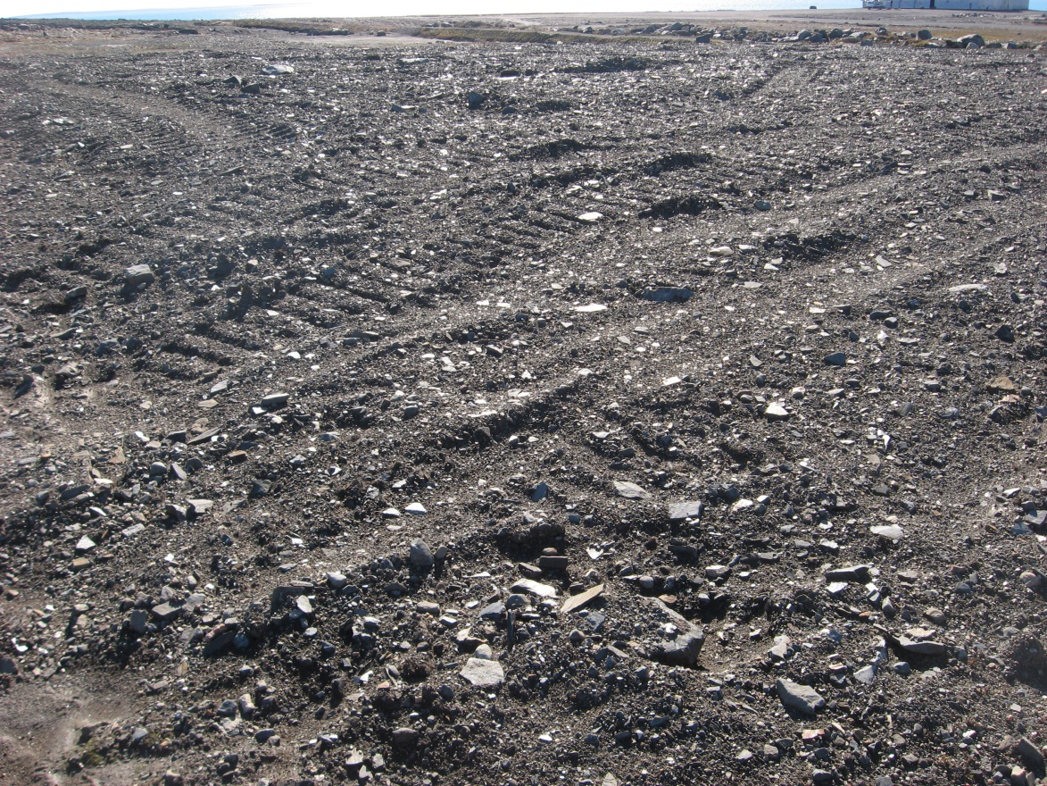
Photograph 2. Looking S (WP 148, FOX-2 124).
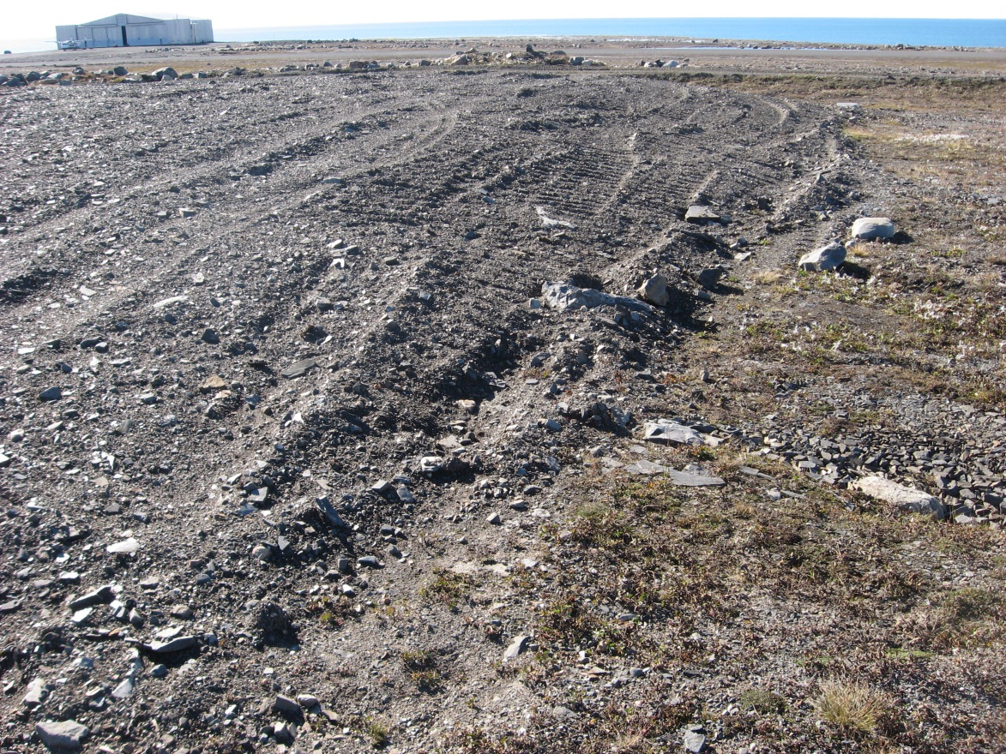
Photograph 3. Looking SW (WP 148, FOX-2 125).
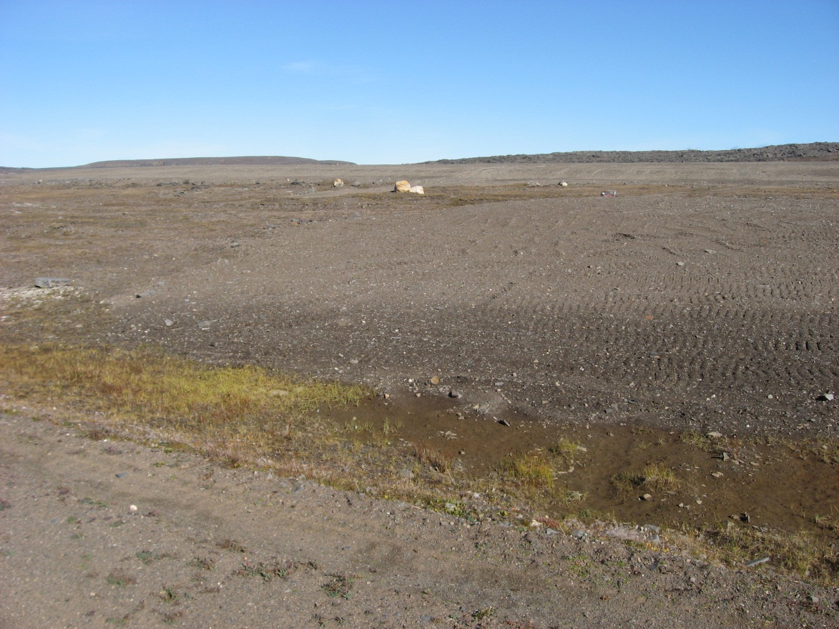

Photograph 4. Looking NE (WP 149, FOX-2 126).
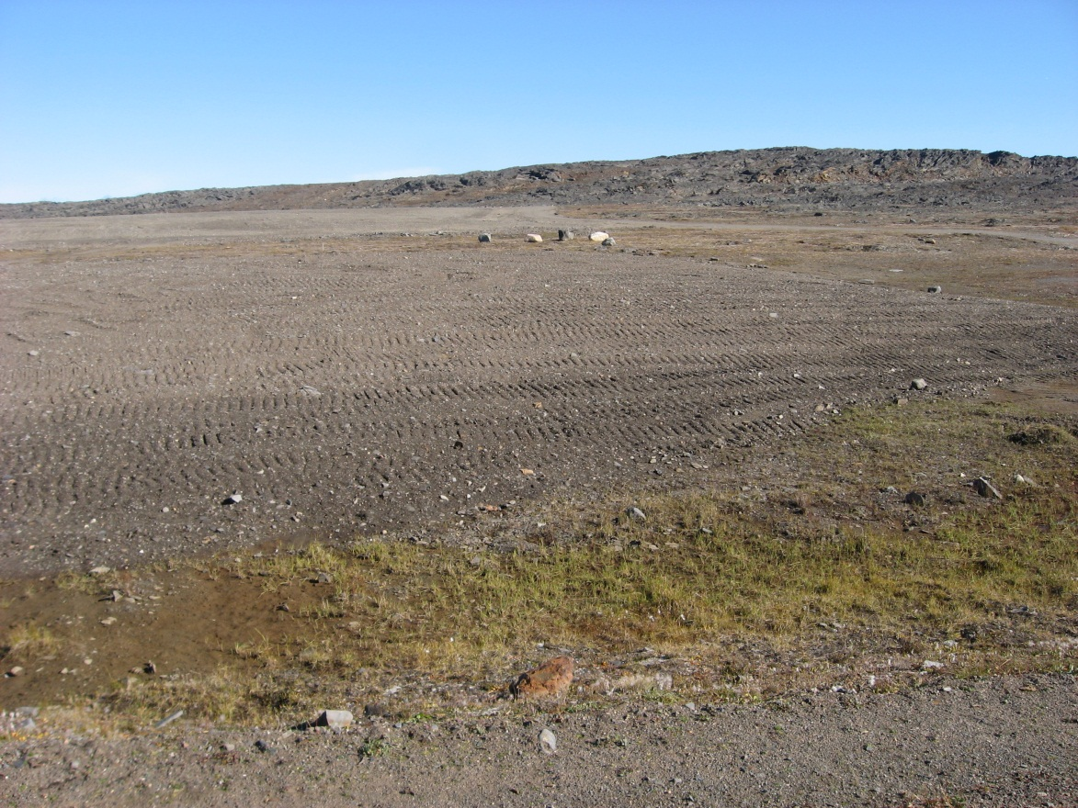
Photograph 5. Looking E (WP 149, FOX-2 127).
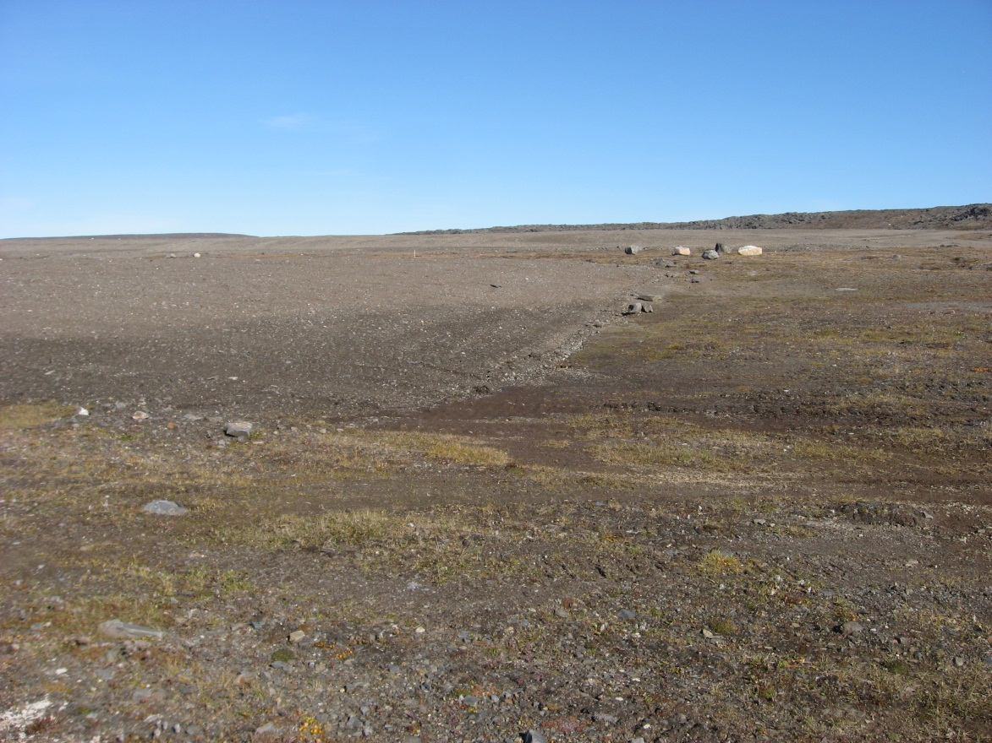
Photograph 6. Looking NE (WP 150, FOX-2 128).
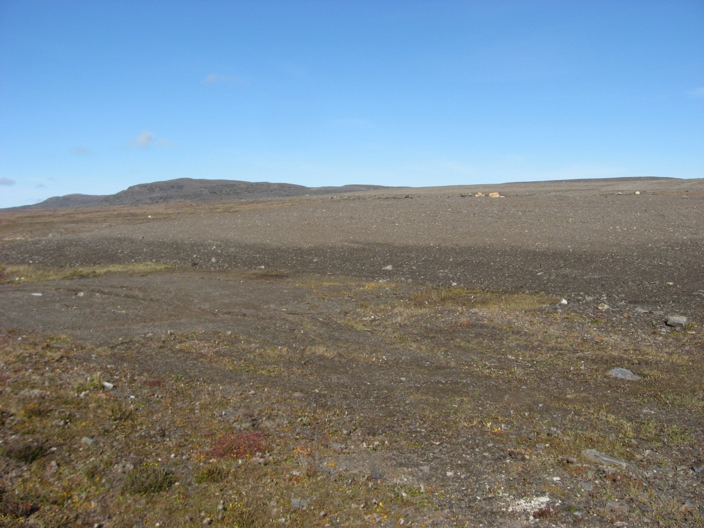
Photograph 7. Looking NW (WP 150, FOX-2 129).
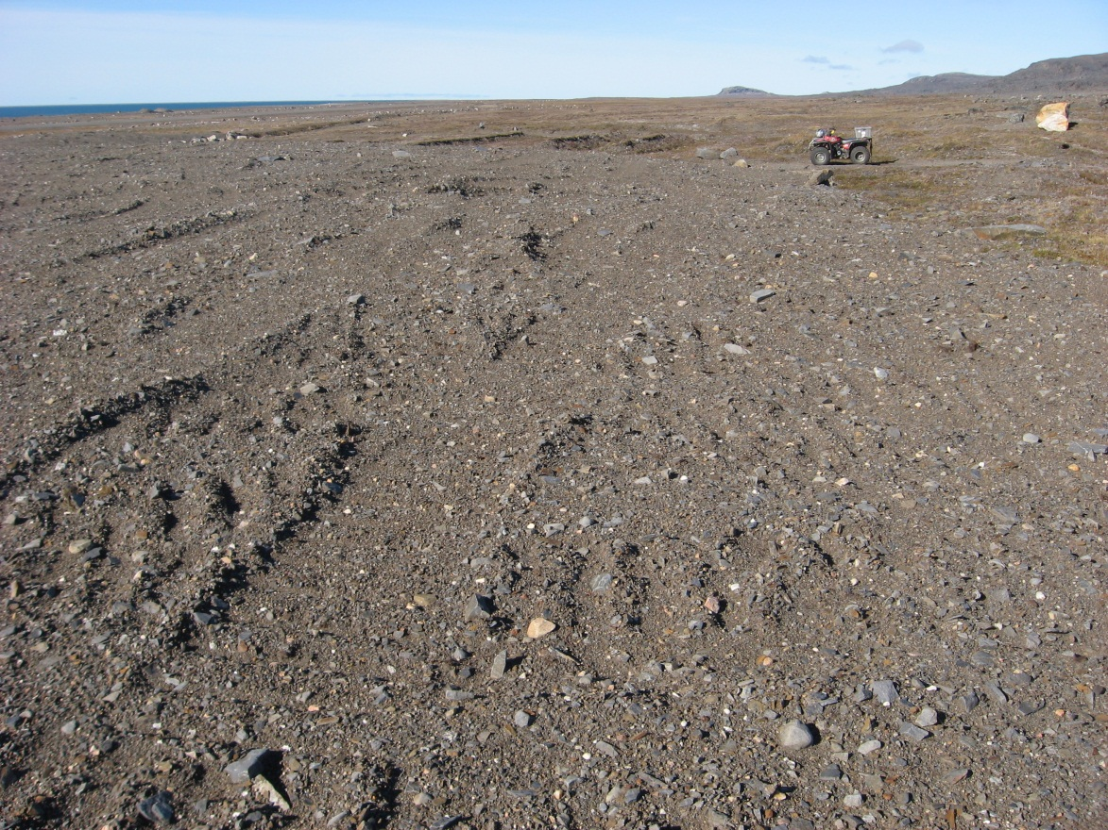
Photograph 8. Looking NW (WP 151, FOX-2 130).
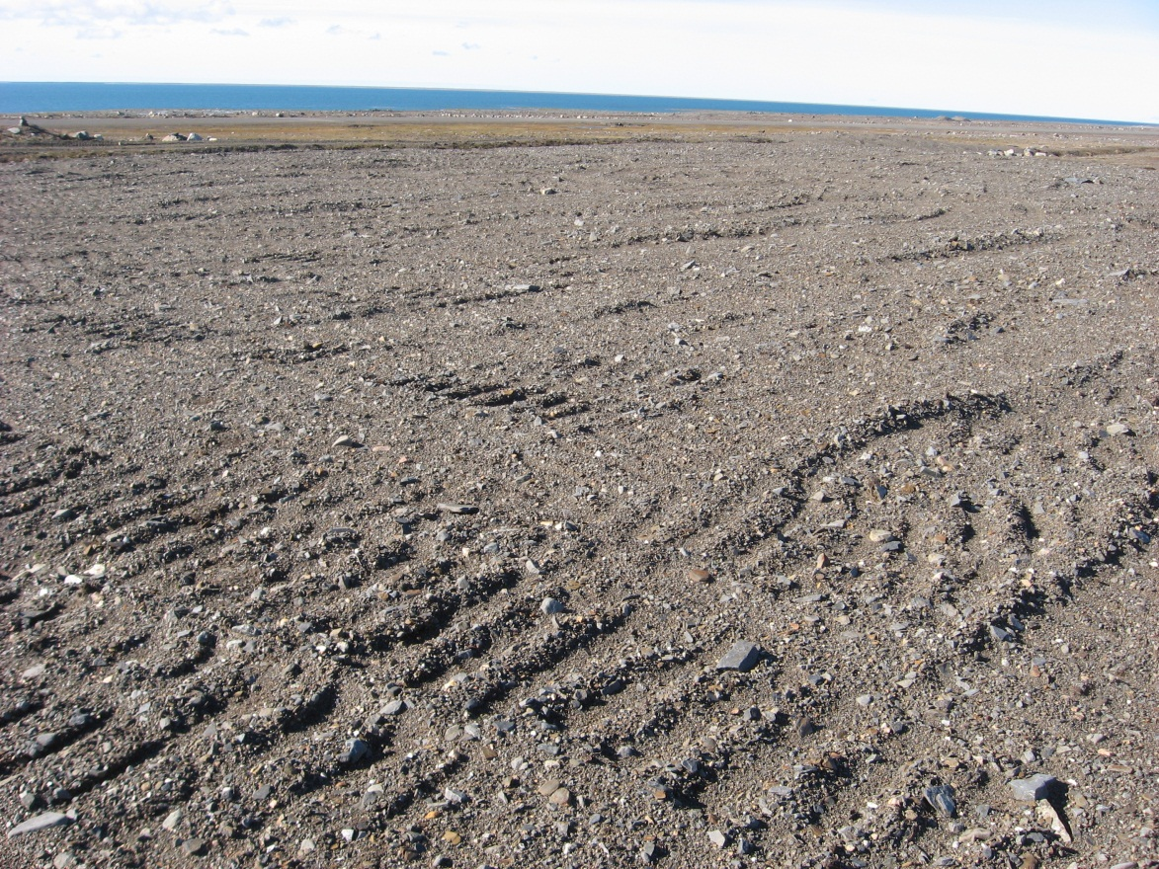
Photograph 9. Looking W (WP 151, FOX-2 131).
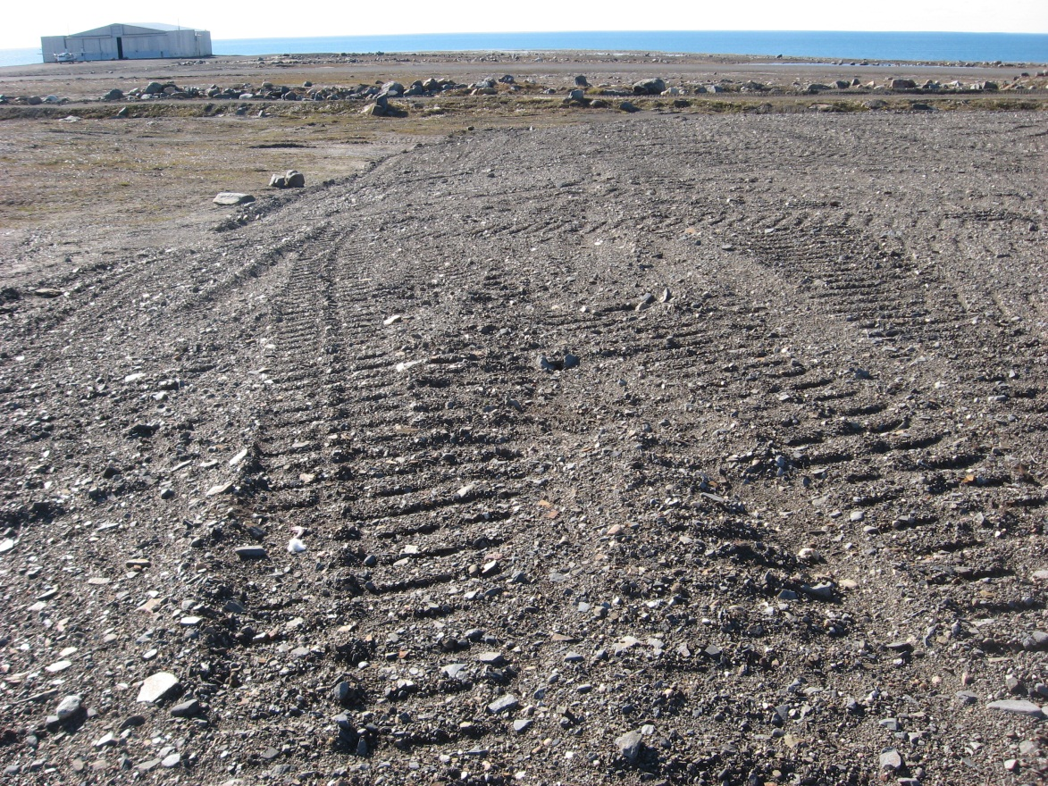
Photograph 10. Looking SW (WP 151, FOX-2 132).
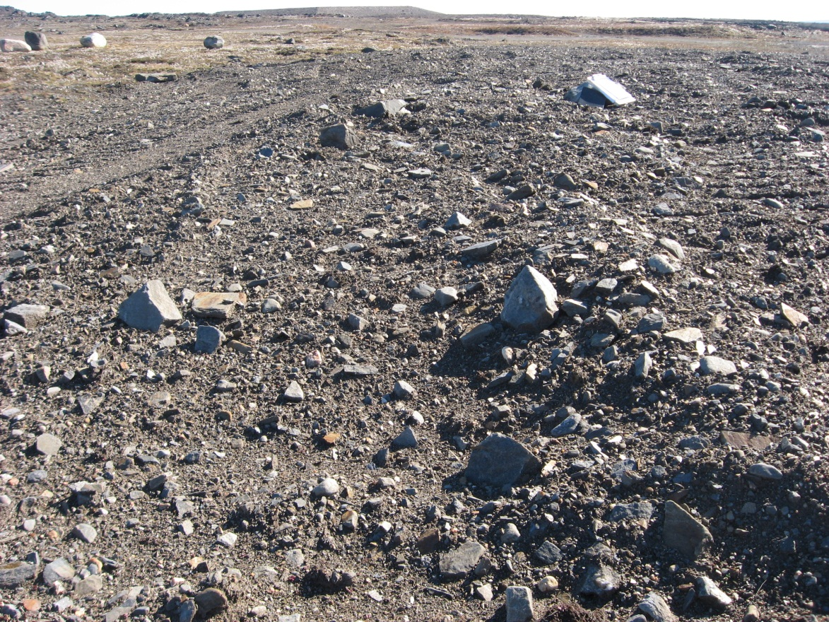
Photograph 11. Rough Finish Grading/Minor Settlement – Looking SE (WP 152, FOX-2 133).
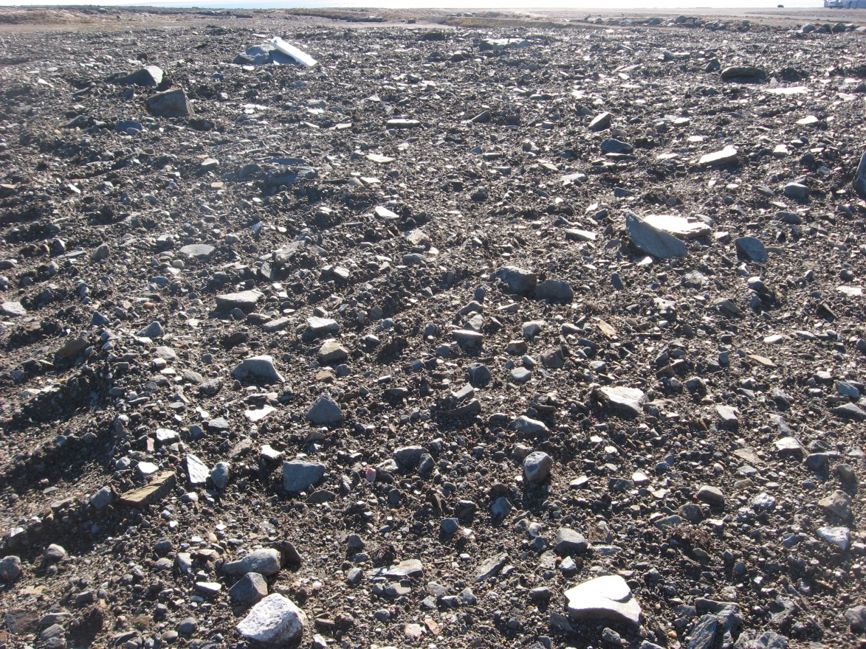
Photograph 12. Rough Finish Grading/Minor Settlement – Looking S (WP 153, FOX-2 134).
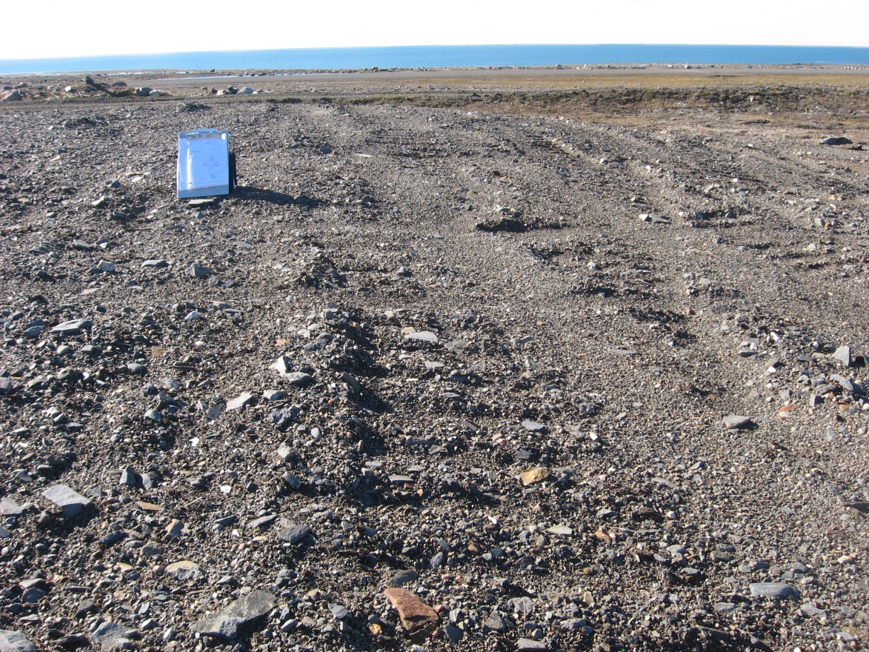
Photograph 13. Rough Finish Grading/Minor Settlement – Looking SW (WP 154, FOX-2 135).
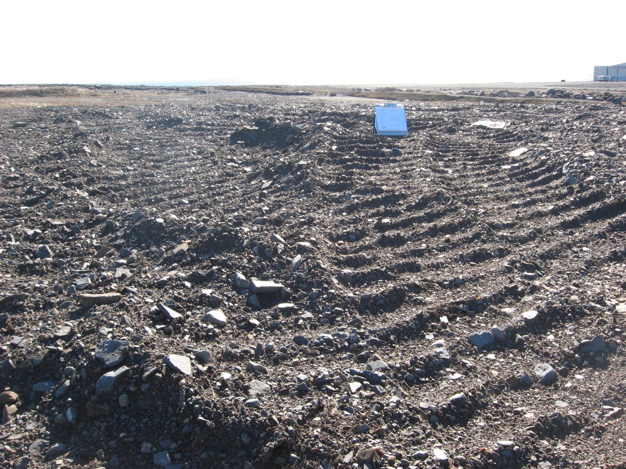
Photograph 14. Rough Finish Grading/Minor Settlement – Looking SW (WP 155, FOX-2 136).

