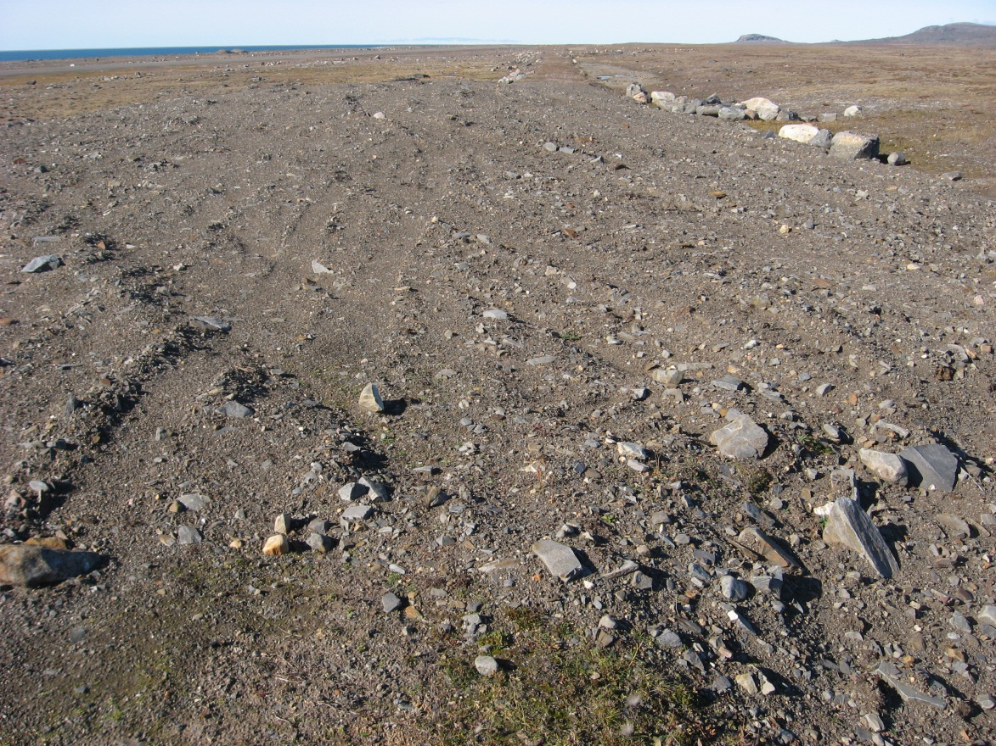
Photograph 137. Airstrip Camp Debris Area Lobe A – Looking NW (Way Point 156, Photo FOX-2 137).
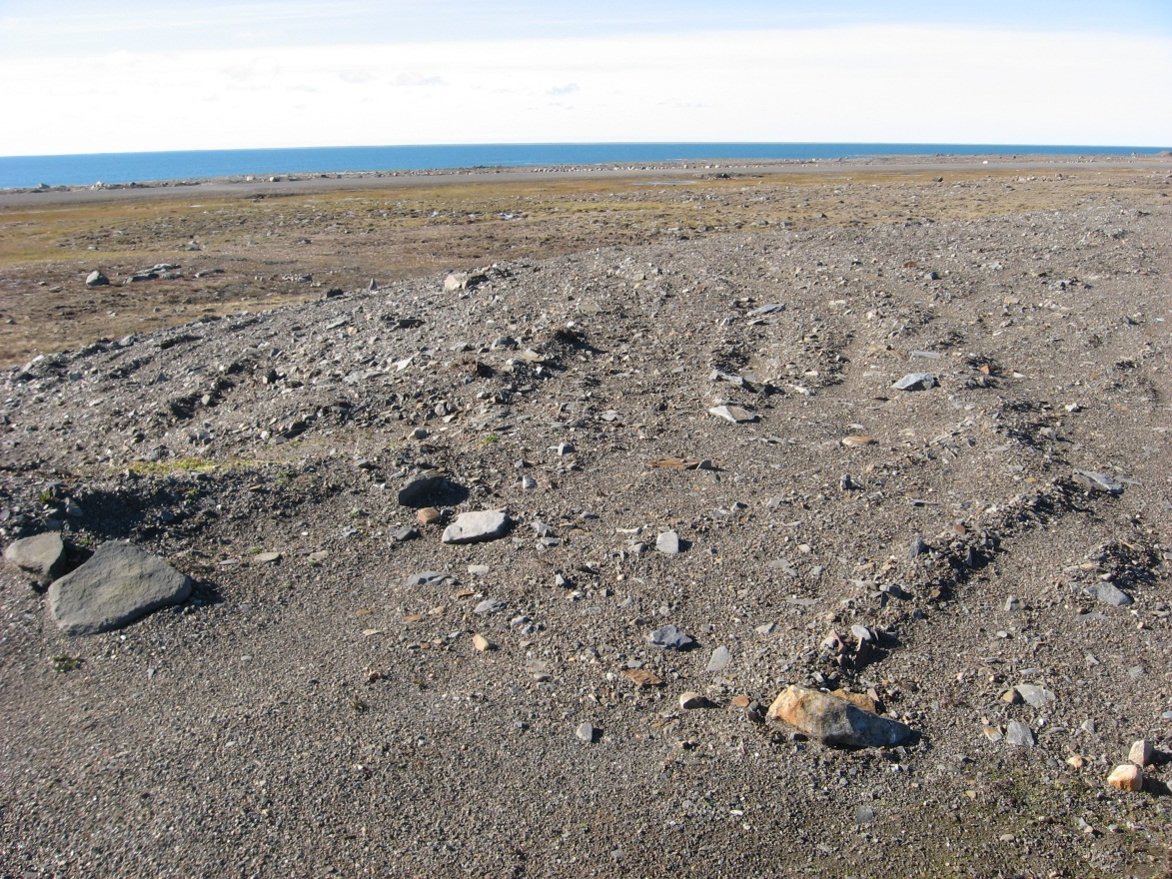
Photograph 138. Looking W (WP 156, FOX-2 138).
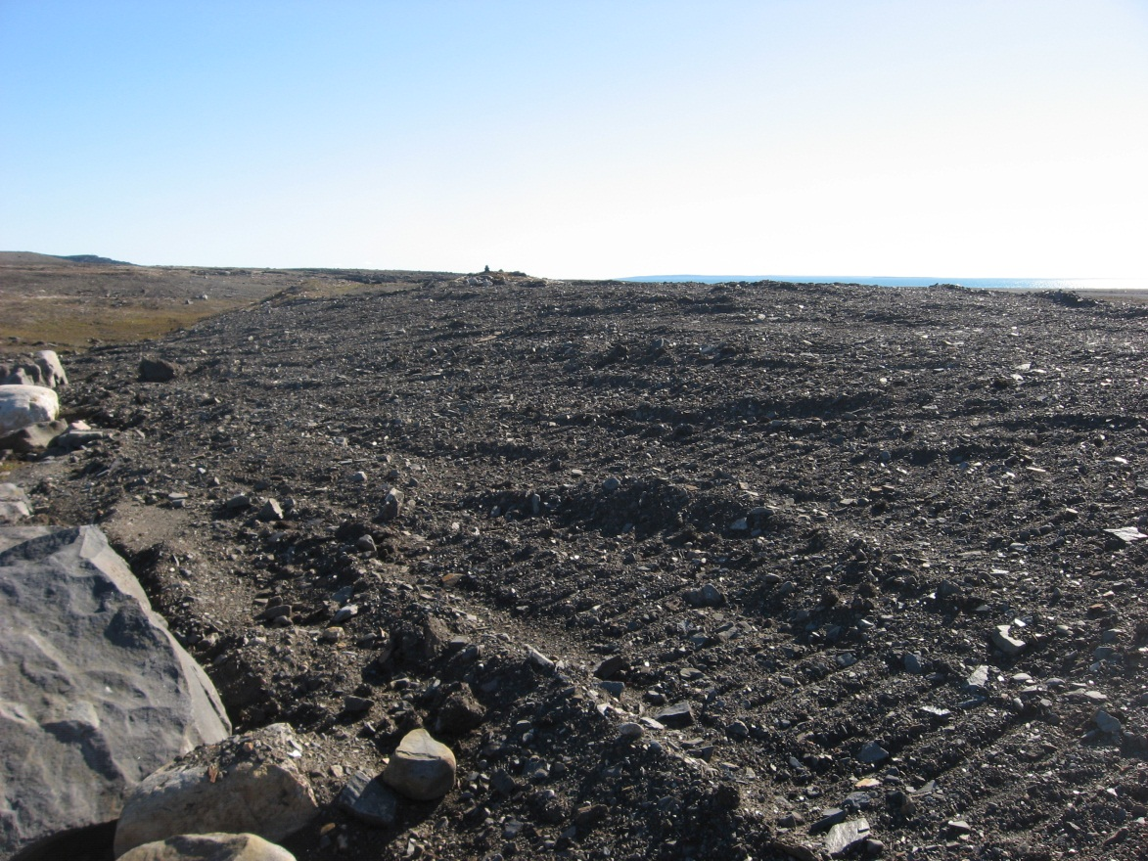
Photograph 139. Rough Finish Grading – Looking SE (WP 157, FOX-2 139).
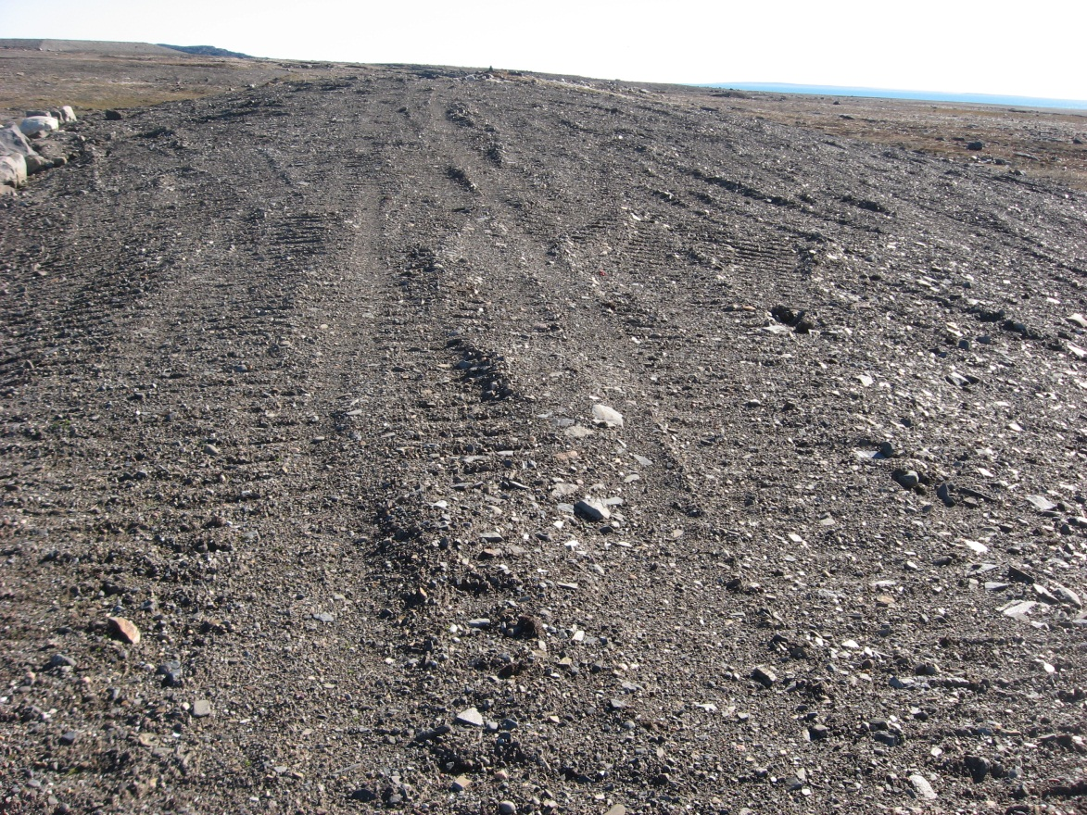

Photograph 140. Looking SE (WP 158, FOX-2 140).
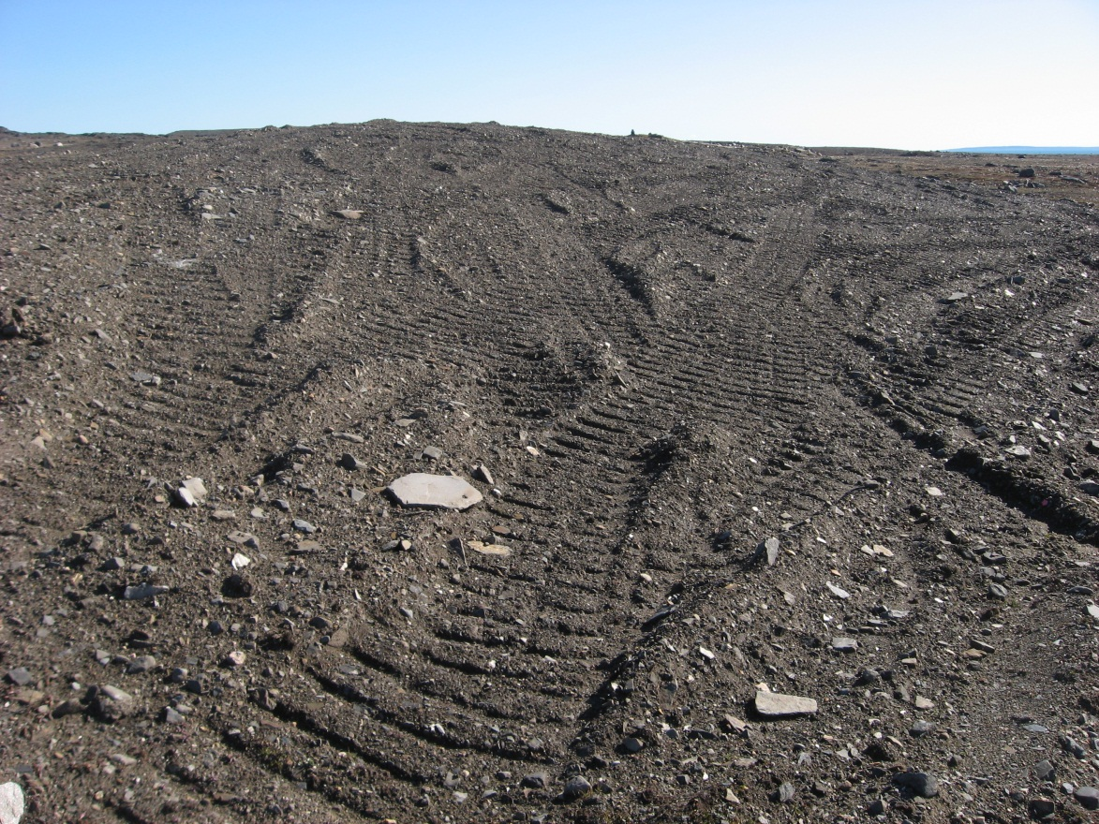
Photograph 141. Rough Finish Grading – Looking SE (WP 159, FOX-2 141).

