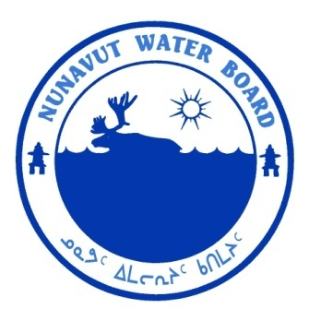  P.O. Box 119 | kNK5 wmoEp5 vtmp5
Gjoa Haven, NU X0B 1J0 | NUNAVUT WATER BOARD
Tel: (867) 360-6338 | NUNAVUT IMALIRIYIN KATIMAYIT
Fax: (867) 360-6369 | OFFICE DES EAUX DU NUNAVUT

File: 1BR-LTU1013/TR/B2, J10
June 25, 2012

Michael Molinski, Environment Officer
Environmental Affairs Transport Canada
P.O. Box 8550
3 Floor – 344 Edmonton St.
Winnipeg, MB R3C 0P6

Email: Michael.molinski@tc.gc.ca

Subject: Licence No. 1BR-LTU1013 “Iqaluit Airport Project”, Qikiqtani Region, Nunavut; Submission of 2011 Annual Report and updated QA/QC Plan.

Dear Mr. Molinski:

The Nunavut Water Board (“NWB”) has received, on March 12, 2012, the 2011 Annual Report for the above-mentioned project. The following documents were included with the annual report:
- Accredited Lab Letter Approving QA/QC Plan;
- Lab Scope of Accreditation Document;
- Updated QA/QC Plan; and
- Biogenie Final Report of Land Treatment Maintenance Activities, February 2012.

The submissions were distributed for information. The Annual Report and updated QA/QC Plan were found to be complete and meeting the requirements of Part B, Item 2 and Part J, Item 10, respectively. In addition, the NWB appreciates the inclusion of Biogenie’s report of maintenance activities to help aid in the understanding of the activities that have taken place.

Should you have any questions, please feel free to contact the undersigned at (867) 360-6338 Ext. 30, or k.kharatyan@nunavutwaterboard.org, at your earliest convenience.

Yours truly,

Original signed by:

Karén Kharatyan
Technical Advisor

cc: Distribution List – Qikiqtani

