DUVAL RIVER CROSSIMG
MUNICIPALITY OF PANGNIRTUNG

ABANDONMENT AND RESTORATION PLAN

REVISED

MARCH 2021

Table of Contents
1.0 INFORMATION OF THE LICENSEE 3
2.0 INFORMATION OF 24 HOUR CONTACT 3
3.0 EFFECTIVE DATES AND REVISIONS 3
4.0 COMMUNITY INFORMATION 3
5.0 GENERAL DESCRIPTION OF PROPERTY 4
6.0 DUVAL RIVER CROSSING DECOMMISSIONING 4
7.0 MONITORING MEASURES 4
8.0 SCHEDULE AND IMPLEMENTATION PLAN 4
9.0 BIBLIOGRAPHY 5
APPENDIX A: SITE LOCATION 6
APPENDIX B: PRE-DISTURBED SITE CONDITIONS – 2009 8
APPENDIX C: CURRENT SITE CONDITIONS - 2012 11
APPENDIX D: CURRENT AS-BUILT 14

- INFORMATION OF THE LICENSEE

The currentLicence # 1BW-DUV 2025.
This Licence was originally issued to DFO as the condition of building the Small Craft Harbour Later on, after construction of the Harbour, this licence was transferred to the Hamlet because they wanted to retain the culverts and keep using them.
The Licensee Is:

Municipality of Pangnirtung
Represented by: Chief Administrative officer
P.O. Box 253 , Nunavut
Ph: 867 473 8953
E -mai: pang_sao @qiniq.com

2.0 INFORMATION OF 24 HOUR CONTACT

Technical Representative
Bhabesh Roy, M.A.Sc., P.Eng.
Municipal Planning Engineer
Community Government Services
Government of Nunavut
Baffin Region, Pond Inlet
Ph. 867 899 7314
E mail: broy@gov.nu.ca

- EFFECTIVE DATES AND REVISIONS

Abandonment and Restoration Plan Effective Date:

    - January 17, 2013 by DFO

Abandonment and Restoration Plan Revisions Date:

- Revised March 2021 By the Hamlet of Pangnirtung

4.0 COMMUNITY INFORMATION

Pangnirtung is located on the Eastern side of Baffin Island, sitting on the southeast shore of the Pangnirtung Fiord not far from where the fiord merges with Cumberland Sound. Pangnirtung’s coordinates are 66º 09’ N and 65º 43’ W. In relation to other communities, Pangnirtung approximately 300 km northeast of Iqaluit, Nunavut.

The community is located on a gently sloping beach at the bottom of a classic glaciated U-shaped valley known as the Pangnirtung Fiord. The Duval River flows through the northern portion of the community. The headwaters of the river are high above the settlement in the glaciated highlands between Pangnirtung Fiord and Kingnait Fiord. The bedrock found in this area is largely metamorphic, biotite-quartz-feldspar gneiss. Bedrock outcrops are common along the upper slopes of the fiord and in several places along the Duval River channel. The town site is situated on glacial till consisting primarily of silty sand which contains numerous boulders (Government of Nunavut, March 2007)

Pangnirtung receives an average of 16.2 cm of rainfall and 180.3 cm of snowfall per year. July mean high and low temperatures are 11.1ºC and 3.9ºC. January mean high and low temperatures are -25.5ºC and -37.8ºC (Government of Nunavut, March 2007).

The Duval River Crossing is located near the existing bridge crossing the Duval River. Fisheries and Oceans Canada in consultation with the Hamlet of Pangnirtung selected the site. Current photos of the river crossing can be found in Appendix C and an as-built drawing of the river crossing can be found in Appendix D.

5.0 GENERAL DESCRIPTION OF PROPERTY
The site for the Duval River Crossing is located in the area of: Latitude: 66° 9' 2.61"N
Longitude: 65° 41' 28.54"W See Appendix A for a site map.
  - DUVAL RIVER CROSSING DECOMMISSIONING

This River crossing was built in 2012 by DFO during the construction of the Small Craft Harbour considering that this structure would be decommissioned soon after the construction was completed. But Once the Harbour project was completed, The municipality of Pangnirtung took over this facility and the License was transferred to them at the same time. Currently the Municipality is using this structure for Heavy traffic movement from one side to other side of the River,

Once the river crossing is determined that it is no longer required, the decommissioning process will begin. The planned procedure for removing the culverts will consist of the following:

    - Removing the fill covering the culverts with land based excavation equipment and disposing of the material off-site
    - Removal of culverts for storage off-site
    - Once all excess material has been removed from the site, the site can be returned to the natural state and all disturbed areas will be graded and restored to a pre-disturbed state.

Photos of the site conditions prior to installation of the river crossing are shown in Appendix B.

  - MONITORING MEASURES

The following monitoring and measures will be implemented during decommissioning:

    - Digital photographic record before, during and after abandonment.
    - Construct water quality sampling at Monitoring Program Stations DUV-1 and DUV-2:
      - At least once prior to decommissioning the crossing
      - Weekly during decommissioning activities
      - At least once following completion of decommissioning activities
    - Analyze water samples for the following parameters:
      - pH
      - Conductivity
      - Temperature
      - Total Suspended Solids
      - Total Oil and Grease
    - All sampling, sample preservation and analyses shall be conducted in accordance with methods prescribed in the current edition of Standard Methods for the Examination of Water and Wastewater.
    - All analyses shall be performed in a laboratory accredited according to ISO/IEC Standard 17025.

8.0 SCHEDULE AND IMPLEMENTATION PLAN

It was anticipated that the river crossing would be decommissioned in early October 2013 after the harbour construction had been completed and prior to the final sealift of the season. But it was not done. The Municipality is using this facility on daily basis and maintain it as required.
Hamlet is not planning to abandon or decommission this facility at any time soon.

9.0 BIBLIOGRAPHY

Government of Nunavut. (March 2007). Final Background report - Pangnirtung Community Plan and Zoning By-Law Update. Cape Dorset, NU: Government of Nunavut.

APPENDIX A: SITE LOCATION

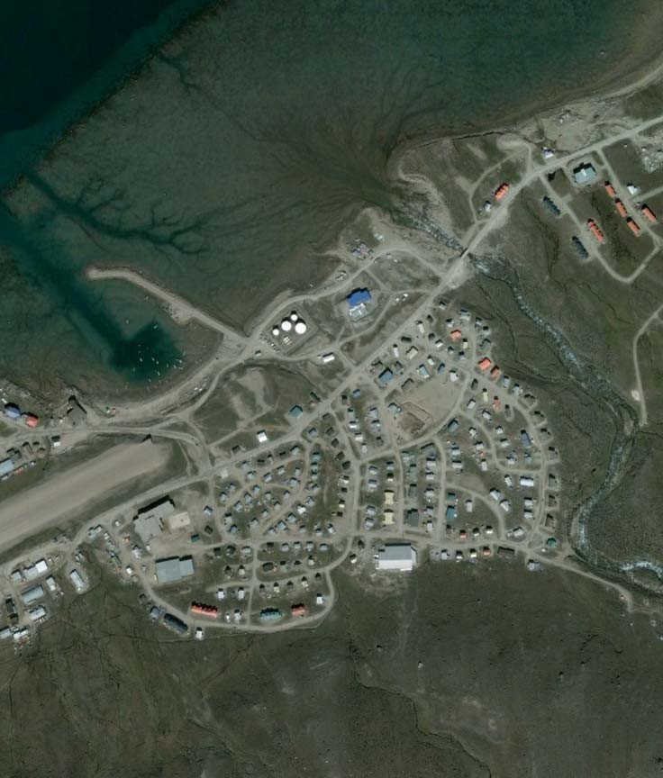
Site Location
66° 9'2.61"N
65°41'28.54"W

APPENDIX B: PRE-DISTURBED SITE CONDITIONS – 2009

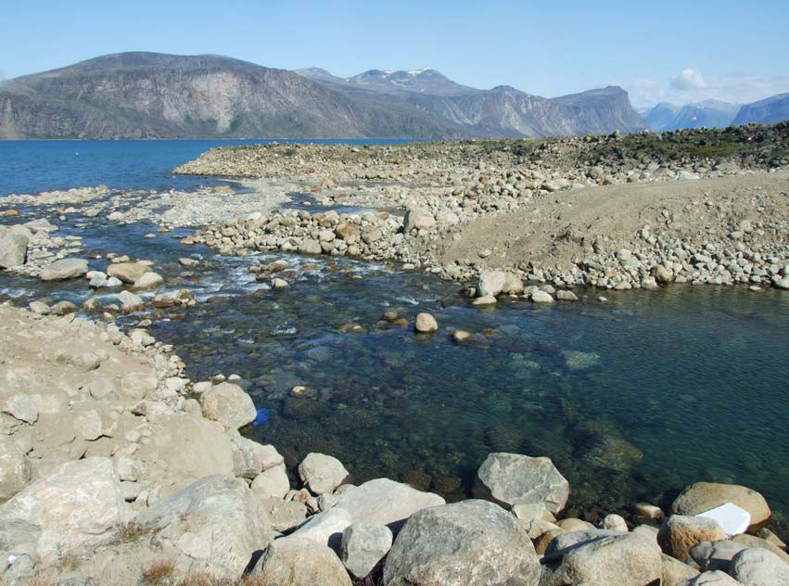

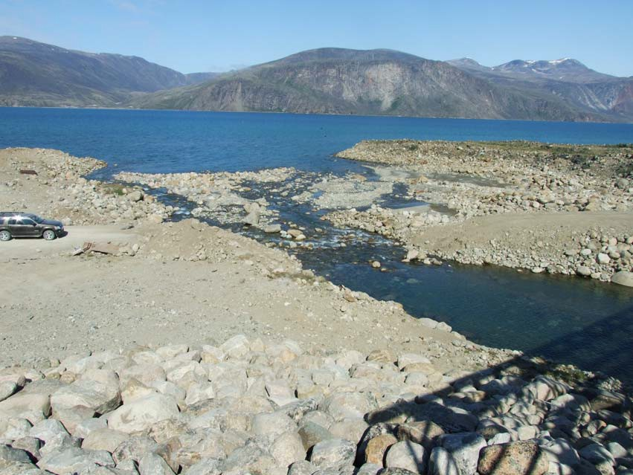

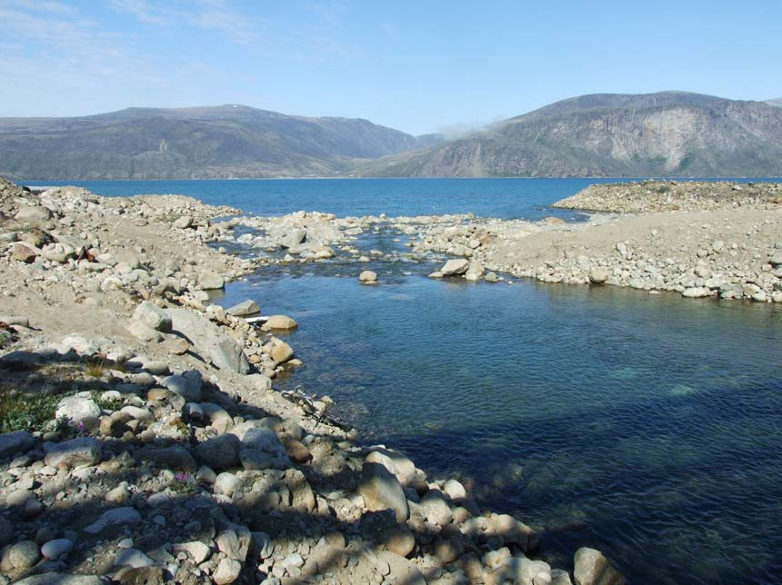

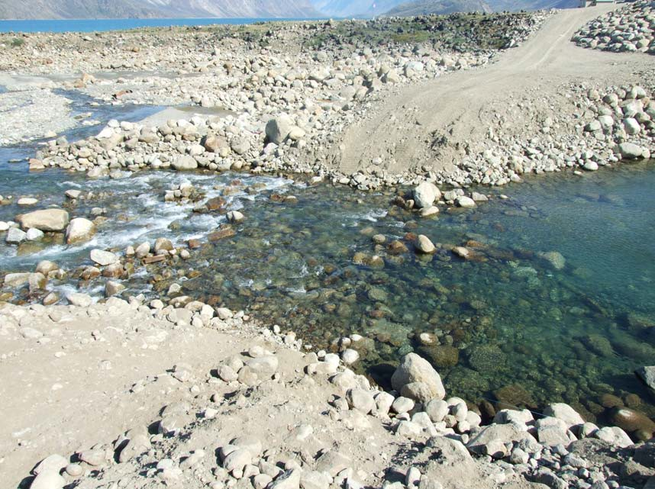

APPENDIX C: SITE CONDITIONS - 2021

Downstream:

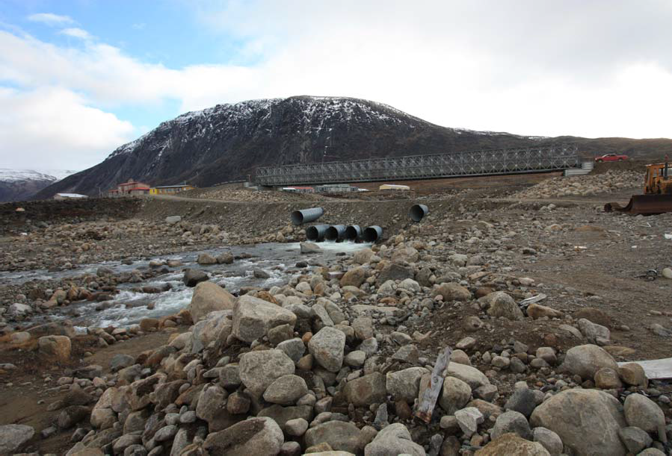

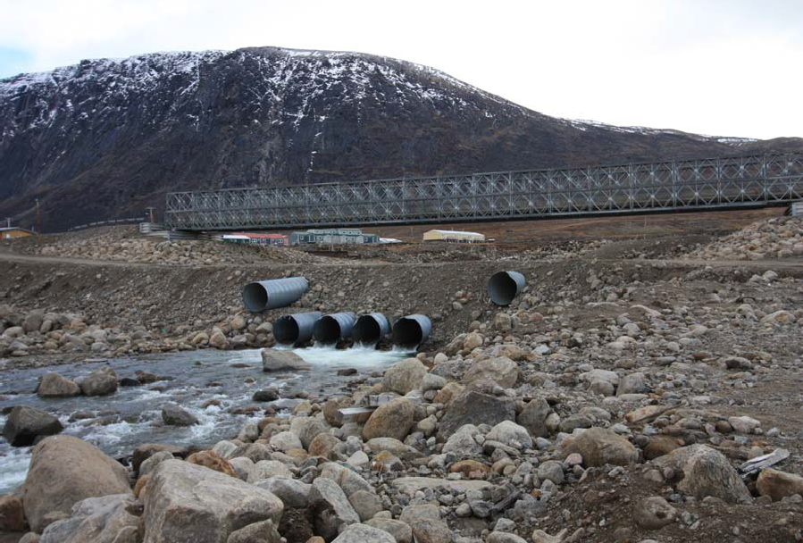

Upstream:

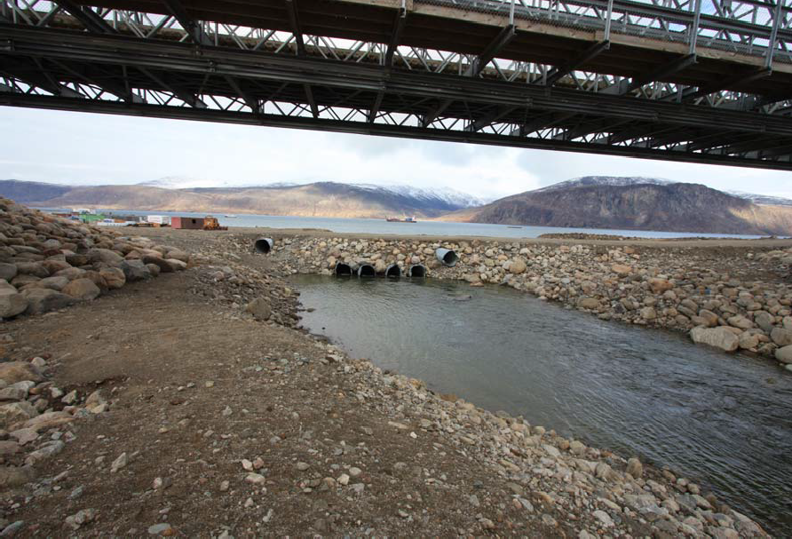

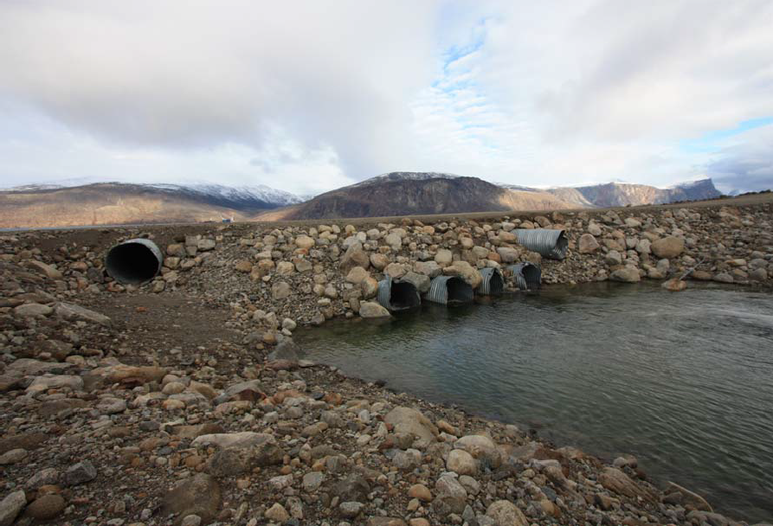

APPENDIX D: CURRENT AS-BUILT

