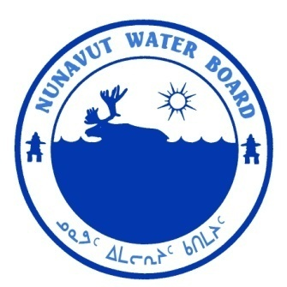  P.O. Box 119 | kNK5 wmoEp5 vtmp5
Gjoa Haven, NU X0B 1J0 | NUNAVUT WATER BOARD
Tel: (867) 360-6338 | NUNAVUT IMALIRIYIN KATIMAYIT
Fax: (867) 360-6369 | OFFICE DES EAUX DU NUNAVUT

File: 2BE-KIR0812/TR/B2

June 25, 2012

Walter Melnyk
Canterra Minerals Corporation
PO Box 11584
1410-650 W. Georgia St.
Vancouver, BC V6B 4N8
E-mail: wmelnyk@canterraminerals.com

Subject: Licence No. 2BE-KIR0812 “Kirwan Lake Project”, Canterra Minerals Corporation; Submission of the 2009 Annual Report.

Dear Mr. Melnyk:

The Nunavut Water Board (“NWB”) received on April 24, 2012 the 2009 Annual Report for the above-mentioned project as a requirement of Part B, Item 2 of the current licence that was originally issued to Triex Minerals Corporation. The report was forwarded to the distribution list for information.

The NWB understanding is that no undertakings have occurred under this licence since 2009, and the areas subject to licence 2BE-KIR0812 are scheduled for clean-up during the summer 2012.

Should you have any questions, please feel free to contact the undersigned at (867) 360-6338Ext. 30 or k.kharatyan@nunavutwaterboard.org, at your earliest convenience.

Yours truly,

Original signed by:

Karén Kharatyan
Technical Advisor

cc: Distribution List – Kitikmeot

