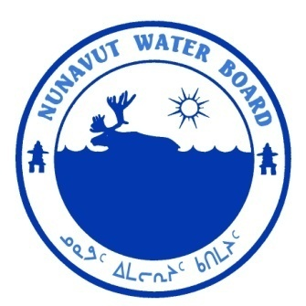  P.O. Box 119 | kNK5 wmoEp5 vtmp5
Gjoa Haven, NU X0B 1J0 | NUNAVUT WATER BOARD
Tel: (867) 360-6338 | NUNAVUT IMALIRIYIN KATIMAYIT
Fax: (867) 360-6369 | OFFICE DES EAUX DU NUNAVUT

File No.: 3BC-ACP1010/TR/B2
July 14, 2011

Benoit Beauchamp, Ph.D.
Executive Director
Arctic Institute of North America
University of Calgary
Calgary, AB T2N 1N4

Email: bbeaucha@ucalgary.ca

RE: Licence 3BC-ACP1010, “Raanes Peninsula/Arctic Carbonate Project” Qikiqtani Region, Nunavut;
Submission of 2010 Annual Report

Dear Mr. Beauchamp:

The Nunavut Water Board (“NWB”) has completed a technical review of the 2010 Annual Report for the above mentioned project received on April 1, 2011. The report was distributed for the information.

The document is found to conform to the requirements specified under Part B, Item 2 of the Licence 3BC-ACP1010.

Should you have any questions, please feel free to contact the undersigned at 867-360-6338 ext. 30 or by email at k.kharatyan@nunavutwaterboard.org.

Yours truly,

Karén Kharatyan

Technical Advisor

Cc: Distribution List – Qikiqtani

