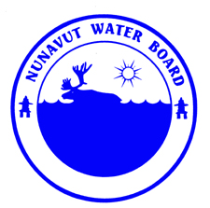  P.O. Box 119 | kNK5 wmoEp5 vtmpq
Gjoa Haven, NU X0B 1J0 | NUNAVUT WATER BOARD
Tel: (867) 360-6338 | NUNAVUT IMALIRIYIN KATIMAYINGI
Fax: (867) 360-6369 | OFFICE DES EAUX DU NUNAVUT

File: 3BC-CPI0910/TR/B1

February 17, 2011

Mary Sanborn-Barrie, Research Scientist
Geological Survey of Canada
Natural Resources Canada
611-615 Booth St.
Ottawa, ON K1A 0E9
Email: msanborn@NRCan.gc.ca

Subject: Licence No. 3BC-CPI0910, “Cumberland Peninsula Integrated Geoscience Project” Qikiqtani Region, Nunavut;
Submission of the 2010 Annual Report

Dear Ms. Sanborn-Barrie:

The Nunavut Water Board (“NWB”) has completed a technical review of the 2010 Annual Report for the above-mentioned project, which was received on February 15, 2011. The report was forwarded to the distribution list for information

The annual report is found to be complete and meeting the reporting requirements of licence 3BC-CPI0910.

Should you have any questions, please feel free to contact the undersigned at (867) 360-6338 Ext. 30 or k.kharatyan@nunavutwaterboard.org, at your earliest convenience.

Yours truly,

Original Signed By:

Karén Kharatyan
Technical Advisor

cc: Distribution List – Qikiqtani

