August 21 2013 File No: NWB2NAN97022BE-ANI0813/TR/A

Eva Paul
Water Resources Officer
Aboriginal Affairs and Northern Development Canada
Nunavut Regional Office
P.O. 100
Iqaluit, NU X0A 0H0
Email: eva.paul@aandc-aadnc.gc.ca

Subject: Submission of Water License Inspection Report for Anialik Project/Rush Lake CampDrawings - Part G, Item 12

Dear Mr. Ledrew,Dear Ms. Paul:

The Nunavut Water Board (“NWB”) acknowledges receipt, on August 09, 2013, of a submission from Aboriginal Affairs and Northern Development Canada, dated July 05, 2013, entitled Inspection of Water Licence 2BE-ANI0813, July 5, 2013. This submission has been placed on the NWB public registry and is available from the NWB ftp site, username public, password: registry.
Received January 26, 2000
Notice of this report is forwarded to the distribution list for information only. Anyone wishing to provide comments may do so by return email to the Manager of Licensing at licensing@nunavutwaterboard.org.

Please note contact information as follows for the AANDC Inspectors:
Qikiqtani Region – Andrew Keim Andrew.Keim@aandc-aadnc.gc.ca
Kivalliq Region – Christine Wilson – Christine.Wilson@aandc-aadnc.gc.ca
Kitikmeot Region – Eva Paul - Eva.Paul@aandc-aadnc.gc.ca

Sincerely,

Original signed by:

Megan Porter
Licence Administrator Assistant

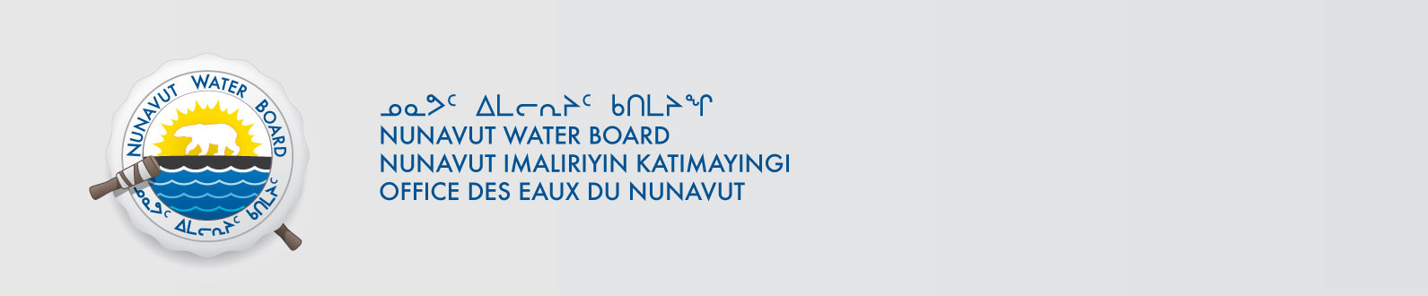
cc. Kitikmeot Paula Pacholek, EC
Chris Nichols, DSD
Gladys Joudrey, NIRB
Jordan Degroot, DFO
Roxanne Beavers, DIAND (YK)
Paul Smith, DIAND (Iqaluit)Distribution List

