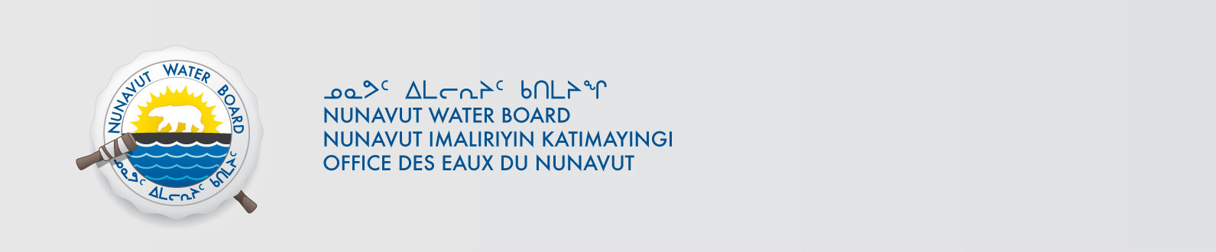
July xx, 2013 NWB File Number: 2BE-COR0608

Ms. Nicole Westcott
Stornoway Diamond Corporation
Unit 116-980 West 1st Street
North Vancouver, BC V7P 3N4
Email: nwestcott@stornowaydiamonds.com

Subject: Request for Closure of Water Licence File 2BE-COR0608 – Stornoway Diamond Corporatoin

Dear Ms. Westcott:

The Nunavut Water Board (Board or NWB) acknowledges receipt on June 20, 2013 of a request for closure of the above referenced file. In accordance with Section 43(1) (c)(i) of the Nunavut Waters and Nunavut Surface Rights Tribunal Act, the Board may cancel a licence on application by the licensee.

The application request can be obtained from our ftp site under PRUC with Username: public, Password: registry.

To ensure this application is dealt with in a timely fashion, the NWB forwards notice of all documentation to regulators and council of the municipality(ies) most affected by the project, inviting interested parties to make representation directly to the NWB within 30 days from the date of this letter. The NWB may provide additional procedural instructions once the application has been reviewed by interested parties.

The Board further requests that Aboriginal Affairs and Northern Development Canada advise the Board when a final site inspection is complete. At that time the Board will make a determination on the Application.

Sincerely,

Original signed by:

Phyllis Beaulieu
Manager of Licensing

Cc: Distribution - Kitikmeot

