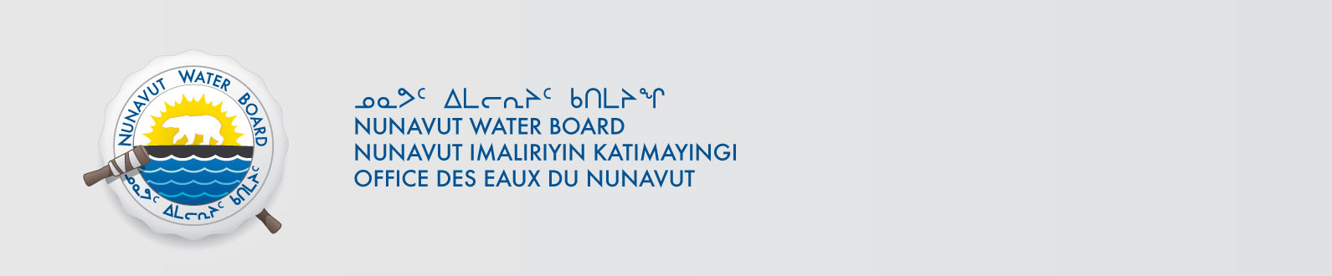

File No: NWB2ATU9899 2BE-COR0608

February 26, 2014

To: Hamlet, CLARC, HTO, RIA, Coop, and NorthernLocal Organizations – Request to Post Notices

The Nunavut Water Board requests that you post on a bulletin board, until April 10, 2000March 28, 2014, the attached notices (in English and Inuinnaqtun), where they can be viewed by the public. The attached letter is for your information only and does not require posting.

Your time and effort is greatly appreciated.

Sincerely,

Original signed by:

Megan Porter
Licensing Administrator Assistant

Cc: CLARC & KIA – Cambridge Bay (867) 983-2701
HTO – Cambridge Bay (867) 983-2427
Hamlet of Cambridge Bay (867) 983-2193
Northern Store (867) 983-2452
Ikaluktutiak Co-op (867) 983-2085
CLARC & KIA – Kugluktuk (867) 982-3311
HTO – Kugluktuk (867) 982-5912
Hamlet of Kugluktuk (867) 982-3060
Northern Store (867) 982-3607
Kugluktuk Co-op (867) 982-3070
CLARC - Bathurst Inlet General Delivery, Bathurst Inlet, NU Via Reg. Mail

CLARC – Umingmaktok General Delivery, Umingmaktok, NU Via Reg.Mail

