September 27th, 2013

Joe Kidston, P. Geologist
Stornoway Diamond Corporation
#116 - 980 West 1st Street
North Vancouver, BC, V7P 3N4

Eva Paul, Water Resources Officer
Aboriginal Affairs and Northern Development Canada
Nunavut Regional Office
Building 918, P.O. Box 100
Iqaluit, NU, X0A 0H0

Re : Response to Inspection Report “Inspection of Water Licence 2BE-COR0608, 2BE-CGP1012, 2BE-CGR1012, July 7 2013”. Inspection report is dated September 5th, 2013.

Dear Eva,

I am the Geologist who supervised Eureka camp (N67⁰01’33.7” / W113⁰39’04.6”) in 2011 during its final use before it was permanently closed and removed that year. As part of my role, I was in charge of making sure camp was kept clean and maintained in good order. You recently inspected the camp-site and sent us a copy of your inspection report along with some concerns. Your inspection report says you visited the camp-site July 4th, 2013.

I was in Yellowknife last week and was able to fly up to the old Eureka camp-site September 18th, 2013, and address the concerns mentioned in your report. I picked up the garbage you identified during your inspection (see Photos 1 & 2 below), refilled the sump (Photos 3 & 4), and re-stacked the core which had been knocked over by a bear (Photos 5 through 8). No signs of fuel contamination were seen.

You and I had a phone conversation yesterday afternoon where I explained to you that because I was the Geologist last in charge of Eureka camp, I myself went to the old camp-site to personally make sure all of your concerns were taken care of. I also explained over the phone that no core boxes were ever moved from their original stacks (see Photos 5 through 8 below), and that there were no fuel spills.

Regarding the old drums mentioned on page 6 of your report, a Stornoway representative visited Eureka camp July 21st, 2009, and reported after inspecting the drums that none were leaking or showed any signs of leakage. A letter summarising this visit was sent to John Craig (DINA) by email August 25th, 2009, and by hard copy to Phyllis Beaulieu (NWB) August 28th, 2009. When I arrived in camp in 2011, I saw no leaking drums or signs of contamination, and all drums were back-hauled to Yellowknife that summer.

Page 2 of your report also mentions two empty fuel drums labelled “Tahera” and “Northwest Rotors” seen on a nearby island with small amounts of garbage and an old camp-fire. As the labels on the drums indicate, these drums are not ours. The garbage and old camp-fire are also not ours, and we never saw them while working up there in 2011. I tried to find this small island with the drums on it last week when I was up there but could not. The only coordinates given in your inspection report are for Eureka camp, and I did not see any drums on the islands we flew over.

The following photos should address the concerns mentioned in your report Eva, and I feel that the old Eureka camp-site is now fully clean. As such, I would like to request the closure of licences 2BE-COR0608 and 2BE-CGP1012. If you have any questions, please feel free to contact me at the info below.

Thank you for your time,

Joe Kidston, P. Geol.
(604) 983-7769
jkidston@stornowaydiamonds.com

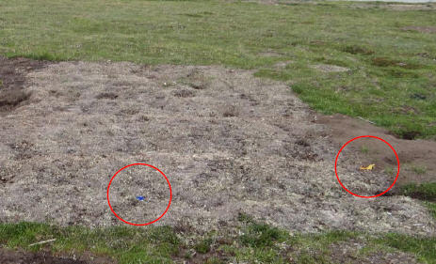
Photo 1 : July 2013 - Garbage needing to be picked up (photo taken from your report).

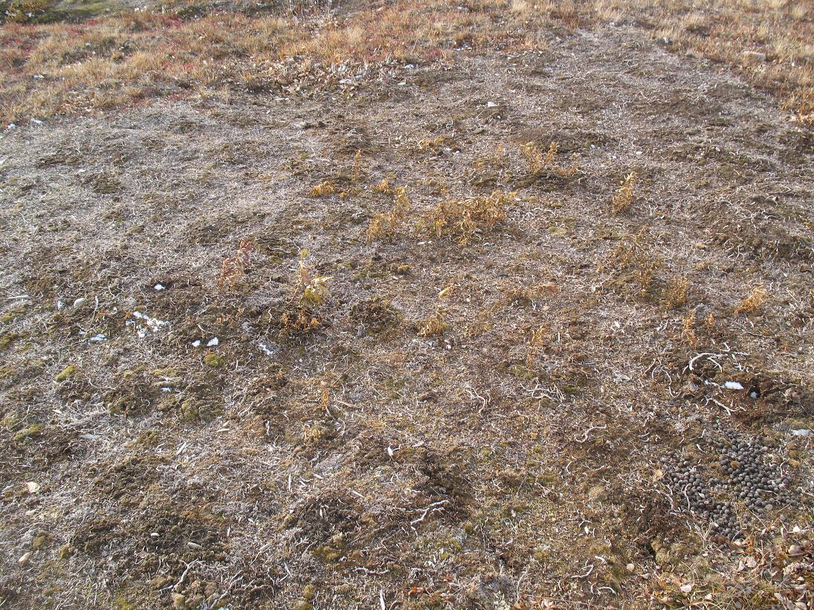
Photo 2 : September 2013 - Garbage all picked up. The blue item was a plastic bottle cap from a juice jug and the yellow item was flagging. Note also the regrowth in vegetation since July (compare with the photo above).

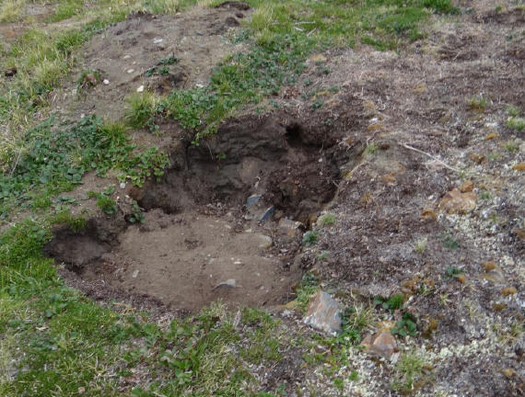
Photo 3 : July 2013 - Old sump needing to be refilled (photo taken from your report).

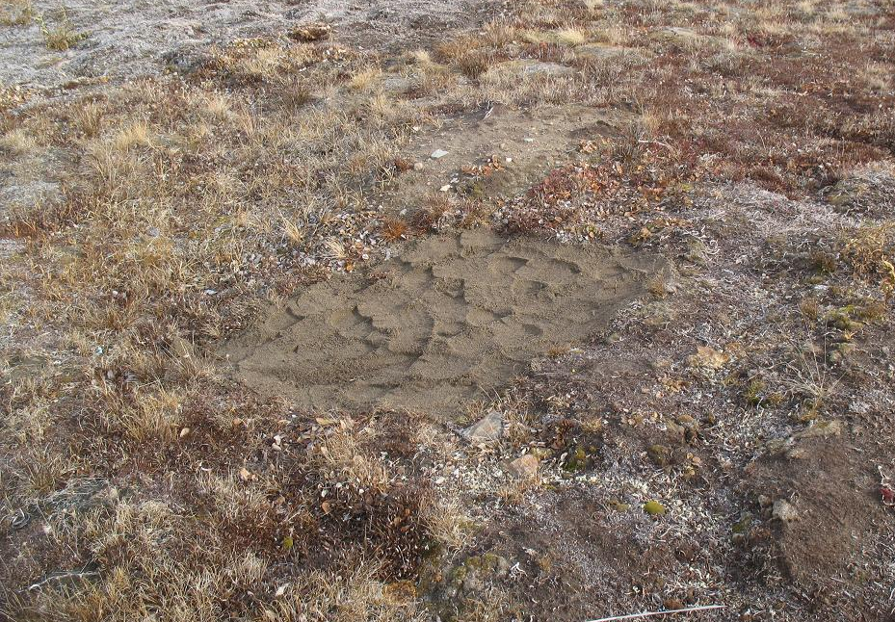
Photo 4 : September 2013 - Sump filled in, levelled, and scarred to promote regrowth.
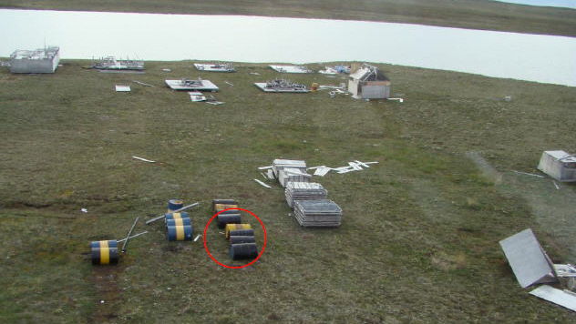
Photo 5 : Old photo of Eureka Camp (taken from your report) from 2009 showing the original position of the core boxes from 2003. The old drums (circled in red) were back-hauled out of camp (no leaks) in 2011, and the new core boxes were placed beside the older ones (see photo below).

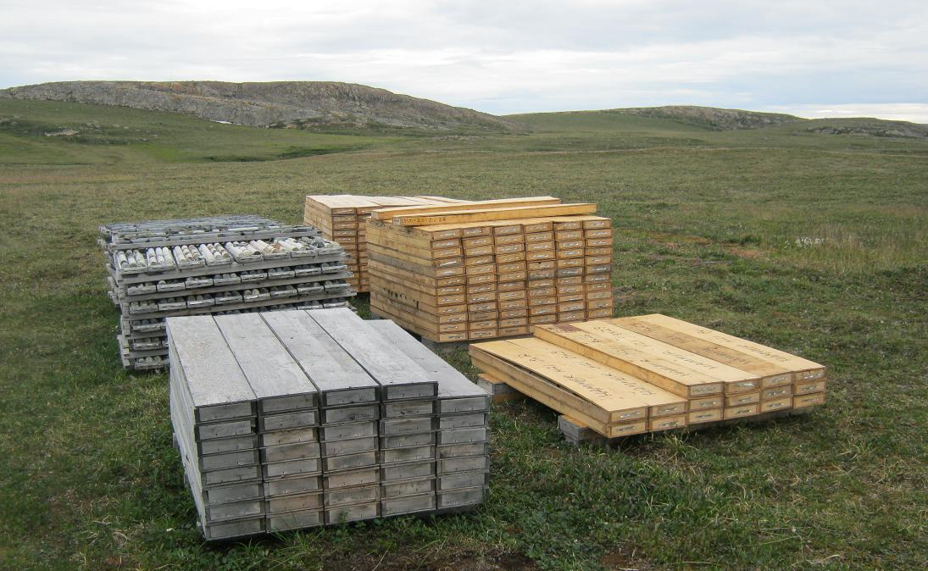
Photo 6 : This is how we left the core in 2011. The older, faded boxes on the left are from 2003 and in their original position (see photo above) while the newer boxes to the right are from 2011. All old drums were back-hauled to Yellowknife and no signs of contamination were seen.
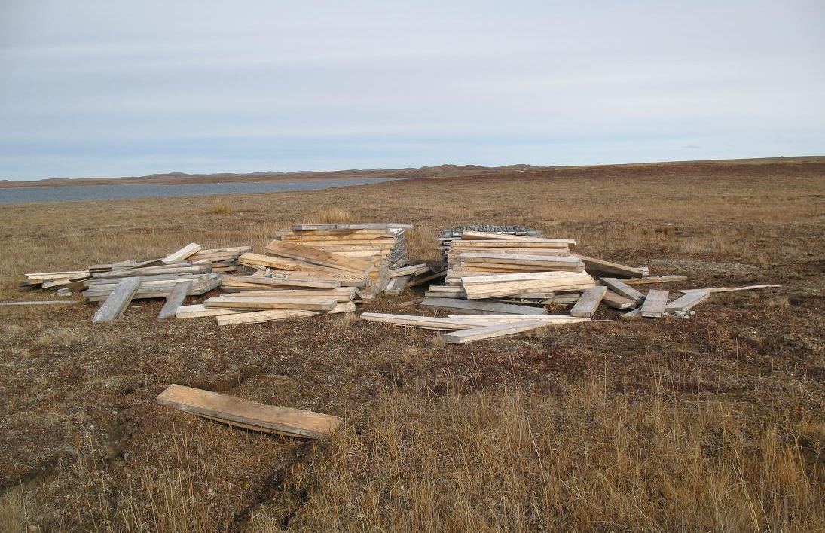
Photo 7 : September 2013 - This is how the core looked during your July camp inspection, all knocked over and spilled about. Claw marks and tufts of white/brown hair around the core boxes suggest this was done by a bear. Several boxes had also been smashed open.

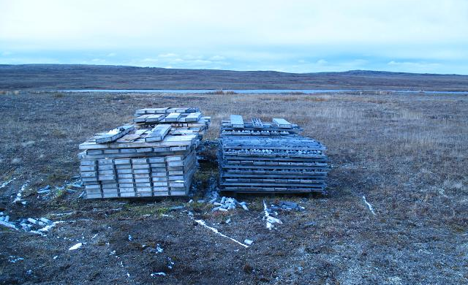
Photo 8 : September 2013 - The core boxes now, all re-stacked in their original piles.

