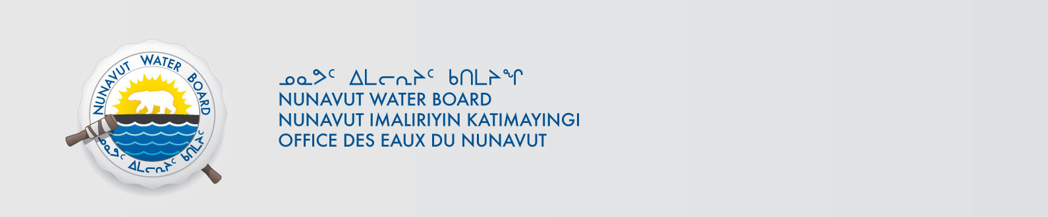

January 23, 2014 NWB File No: 2BE-MVP1217

Clayton Pearson
Vale Exploration Canada Inc.
2600 Flavelle Boulevard
Mississauga, Ontario
L5K 1Z9
Email: clayton.pearson@vale.com

Re: Acknowledgement and Receipt of Application Fee for Cancellation Water Licence Application – Melville Project

Dear Clayton

The Nunavut Water Board acknowledges receipt on December 11, 2013 of your Master Card information for an application fee for the above project. Your information for payment has been forwarded to Aboriginal Affairs and Northern Development Canada in Iqaluit for processing. A receipt will be issued through their office for fees totaling $ 30.00.

Please call the undersigned at (867) 360-6338 or e-mail licensing@nunavutwaterboard.org if you have any questions.

Sincerely,

Original signed by:

Megan Porter
Licensing Administrator Assistant

Cc: Jean Allen, AANDC
Rory MacDonald, AANDC
Olivia Netser, AANDC

