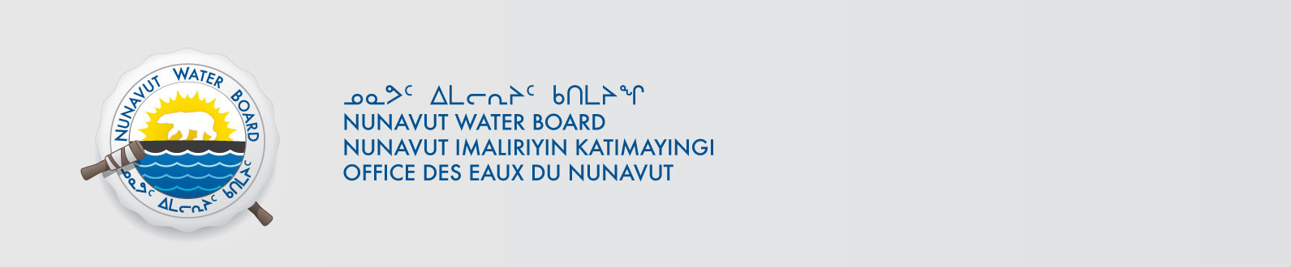
February 14, 2014 NWB File Number: 2BE-MVP1217

Clayton Pearson
Project Geologist
Vale Exploration Canada Inc.
Highway 17 West, Copper Cliff, ON
P0M 1N0
Email: clayton.pearson@vale.com

Subject: Request for Cancellation of Water Licence 2BE-MVP1217 – Melville Project

Dear Clayton Pearson:

This letter acknowledges receipt on December 16, 2013 of an application from Vale Exploration Canada Inc to cancel Water Licence 2BE-MVP1217 (Application). In accordance with Section 43(1) (c) of the Nunavut Waters and Nunavut Surface Rights Tribunal Act, the Nunavut Water Board (Board or NWB) may cancel a licence on application by the licensee.

The application can be obtained from our ftp site: ftp://nunavutwaterboard.org/1%20PRUC/2%20MINING%20MILLING/2B/2BE%20-%20Exploration/2BE-MVP1217%20Vale%20Exploration/1%20APPLICATION/ with Username: publicPassword: registry.

To ensure this application is dealt with in a timely fashion, the NWB forwards notice of all documentation to regulators and council of the municipality(ies) most affected by the project, inviting interested parties to make representation directly to the NWB within 30 days from the date of this letter. The NWB may provide additional procedural instructions once the application has been reviewed by interested parties.

The Board further requests that Aboriginal Affairs and Northern Development Canada advise the Board when a final site inspection is complete. At that time the Board will make a determination on the Application.

Sincerely,

Original signed by;

Megan Porter
Licensing Administrator Assistant

Cc: Distribution – Kivalliq, Qikiqtani and Kitikmeot

