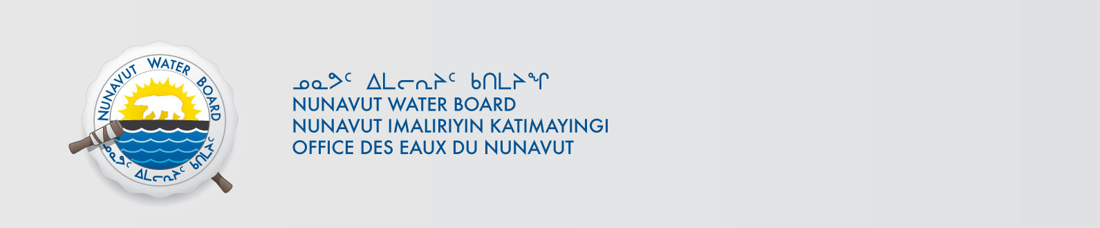

February 14, 2014 File No: 2BE-MVP1217

To: Hamlet, CLARC, HTO, RIA, Coop, and NorthernLocal Organizations – Request to Post Notices

The Nunavut Water Board requests that you post on a bulletin board, until March 16, 2014, the attached notices (in English and Inuktitut), where they can be viewed by the public. The attached letter is for your information and does not require posting.

Your time and effort is greatly appreciated.

Sincerely,

Original signed by:

Megan Porter
Licensing Administrator Assistant

Cc: Hamlet of Hall Beach (867) 928-8871
QIA (867) 928-8114
Hall Beach HTO (867) 928-8765
NORTHERN STORE (867) 928-8874
Co-op (867) 928-8122
Hamlet of Igloolik (867) 934-8757
QIA (867) 934-8562
Igloolik HTO (867) 934-8067
Northern Store (867) 934-8978
Igloolik Co-op (867) 934-8740
Hamlet of Kugaaruk (867) 769-6069
KIA (867) 769-6202
Kurtajuak HTO (867) 769-6713
Koomiut Co-op (867) 769-6098
Hamlet of Repulse Bay (867) 462-4411
KivIA (867) 462-4439
Ariq HTO (867) 462-4335
Northern Store (867) 462-4011
Naujat Co-op (867) 462-4152

