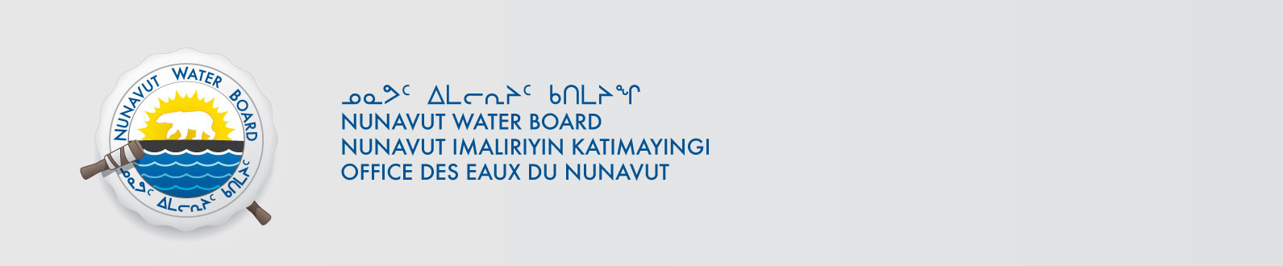
NWB File No: 2BE-MVP1217
April 17, 2013

Clayton Pearson, Project Geologist
North American Exploration
Vale Exploration Canada Inc.
2060 Flavelle Boulevard
Mississauga, Ontario Canada L5K 1Z9
E-mail: clayton.pearson@vale.com

Re: Acknowledgement and Receipt of Water Use Fee for Water Licence Application- Melville Project

Dear Mr. Pearson:

The Nunavut Water Board acknowledges receipt on April 16, 2013 of your credit card information for water use fees for the above project. Your information for payment has been forwarded to Aboriginal Affairs and Northern Development Canada in Iqaluit for processing. A receipt will be issued through their office for fees totaling $ 365.00.

Please refer to the calculation for water use fees, in the Northwest Territories Waters Regulations, Section 9, to ensure that the correct fee has been submitted. A copy of this regulation is available from our ftp site or by contacting this office. This is an annual fee which is required to be submitted yearly on the anniversary of the issuance of your water license.

Please call the undersigned at (867) 360-6338 or e-mail licensing@nunavutwaterboard.org if you have any questions.

Sincerely,

Original Signed by:

Megan Porter
Licensing Administrator Assistant

Cc: Ian Parsons, AANDC
Jean Allen, AANDC
Rory MacDonald, AANDC

