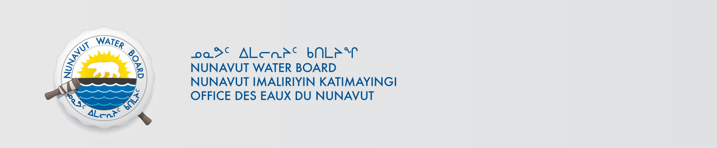
File: 2BE-PER0610
February 19, 2014

Deborah Chadwick
Canterra Minerals Corp.
P.O. Box 11584
Suite 1410, 650 West Georgia Street
Vancouver, BC V6B 4N8
Email: dchadwick@canterraminerals.com

Subject: Licence No. 2BE-PER0610 “Peregrine Project”, Kitikmeot Region, Nunavut; Cancellation of the Licence

Dear Ms. Chadwick,

On January 5, 2009, the Nunavut Water Board (“NWB or Board”) received from Diamondex Resources Ltd. an application to cancel the water licence for the above-mentioned project. The Licence issued on May 24, 2006 authorized water use (100 m³ per day) and waste disposal associated with exploration works at the Peregrine Project in the Kitikmeot Region of Nunavut.

On March 9, 2009, the Board distributed the application for a thirty (30) day comment period. Before the deadline for comments, submissions were received from Indian and Northern Affairs Canada (INAC AANDC at present) and Environment Canada (EC).
INAC recommended that the licence not be cancelled/ closed until a Water Resources Officer completes an on-site inspection and provides confirmation that no compliance issues are associated and/ or remain outstanding with the project. EC expressed no objections to the cancellation of the licence, provided that it is demonstrated that the Proponent has met all closure obligations.

On December 9, 2009 the Diamondex Resources Ltd. changed its name to Canterra Minerals Corporation.

On October 9, 2013, AANDC Inspector informed that a final site inspection was conducted on September 16, 2013, and recommended the NWB to cancel the licence.

Upon review of all information, NWB determined that the application fulfills the requirements of s. 43(1) of Nunavut Waters and Nunavut Surface Rights Tribunal Act (Act) and NWB Guide 7. The NWB has, therefore, approved the application for cancellation of Licence 2BE-PER0610 through Board Motion No. 2013-B1-051, dated February 19, 2014.

Should you have any questions, please feel free to contact the Board at (867) 360-6338 or licensing@nunavutwaterboard.org, at your earliest convenience.

Sincerely,

Thomas Kabloona
Nunavut Water Board
Chair
TK/kk/pb

cc: Distribution – Kitikmeot

Indian and Northern Affairs Canada (INAC), March 9 and April 7, 2009; Environment Canada (EC), March 9, 2009.
The s. 43(1)(c) indicates when the Board may cancel a water licence.
The minimum information requirements set out in the NWB Guidance Document- Guide 7 – Licensee Requirements Following the Issuance of a Water Licence, April 2010, see Part 11 and Table 4.

