NWB File No.: 2BE-PIX0510
January 23, 2014

Nicole Westcott
Ashton Mining (Northwest Territories) Ltd.
Unit 116-980 West 1st Street
North Vancouver, BC V7P 3N4
Email: nwestcott@stornowaydiamonds.com

Subject: Cancellation of Water Licence No. 2BE-PIX0510
Submission of Inspection of Water Licence 2BE-PIX0510, July 8, 2013

Dear Ms. Westcott:

The Nunavut Water Board (“NWB” or “Board”) has completed a review of the above mentioned document submitted from Aboriginal Affairs and Northern Development Canada (“AANDC”) to the Board on August 2, 2013. The report is based on observations made during a site visit of the project site associated with the licence, located in the Kitikmeot Region, Nunavut. AANDC indicates that it appears no camp was established at the coordinates listed in the licence and that no water was used and no waste was deposited with no signs of activity at or nearby the location. AANDC recommends that this file may now be closed. A review of the 2009 and 2010 Annual Reports was conducted during the review of the above mentioned file and found that the reports are complete and consistent with the reporting requirements.

The NWB hereby informs all parties that the 2BE-PIX0510 file is now cancelled under Board Motion #2013-B1-045. Any future activities on this site involving the use of water or the deposit of waste will require a new licence. Should you have any questions, please feel free to contact Erik Skiby, Assistant Technical Advisor at 867-360-6338 or by e-mail at eskiby@nunavutwaterboard.org .

Sincerely,

Thomas Kabloona
Nunavut Water Board, Chair

TK/es/ri

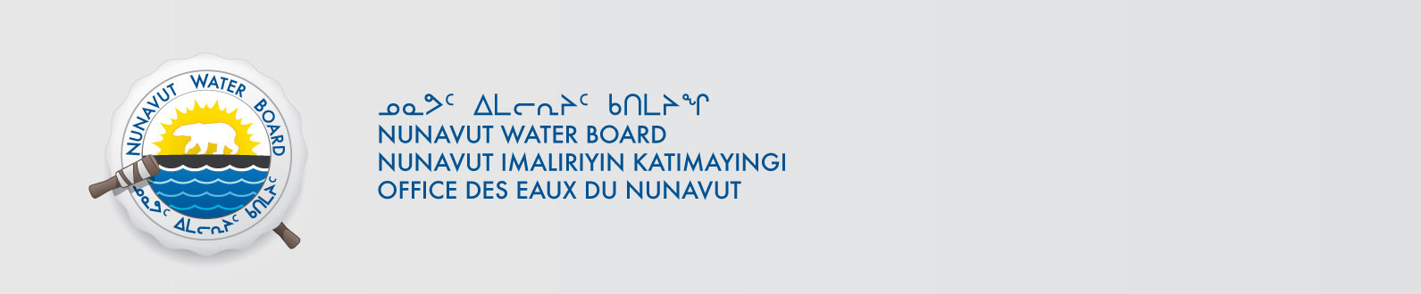
Cc: Distribution List – Kitikmeot

