October 9th, 2013

Cory Zyla
Technical Advisor
Nunavut Water Board
CP 119
Gjoa Haven (Nunavut), X0B 1J0

Cory,

Please be notified that effective July 31, 2013, Xstrata Canada Corporation changed its name to Glencore Canada Corporation.

Sincerely,

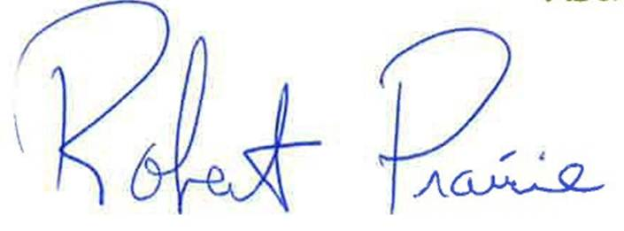

Robert Prairie
Director, Environment
Glencore
514-745-9357

c.c. Robin Ikkutisluk
Phyllis Beaulieu

