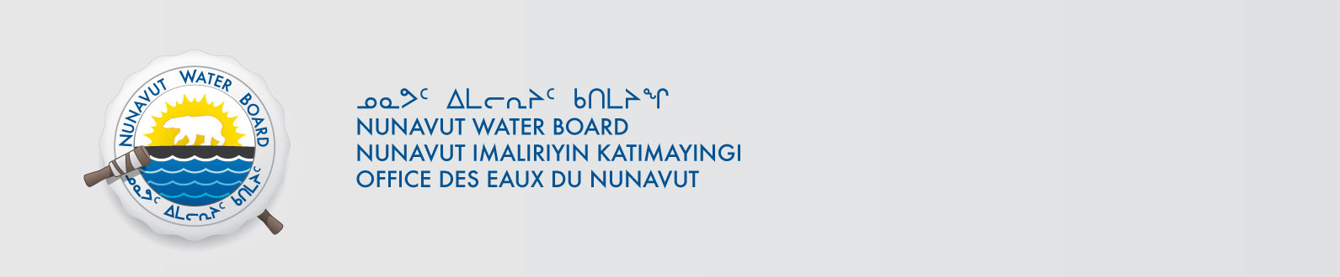

March 25, 2015 NWB File No: 2BE-SIP1117

Christopher Hicks
2060 Flavelle Blvd
Mississauga, ON
L5K 1Z9
E-mail: chris.hicks@vale.com

Subject: Final Inspection – Cancellation of Licence and Closure of NWB File

Dear Mr. Hicks:

On November 26, 2014 the Nunavut Water Board (NWB) received a final water inspection report from Aboriginal Affairs and Northern Development Canada (AANDC) covering the above noted file. The report indicates there are no outstanding reclamation issues associated with the project. Further, there are no outstanding NWB administrative matters that require attention.

In accordance with section 43.(i)(c) of the Nunavut Waters and Nunavut Surface Rights Tribunal Act (NWNSRTA), the Board may cancel a licence in certain specific cases.

The NWB hereby notifies all parties that the aforementioned licence is now cancelled and that the corresponding NWB file is now considered closed. Any future relevant activities on this site will require a new water licence assessment.

Sincerely,

Original signed by:

Robin Ikkutisluk
Licensing Administrator Assistant

Cc: Kivalliq Distribution List
AANDC Enforcement

