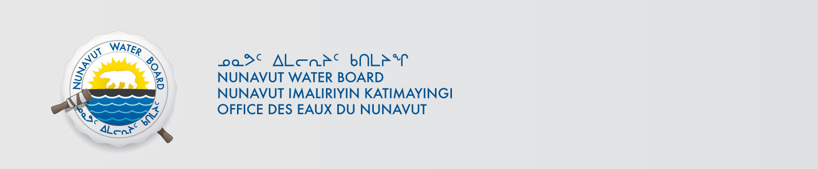
NWB File No: 2BE-SNN0813

October 30, 2014

Nicole Westwcott
Manager of Community and Regulatory Affairs-Exploration
Stornoway Diamond Corporation
Unit 116-980 West 1st Street
North Vancouver, BC V7P 3N4
Email: nwestcott@stornowaydiamonds.com

Re: Requirement for Water Use Fee for the Aviat Project

Dear Ms. Westcott:

The Nunavut Water Board hereby advises that the water use fee for the period October 6, 2012 to September 30, 2013 has not been received in this office. Based on the attached letter and calculator the outstanding amount is two hundred and sixteen dollars ($216.00). Acceptable methods of payment are by cheque, money order, or credit card. If paying by cheque or money order, please make payable to Receiver General for Canada.

Please call the undersigned at (867) 360-6338 or e-mail licensing@nwb-oen.ca if you have any questions.

Sincerely,

Original signed by:

Robin Ikkutisluk
Licence Administrator Assistant

Cc: Jean Allen, AANDC
Melanie Netser, AANDC

