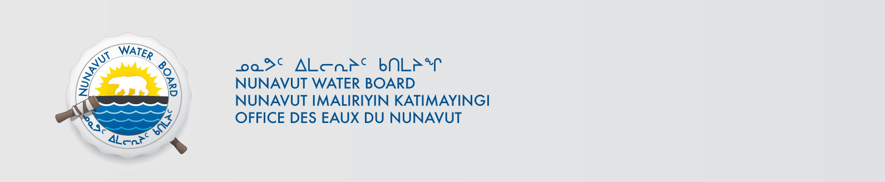

March 24, 2014 File No: 2BE-THE0813

To: Hamlet, CLARC, HTO, RIA, Coop, and NorthernLocal Organizations – Request to Post Notices

The Nunavut Water Board requests that you post on a bulletin board, until April 24, 2014 the attached notices (in English and Inuktitut), where they can be viewed by the public. The attached letter is for your information and does not require posting.

Your time and effort is greatly appreciated.

Sincerely,

Original signed by:

Megan Porter
Licensing Administrator Assistant

Cc: Hamlet of Baker Lake (867) 793-2509
KIA (867) 793-2126
HTO (867) 793-2034
Northern Store (867) 793-2565
Sanavik Co-op (867) 793-2594
Hamlet of Rankin Inlet (867) 645-2146
KIA (867) 645-2348
Northern Store (867) 645-2082
HTO (867) 645-3257
Kissarvik Co-op (867) 645-2280
Hamlet of Chesterfield (867) 898-9108
KIA (867) 898-9161
Aqigiq HTO (867) 898-9079
Northern Store (867) 898-9160
Pitsulak Co-op (867) 898-9056

