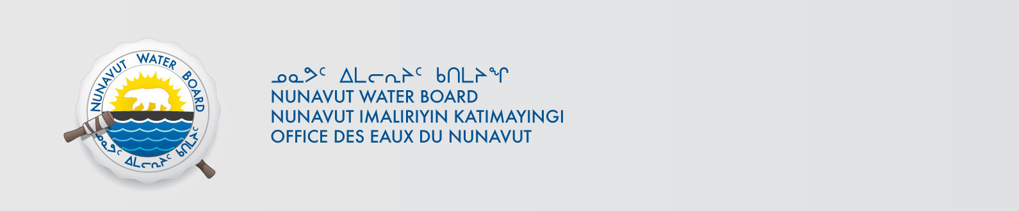

October 8, 2013 File No: 2BE-TRE0608

To: Hamlet, CLARC, HTO, RIA, Coop, and NorthernLocal Organizations – Request to Post Notices

The Nunavut Water Board requests that you post on a bulletin board, until October 8, 2013, the attached notices (in English and Inuinnaqtun), where they can be viewed by the public. The attached letter is for your information and does not require posting.

Your time and effort is greatly appreciated.

Sincerely,

Original signed by:

Robin Ikkutisluk
Licence Administrative Assistant

Cc: CLARC & KIA – Cambridge Bay (867) 983-2701
Ekaluktutiak HTO (867) 983-2427
Hamlet of Cambridge Bay (867) 983-2193
Northern Store (867) 983-2452
Ikaluktutiak Co-op (867) 983-2085
CLARC & KIA – Kugluktuk (867) 982-3311
Angoniatit HTO (867) 982-5912
Hamlet of Kugluktuk (867) 982-3060
Northern Store (867) 982-3607
Kugluktuk Co-op (867) 982-3070
CLARC - Bathurst Inlet General Delivery, Bathurst Inlet, NU
CLARC – Umingmaktok General Delivery, Umingmaktok, NU

