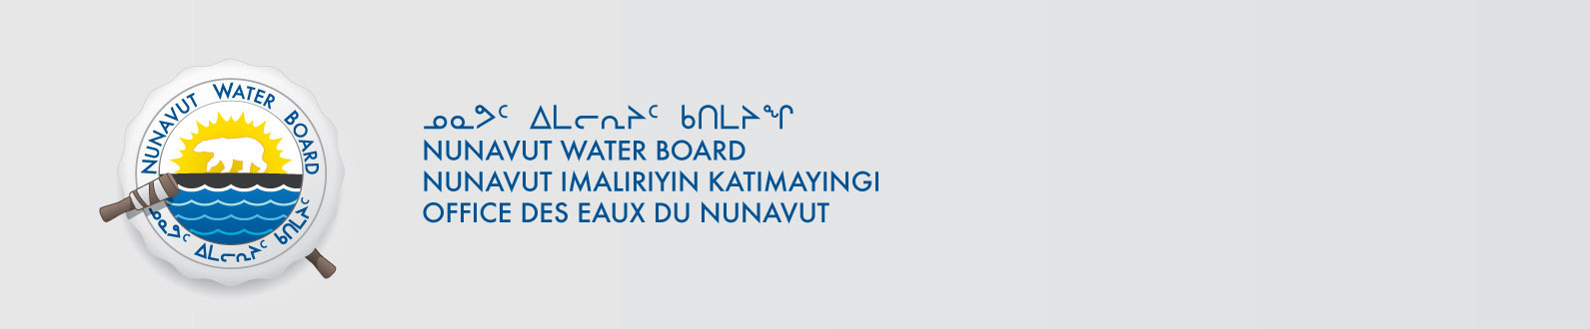

March 20, 2014 NWB File No: 2BE-REG0608

2BE-WLS0406

Mr. Mike MacMorran
Strongbow Exploration Inc.
Suite 960 – 789 West Pender Street
Vancouver, BC V6C 1H2
Email: mmacmorran@northarrowminerals.com

Re: Acknowledgement and Receipt of Application Fees for Cancellation Water Licence Applications

Dear Mr. MacMorran:

The Nunavut Water Board acknowledges receipt on March 19, 2014 of your Visa information for an application fee for the above two projects. Your information for payment has been forwarded to Aboriginal Affairs and Northern Development Canada in Iqaluit for processing. A receipt will be issued through their office for fees totaling $30.00 for 2BE-REG0608 and $30.00 for 2BE-WLS0406..

Please call the undersigned at (867) 360-6338 or e-mail licensing@nwb-oen.ca if you have any questions.

Sincerely,

Original signed by:

Phyllis Beaulieu
Manager of Licensing

Cc: Jean Allen, AANDC
Leetia Angoyuak, AANDC

