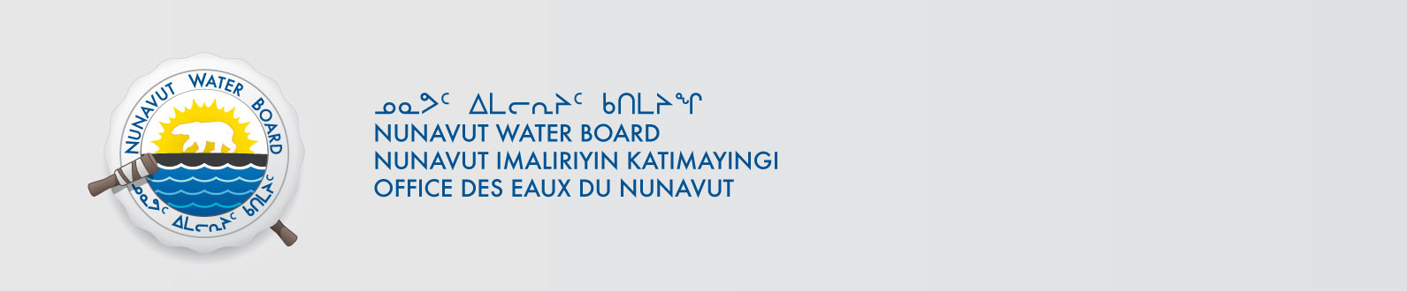

February 11, 2015 NWB File No: 3BC-PVE1313

Neil H. Shubin
Senior Advisor to the President
Robert R. Bensley Distinguished Service Professor of Anatomy
The University of Chicago
1027 E. 57th Street
Chicago, IL 60637
E-mail: neil.shubin@gmail.com

Subject: Final Inspection – Cancellation of Licence and Closure of NWB File

Dear Mr. Shubin:

On October 28, 2014 the Nunavut Water Board (NWB) received a final water inspection report from Aboriginal Affairs and Northern Development Canada (AANDC) covering the above noted file. The report indicates there are no outstanding reclamation issues associated with the project. Further, there are no outstanding NWB administrative matters that require attention.

In accordance with section 43.(i)(c) of the Nunavut Waters and Nunavut Surface Rights Tribunal Act (NWNSRTA), the Board may cancel a licence in certain specific cases.

The NWB hereby notifies all parties that the aforementioned licence is now cancelled and that the corresponding NWB file is now considered closed. Any future relevant activities on this site will require a new water licence assessment.

Sincerely,

Original signed by:

Robin Ikkutisluk
Licence Administrator Assistant

Cc: Qikiqtani Distribution List
AANDC Enforcement

