WATER LICENCE INSPECTION FORM | Original
WATER LICENCE INSPECTION FORM | Follow-Up Report

Licensee | Licensee Representative
Sabina Gold and Silver Corp. | Rob Davidson
Licence No. / Expiry | Representative’s Title
2AM-BRP1831 | Operations Manager
Land / Other Authorizations | Land / Other Authorizations
Not applicable | Not applicable
Date of Inspection | Inspector
September 4, 2021 | Omer Pasalic
Activities Inspected

Camp | Drilling | Mining | Construction | Reclamation | Fuel Storage

Roads/Hauling |  | Other: Potable Water Source, Waste Water Treatment Facility, Solid Waste Facility |  | Other:
SECTION 1 | Comments (s.__) |  | Non-Compliance with Act or Licence (s.__) |  | Action Required (s.__)
BACKGROUND

On Saturday September 4th, 2021 I, Omer Pasalic hereafter referred as an “Inspector” with the Crown Indigenous Relations and Northern Affairs Canada ( CIRNAC ), did visit the site of Goose Bay, Nunavut located at the following GPS coordinates: 66° 38’ 47.8’’ N 107° 41’ 19.4’’ W. The purpose of the visit was to ensure that the conditions contained within the Water License number 2AM-BRP1831 are followed by the licensee registered as Sabina Gold and Silver Corporation of 1800-555 Burrard Street, Mailing Postal Box 220 Vancouver, BC V7X 1M9 . The mention Water License was issued by the Nunavut Water Board on September 21st, 2018 with an expiry date of December 31st, 2031.

It is noted in this report due to the inclimate weather Marine Laydown Area was not inspected at this time.

At approximately 1050 hours on the date mentioned above, the inspector was met by Rob Davidson, Operations Manager for the Goose Bay site. Throughout the inspection, a numerous items of the Goose Bay property, identified within issued permits, were inspected including a large diesel fuel spill next to the tank number 7 at the diesel storage facility. The fuel spill observed appeared to have escaped from the holding tank through the connecting outside pipe and onto the adjacent ground directly below the tank. Photographs of the spill are attached to this report.

Jetty area of the Goose Bay site, appeared to have debris laying around, a car battery left unattended on the dock of the lake, gas cans next to the water were also observed. Photographs of the jetty are included with this report.

Repair garage floor had visible fuel leaks on the ground. These leaks have been contributed to the heavy equipment entering the garage and seeping the fuel directly onto the ground without containment. Photographs of the leaks are included with this report.

The licensee has installed a “ Burn Cage “ within the grounds of the main camp where it has been used to burn material, left over groceries, regular garbage, scrap and wood. Photograph of the Burn Cage is included in this report.

For disposal of sewage, the licensee is using a two-tank incinerator located at the main camp of Goose Bay site. No visible items not authorized by the license have been observed at or near the incinerator facility. Photographs of incinerator are included with this report.

New constructions on the site were also observed. In addition to the construction of the new camp and fuel storage facility located about 4 kilometers south from the existing Goose Bay site’s location, a two new bridges connecting the two sites were built within the last two years. Photographs of the new construction and built bridges are attached to this report.

Currently, the licensee is expanding the air strip to allow for larger and heavier airplanes to operate to and from the site. The expansion currently under way is 50 feet widening of the air strip. Photographs of the air strip are attached to this report.

The inspector observed a few passing herds of caribou, hares throughout the camp and on the land as well as other small mammals throughout the inspection of the site. The presence of these animals indicate that the nearby activities of the camp have no or minimal impact on the wildlife.

Water usage for camp operations drawn from its identified locations are within the allowable limits, as described in the Water License PART E: CONDITIONS APPLYING TO WATER USE AND MANAGEMENT – Namely part 3 and part 3 (a). Dust control measures are visible throughout the site. At the time of the inspection, there were 92 people present at the site in total.

Future site visits as well as corrective actions of items identified below, will be required in order to ensure compliance of terms and conditions of the Water License and or any other applicable permits issued to Sabina Gold and Silver Corporation.

SECTION 2 | Comments |  | Non-Compliance with Act or Licence |  | Action Required
PART F: CONDITIONS APPLYING TO WASTE DISPOSAL AND MANAGEMENT:

14. Unless otherwise approved by the Board in writing, the Licensee shall not open burn plastics,
wood treated with preservatives, electric wire, Styrofoam, asbestos or painted wood to
prevent the deposition of waste materials of incomplete combustion and/or leachate from
contaminated ash residual, from impacting any surrounding waters.

PART H: CONDITIONS APPLYING TO EMERGENCY RESPONSE AND
CONTINGENCY PLANNING:

2. The Licensee shall prevent any chemicals, petroleum products or unauthorized Wastes
associated with the Project from entering Water.
3. The Licensee shall provide secondary containment for fuel and chemical storage as required
by applicable standards and acceptable industry practice.
8. The Licensee shall, subject to Section 16 of the Regulations, report any unauthorized deposits
or foreseeable unauthorized deposits of waste and/or discharges of Effluent, and:
a. Employ the Spill Contingency Plan;
b. Report the incident immediately via the 24-Hour NWT/NU Spill Reporting Line (867)
920-8130 and to the Inspector at (867) 975-4295; and
c. For each spill occurrence, submit a detailed report to the Inspector and the NWB, no later
than thirty (30) days after initially reporting the event, which includes the amount and
type of spilled product, the GPS location of the spill, and the measures taken to contain
and clean up the spill.

SECTION 3 | Comments |  | Non-Compliance with Act or Licence |  | Action Required
The following information is a summary of the Actions Required by the licensee to promote and ensure compliance. Please provide a response to the following Actions Required within 30 days of receiving this report.

- If not already done so, please provide Board’s approval to burn materials named above in Section 2.
- If no approval, stop burning the material as described above in Section 2, until such time the approval has been granted.
- Remove items near jetty area to prevent contamination of water.
- Install and maintain secondary fuel spill containment to prevent fuel seeping onto the ground. ( Maintenance garage ).
- Immediately report any an all spills, regardless of quantity, to the NWT/NU Spill line at the numbers provided above in Section 2.
- Provide quantity of spill identified in the report above. Diesel fuel/tank number 7, plan for remediation and future preventable measures put in place.
- Instruct employees to use provided cigarette butts containers to dispose used cigarettes as opposed to dispose same directly onto the ground.

Licensee or Representative | Inspector’s Name
Matthew Picard/Merle Keefe | Omer Pasalic
Signature | Signature
 | 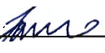
Date | Date
 | October 25, 2021
CC: Licensing Department, NWB

Photo Log
Date | Camera | Inspector
September 4, 2021 | Huawei P30-Pro | Omer Pasalic
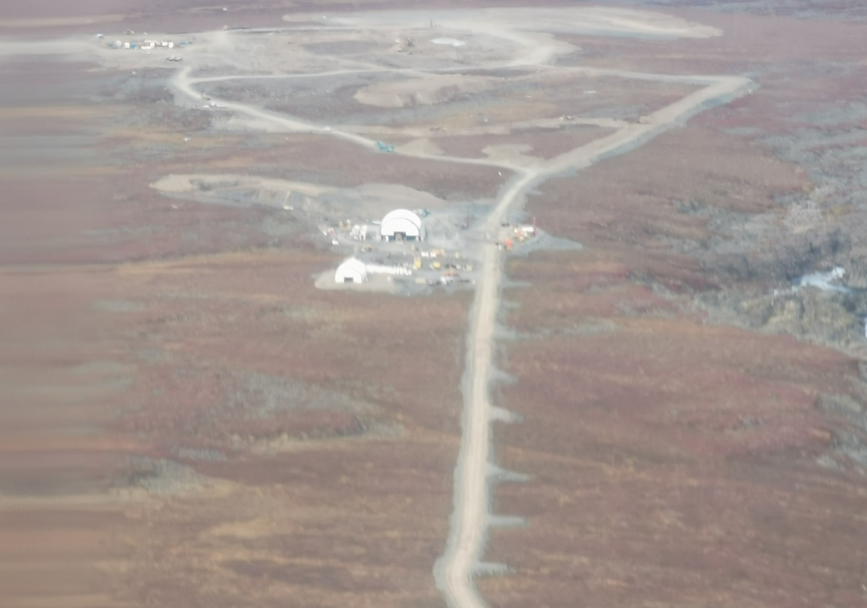
Goose Bay – New Construction Overall picture
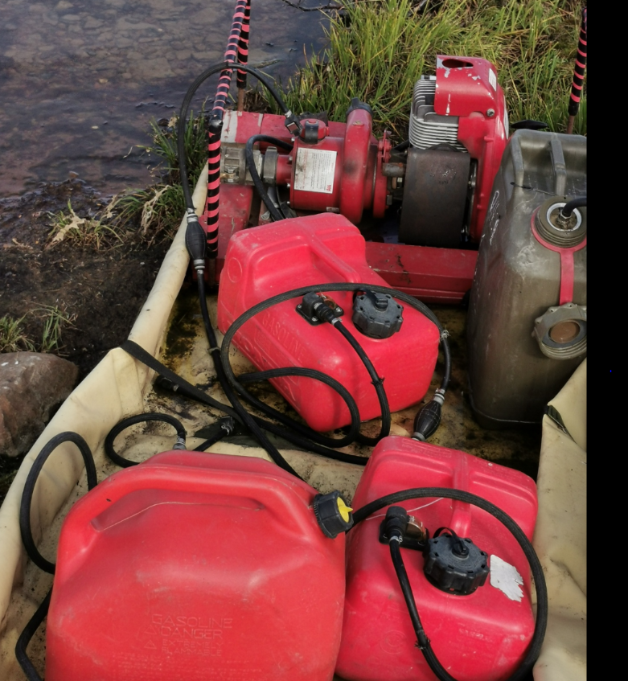
Fuel cans at the edge of the nearby water intake – Goose Lake

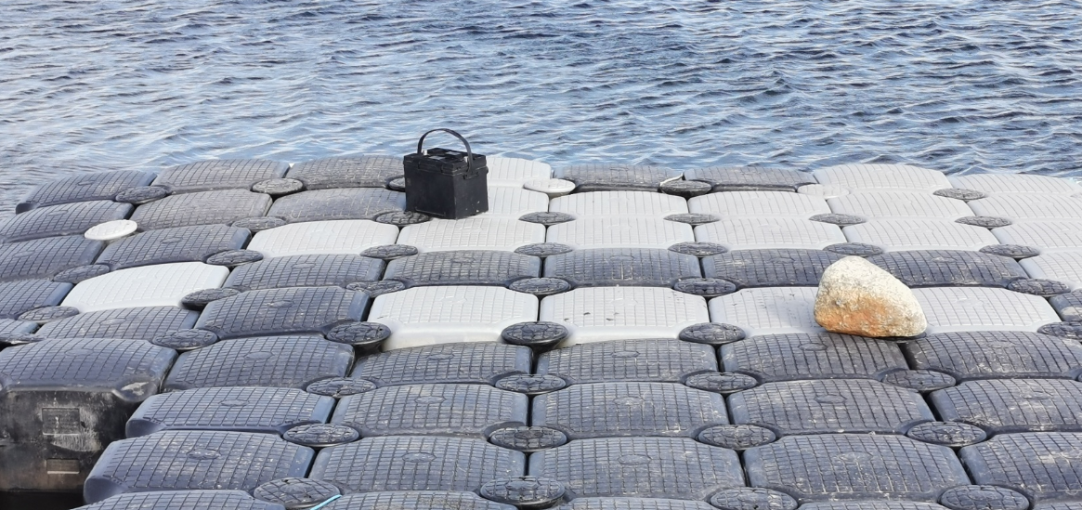
Unattended car battery left at the edge of the dock. Goose Lake.
Loose unauthorized items observed within the 31 meters of the high water mark. Goose Lake.
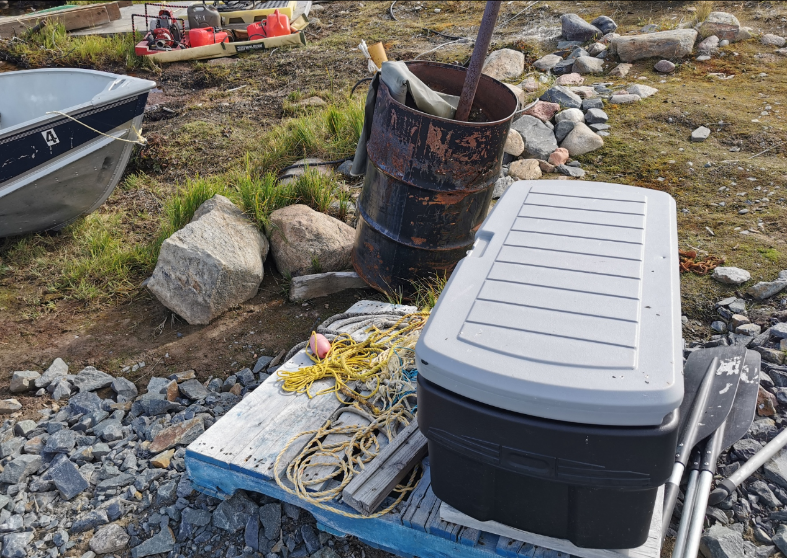

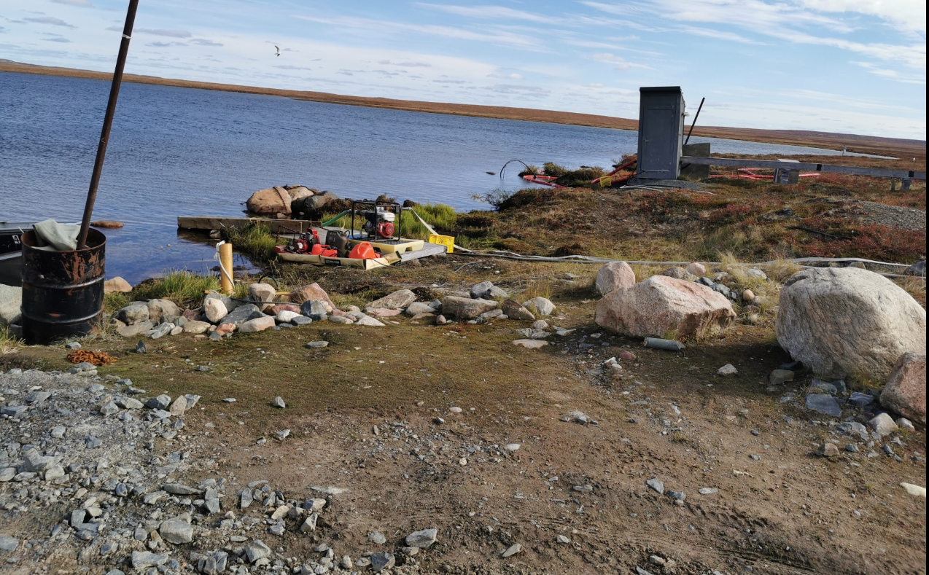
Overall photograph of the Goose Lake Intake.

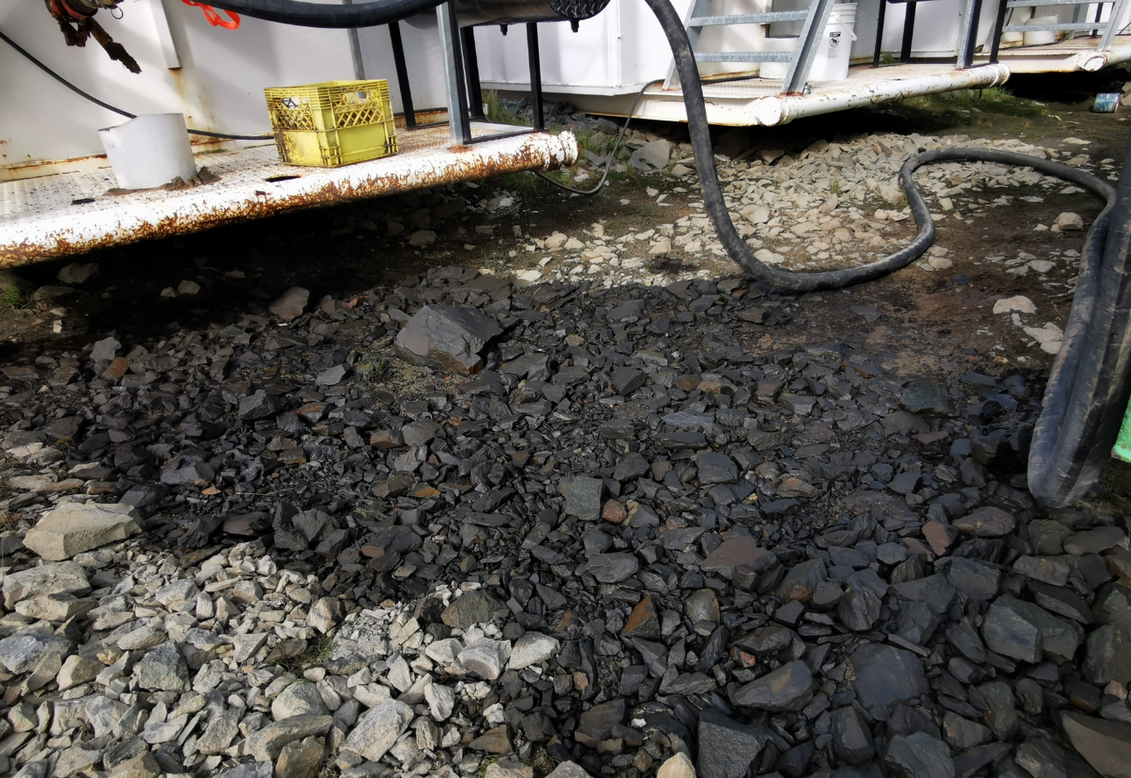
Diesel fuel spill. Tank number 7.

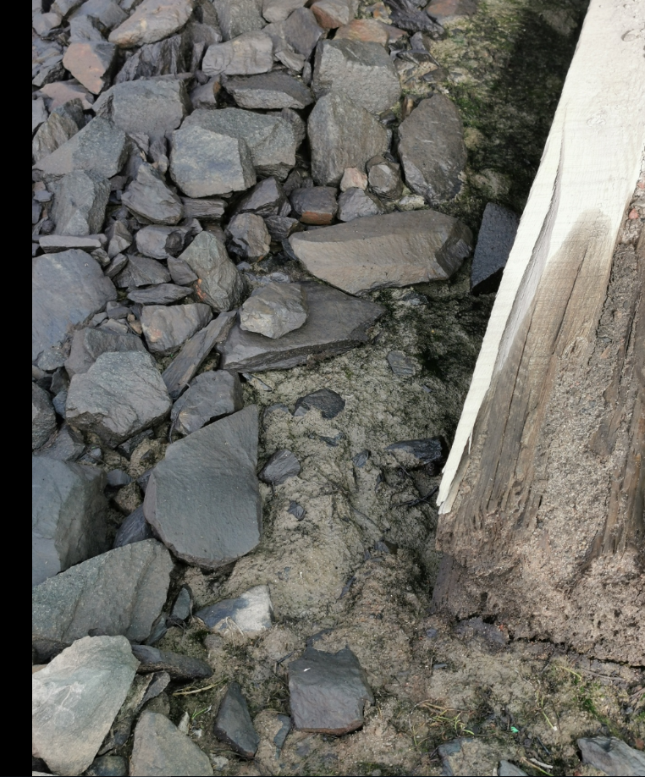
Tank number 7. Seepage detected into the ground/soil.

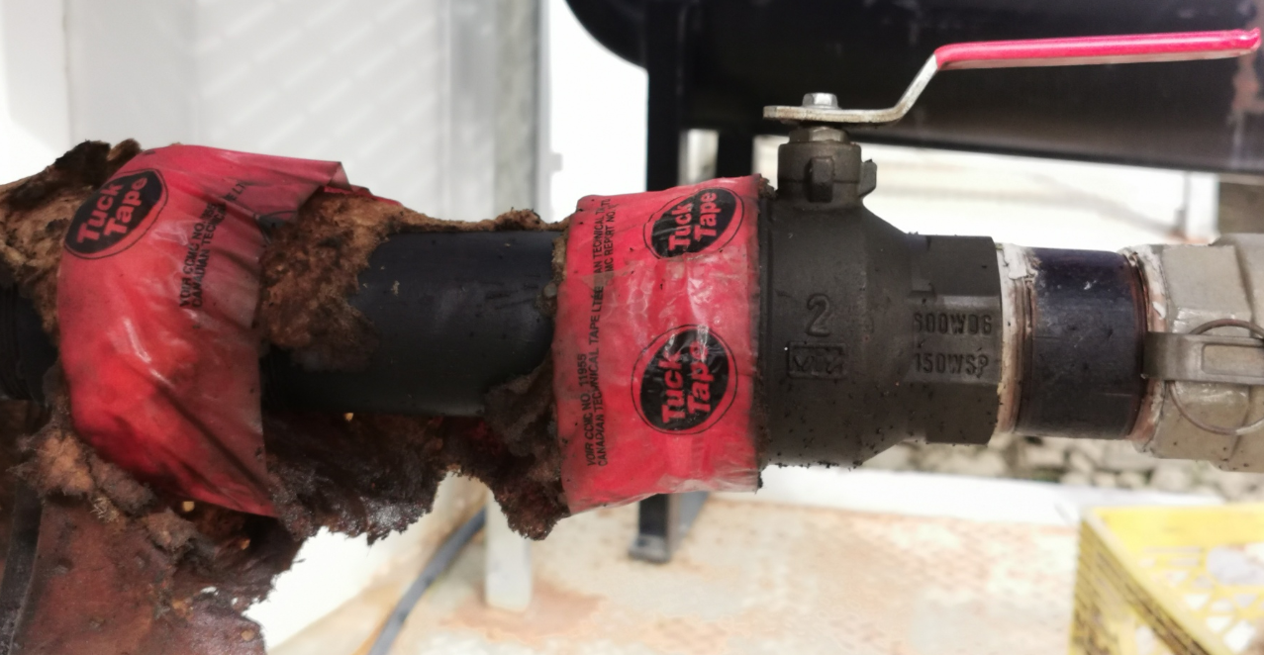
Coupling device attached to tank number 7 where the spill occurred from. Improper temporary fix in order to prevent further discharge.

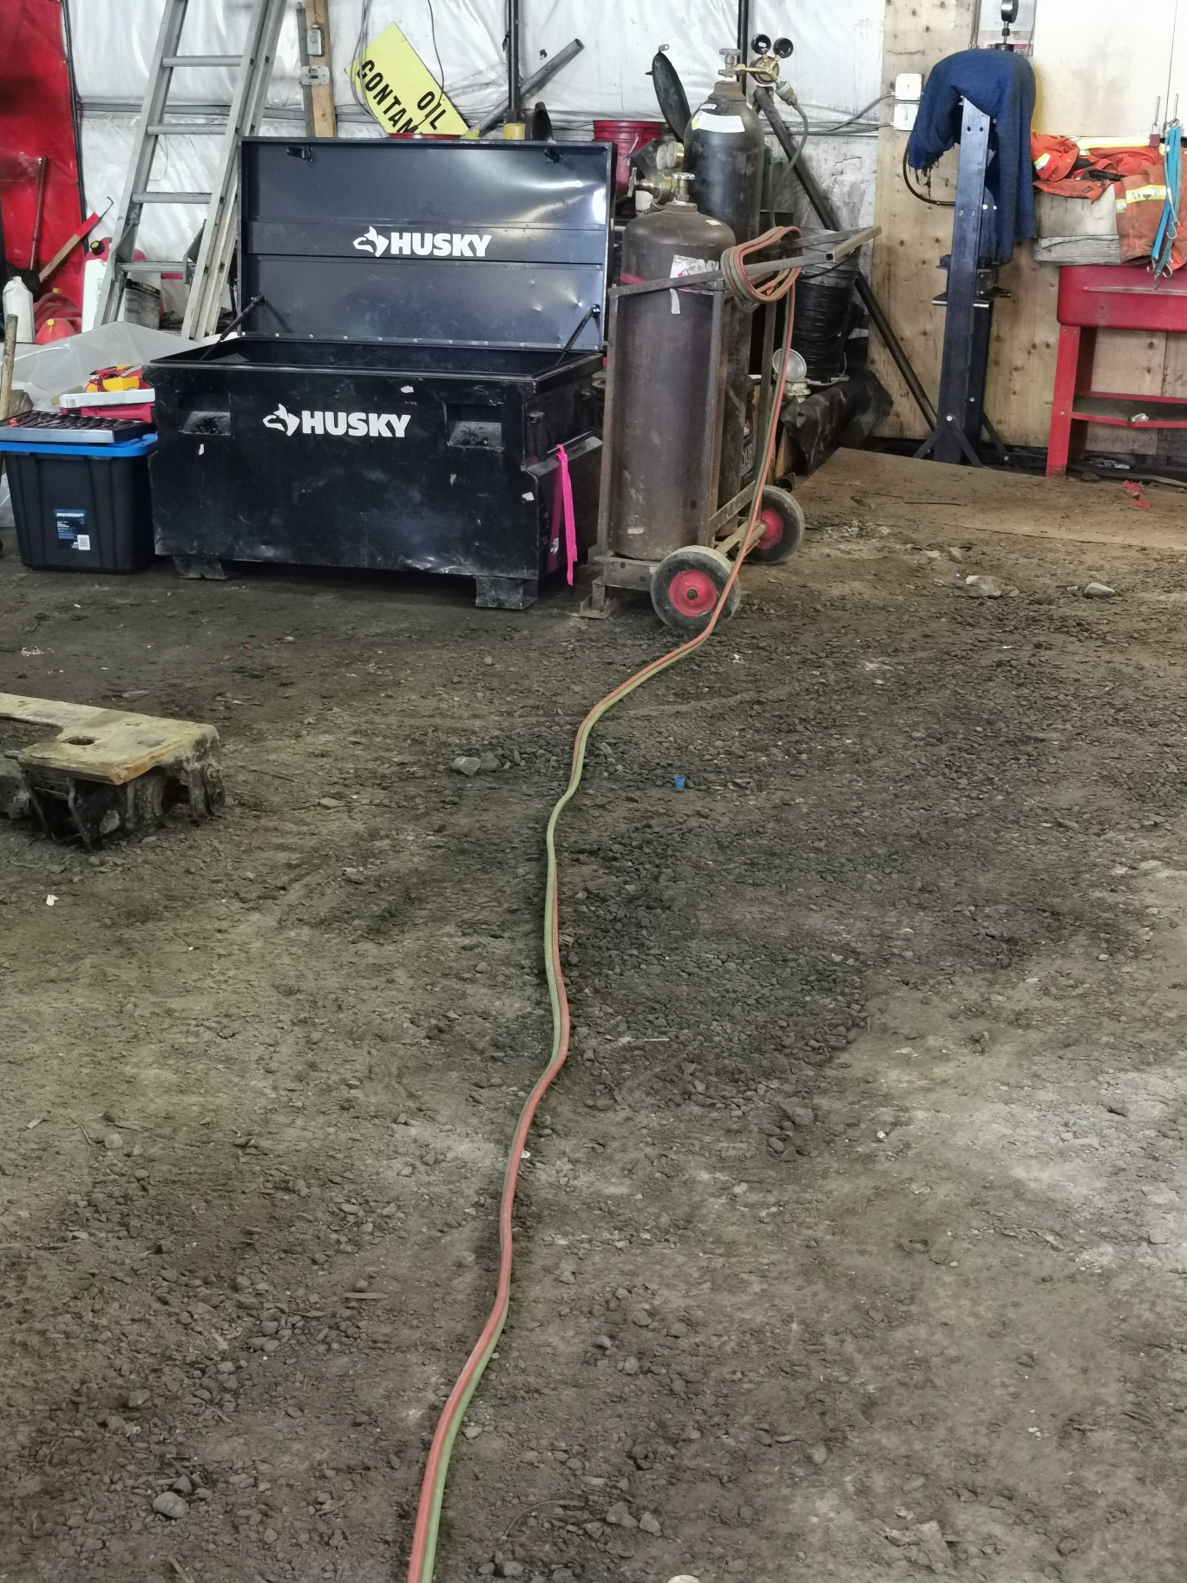
Fuel spill detected inside the maintenance vehicle garage. No secondary containment found or seen.

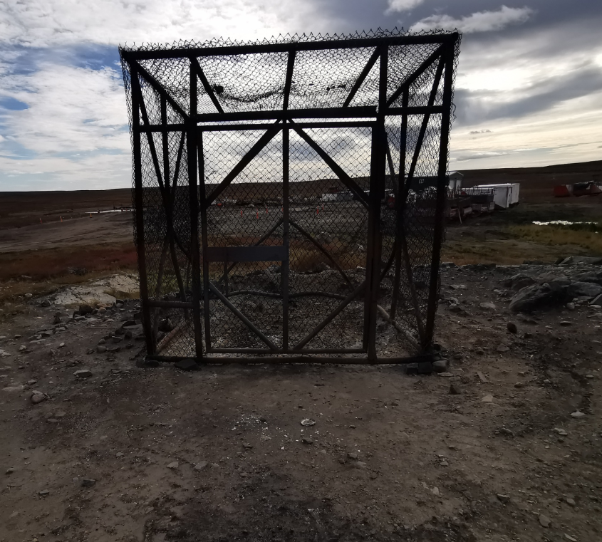
Burn cage.

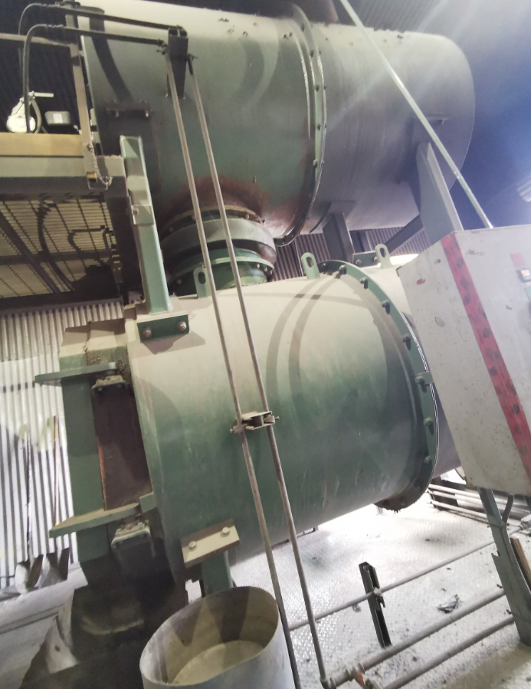
Incinerator. Photograph number 1.

. 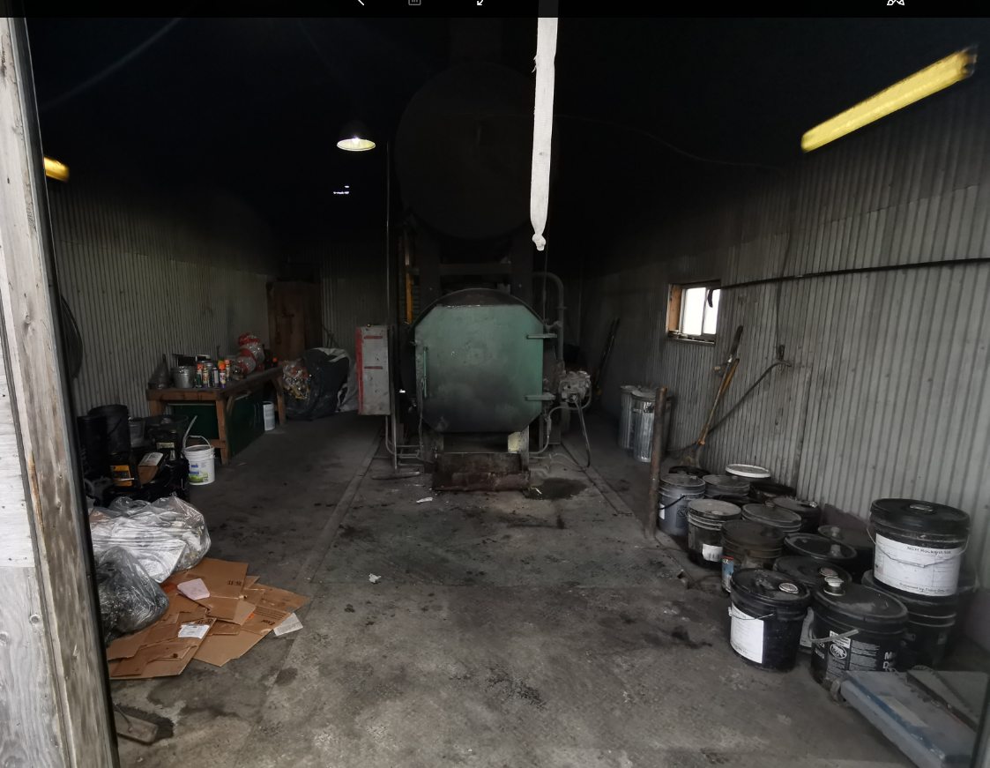
Incinerator. Photograph number 2.

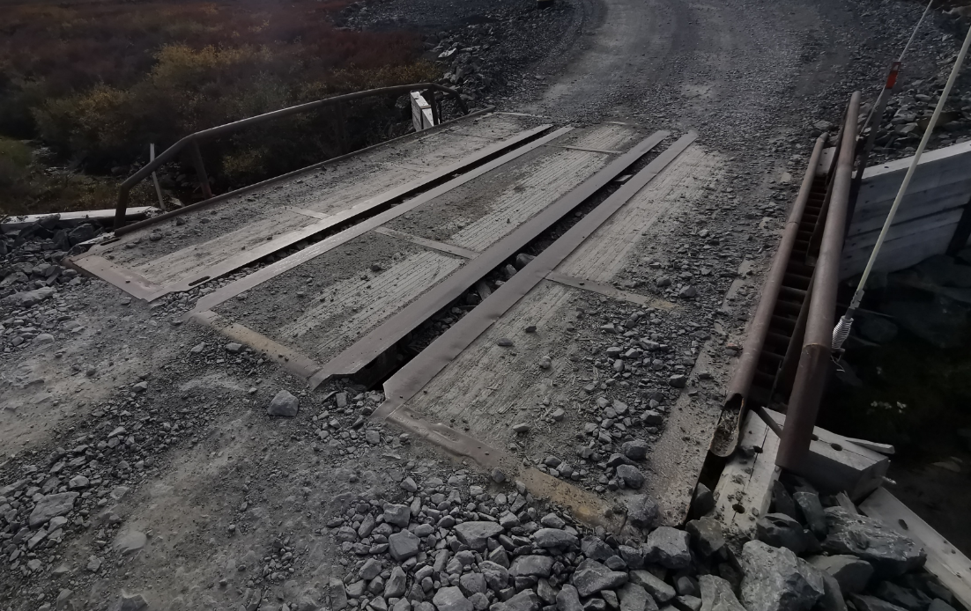
Newly constructed bridge number 1.
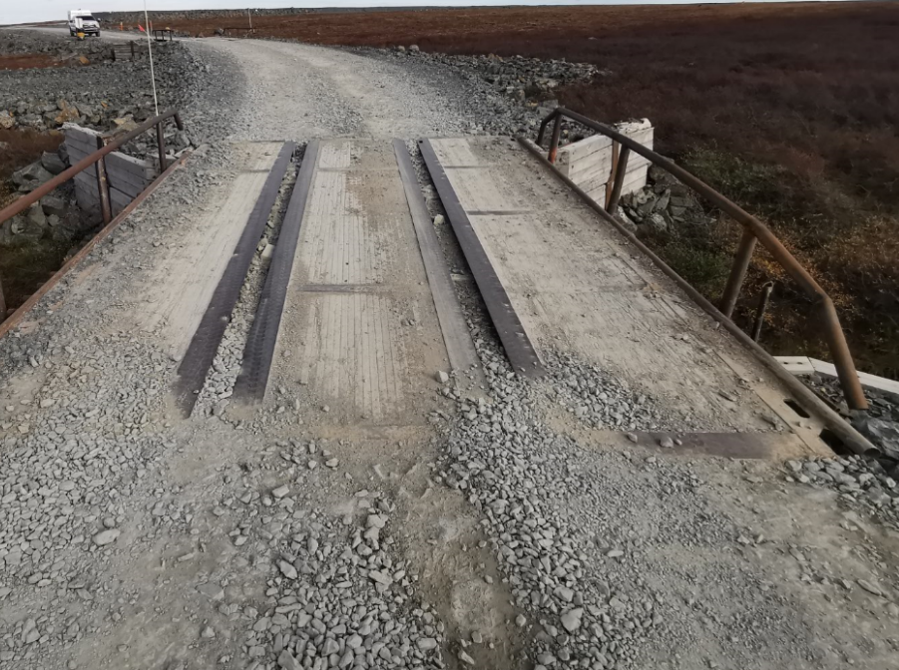
Newly constructed bridge number 2.

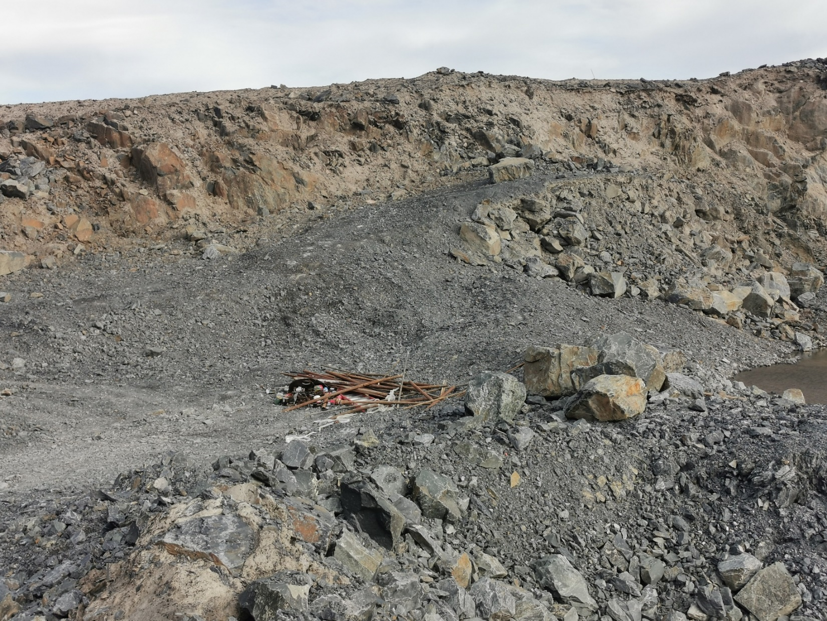
Main quarry. Photograph number 1.
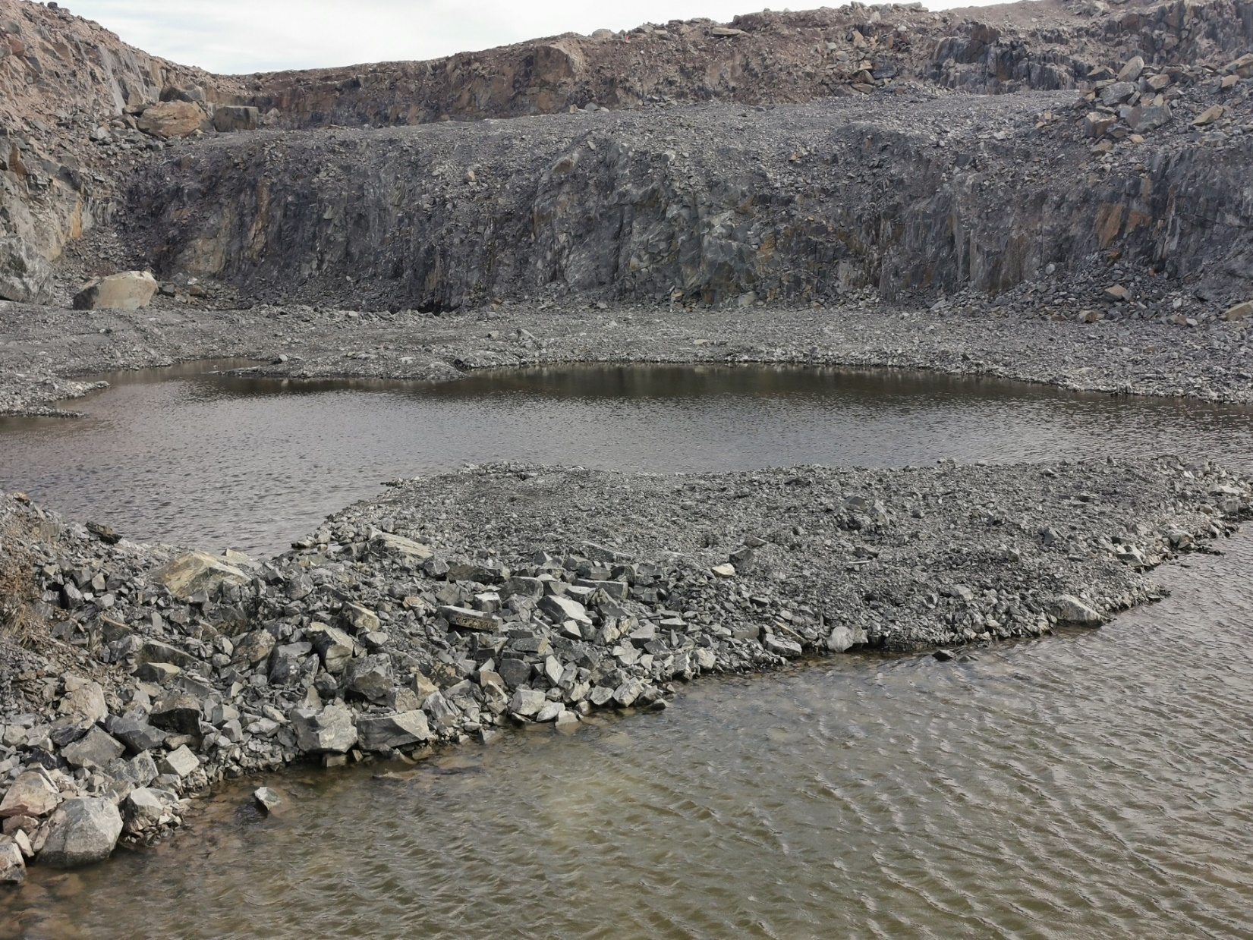
Main quarry. Photograph number 2.

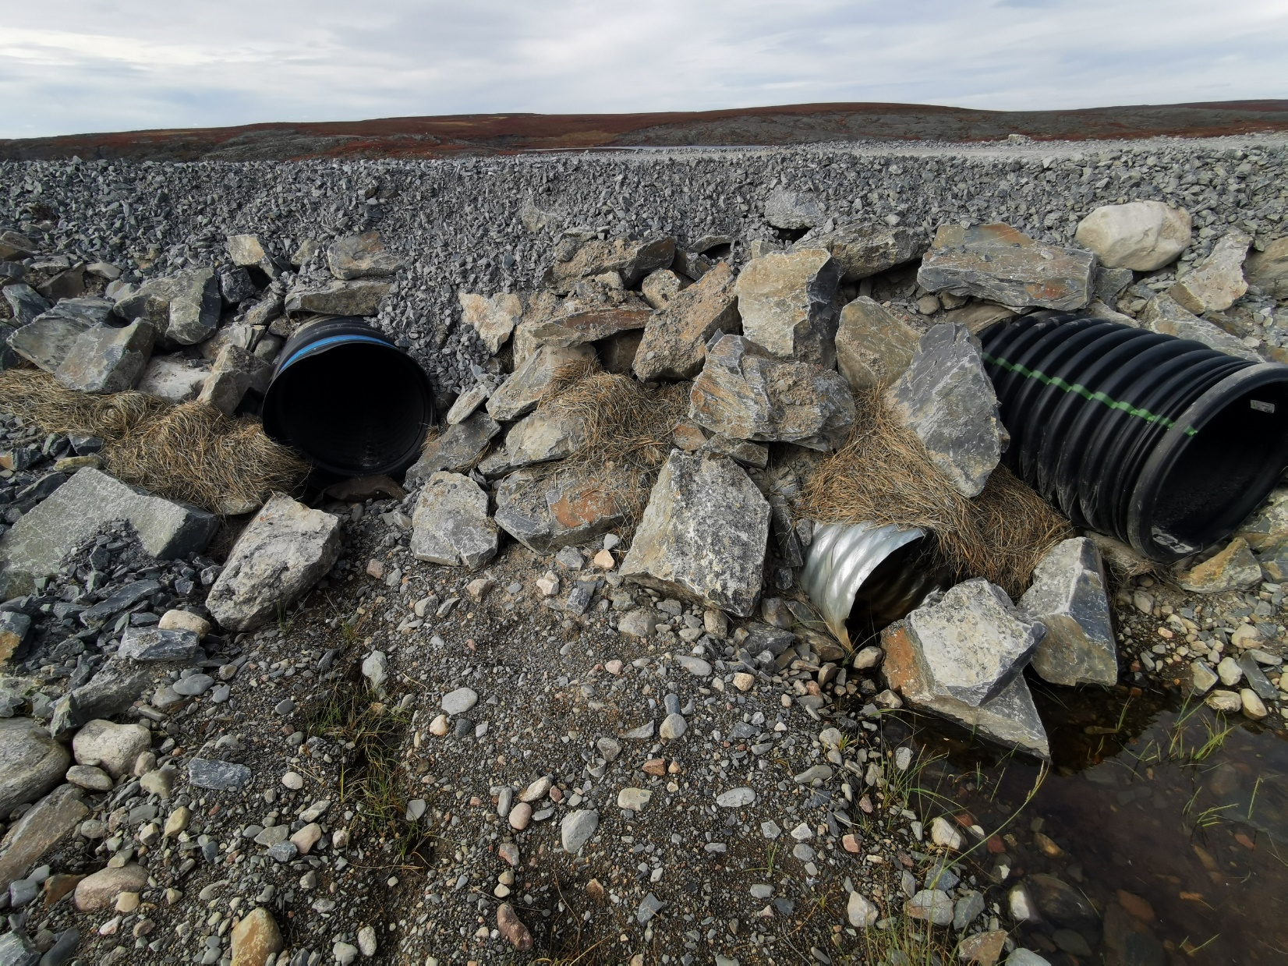
Culverts.
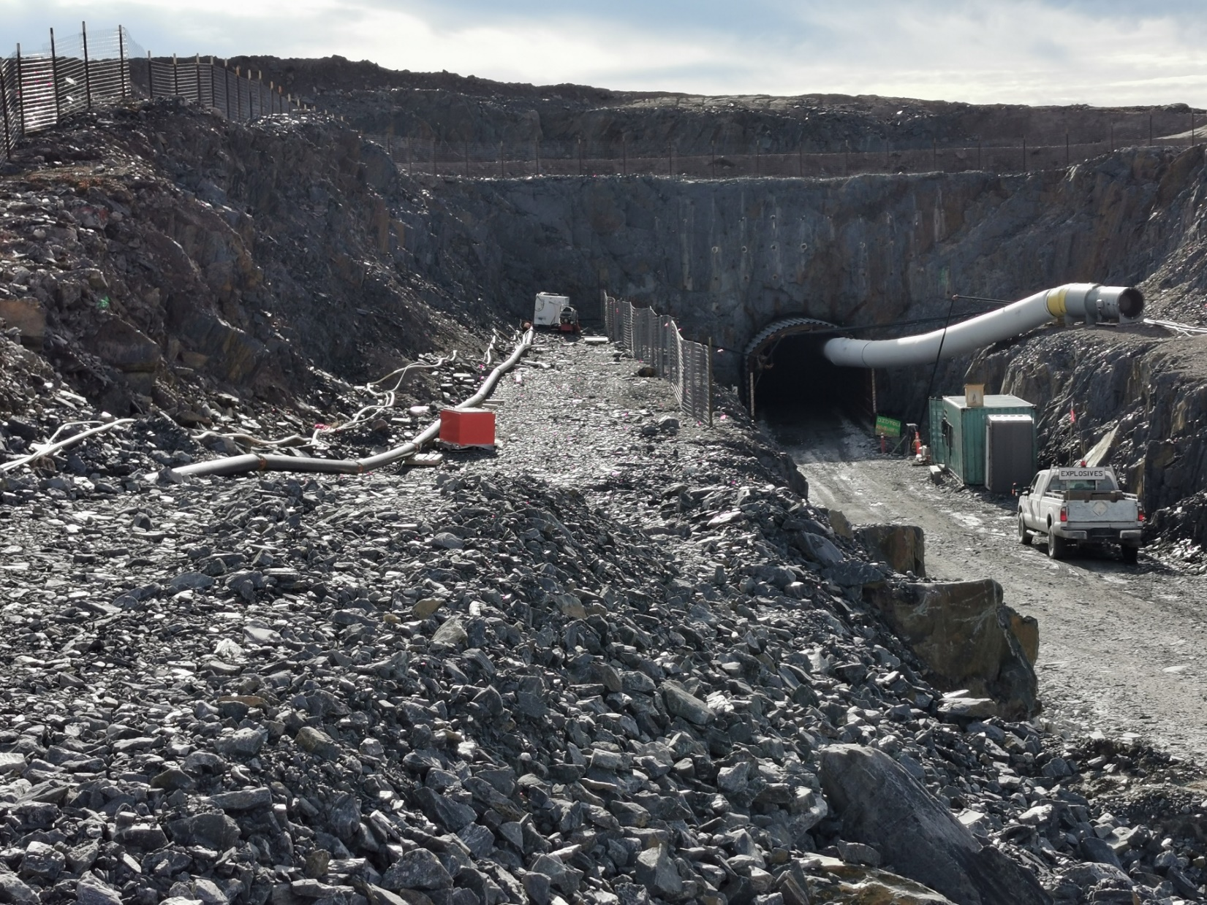
Portal to the mine.

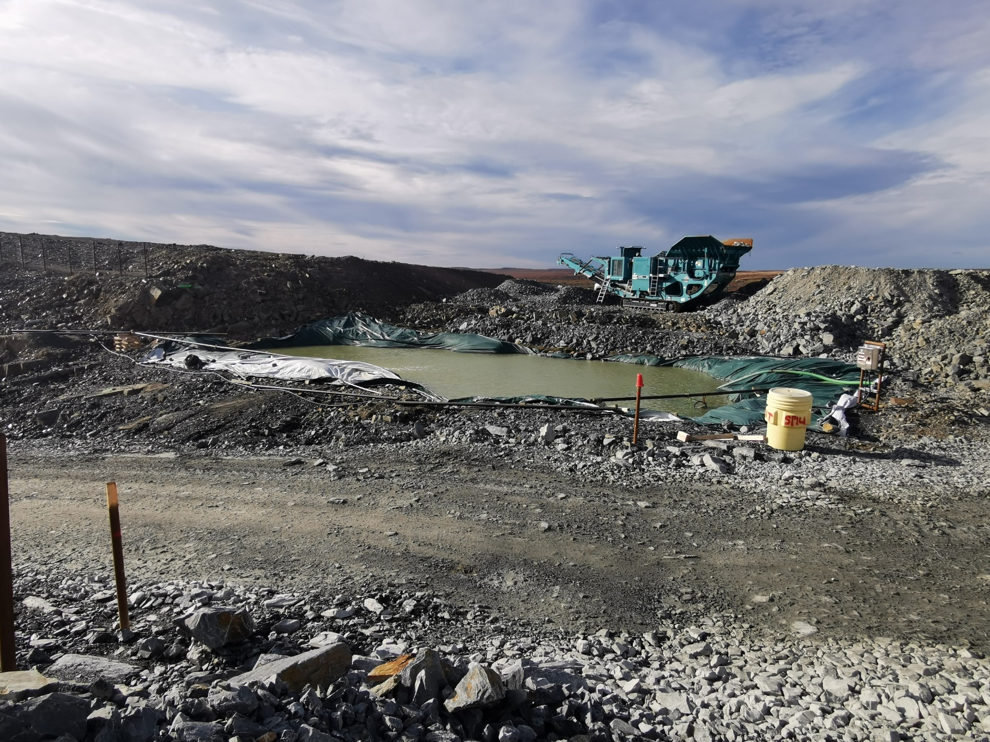
Water re-circulation pond.
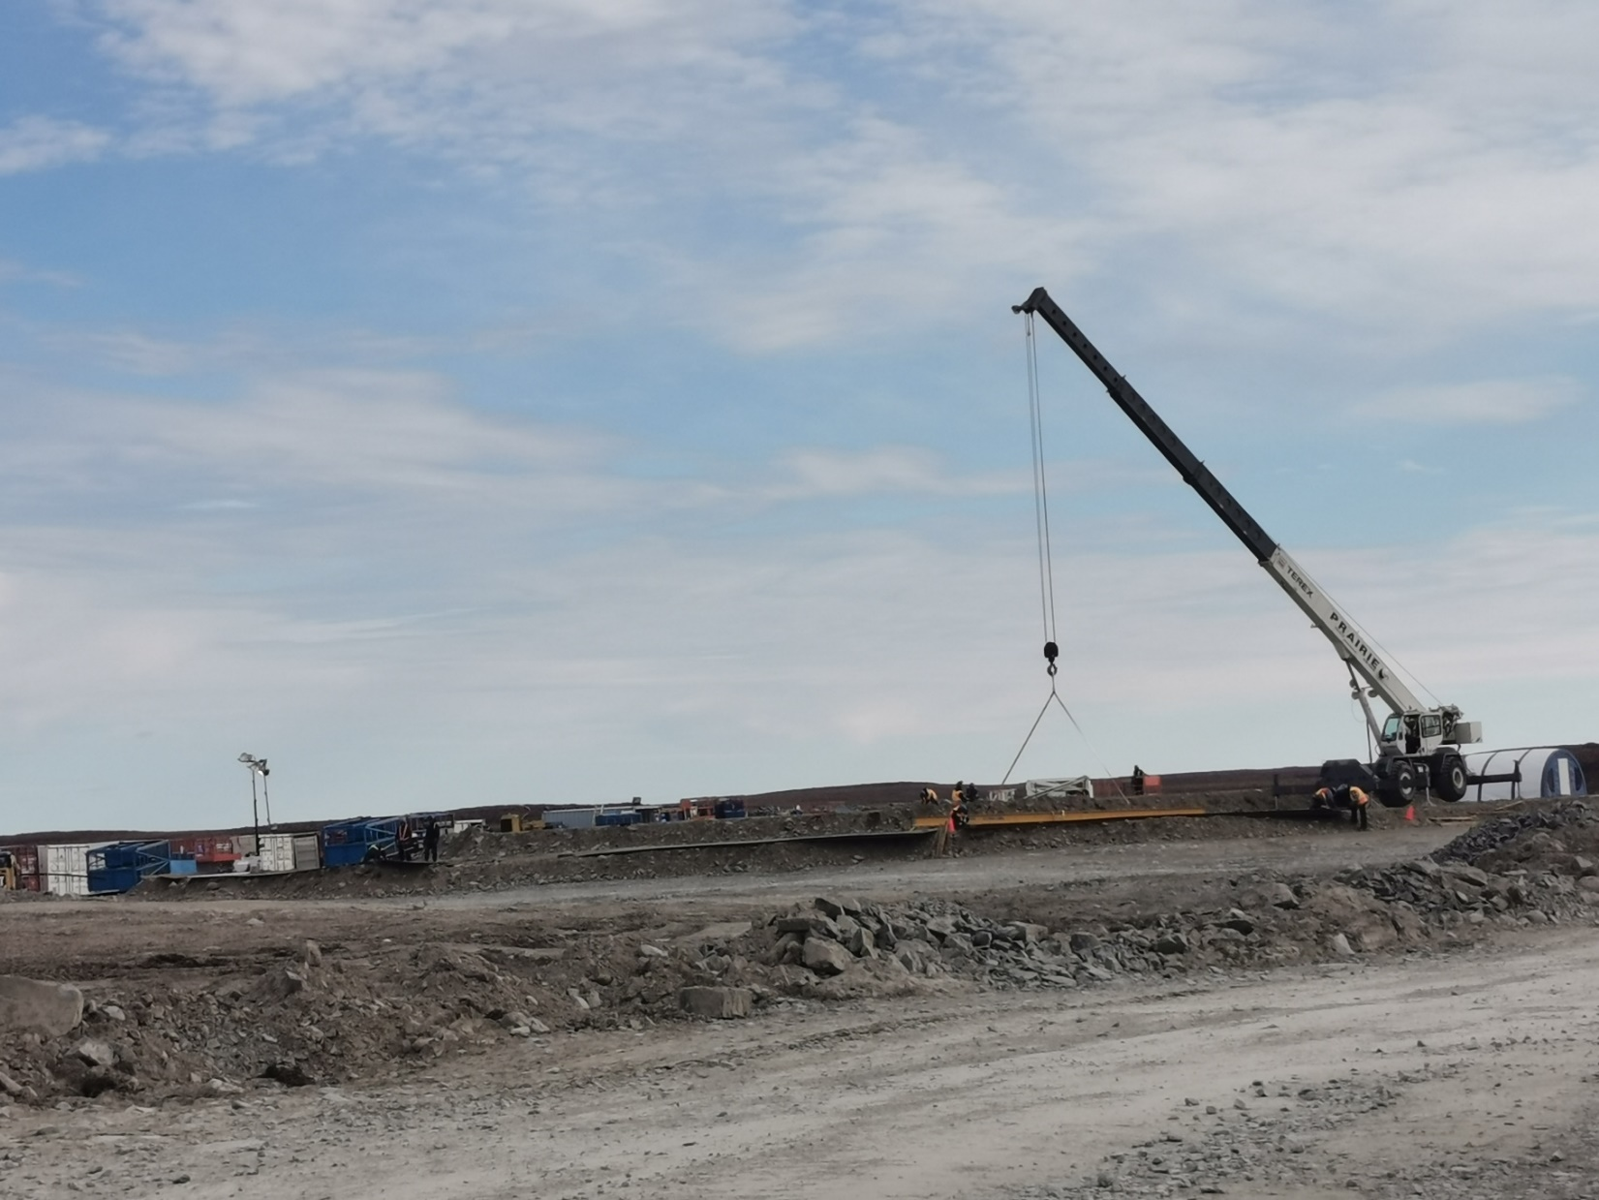
New camp construction site. Photograph number 1.

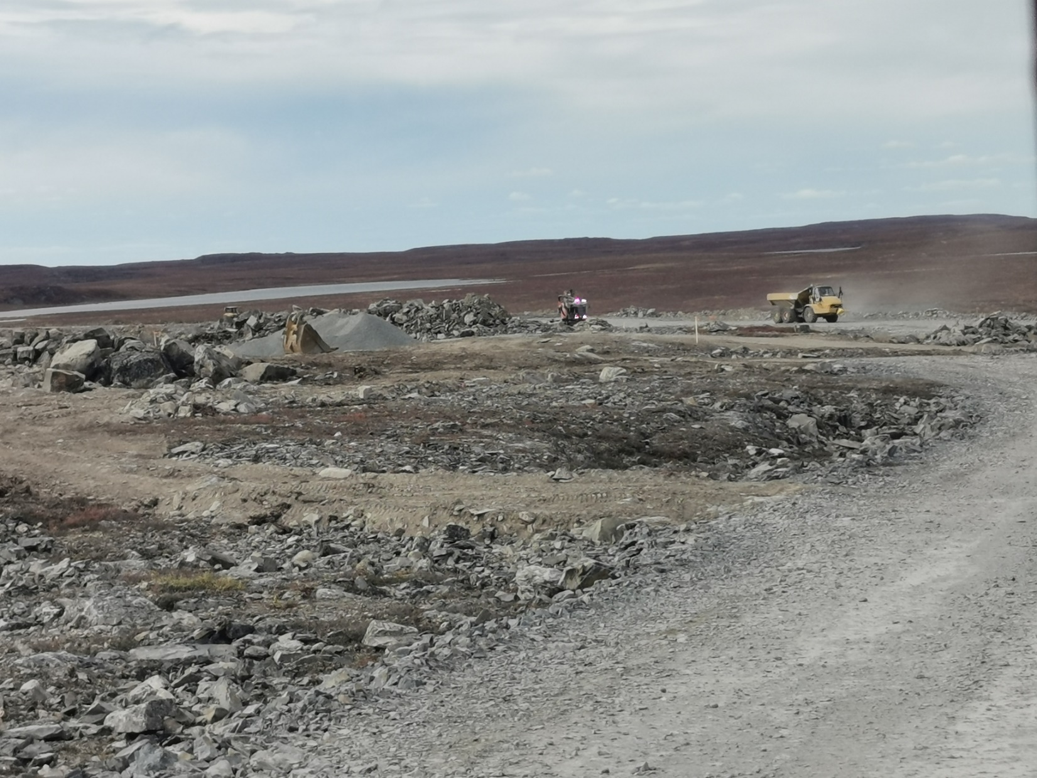
New camp construction site. Photograph number 2.
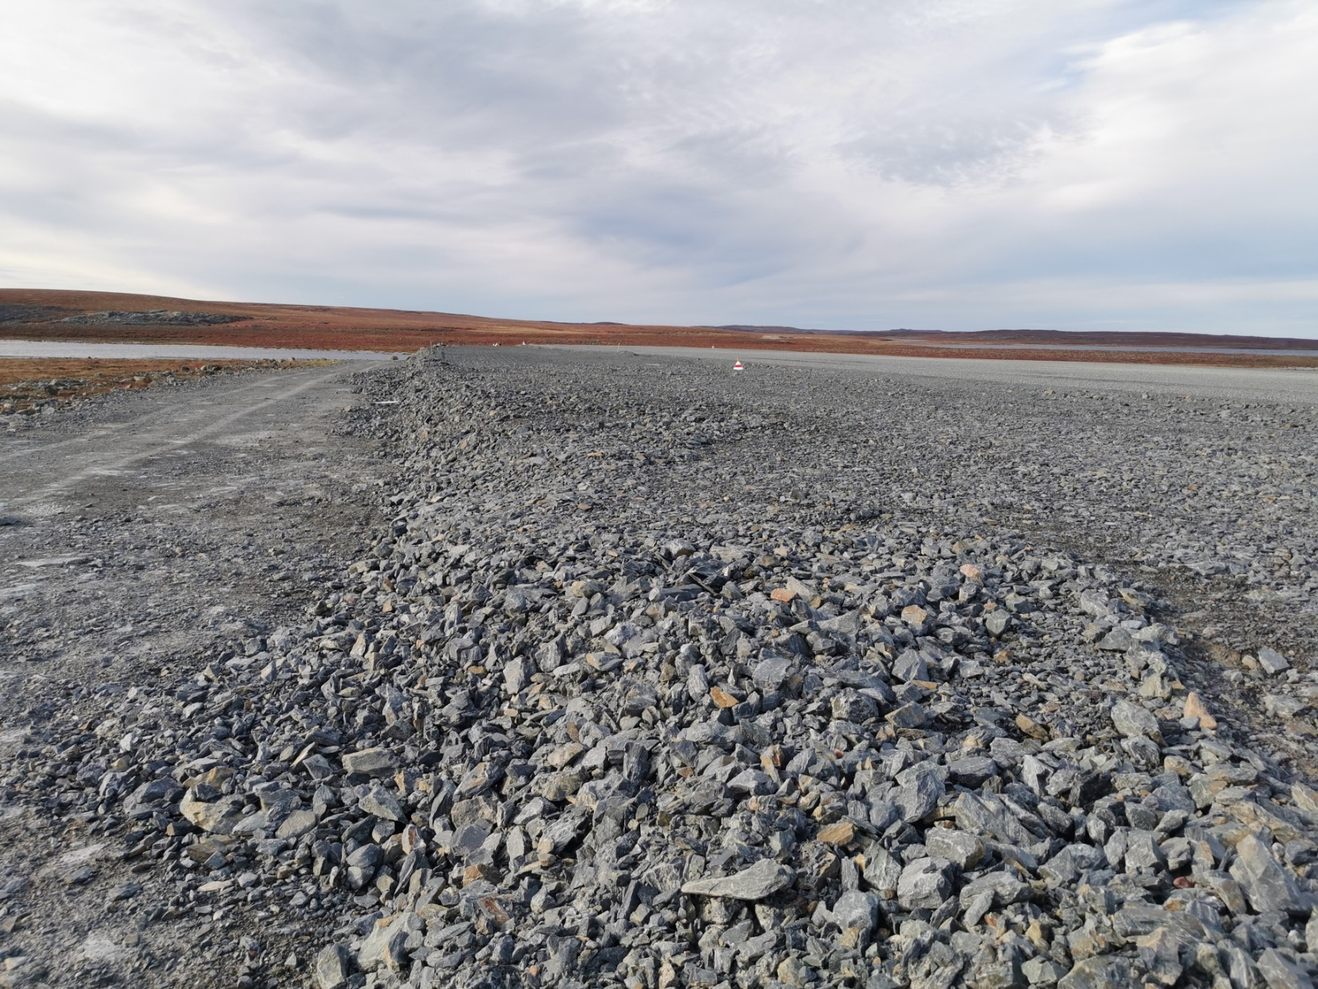
Air strip widening.

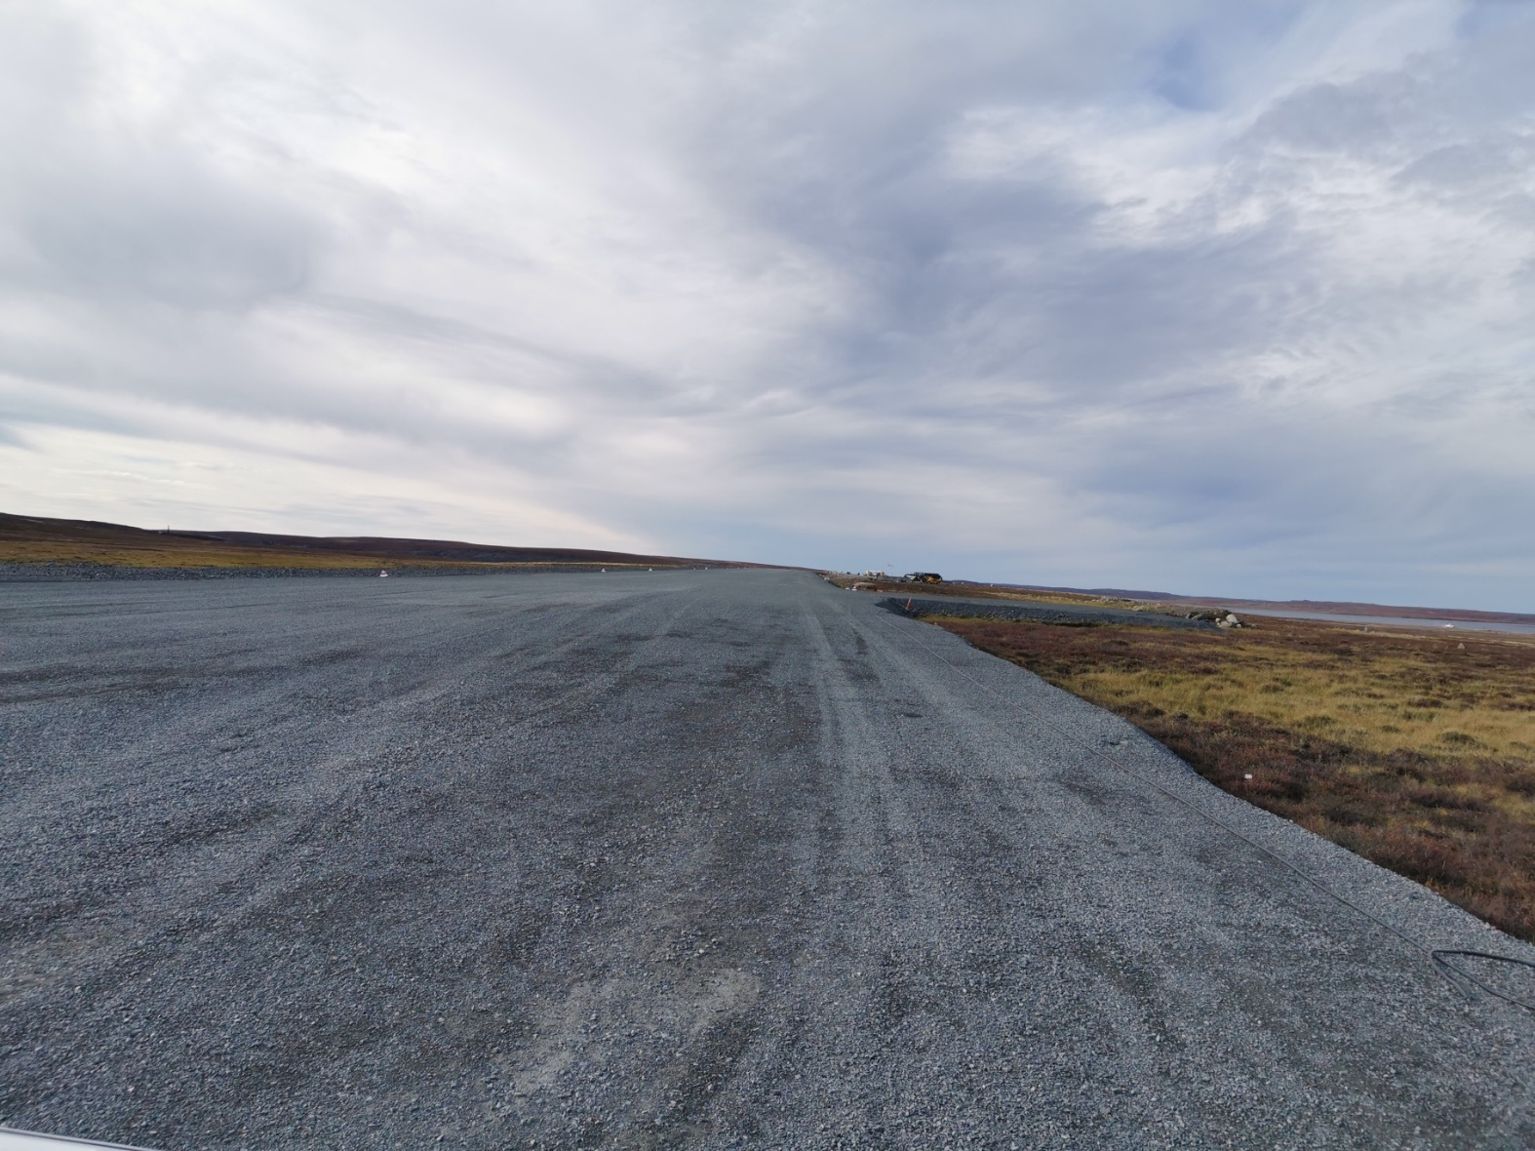
Runway.
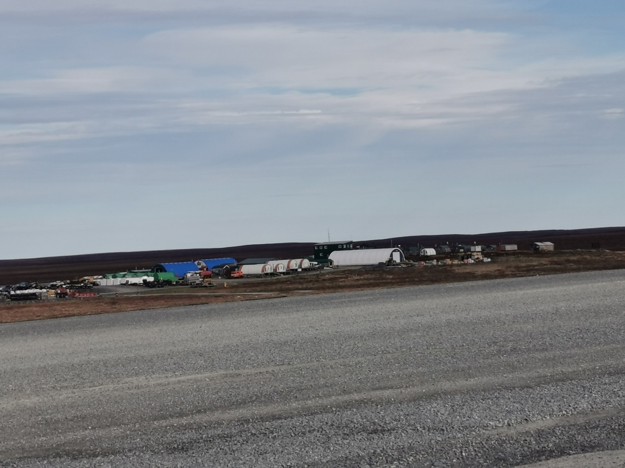

Goose Bay overall site.

