Richard Dwyer

Kugluktuk

Bathurst Inlet
Kingaok

Bay Chimo
Umingmaktok

Cambridge Bay
Ikaluktutiak

Gjoa Haven
Okhoktok

Taloyoak

Kugaaruk

Manager of Licensing
Nunavut Water Board
P.O. Box 119
Gjoa Haven, Nunavut
X0B 1J0

July 13th, 2023

Re: Review of Sabina Gold & Silver 2022 Annual report for Back River Project.
Dear Richard Dwyer, the KIA has reviewed Sabina’s 2022 Annual Report for the Back River project to the NWB.
- Compliance Monitoring:
The KIA’s Framework Agreement (FA) and Inuit Impact and Benefits Agreement (IIBA) with Sabina Gold & Silver Corp. the cover terms and conditions of NIRB Project Certificate 007 and the NWB Type A water license.
The Framework Agreement is a confidential agreement between KIA and Sabina that supersedes and replaces all previous contractual arrangements between both parties. Section 3.1 of the FA covers Terms and conditions of land use license and reporting.
Appendix A of Section 3.1 of the Framework Agreement specifies the details of annual reporting by Sabina to the KIA, which is summarized as follows:
Sabina is to provide an annual report to KIA providing details of its operations under any land use License, Advanced Exploration Lease and/or Commercial Lease covering the location and operations area of lands affected, and the nature of facilities and equipment at these sites. In addition, Sabina is to provide details of progressive reclamation or closure activities undertaken during the year and details of all permits, licenses, and authorizations from other regulatory bodies or agencies that are required for operations.
This annual report is to provide information on:
- Ground disturbances including land use activities for camps, infrastructure, equipment, winter roads and trails.
- Fuel and Chemical storage including Chemicals of Potential Concern inventory (COPC), fuel and chemical usage, and spill records.

- Drilling programs, methods, locations, spills of fluids or muds and the amount of water discharge.
- Water use and effects on water.
- Wildlife interaction, data logs, and summaries.
- Waste disposal, waste management practices, inventory of waste on site, and inventory of hazardous materials or non-combustible waste removed from site.
- Closure and reclamation progress associated with waste management, drilling, and ground disturbance along with associated costs.
- General information on annual inspection activities by staff and other agencies and their results, community consultations, future exploration work plans, submissions to NIRB, NWB, or NPC or other regulators related to mining activity, archaeological sites and burial grounds, and any incidents of storage or possession of alcohol and drugs on site.
Sabina has provided the KIA with the Back River Project 2022 Annual Report for KIA Framework Agreement in accordance with Appendix A to Schedule 3.1 of the Framework Agreement. This report is separate from the Back River 2022 Annual Report to the NWB.
Compliance Status

- Effects of Monitoring:

- Whether the conclusions reached by Sabina in the Back River 2022 Annual Report to the NWB are Valid.

KIA’s consultants in the areas of aquatic sciences, and geotechnical engineering reviewed the Back River 2022 Annual Report to the NWB and the following documents:

- Back River Project 2022 Nunavut Water Board Annual Report,
- Appendix C Monitoring Activity Overview by Station,
- Appendix D Water Quality Analytical Results,
- Appendix E Back River Project 2022 Aquatic Baseline Report,
- Back River Landfill and Waste management Plan, and
- Back River Incinerator Plan.
In 2022, Sabina completed several initial construction activities at the site that focused on advancing and de-risking future development. However, no mine waste and water management infrastructure has yet been developed at the Goose site nor at the MLA site. Therefore, only limited activities fell under the reporting requirements listed under Schedule B of the NWB Water Licence.

Overall, our consultants find Sabina’s conclusions in the 2022 Annual Report to the NWB are valid. Sabina has presented adequate information to demonstrate that the Back River Project has complied with the conditions of its Type A water license.

- Any areas of significance requiring further supporting information or changes to the monitoring program, which may be required.

Back River Project 2022 Annual Report to NWB

KIA-NWB-01

Review Comment Number | KIA-NWB-01
Subject/Topic | Quality control of metals data
References | Appendix E Back River Project 2022 Aquatic Baseline Report; Sub appendix A – Section 3.3.2.3
Summary | Clarity in the specificity of notable dissolved solids is required.
Detailed Review Comment | It is stated on pg. A-5 that “Where results of the total and dissolved concentrations were more than five times the DL and the RPD between the dissolved and total concentration was more than or equal to 20%, the dissolved concentration was considered notable.”  Presumably what is meant is that if the dissolved metals concentration is >20% above the total, the sampled is flagged. As stated, the text also means that a sample is considered "notable" if <80% of a metal is present in dissolved form (based on the definition of Relative Percent Difference (RPD) in Section 3.3.2.2); in reality, there is no reason to expect this.
Recommendation/Request | Please revise the text so that it accurately identifies the notability of a sample only when the concentration of dissolved metals is greater than the concentration of total metals. The action that follows the identification of a "notable" result should also be specified.
Importance | Moderate

KIA-NWB-02

Review Comment Number | KIA-NWB-02
Subject/Topic | Underground Ramp
References | Operations Overview \ 2022 HIGHLIGHTS AND CHALLENGES
Summary | Approximately 1,500 m of exploration underground ramp completed
Detailed Review Comment | No information about the development of the exploration underground ramp was included in the 2022 Annual Report. KIA’s consultant should indicate the conditions encountered during the construction of the exploration underground ramp. In particular, the consultants should indicate if permafrost conditions were encountered during the excavation of the ramp, or if inflow of saline water or freshwater was experienced during the development of the ramp.
Recommendation/Request | In case inflow into the ramp was experienced, the consultants should indicate the type of water (saline or fresh), the amount, the quality and the discharge point.
Importance | Moderate

KIA-NWB-03

Review Comment Number | KIA-NWB-03
Subject/Topic | Appendices
References | Appendix C Monitoring Activity Overview by Station
Summary | Appendix C is missing from the PDF of the report.
Detailed Review Comment | The missing Appendix C may contain information pertaining to fish and fish habitat.
Recommendation/Request | Please repost the 2022 Annual Report with all appendices.
Importance | Moderate

KIA-NWB-04

Review Comment Number | KIA-NWB-04
Subject/Topic | Spills
References | Section 2.11 A LIST AND DESCRIPTION OF ALL UNAUTHORIZED DISCHARGES INCLUDING VOLUMES, SPILL REPORT LINE IDENTIFICATION NUMBER AND SUMMARIES OF FOLLOW-UP ACTION TAKEN
Summary | Dozer fell through the ice. 150 L of hydrocarbons is listed as being spilled.
Detailed Review Comment | For mitigation of this spill, it is stated the incident is currently under investigation. The hydrocarbon type is not listed, nor whether they are still contained in the vehicle or if the vehicle is still in the water body.
Recommendation/Request | Please provide more information on the type of hydrocarbons and whether the total amount of 150 L was actually lost in the water body. Additionally, please provide information on fish presence in the water body and whether any spill containment or cleanup occurred in 2022.
Importance | Moderate

KIA-NWB-05

Review Comment Number | KIA-NWB-05
Subject/Topic | Water and Load Balance Report - Flow Diagrams
References | Flow Diagrams
Summary | Pit Dewatering
Detailed Review Comment | Umwelt Open Pit inflows will be pumped to Primary Pond during construction. Llama Pit inflows will be pumped to the Saline Water Pond during Operations (Year 1).  In addition, inflows into the Umwelt Open Pit are considered “Contact Water” (Figure B-2) while inflows into Llama Pit are considered Saline Water.
Recommendation/Request | Please provide the rationale for considering the inflows into Umwelt Open Pit as “Contact Water” and the inflow into Llama Pit as “Saline Water”.
Importance | Moderate

KIA-NWB-06

Review Comment Number | KIA-NWB-06
Subject/Topic | Water and Load Balance Report – Appendix C
References | Fe-flow model
Summary | Calibration
Detailed Review Comment | Golder made the following modifications to the 2015 SRK numerical model:  - Grid refinement in proximity of Llama Open Pit, the Llama, Goose Main, and Echo underground workings;  - Addition of two layers to increase the maximum depth of the modelled area;  - Layers 2 and 3 of the previous model were removed; and  Boundary conditions have been updated.
Recommendation/Request | Golder should clarify how these changes affected the calibration and the overall baseline condition model mass budget.
Importance | Moderate

KIA-NWB-07

Review Comment Number | KIA-NWB-07
Subject/Topic | Water and Load Balance Report – Appendix C
References | Fe-flow model
Summary | Hydraulic Conductivity - 1
Detailed Review Comment | The vertical profile for the hydraulic conductivity shows a decrease in K-values with depth. Based on this assumption, higher groundwater inflows should be expected in the open pits rather than in the underground workings. The results included in Table 1 show the opposite occurring, with higher inflow values for the underground workings rather than the open pits.  In addition, the model should take into consideration that up to a depth of approximately 400 metres below ground surface, the soil is frozen, which results in minimal inflows into the open pits.
Recommendation/Request | Golder should clarify the reason why higher groundwater inflows have been estimated for the underground workings rather than the open pits, considering that the K values decrease with depth.  In addition, it should be further explained if the numerical model is capable of simulating (e.g., by reducing the K value) the presence of frozen soil up to 400 mbgs.
Importance | Moderate

KIA-NWB-08

Review Comment Number | KIA-NWB-08
Subject/Topic | Water and Load Balance Report – Appendix C
References | Fe-flow model
Summary | Hydraulic Conductivity - 2
Detailed Review Comment | The bullet point list at Page 4 of Appendix C describing two scenarios for conductivity (see screenshot below) should indicate mbgs rather than masl. If 0 masl is being used a local datum, that should also be stated.  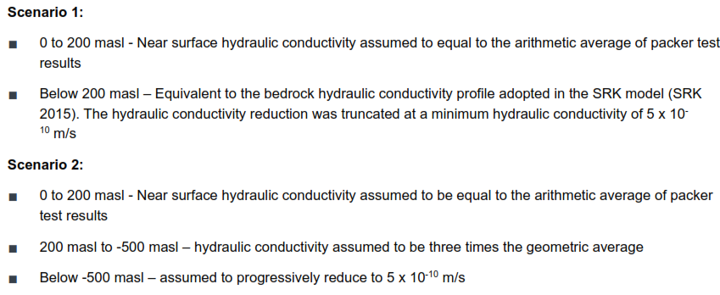
Recommendation/Request | Please review and update/ clarify the bullet point list, as needed.
Importance | Low

KIA-NWB-09

Review Comment Number | KIA-NWB-09
Subject/Topic | Water and Load Balance Report – Appendix C
References | Fe-flow model
Summary | Model Predictions
Detailed Review Comment | Golder states that groundwater inflows to the Llama Open Pit are expected to be minimal (i.e., less than 50 m³/day) as the area is under drained by the dewatered Llama Underground.  No groundwater inflows have been estimated for Umwelt Pit, Echo Pit and Goose Pit.
Recommendation/Request | It is recommended to produce an additional model run to estimate the groundwater inflow with the open pit only scenario.  Please clarify the rationale for not estimating groundwater inflows for Umwelt Pit, Echo Pit and Goose Pit.
Importance | Moderate

KIA-NWB-10

Review Comment Number | KIA-NWB-10
Subject/Topic | Water and Load Balance Report – Appendix C
References | Fe-flow model
Summary | Model Predictions
Detailed Review Comment | Golder states that to estimate groundwater inflows, the 2015 SRK Fe-flow model was used. Minor changes have been made by Golder, as described in Comment KIA-NWB-04.  Golder Scenario 1, which has the same hydraulic conductivity profile as the SRK model, provides groundwater inflows that are significantly different than the one estimated by SRK.
Recommendation/Request | Please provide an explanation for obtaining different groundwater inflow values, from using the same numerical model. Alternatively, please outline any changes to the model parameters that were implemented and their rationale.
Importance | Moderate

KIA-NWB-11

Review Comment Number | KIA-NWB-11
Subject/Topic | Maintenance and aggradation of permafrost below and within landfills.
References | Landfill and Waste Management Plan
Summary | An updated Landfill and Waste Management plan (LWMP) was presented in consideration of all applicable guidelines and requirements, including those of the Type A Water Licence, 2AM-BRP1831, and Project Certificate, No. 007. The revision reflects construction phase waste management activities, to align with the overall project waste management approach, and to complement and remove overlap with related waste management plans.
Detailed Review Comment | KIA understands that Sabina proposes to use the area fill method to develop landfills within the Waste Rock Storage Areas (WRSAs). According to the LWMP (Section 7.3.1) they “will be designed to ensure the maintenance and aggradation of permafrost”. However, based on the information provided in Section 8 (Environmental Protection Measures and Monitoring Program) of the LWMP, it is not clear how the performance of the landfills, specifically the maintenance and aggradation of permafrost, is measured.
Recommendation/Request | Sabina (B2Gold Nunavut) should provide information on how the ground thermal regime is monitored and what performance criteria is used to ensure the maintenance and aggradation of permafrost below and within the landfills.
Importance | Moderate

KIA-NWB-12

Review Comment Number | KIA-NWB-12
Subject/Topic | Incinerator Log
References | Sabina, Back River Project 2022 Annual Report for Water Licence 2AM-BRP1831 (March 31, 2023)  - FEIS Vol 10: No.10 - Waste Management Plan  - FEIS Vol 10: No. 11 - Incineration Management Plan
Summary | Section 8 (Record Keeping) of the FEIS (Vol 10: Waste Management Plan) states that “Waste material logs will be completed to track the volume, material type and material source for all materials that are passed through the waste segregation and waste management process”. The IMP states that “Prior to incineration, the type of waste in each bag will be determined, weighed, and the source noted. The total weight of each type of waste will be recorded before the burn cycle is started.” However, there is no information on record-keeping for the incinerator at the MLA except during the months of November and December 2022.
Detailed Review Comment | Within the 2022 Annual Report for Water Licence 2AM-BRP1831, pages 2-8, Sabina states that “wastes incinerated at the MLA were not tracked until November of 2022 due to a record-keeping oversight.” In addition, Sabina states in Section 2.10 “No incinerator testing was conducted in 2022.” However, it is unclear from the IMP whether stack emissions testing is required during the pre-construction and construction phases.  Garbage and waste can pose a wildlife management concern as they can be attractants for grizzly bears. In addition, if no incineration testing is conducted, it is impossible to determine if toxic ash may be spread through dust on the tundra. If ash contains toxic components, these toxic components may be ingested by wildlife that eat vegetation or may build up in surrounding soils and vegetation.  Currently, information on waste incineration and incinerator testing is necessary to determine if Sabina is in compliance with Canada-wide Standards.
Recommendation/Request | The KIA requests the following:  In the absence of a record-keeping log for incinerated waste between January and October 2022, please clarify approximate volumes of waste and waste types incinerated at the MLA during the 2022 period and whether there were any unusual incinerating events (e.g., unusually large incinerating events or incineration of waste types that should be disposed of differently).
Importance | Low

KIA-NWB-13

Review Comment Number | KIA-NWB-13
Subject/Topic | Updates to Plan and Reports
References | Sabina, Back River Project, 2022 Annual Report for Water Licence 2AM-BRP 1831 (March 31, 2023) Section 2.20
Summary | Section 2.20 provides a table describing updates made to various plans and includes the current update date. While plans submitted in April of 2022 were indeed available on the WLB FTP site (Water Management Plan, Tailings Management Plan, Mine Waste Rock Management Plan), these plans are still listed as pending NWB approval in a Table in Section 2.20. Sabina has not addressed the KIA’s previous review comments on the Landfill and Waste Management Plan, Waste Rock Management Plan, and 2021 Interim Closure and Reclamation Plan.
Detailed Review Comment | In Section 2.20 Sabina states that they have submitted updates to the following plans:  - Landfill and Waste Management Plan (August 2022)  - Water Management plan (April 2022)  - Tailings Management Plan (April 2022)  - Mine Waste Rock Management Plan (April 2022)  These 2022 plans were available on the NWB FTP site. However, there is potentially a typo within the table in Section 2.20, which lists these updated plans as “pending NWB approval”. This may not be a typo, if the NWB has indeed not accepted them.  The KIA previously submitted review comments on the August 2022 version of the Landfill and Waste Management Plan, submitted to the NWB in September 2022. As Sabina still needs to produce an updated Landfill and Waste Management Plan, the KIA’s questions and concerns still need to be addressed.  In addition, in the 2021 Annual Review of Water Licence 2AM-BRP1831, the KIA indicated that the Waste Rock Management Plan is vague on measures to manage waste rock seepage and runoff. Sabina responded that updates would be completed in the next iteration of the Waste Rock Management Plan and appended as an addendum to the Annual Report (March 2023). The 2022 Waste Rock Management Plan should have included these updates. It is unclear whether these updates are in progress and will be provided as an addendum to the 2022 Annual Report for Water Licence 2AM-BRP1831, as there were no plan updates since April 2022 on the NWB FTP site.  Similarly, during the 2021 Annual Report for the Water Licence review, the KIA noted discrepancies between waste rock and overburden volumes reported in the WRMP compared to those presented in the July 2021 Interim Closure and Reclamation Plan (ICRP). Sabina responded that updates would be completed to the volumes and areas of the waste rock storage areas, as appropriate, in the next iteration of the ICRP, as an addendum to the Annual Report (March 2023). At the time of review of the 2022 Annual Report, an updated ICRP was unavailable.
Recommendation/Request | The KIA requests the following:  - Please update the table in Section 2.20 to correct the plans, if they are erroneously listed as pending NWB approval, and are available on the NWB registry.  - The KIA would like to review the ICRP update when it becomes available. Please indicate when updated ICRP and Landfill and Waste Management Plans can be expected.  - Future iterations of the Annual Report should reflect reporting commitments, including any updates to the above plans.
Importance | Low

Thank you.
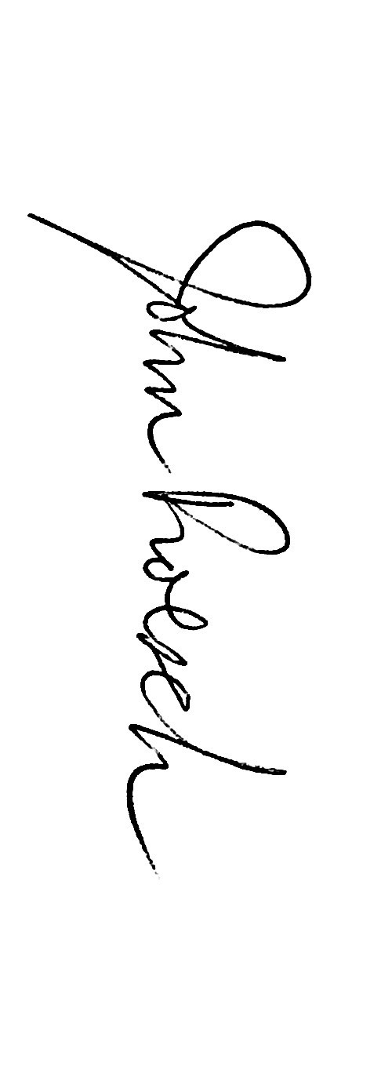
John Roesch, P.Eng.
Senior Hope Bay Project Officer
Kitikmeot Inuit Association, Department of Lands and Environment

Cc Wynter Kuliktana, Director, KIA, Department of Lands and Environment

