

Eva Paul
Water Resource Officer
Aboriginal Affairs and Northern Development Canada
Building 918, PO Box 100
Iqaluit, NU. X0A 0H0

Dear Eva:
RE: Follow up for spill #12-148 reported April 26th, 2012

This report is being submitted in accordance with the terms and conditions in Part H, Section 8(c) of Shear Diamonds Water Board (NWB) License 2AM-JER1119 pursuant to the Nunavut Waters and Nunavut Surface Rights Tribunal Act and as required by Environment Canada’s Storage Tank Systems For Petroleum Products and Allied Petroleum Products Regulations section 41 pursuant to paragraph 212(1)(a) of the Canadian Environmental Protection Act, 1999.

Summary

On April 25th, 2012 at approximately 4:30 AM it was discovered that a fuel tank located within the powerhouse, generator #3, was left to fill overnight. The tank overflowed into the powerhouse and eventually leaked out onto the ground beneath the powerhouse. At the time it was estimated that there was about 400L that spilled out of the powerhouse. This estimate was based on fuel dips that were taken around that date and comparing to normal fuel usage. The spill was reported to the Site manager and personnel were able to recover 100L of diesel that had pooled on the ground (Figure 1) by bailing it into a drum. The rest of the diesel on the ground was cleaned up by using absorbent pads.

Figure 1
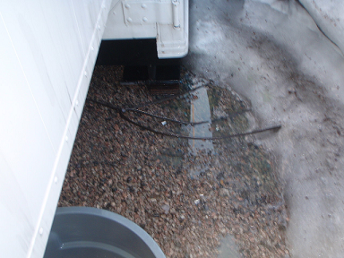

The spill coordinates are N 65 59’26.7” W 111 29’56.9”, approximately 550m northeast of Ash Lake and 1.4Km south of Carat Lake. The area of the spill was approximately 10 square meters. The indoor tank was being filled from tank EC-000158282. Once the spill was cleaned up the diesel that was collected was brought into the truck shop to fuel a waste oil burner.

Immediate Action

The spill was contained following the Diesel Spill Response Procedure outlined in Appendix A of our Contingency Management Plan. As soon as the spill was discovered the pump was turned off. A shallow trench was dug around the area to collect any contaminated runoff (Figure 2).

Figure 2
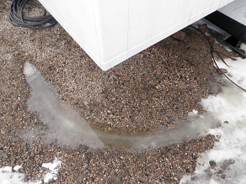

Follow-up Action

The trench that was dug around the area will have to be monitored and emptied whenever water pools up to minimize the spread of diesel to the surrounding area. Approximately 40L of diesel contaminated water has been removed from the trench and put in a drum for storage until it can be treated with the Oztek remediation unit. Contaminated dirt located beneath the generator is inaccessible due to buried cables and foundation issues of the building. Therefore the area beneath the building has been declared a contaminated site that will require on-going monitoring until such time as the area can be reclaimed upon mine closure.

An investigation into the cause of this spill has determined that it was due to human error. Fuel handling procedures are being reviewed with all applicable staff and everyone is taking part in a refresher on spill reporting and clean up procedures.

If you require additional information or clarification regarding this spill please contact me at any time.

Wes Atchison
Environmental Technician
Shear Diamonds
Jericho Diamond Mine
watchison@sheardiamonds.com
Ph - 778-372-2723

