WATER LICENCE INSPECTION FORM |  |  |  |  |  | Original
 |  |  |  |  |  | Follow-Up Report
Licensee |  |  | Licensee Representative
Agnico Eagle Gold Mines |  |  | Samuel Tapp
Licence No. / Expiry |  |  | Representative’s Title
2AM-MEA1530/ March 27, 2030 |  |  | Environmental Coordinator
Land Authorization No. |  |  | Land Authorization No.
66A-8-71 All Weather Access Road |  |  | 66A-8-72 Quarry Lease
Date of Inspection |  |  | Inspector
September 12-14, 2022 |  |  | WRO K AMSEL
Activities Inspected
Camp | Drilling | Mining |  | Construction | Reclamation |  | Fuel Storage
Roads/Hauling | Other: |  |  | Other:

SECTION 1 | Comments (s.__) | Non-Compliance with Act or Licence (s.__) | Action Required (s.__)
Between September 12-14, Water Resource Officer Kyle Amsel (Inspector) for Crown-Indigenous Relations and Northern Affairs Canada conducted an inspection of Water Licence number 2AM-MEA1530 (Licence). The licence is issued to Agnico Eagle Mines Limited (Licensee) for the use of waters and deposit of wastes in support of a mining undertaking (Undertaking).
Accompanying the Inspector was Environment Coordinator, Samuel Tapp. The aforementioned is here on referred to as representative.
Preliminary Information
The primary focus of this inspection was completing closures of spills reported to the NT-NU 24hr Spill Reporting Line. The secondary focus was follow up to items noted in the June 15, 2022 inspection.

Observations
- The following 21 spills were inspected and recommended for closure-remediated.
  - 2022-440 Recommended for closure.
  - 2022-342 Recommended for closure.
  - 2022-192 Recommended for closure.
  - 2022-060 Recommended for closure.
  - 2021-489 Recommended for closure.
  - 2021-450 Recommended for closure.
  - 2021-447 Recommended for closure.
  - 2021-437 Recommended for closure.
  - 2021-414 Recommended for closure.
  - 2021-244 Recommended for closure.
  - 2021-093 Recommended for closure.
  - 2021-026 Recommended for closure.
  - 2021-026 Recommended for closure.
  - 2021-010 Recommended for closure.
  - 2020-412 Recommended for closure.
  - 2020-387 Recommended for closure.
  - 2020-294 Recommended for closure.
  - 2020-098 Recommended for closure.
  - 2020-077 Recommended for closure.
  - 2020-032 Recommended for closure.
  - 2019-430 Recommended for closure.

- Spill file 2021-387 was inspected with no concerns noted. The representative indicated the spill site would be sampled this year and resampled in 2023 to ensure remediation. The location was selection in consultation with the Inspector (photo 1).
- Five spills occurred in the two HDPE lined fuel transfer area at the Mine site and Marshalling Facility. A sheen was noted on the water puddles and/or smell of fuel at the location. Due to the area being lined there is no concern, however the spills cannot be closed-remediated. The status will be set to closed- inactive at this time.
  - 2022-141 Recommended for closure.
  - 2022-101 Recommended for closure.
  - 2020-450 Recommended for closure.
  - 2020-389 Recommended for closure.
  - 2020-172 Recommended for closure.
- Marshalling Facility
  - Total Suspended Solids (TSS) mitigation measures put in place during times of increase flow appear to be adequate and has captured sediments from flowing into Baker Lake. (photo 2)
  - A small stream appears to be still carrying TSS at N64⁰ 18’ 19.8” W95⁰ 57’ 14.7”. Representative stated mitigation measures will be installed in this area.
- NP1 West Diversion Ditch
  - The culvert connecting NP1 and NP2 Lakes situated under the Vault Haul road has been repaired to the satisfaction of the Inspector. (photo 3)
  - The location previous had reportable spills for TSS exceedances.
  - The Representative indicated on going monitoring at this location will be completed as per the Freshet Action Plan.

SECTION 2 | Comments (s.__) | Non-Compliance with Act or Licence (s.2) | Action Required (s.__)
No instances of non-compliance were noted.

SECTION 3 | Comments (s.__) | Non-Compliance with Act or Licence, (s.__) | Action Required (s.3)
Action Required
- The Licensee will provide the Inspector and the Nunavut Water Board with the long term plan to address total suspended solids from flowing into Baker Lake from the Marshalling Facility by November 18, 2022.

Licensee or Representative | Inspector’s Name
Samuel Tapp | WRO K Amsel
Signature | Signature
Date | Date
October 18, 2022 | October 18, 2022

Office Use Only: | Follow-up report to be issued by Inspector | Yes No

PHOTO LOG
Date: | Authorization Number: | Camera/Model: |  | Inspector
September 27, 2022 | 2AM-MEA1530 | Samsung S9 |  | WRO K Amsel
Photo No. |  |  | Lat/Long (DD.MM.SS.SS, NAD83)
Photo 1 |  |  | N64⁰ 18’ 19.8” W95⁰ 57’ 14.7”
Sample date |  | 10/10/2021 | 10/10/2021 | 9/12/2022
Sample name |  | Spill km103 #2 | Spill km103 #5 | ST-KM 103.2
Parameter | Unit | - | - | -
F2-F4 Hydrocarbons
Total oil and grease | ug/g | < 100 | < 100 | 149
General Organics
Total Glycols | mg/kg | < 10 | 37 | < 10
Ethylene Glycol | mg/kg | < 10 | 37 | < 10
Diethylene Glycol | mg/kg | < 10 | < 10 | < 10
Propylene Glycol | mg/kg | < 10 | < 10 | < 10
Volatile Organics
Benzene | ug/g | < 0.0060 | < 0.0060 | < 0.0060
Ethylbenzene | ug/g | < 0.010 | < 0.010 | < 0.010
Toluene | ug/g | < 0.020 | < 0.020 | < 0.020
Xylenes | ug/g | < 0.020 | < 0.020 | < 0.020
m,p-Xylenes | ug/g | < 0.020 | < 0.020 | < 0.020
o-Xylene | ug/g | < 0.020 | < 0.020 | < 0.020

Description:
Sample results for spill 2021-387

Date: | Authorization Number: | Camera/Model: |  | Inspector
September 16, 2022 | 2AM-MEA1530 | Samsung S9 |  | WRO K Amsel
Photo No. |  |  | Lat/Long (DD.MM.SS.SS, NAD83)
Photo 2 |  |  | N64⁰ 18’ 19.8” W95⁰ 57’ 14.7”
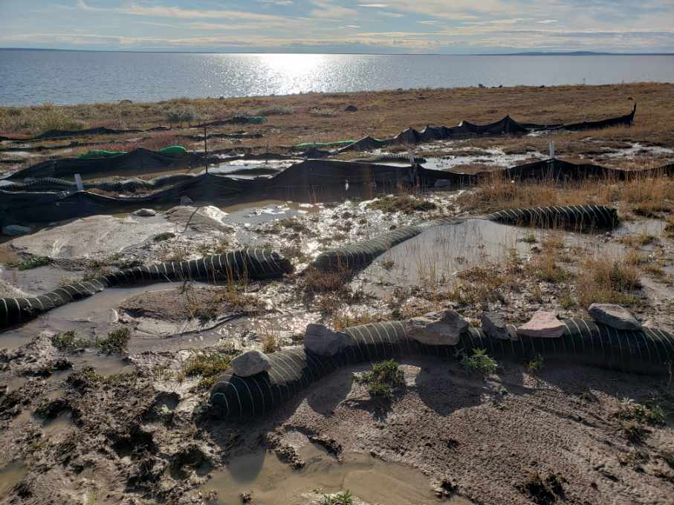
Description:
TSS mitigation measures put in place prior to Baker Lake from Marshalling Facility. Baker Lake in background.

Date: | Authorization Number: | Camera/Model: |  | Inspector
September 12, 2022 | 2AM-MEA1530 | Samsung S9 |  | WRO K Amsel
Photo No. |  |  | Lat/Long (DD.MM.SS.SS, NAD83)
Photo 3 |  |  | N65⁰ 02’ 24.4” W 96⁰ 02’ 29.3”
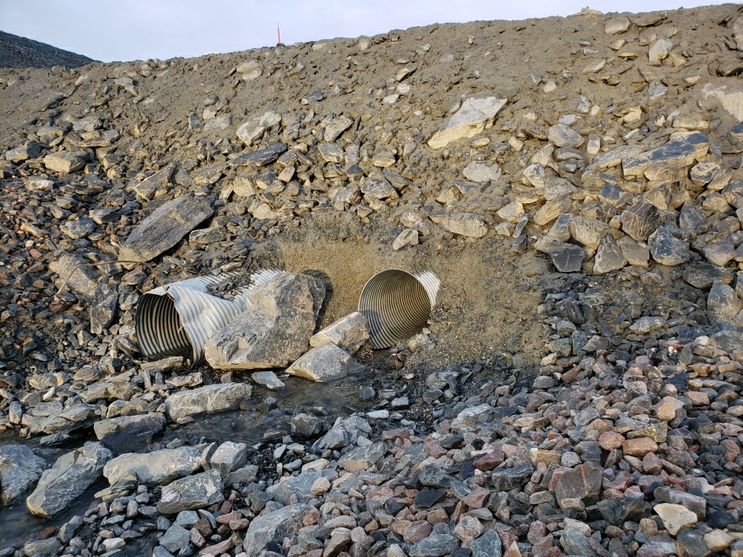
Description:
Repaired culvert at the NP1 West Diversion.

