 |  | PROCEDURE NUMBER: MEL-????-00XX
People concerned | - Sewage Truck and Water Truck Operators for Energy and Infrastructure Department |  | Prepared by | Site Services
People concerned |  |  | Authorized by  Reviewed by | Guillaume Gemme, E&I General supervisor  OHSC hourly rep: Serge Sirois
Effective : | February 26, 2018 |  | “Safety First, Safety Last … Safety Always!”  “No Repeats” – Our Stepping Stone to ZERO HARM
This procedure corresponds to the required minimum standard. Each and everyone also have to comply with the rules and regulations of the Nunavut Government in terms of health and safety at work.

Objective: To clearly define the procedure of Extracting Water from Exploration STP Retention Tanks to reduce the risk of having a leak or spill from the discharge line of these tanks.

Concerned departments:    Energy & Infrastructure | Required equipment:  - Sewage truck or water truck  - Key for lock on valve

Risks/ Impacts Legend


Health & Safety Process/quality Costs Environment

Procedure | Risks/ Impacts
- Obtain key from Supervisor for the locked wood box that contains transfer valve. | by supervisor having key this allows for the supervisor to depict who will be in charge of open the valve for this water.
- Park truck outside door for genset building, install wheel chocks.  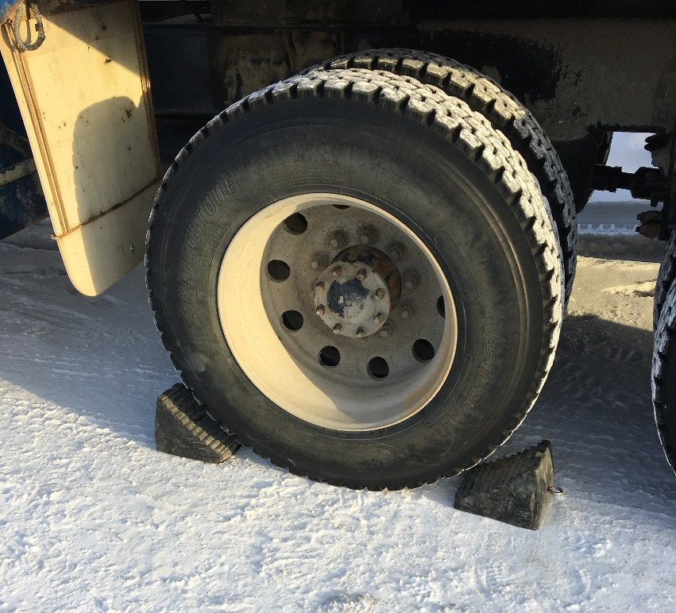 | Install wheel chocks to avoid any rolling of the truck while working around it.
- Remove 3” hose from truck. Connect hose to truck intake. | Use proper lifting techniques
- Take the truck hose inside door of the genset building and connect to green rigid hose on the floor.  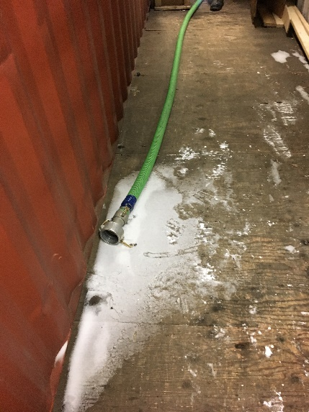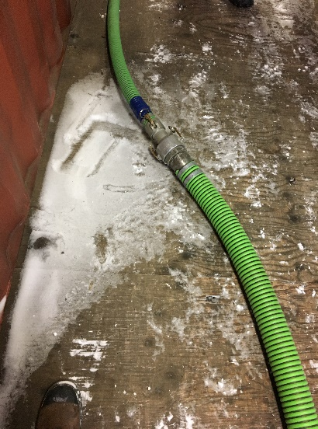 | By connecting hose before opening valves reduce the risk of spills on the ground
- Open appropriate valves on truck to accept water.
- Use key that has been provided in step 1; to unlock wood box.  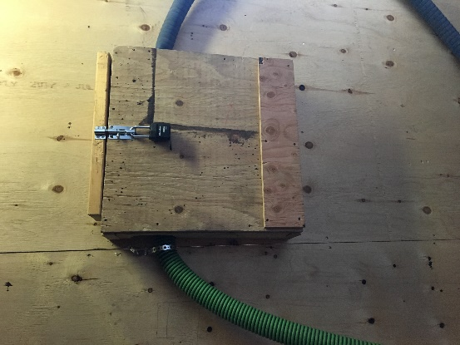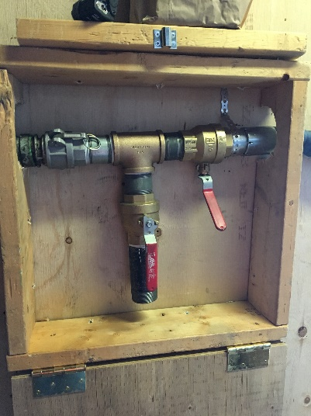 | by supervisor having key this allows for the supervisor to depict who will be in charge of open the valve for this water.  By keeping wood box locked that contains valve there is a one window approach to opening and closing.
- Close air valve # 2 inside box and open water valve #1.
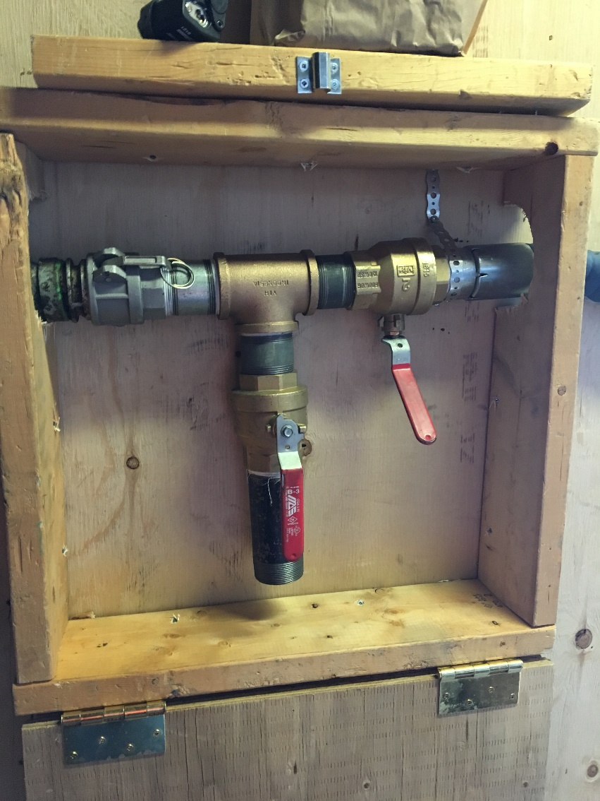
VALVE #1 WATER
VALVE #2 Air
- Return to truck, Open Valve for line and start PTO/suction on truck. | Watch for moving parts when PTO starts.
- Operator must stay with truck to monitor level going into truck. Truck should be filled to maximum 90% capacity to avoid overflow. | This will alleviate the risk of spills and overflow.
- Once full turn off PTO/Suction to truck. | watch for moving parts
- Go inside and close water valve #1 inside box. Once valve is closed; open the air valve # 2.  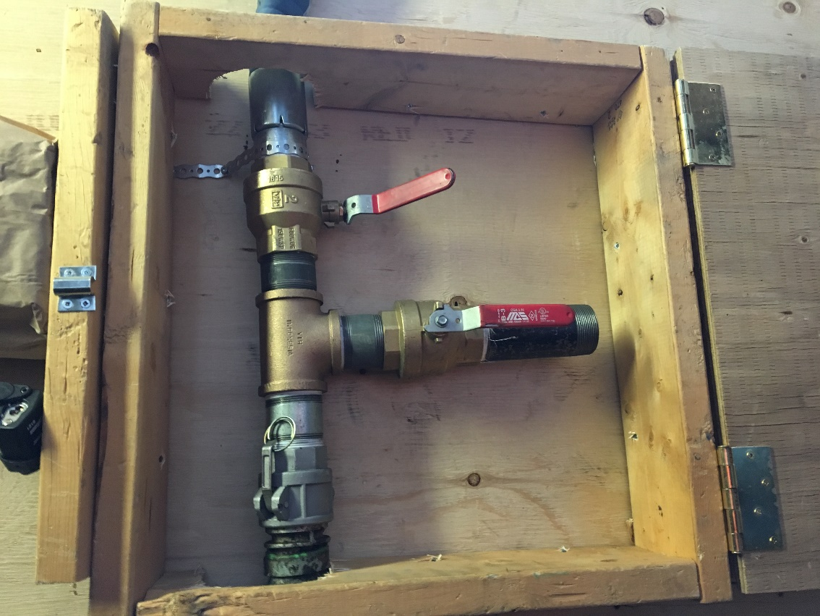 | This will assist to draw remaining water from hose.
- Restart PTO to drain hoses from valve. Only needs to run for about 5 seconds to empty the hose. Then shut PTO back off. | This will alleviate the risk of spill from the end of hose.
- Close all valves on truck.
- Close box and lock attach lock.  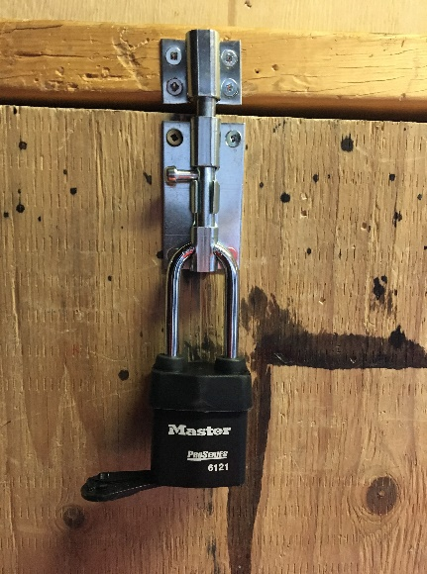 | by supervisor having key this allows for the supervisor to depict who will be in charge of open the valve for this water.
- Remove truck hose from stationary green rigid hose. Wrap hose on truck and secure hose to truck. | Use proper lifting techniques
- Complete water/Sewage transfer log sheet for removal of water.  Blanks of these forms can be found on the server here: \\Camefs02\groups\Site Services\WATER AND SEWAGE | It is required by government for us to report water and sewage transfers
- Remove wheel chocks.
- If using water truck take water to dispose in CP1 pond.  - If using sewage truck take water to Lift station 1 at New camp. | Only treated water from Explo STP can be deposited at CP1.

