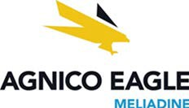
Follow Up Report: #19-491

December 21, 2019 Sodium Hydroxide Spill
The following information refers to spill 19-491 reported by Agnico Eagle Mines Ltd. December 22, 2019, and is being provided in accordance with:

the Nunavut Water Board License 2AM-MEL1631 Water License, part H, item 8c

Description of Incident:

On December 21st the Environment Department was contacted by a worker at the Saline Water Treatment Plant informing that two bags of powdered sodium hydroxide had torn open and partially spilled to the ground. While unloading a pallet, the load shifted and the bags slid off. Each bag contains 22.68kg (50lbs).

No water bodies were impacted by this spill. The closest natural water body is over 900m from the spill location. The coordinates of the spill are 63º1’34”, 92º12’38”.

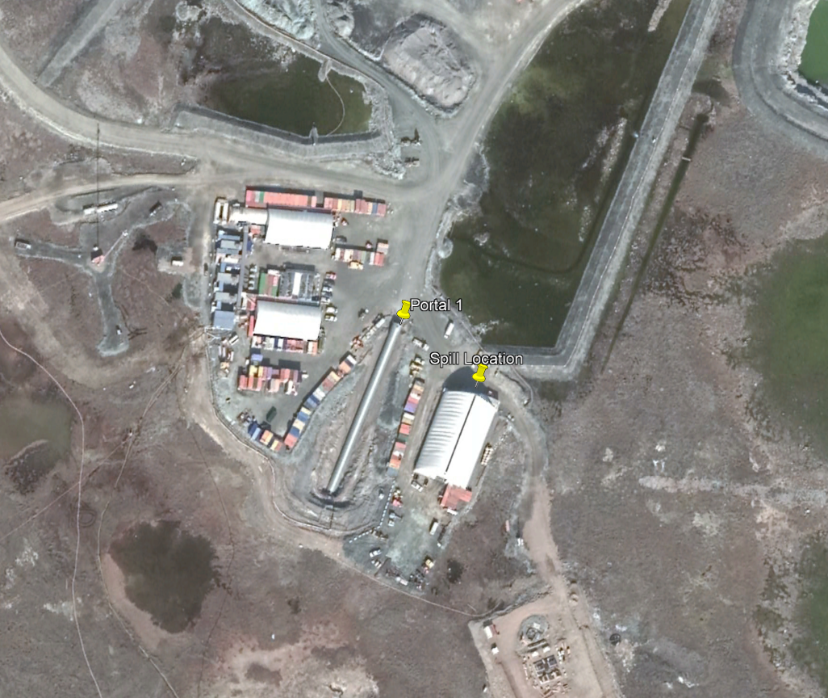
Figure 1: Location of powdered caustic soda spill near portal one and SWTP.

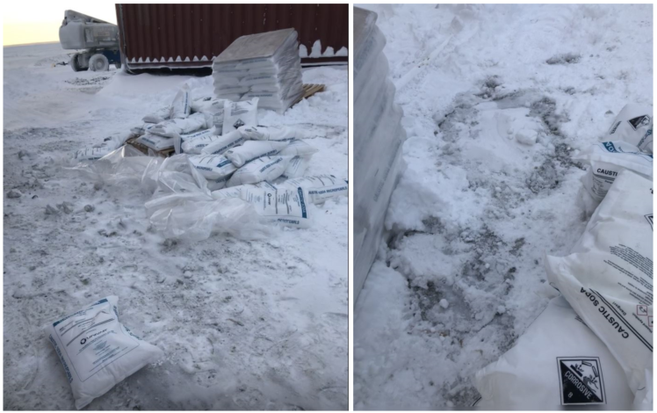
Figure 2: Two bags of Sodium Hydroxide powder spilled near portal one.

Spill Response & Cleanup:
The operators involved shoveled the contaminated snow and material into buckets and transferred it into containers already used for sodium hydroxide wastes. This material will be shipped as hazmat.

Corrective Measures:
This incident occurred due to a deviation from standard operating practices. Normally, pallets of sodium hydroxide are transported into the SWTP, by forklift, with plastic wrap intact. Due to the service door being broken, workers were transferring bags from the pallet to the SWTP by hand. Following the repair of the service door, the operator attempted to move the pallet without securing the load.
The operator’s manager has reiterated the need to comply with forklift training, by inspecting and securing loads prior to transport. Normal operations have resumed and sodium hydroxide bags are now unloaded in a contained area within the SWTP building.
 |  | Dan Gorton Environmental Coordinator  dan.gorton@agnicoeagle.com Direct 819.759.3555 x4603996  Agnico Eagle Mines Limited - Meliadine Mine, Suite 879 - Rankin Inlet, Nunavut, Canada X0C 0G0  agnicoeagle.com

