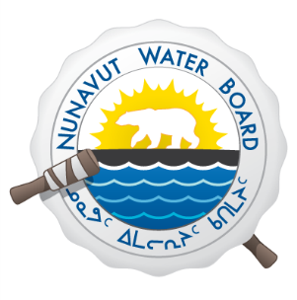

PUBLIC NOTICE

NUNAVUT WATER BOARD

The Nunavut Water Board (NWB or Board) will be holding a Technical Meeting and Pre-Hearing Conference by way of Teleconference for an Application filed by Baffinland Iron Mines Corporation to Amend (Amendment No.1) the Licence issued to the Mary River Project (Licence 2AM-MRY1325).

The Technical meeting and Pre-Hearing Conference will be held on Wednesday, January 28, 2015 – Starting 8:30am MST (10:30am EST) (and January 29, 2015 if required).

All community members are invited to participate. Persons interested in participating in the Teleconference should contact the Hamlet of Pond Inlet as soon as possible.

For further information, please contact the NWB’s Manager of Licensing:

P.O. Box 119, Gjoa Haven, Nunavut X0B 1J0
Phone: (867) 360-6338; Fax: (867) 360-6369;l
E-mail: licensing@nwb-oen.ca

