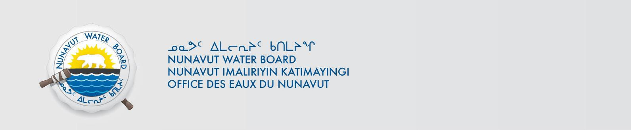
NUNAVUT WATER BOARD
NOTICE OF PUBLIC HEARING

Notice is given that in the week of September 25, 2017 (September 26-27, 2017) the Nunavut Water Board (NWB) will conduct an in person Public Hearing in respect of an application to a Type “A” Water Licence 2AM-WTP--- for the Whale Tail Pit Project and potential consequential amendment to the Type “A” Water Licence 2AM-MEA1525 for the Meadowbank Gold Mine details of which are as follows:

File #: 2AM-WTP---- 2AM-MEA1525
Project: Whale Tail Pit Meadowbank Gold Mine
Location: 65° 25' 22.241" N, 96° 46' 06.042" W 65° 01’ 33’’ N, 96° 04’ 01’’ W
65° 25' 12.707" N, 96° 35' 44.100" W
65° 21' 35.740" N, 96° 36' 03.944" W
65° 21' 45.248" N, 96° 46' 24.463" W

Purpose: Type “A” Water Licence.
Location of Hearing: Baker Lake, Nunavut
Date: The Public Hearing will occur in the week of September 25 (26-27, 2017)
Time and Location: 9:00am CT- 5:00pm CT in Community Hall
Community Session will be held on September 26, 2017 at 7:00pm CT.

The Public Hearing will proceed in accordance with the NWB Rules of Practice and Procedure and the directions of the Panel provided in the NIRB and NWB Joint Pre-Hearing Conference (PHC) Decision issued on June 8, 2017 and available from the link below. The timetable for the pre-hearing exchange of information is also included within the PHC Decision. The representations are to be made to:
Licensing Department, Nunavut Water Board
P.O. Box 119, Gjoa Haven, Nunavut X0B 1J0
Phone: (867) 360-6338; Fax: (867) 360-6369
E-mail: licensing@nwb-oen.ca
NOTE: Anyone who may be adversely affected by the Applicant’s proposed Amendment but fails to make representations to the NWB at least 10 days before the Public Hearing may lose the right to seek compensation under the Nunavut Waters and Nunavut Surface Rights Tribunal Act.

Copies of the application and supporting documents may be obtained, free of charge, through the internet on the NWB ftp site at the following link (Username: public and password: registry):
ftp://ftp.nwb-oen.ca/registry/2%20MINING%20MILLING/2A/2AM%20-%20Mining/2AM-WTP----%20Agnico/

or by contacting: Ryan Vanengen, Environment Superintendent
Agnico Eagle Mines Limited – Meadowbank Division
T: 819-759-3555 x 6838 M: 819-651-2974
Email: ryan.vanengen@agnicoeagle.com

Failure to respond to this Notice of Application within the specified period will result in the loss of the right to be compensated, pursuant to Sections 58 to 61 of the Act.

