January 15, 2014 NWB File No: 2BB-MRY1114

Christine J. Kowbel
Lawson Lundell
1600 Cathedral Place
925 West Georgia Street
Vancouver, BC Canada
V6CX 3L2
E-mail: ckowbel@lawsonlundell.com

Re: Acknowledgement and Receipt of Application Fee – Renewal Amendment Water Licence – Mary River Exploration Project

Dear Christine:

The Nunavut Water Board acknowledges receipt on October 4, 2013 of your application fee, cheque number 27647, for the above project. Your payment has been forwarded to Aboriginal Affairs and Northern Development Canada in Iqaluit for processing. A receipt will be issued through their office for fees totaling $30.00.

Please call the undersigned at (867) 360-6338 or e-mail licensing@nunavutwaterboard.org if you have any questions.

Sincerely,

Original signed by:

Megan Porter
Licensing Administrator Assistant

Enclosure

Cc: Jean Allen, AANDC
Rory MacDonald, AANDC
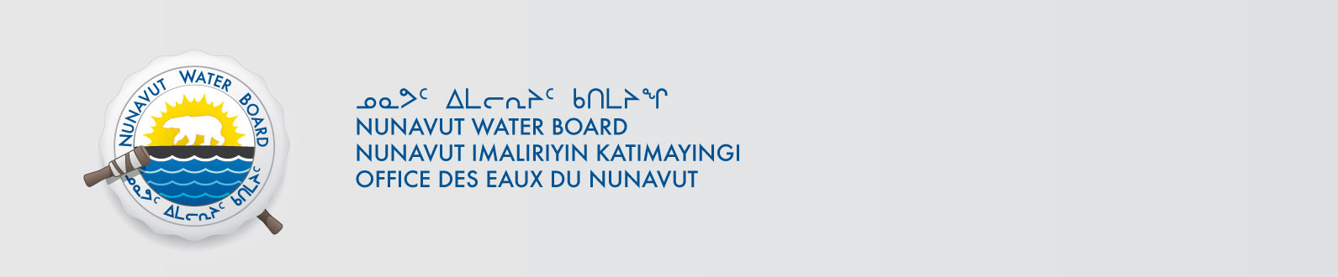
Melanie Netser, AANDC

