June 24, 2013 File No: NWB2NAN97022BB-MRY1114/TR/A

Jim Millard, M.Sc.,P.Geo.
Senior Environmental Superintendent
Baffinland Iron Mines Corporation
Suite 1016, 120 Adelaide Street West
Toronto, ON M5H 1T1
Email: jim.millard@baffinland.com

Subject: Submission of Water License Inspection Report and Photos for Mary River Project- Mary River Camp/Milne Inlet Camp Drawings - Part G, Item 12

Dear Mr. Ledrew,Dear Mr. Millard:

The Nunavut Water Board (“NWB”) acknowledges receipt, on May 31, 2013, of a submission from Aboriginal Affairs and Northern Development Canada, dated May 4 & 5, 2013 entitled Water Licence Inspection Report and Photos Mary River Project- Mary River Camp/ Milne Inlet Camp 2BB-MRY1114. This submission has been placed on the NWB public registry and is available from the NWB ftp site, username public, and password: registry.
Received January 26, 2000
Notice of this report is forwarded to the distribution list for information only. Anyone wishing to provide comments may do so by return email to the Manager of Licensing at licensing@nunavutwaterboard.org.

Please note contact information as follows for the AANDC Inspectors:
Qikiqtani Region – Andrew Keim Andrew.Keim@aandc-aadnc.gc.ca
Kivalliq Region – Christine Wilson – Christine.Wilson@aandc-aadnc.gc.ca
Kitikmeot Region – Eva Paul - Eva.Paul@aandc-aadnc.gc.ca

Sincerely,

Original signed by:

Megan Porter
Licensing Administrator Assistant

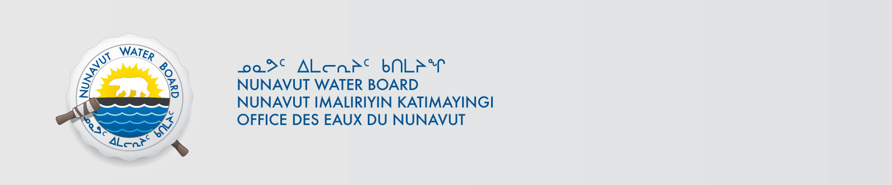
cc. Qikiqtani Paula Pacholek, EC
Chris Nichols, DSD
Gladys Joudrey, NIRB
Jordan Degroot, DFO
Roxanne Beavers, DIAND (YK)
Paul Smith, DIAND (Iqaluit)Distribution List

