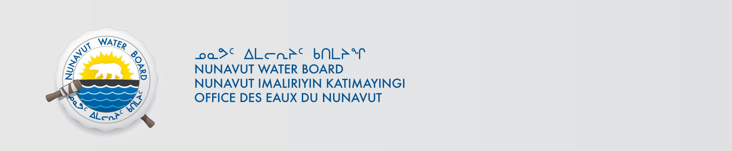
NWB File No: 2BB-MRY1314

August 15, 2013

Oliver Curran
Director, Sustainable Development
Baffinland Iron Mines Corporation
2275 Upper Middle Road East, Suite 300
Oakville, ON Canada LH6 0C3
E-mail: oliver.curran@baffinland.ca

Re: Acknowledgement and Receipt of Water Use Fees for Water Licence –2BB-MRY1314

Dear Mr. Curran:

The Nunavut Water Board acknowledges receipt on August 14, 2013 of your water use fees, cheque number 6894, for the above project. Your payment has been forwarded to Aboriginal Affairs and Northern Development Canada in Iqaluit for processing. A receipt will be issued through their office for fees totaling $1405.25 for water use fees.

Please refer to the calculation for water use fees, in the Nunavut Waters Regulations, Section 12, to ensure that the correct fee has been submitted. A copy of this regulation is available from our ftp site or by contacting this office. This is an annual fee which is required to be submitted yearly on the anniversary of the issuance of your water licence.

Please call the undersigned at (867) 360-6338 or e-mail licensing@nunavutwaterboard.org if you have any questions.

Sincerely,

Original signed by:

Megan Porter
Licence Administrator Assistant

Cc: Jean Allen, AANDC
Rory MacDonald, AANDC
Melanie Netser, AANDC

