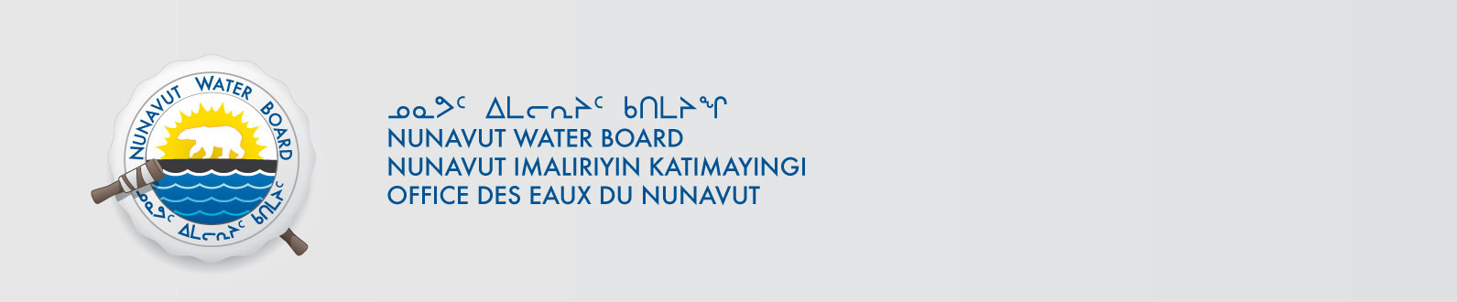
2BE-ANG1318 / Renewal ApplicationNWB2MEL01--
March 23, 2018

Mr. Andrew Berry
Chief Operation Officer
Kivalliq Energy Corporation
1020 – 800 Pender St W
Vancouver BC, V6C 2V6
E-mail : andrewb@kivalliqenergy.com

Subject: Kivalliq Energy Corp – WMC International Limited Angilak Property – Renewal – Type “B”, Kivalliq Region

Dear Mr. Berry:

The Nunavut Water Board (NWB) provides notice that on March 1, 2018, a renewal an application for a licence renewalapplication for a Type “B” water license January 5, 2001for water use and/or waste disposal associated with exploratory drillingactivities in the Kivalliq Region of Nunavut was filed by Kivalliq Energy Corporation By way of this correspondence, the Board invites parties to provide the NWB with their comments with respect to the application as outlined below. The application consists of the following documents:
- Appendix A Executive Summary English & Inuktitut
- Appendix B 2018 Angilak Property Work Plan 2018
- Appendix C 2013 NWB Renewal Licence
- Appendix C 2014 NWB Licence Amendment
- Appendix C 2016 NWB Licence Amendment
- Appendix D Authorization Letter
- Appendix E Certificate of Incorporation Name Change
- Appendix F Financial Statements
- Appendix G Spill Contingency Plan
- Appendix H Fuel Management Plan
- Appendix I Environmental & Wildlife Management Plan
- Appendix J Abandonment & Restoration Plan
- Appendix K Emergency Response Plan
- Appendix L Waste Management Plan
- Appendix M Community Consultation Plan
- Appendix N NPC Documents
- Appendix O NIRB Amend Application Exemption
- Appendix O NIRB Screening Decision Report
- Appendix P Land Use Permit Inspection Form
- Application for Water Licence Renewal Cover Letter
- Application for Water Licence Renewal
- 2018 Abandonment & Restoration Plan
- 2018 Spill Contingency Plan
- Renewal Application Clarification

The application can be obtained from our ftp site at the following link:

ftp://ftp.nwb-oen.ca/registry/2%20MINING%20MILLING/2B/2BE%20-%20Exploration/2BE-ANG1318%20Kivalliq%20Energy%20Corp/

As noted in the NWB’s earlier correspondence acknowledging receipt of this application, under the Agreement Between the Inuit of the Nunavut Settlement Area and Her Majesty the Queen in Right of Canada (Nunavut Agreement) Article 11, Section 11.5.9 and s. 76 (1) of Nunavut Planning and Project Assessment Act (NuPPAA), the proponent of a project proposal governed by the Nunavut Agreement and NuPPAA that requires a water licence is required to submit a project proposal document (which may include the water licence application) directly to the Nunavut Planning Commission (NPC or Commission). The NPC then reviews the project proposal and makes a determination regarding the applicable land use planning requirements and/or provides direction regarding whether the project proposal is subject to screening by the Nunavut Impact Review Board (NIRB). Under Articles 11, 12 and 13 of the Nunavut Agreement, NuPPAA and Part 3 of the Nunavut Waters and Nunavut Surface Rights Tribunal Act (NWNSRTA), until the project proposal has concluded the applicable land use planning and assessment process required by the NPC and the NIRB, the NWB cannot issue a water licence.

On this basis, the NWB, while previously acknowledging the receipt of the application, waited for the Commission’s determination and recommendations before proceeding to the next steps in the NWB’s processing of the application. Please be advised that on March 13, 2018 the NWB received the required determinations and recommendations from the Commission.

Now that the application has concluded the pre-licensing steps required under the Nunavut Agreement, NuPPAA and the NWNSRTA, the NWB is now proceeding to the next steps in processing the application, including providing the attached Notice of Application which will be published in due course. In addition, to ensure this application is dealt with in a timely fashion, the NWB has forwarded notice of all documentation received by the NWB in respect of the application to regulators and Council of the Municipality(ies) most affected by the project. The NWB is also inviting interested parties to make representations about the application, including information requests, identifying issues of water user compensation and providing technical review comments directly to the NWB within thirty (30) days from the date of this letter; on or before April 23, 2018.

After the NWB receives and reviews the comments received, the Board may provide additional procedural instructions regarding the next steps in the Board’s processing of the application. Please note that throughout the Board’s consideration of the application, the NWB retains the right to request additional information and studies, as set out under ss. 48(1)-(3) of the NWNSRTA. If additional information will be requested, the NWB’s technical staff will contact the applicant to discuss the Board’s request in detail.

If the applicant or parties have any questions regarding this matter, please contact Derek Donald, the Technical Advisor for the file at derek.donald@nwb-oen.ca.

Sincerely,

Licence Administratror

Enclosure: Notice of Application

Cc: Distribution List – Kivalliq

