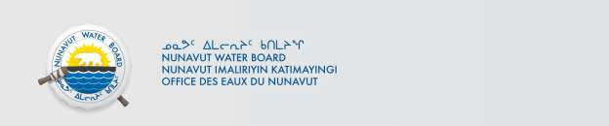

December 04, 2024 NWB File No. 2BE-ANG2227

Jeff Dare  5833 Nunavut Ltd.  1020-800 West Pender St.  Vancouver, BC V6C 2V6  E-mail: jdare@valoremetals.com | Tara Gunson, P.Geo.  APEX Geoscience Ltd.  #100, 11450 – 160th Street NW  Edmonton, AB T5M 3Y7  E-mail: tgunson@apexgeoscience.com

Re: Acknowledgement and Receipt of Water Use Fee for 2BE-ANG2227

Dear Ms. Gunson:

The Nunavut Water Board acknowledges receipt on November 27, 2024 of your credit card information for payment of water use fee for the above project. Your information for payment has been forwarded to Crown Indigenous Relations and Northern Affairs Canada in Iqaluit for processing. A receipt will be issued through their office for fees totaling $1091.35.

2024 Water Use Fee $1091.35

Please refer to the calculation for water use fees, in the Nunavut Waters Regulations, Section 12, to ensure that the correct fee has been submitted. A copy of this regulation is available from our ftp site or by contacting this office. This is an annual fee which is required to be submitted yearly on the anniversary of the issuance of your water licence.

Please call the undersigned at (867) 360-6338 or e-mail licensing@nwb-oen.ca if you have any questions.

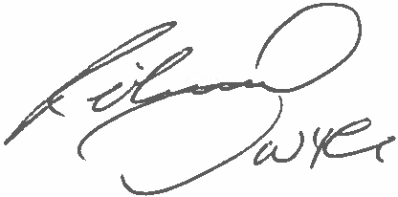
Sincerely,
Richard Dwyer Manager Licensing

Cc: Margaret Mike, CIRNAC Andrew Keim, CIRNAC
CIRNAC Inspectors



